6.1

(a) p1

(b) ¬p1

(c) (p1∧(¬p2))∨(p2∧(¬p1))

(d) p1∨p2

(e) p1∨(¬p2)

(f) ¬(p1∧p2)

(g) (¬p1) → p2

(h) ¬(p1 → p2)

(i) ¬(p2 → p1)

(j) p1↔ (¬p2)

(k) (¬p1)∧(¬p2)

(l) (p1∧p2) → p2

(m) (¬p1) → (p1∧p2)

(n) p1∨(p1∧p2)

(o) (p1∧p2)∨((¬p1)∧p2)

6.2

(a) ¬A = A↑A, or

¬A = A↓A

(b) A ∨ B = (A ↑ A) ↑ (B ↑ B), or

A ∨ B = (A ↓ B) ↓ (A ↓ B)

(c) A ∧ B = (A ↓ A) ↓ (B ↓ B), or

A ∧ B = (A ↑ B) ↑ (A ↑ B)

(d) A → B = ((A ↑ A) ↑ B) ↑ ((A ↑ A) ↑ B), or

A → B = ((A ↓ A) ↓ B) ↓ ((A ↓ A) ↓ B)

6.3

(a) A ∨ (¬A)

T T FT

F T TF

tautology

(b) A ∧ (¬A)

T F FT

F F TF

contradiction

(c) (¬A) ∨ B

FT T T

TF T T

TF T F

FT F F

contingency

(d) ( A ∨ B ) ∧ (¬ ( A ∧ B ))

T T T F F T T T

T T F T T T F F

F T T T T F F T

F F F F T F F F

contingency

(e) ( ( ¬ A ) ∨ ( ¬ B )) ↔ ( A ∧ B )

FT T FT T T T T

FT T TF T T T F

TF F FT F F T T

TF T TF F F F F

contingency

(f) A → ( B ∨ ( ¬ C ))

T T T T FT

T T T T TF

T F F F FT

T T F T TF

F T T T FT

F T T T TF

F T F F FT

F T F T TF

contingency

(g) ( ( A ∧ B ) ∧ ( C ∧ D ) ) → A

T T T T T T T T T

T F F F T T T T T

T F F F F F T T T

T F F F F F F T T

T T T F F F F T T

T T T F T F F T T

T F F F T F F T T

T T T F F F T T T

F F T F T T T T F

F F F F T T T T F

F F F F F F T T F

F F F F F F F T F

F F T F F F F T F

F F T F T F F T F

F F F F T F F T F

F F T F F F T T F

tautology

(h) ( A ↔ ( ( ¬ B ) ∨ C ) ) → ( ( ¬ A ) → B)

T T FT T T T FT T T

T F FT F F T FT T T

T T TF T T T FT T F

T T TF T F T FT T F

F F FT T T T TF T T

F T FT F F T TF T T

F F TF T T T TF F F

F F TF T F T TF F F

tautology

6.4

(a) Tautology

((A → C)∨B∨C) → ((A∨B) → (D∨E∨¬E))

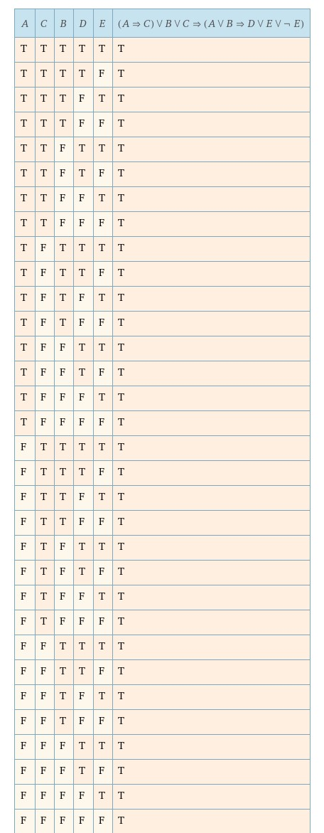

(b) Contingency

(B∨(¬B)∨(A→D)∨(C→E))→((A∨C)→(D∨E))

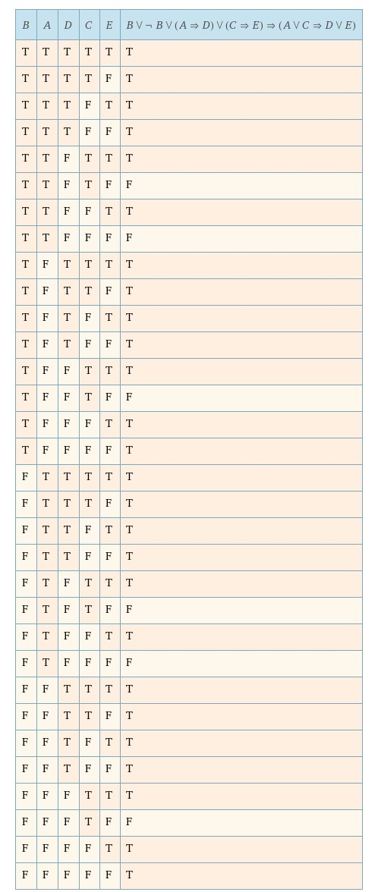

(c) Contradiction

(D∨A∨(¬D)∨(¬B)∨(¬A)) → (E∧(¬E)∧C∧(¬C))

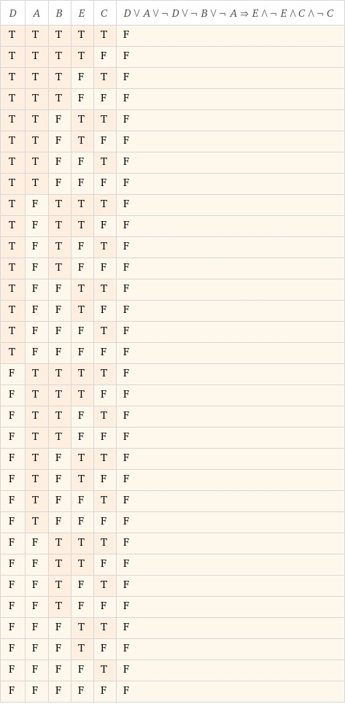

6.5

(a) { A → B, B → C, （C ∨ D） ↔ （¬B） }

A B C D A→B B→C C∨D ¬B （C∨D）↔（¬B）

T T T T T T T F F

T T T F T T T F F

T T F F T F F F T

T F F F F T F T F

T T F T T F T F F

T F F T F T T T T

T F T T F T T T T

T F T F F T T T T

F T T T T T T F F

F T T F T T T F F

F T F F T F T F F

F F F F T T F T F

F T F T T F T F F

F F F T T T T T T

F F T T T T T T T

F F T F T T T T T

**Satisfiable for three situations, no unsatisfiable.** There exist three truth valuations making the formulas always true. (yellow background)

(b) { ¬(（¬B） ∨ A), A ∨ （¬C）, B → （¬C） }

A B C ¬B ¬C (¬B)∨A ¬((¬B)∨A) A∨(¬C) B→(¬C)

T T T F F T F T F

T T F F T T F T T

T F F T T T F T T

T F T T F T F T T

F T T F F F T F F

F T F F T F T T T

F F F T T T F T T

F F T T F T F F T

**Satisfiable.**

(c) { D → B, A ∨ （¬B）, ¬( D ∧ A), D }

A B ¬B D D → B A∨(¬B) ¬( D∧A)

T T F T T T F

T T F F T T T

T F T F T T T

T F T T F T F

F T F T T F T

F T F F T F T

F F T F T T T

F F T T F T T

**Unsatisfiable.**

6.6

(a) { A→B , A }⎥=CPC B

A B A→B

T T T

T F F

F T T

F F T

**Holds.**

(b) { A→B , B }⎥=CPC A

A B A→B

T T T

T F F

F T T

F F T

**Holds.**

(c) { A→B , B→C }⎥=CPC A→C

A B C A→B B→C A→C

T T T T T T

T T F T F F

T F F F T F

T F T F T T

F T T T T T

F T F T T T

F F F T T T

F F T T T T

**Holds.**

(d) { A→B , A→(¬B) }⎥=CPC ¬A

A B ¬B ¬A A→B A→(¬B)

T T F F T F

T F T F F T

F T F T T T

F F T T T T

**Holds.**

(e) A→B ⎥=CPC ¬(B→A)

A B B→A A→B ¬(B→A)

T T T T F

T F T F F

F T F T T

F F T T F

**Does not hold.**

(f) { A∨B , B∨C }⎥=CPC A∨C

A B C A∨B B∨C A∨C

T T T T T T

T T F T T T

T F F T F T

T F T T T T

F T T T T T

F T F T T F

F F F F F F

F F T F T T

**Holds.**

(g) { A , ¬A }⎥=CPC B

A ¬A B

T F T

T F F

F T T

F T F

**Holds.**

(h) C ⎥=CPC A ↔ (A ∨ (A∧B))

A B C A∧B A ∨ (A∧B) A ↔ (A ∨ (A∧B))

T T T T T T

T T F T T T

T F F F T T

T F T F T T

**Holds.**

6.7

(1)

((A∨B)∧C)∨((¬C)∧B∧D∧(¬D)) |=CPC A

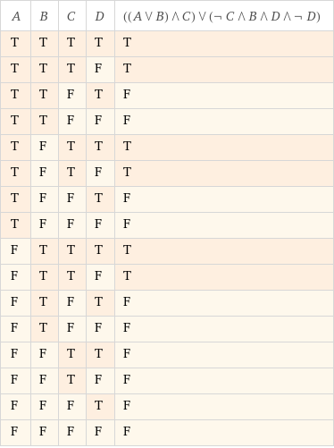

Doesn’t hold.

(2)

(D∨A∨(¬D)∨(¬B)∨(¬A)) → (E∧(¬E)∧C∧(¬C))

|=CPC D

holds