Introduction to Weight Training

The benefits of weight training have never been so accepted and so frequently recommended by experts as being an important part of your total physical fitness plan. It is well documented that building muscular strength and endurance through the use of weight training is an integral part of good health and fitness for all ages and sexes. Other benefits include enhanced muscle tone, better flexibility and balance, prevention of muscle and joint injury, minimized risk of osteoporosis, and decreased risk of cardiovascular disease and stroke. It is not surprising that the value of weight training in the promotion of health has been recognized and recommended by the surgeon general of the United States. This book will include almost everything you will need to safely conduct a well-designed weight-training program.

Years ago weight training was considered an activity reserved for only a few unusual people, like the strongman in the circus.
It was once feared that professional athletes would have reduced speed and limited abilities to perform if they lifted weights. In the past 25 to 30 years, however, weight training has evolved from the Dark Ages into the Scientific Age. As a result, people of all ages and gender are going to health clubs, spas, and gyms all over the country to participate in a variety of resistance training activities. Physical therapists, athletic trainers, and occupational therapists are using weight training. Whether you are a beginner or have some past experience the combination of this book and your experiences in the gym will help you learn the necessary safety guidelines, lifting techniques, and rules for designing a program to meet your health and fitness needs now and for a lifetime.

The History of Weight Training

The origin of lifting traces back to the beginning of recorded history where man's fascination with physical prowess can be found among numerous ancient writings. Chinese texts tell of prospective soldiers having to pass lifting tests as early as 5,000 years ago. Ancient Greek sculptures also depict lifting feats using heavy stones. Dumbbells later replaced stones. The origin of the word dumbbells comes from the practice of removing clappers from bells, resulting in no sound during lifting. Ancient Greek texts report that Hippocrates described the principle of weight training while writing, "that which is used develops, and that which is not used wastes away.” It was during this time that strongmen such as Samson, Hercules, and the Greek warrior Milo are spoken of as part of ancient myth and folklore. Historically, weight training played an important role in preparing soldiers for battle in the days of the Greeks, Egyptians, and Romans. During the Middle Ages, many Roman soldiers were trained by marching over long distances with heavier-than-normal loads to create a form of resistance training. European armies quickly embraced this form of overload training throughout the seventeenth century.

What is Weight Training and What are the Benefits?

Defining weight training and identifying the many benefits of weight training will directly impact your successful experiences in the gym now and for a lifetime. This specialized form of exercise should be an integral part of your health and personal fitness program throughout your life. Having the knowledge of weight training’s many benefits can and will serve as a powerful motivator for your continued successes.

1. What is Weight Training
If you desire to increase the strength or endurance of your muscles you must first consistently subject your muscles to some form of resistance. The continued systematic increase of muscle overload (resistance) through the use of weights, elastic bands or other form of resistance is termed progressive resistance training. Weight training is a very popular form of resistance training that utilizes free weights or machines to overload the muscles sufficiently to produce desired benefits. While weight training may be the focus of this book it is important to realize there are other forms of resistance training you may find interesting.
- Weight lifting. Competitive lifting is done usually by individuals having a definite genetic advantage. They follow a very specific program designed for strength and power. Examples: the Olympic lifter competes in two overhead lifts. One is referred to as the snatch and the other the clean-and-jerk. Both lifts are totaled and the highest total wins the competition. The other competition is Power lifting. Competitors participate in the bench press, the squat and the dead lift. The highest total of all three lifts wins. In both forms of competition, the competitors are grouped into similar body weight categories.
- Bodybuilding. Competitors are concerned more with the appearance of their body than their strength. Perfecting the art of sculpting the muscles for maximum size, symmetry and definition is the end goal. This sport entails many years of specialized training.
- Strength training. Training is done by athletes in a variety of competitive sports other than weight lifting or bodybuilding. The goal is to enhance sport performance and reduce the chance of injury. Virtually all sports have a strength training program specifically designed to meet the needs of their athletes.
- Rehabilitation. This uses resistance exercises to recover from an injury. Physical therapists frequently utilize weight training as a tool to regain muscle strength, endurance and hypertrophy (muscle size). Low levels of resistance are utilized early on and are increased as the muscles respond.
- Fitness Enthusiasts. A person lifting weights purely for health and fitness needs falls in this category. They understand the value of weight lifting and how it can result in a more attractive body and improved self-image. Weight training has many benefits including the building and toning of muscles. It improves your metabolism and increases the strength of not only muscles, but also the strength of tendons (bone to muscle), ligaments (bone to bone) and bone tissue. The following list identifies the primary and secondary benefits of all forms of resistance training.
2. Benefits of Resistance Training (Weight Training)
- Primary Benefits
  - Builds and tones muscles
  - Increases strength and density of bones which reduces the possibility of osteoporosis
  - Increases strength in ligaments and tendons
  - Reduces the risk of type 2 diabetes because it improves glucose tolerance and insulin sensitivity o Helps promote a better ration of “good” cholesterol (HDL) to “bad” cholesterol (LDL)
  - Reduces body fat and increases lean body mass
  - Increases metabolism, which helps control weight by burning more calories
  - Improves blood pressure regulation
  - Can lower resting heart rate
- Other Benefits
  - Increases muscular endurance
  - Reduces incident of injury
  - Improves personal appearance
  - Improves posture
  - Contributes to good self-esteem and self concept
  - Improved flexibility and range of motion in joints
  - Reduces stress and enables you to deal with stress better
  - Slows the aging process
  - Improves daily functional fitness, you are better able to conduct daily activities.

Is Weight Training for Everyone?

When you take into consideration the many benefits associated with weight training it is hard to exclude anyone from regularly participating in this healthy activity. However, over the years there have been many myths about resistance training that may prevent some individuals from making it part of their fitness program. In this next section we will explore some of these myths and better understand the reality of resistance training and its many benefits regardless of your age or gender.

1. Females and Weight Training
The benefits from weight training are the same for women and men and the exercises are the same for both genders. Females can do anything men can do in the weight room. It is, however, important to note the physical differences in men and women and how these differences can impact the outcome of training.
- Females have a smaller skeleton.
- Females have less muscle mass (number of muscle fibers).
- Females have lower levels of the hormone testosterone (muscle-building chemical produced by the body); males have 10-20 times more.
- This lower level of testosterone prevents females from developing bulky muscles, low voice or facial hair.
- Females can experience proportionally the same strength gains as males.
2. Children and Young Teens
When done correctly children can benefit from a well-designed supervised resistance program. They can experience strength gains, improved metabolism, increased bone mass, improved self-esteem and can prevent injuries. The American Academy of Pediatrics suggests that, with proper supervision, even children as young as 5 can safely participate. The following are suggested guidelines for children to follow.
- Never be allowed to train alone
- Never be forced to participate
- Focus on all around physical development
- Use only moderate to light weights
- Use a program with higher repetition requirements (10-15)
- Never do one repetition maximums
- Always maintain strict technique
3. Adults and Older Adults
We know that with aging we begin to experience loss of strength and muscle mass. Additionally, because we live in a society that encourages sedentary lifestyles through technology, automation and many other conveniences we tend to lose muscular strength and muscle mass at a much faster rate than earlier generations. This accelerated loss is however, not due entirely to the aging process. In fact, most of this loss is due to our failure to maintain muscular strength with regular exercise and activity. All adults, whether they are 40 or 80, should practice a lifestyle of resistance training if they wish to maintain their independence and mobility.
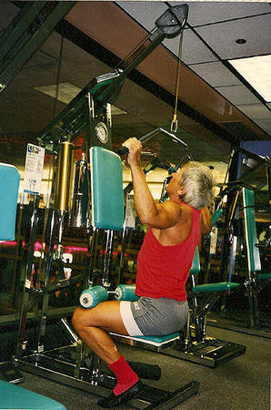
- The loss of muscle mass and strength begins after the age of 30. This condition is called “sarcopenia” which means motor nerves lose their connection to the muscle fiber they once controlled. As much as 15% loss can occur by age 70.
- A lifelong participation in a resistance program can prevent muscle and nervous system degeneration, which can lead to potential disease and injury.
- Strength can be gained by middle-aged adults and older adults at the same rate as younger lifters.
- Strength training decreases the rate of bone loss with aging and may provide minimum benefits of increased bone density.
- Weight training’s positive effect on your metabolism can help prevent fat gains, coronary artery disease and stroke.
- There are marked improvements in joint health and performance.
- All these benefits can be achieved in as little as 15-20 minutes a day two to three days a week.
4. Muscles and Flexibility
Maintaining adequate levels of joint flexibility is an important part of good overall heath and fitness. For years it was believed that lifting weights would greatly reduce the range of motion in your joints. The truth is that weight training is an excellent way to maintain good joint health and improve your flexibility.
- Muscles and joints should be stretched before and after lifting.
- All lifts should be done with correct technique.
- All lifts should be done through a full range of motion on all repetitions.
- Do not exceed your capacity to handle a given amount of weight.

Equipment

A well designed weight training program should start with the right kind of equipment which will include free weights, weight machines, exercise bands, clothing, footwear, weight training belts and possibly wraps and straps. Give careful consideration to these as they may affect the safety, cost and comfort of your training.

1. Clothing
When selecting clothing there are a variety of fabrics to choose from. You may have a preference of material, but keep the following tips in mind.
- Clothing should be nonbinding, allowing for freedom of movement.
- Clothing should be appropriate for the temperature of the training environment. Consider layers when necessary.
- Avoid wearing clothing that can easily get tangled or caught on the equipment.
- Wear clothing that makes you feel comfortable about your appearance during the workout.
2. Footwear
Correct footwear is always required in the weight room. Flip-flops or open toe shoes give little support and are not recommended. Consider the following tips when deciding on footwear.
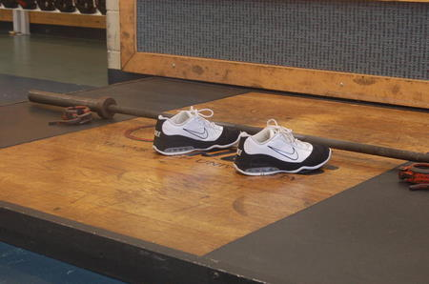
- Cross-training shoes with non-slip bottom are convenient, comfortable and safe.
- Shoes should be properly fitted with good arch support and a thick sole for support.
- There are special designed shoes for serious power and Olympics lifters.
- Always wear socks as they can absorb moisture to help prevent blisters.
3. Gloves
Though not essential, gloves can be a nice addition to your workout gear.
- Their main purpose is to prevent blisters or calluses on your hands while at the same time providing you with an improved non-slipping grip.
- There are a variety of styles such as full fingers and half finger gloves, neither has an advantage.
- Gloves also come in a variety of materials.
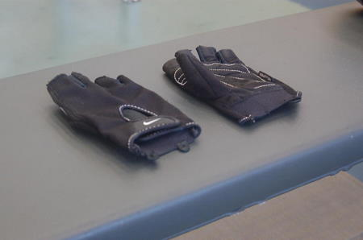
4. Weight Training Belts
Though not essential, weight-training belts can be a valuable safety addition to your workout gear.
- The main purpose of wearing a weight-training belt is to help stabilize your lower back. Do not rely solely rely on a belt for protection. Do your lifts with good technique and lift within your capacity.
- A belt is recommended when performing squats, overhead presses (Olympic lifts) or dead lifts while lifting heavy weight (85% or greater.)
- To many lifters use belts all the time while in the gym, preventing the development of strength in the lower back muscles. Use a belt only when you really need one.
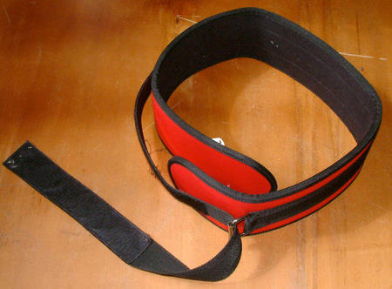
5. Straps and Wraps
Though not essential, straps and wraps can be a valuable safety addition to your workout gear.
- Straps are fastened around your wrist and then twisted around the bar to provide a strengthened grip. They are used when your handgrip is not strong enough to use heavy weights during an exercise. When possible use bare hand grips as this will strengthen your hand grip quicker.
- Wraps are used to support weak or injured joints and muscles. They are most commonly used around the knees during very heavy squat lifts or elbows during very heavy bench press lifts. Ace bandages are frequently used and should be firmly wrapped but not too tight.
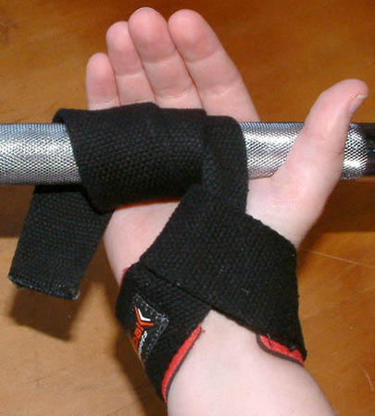
6. Free Weights vs. Weight Machines
There are a variety of resistance training tools and methods. You should choose the method that best suits your needs, desires and budget. Popular methods include free weights, weight machines, rubber/elastic bands, plyometrics and exercises utilizing your body weight. Any of these methods can be used to effectively reach your goals. Weight training focuses on the use of free weights and machines as the preferred method.
Free Weights
The term free weights refers to the use of barbells and dumbbells. Barbells are 5 to 7 feet long and are designed to have varying amounts of weights placed on their ends. They are constructed of metal and are used with both hands at the same time and have collars on the ends to secure the weight. They may weigh between 17 and 30 pounds and the most common types are the standard and the Olympic. Some may be specifically designed for specific exercises. Dumbbells are much shorter than barbells and exercises are conducted with one hand per dumbbell. They each have a set weight that may range from 2 ½ pounds to 100 pounds. Weight plates are placed on the ends of the barbells to vary the resistance. The plates most often come in weight denominations of 2 ½, 5, 10, 25, 35 and 45 pounds. They may also be in kilograms.
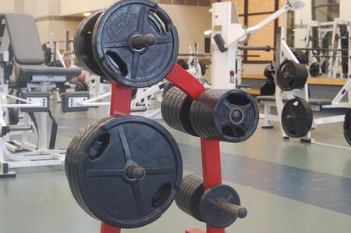
The following identifies the advantages (+) and disadvantages (-) of free weights.
- Considerably less expensive to purchase and maintain (+)
- Require minimal space and can be moved easily (+)
- More likely to improve coordination and balance (+)
- The same piece of equipment can be used for all body parts (+)
- Easier to determine and evaluate strength improvement (+)
- Are not as safe, require balance, will need spotters (-)
- Requires a greater amount of specific technique (-)
- Beginners require more time due to safety concerns (-)
- Requires more time to change weights (-)
Weight Machines
Weight machines are mechanical devices that provide resistance through the use of cables and pulleys. They are safer, more convenient and require less technique than free weights and for those reasons are often preferred by beginners and non-athletes.
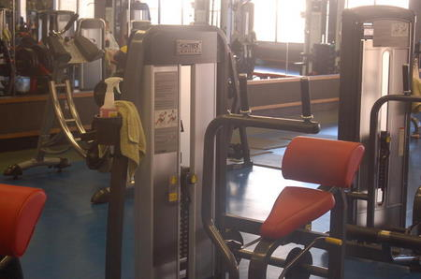
The following identifies the advantages and disadvantages of weight machines.
- Much more expensive and costly to maintain (-)
- Will need many different machines to work the entire body (-)
- Requires additional space and difficult to move (-)
- Can only be used for one main muscle area (-)
- No balance is required thus limiting the improved coordination necessary for athletic performance (-)
- Harder to interpret strength gains (-)
- Much safer and requires no spotters (+)
- Less time required for workout, easier to change weight, no partner required (+)
- Much easier to learn, little technique required (+)
7. Other Considerations
Every resistance training facility will have a different arrangement of equipment and features that may help create an effective lifting environment. The following are additional considerations you may want to employ in your workouts.
- Mirrors
  - These are best placed in a variety of places so participants can observe technique when lifting
  - As a safety precaution do not lift close to the mirrors
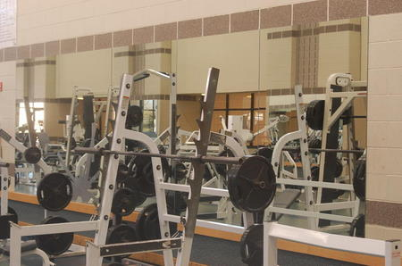
- Flooring
  - Carpets: used for stretching and warm-up areas
  - Rubberized Flooring: used for areas where weights are more likely to be placed on the floor.
  - Wood: most often used for Olympic lifts for its smooth flat surface and excellent footing.
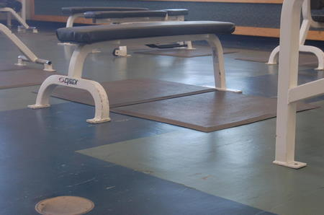
- Environmental Factors
  - Good Lighting
  - Good Signage
  - Appropriate Temperature and Humidity
  - Air Circulation
  - Good Sound System
  - Water and Restrooms

Getting Started

Before you go to the gym or buy any equipment there are a few recommendations that need to be considered. Are you sure weight training is for you; is it safe for your participation? Where and when are you going to work out? Do you want a workout partner? Will you need an instructor to assist you in planning and conducting a safe weight training program? The following suggestions will assist you in answering these questions and others.

1. Medical Clearance
Most college-age students can safely participate in a weight training program if they are in good health, start slowly and follow a reasonable plan. However, if you have a pre-existing medical condition such as coronary disease or skeletal problems you should have a complete medical examination. Inform your doctor of your plans to begin weight training and ask for their advice. Obviously, this medical clearance becomes more important as you grow older. It is your personal responsibility to get this medical clearance, as it is better to be safe than sorry. However, for most people it is safer to exercise than to risk the consequences of living a sedentary lifestyle.

2. Weight Room General Guidelines and Etiquette
The weight room can be a safe productive environment if everyone will practice a few simple considerations. It is likely that the weight room will have a lot of people sharing the same facility and equipment. You should always be aware of what is going on around you and display respect and courtesy for other lifters and the facility. Consider and practice the following behaviors and general guidelines.
- Before starting a program at a new facility be sure to familiarize yourself with all the facilities. Know where the equipment you want to use is located and how it is correctly used.
- Be sure to familiarize yourself with any special rules associated with the facility.
- Always be alert and act responsible. Never engage in any kind of inappropriate behavior that may disturb or potentially cause injury to anyone.
- When using music be considerate of others; they may not like your brand of music.
- Never chew gum or tobacco in the weight room; it is not appropriate and can cause choking.
- If the facility does not provide towels you should use your own to wipe sweat from any equipment you use.
- Return all equipment to the proper place after use.
- Clear your barbells of all weights and correctly replace on rack. It should be ready for the next person.
- Keep the floor clean of all unintended objects.
- Be careful of water bottles and other personal equipment that may get in someone’s way.
- Offer to spot for others and ask politely for a spotter and be ready when they get there.
- Exercise equipment is not for resting on; be sure to not impede the progress of other lifters.
- Limit your time on one piece of equipment, share with others.
- Be aware of your personal hygiene.
3. Spotting
When using free weights, a spotter is always necessary. Even the most skilled lifters can benefit from spotters and the beginner should never lift without the safety factor that spotters provide your workout. The following are important considerations and rules for all spotters and lifters.
- All spotters should know their strength and be able to safely assist the lifter.
- Spotters should be ready to use their legs for most of the lifting and not their backs and arms. Correct technique is important for the spotter as well. Stay in a ready position.
- Spotters should check that weight plates are on correctly and evenly; also check floor and surrounding area for any obstructions.
- Before any lifting is started determine if two spotters are needed.
- The lifter and the spotter should be very clear about the desired lifting and spotting technique and the number of reps.
- Develop a clear communication between spotter and lifter. Terms such as “ready lift” and “ready release” and “rack” are essential to the safe completion of all lifts requiring spotters.
- Spotter is alert at all times and should not touch the bar unless needed.
- When assistance is needed the spotter should not jerk the bar; rather he should apply enough force to keep the lifter’s momentum going until the bar is racked. Important note: lifters should never quit on a lift and expect the spotter to do all the work. Never quit applying pressure until the bar is safely back on the rack.
- Spotters should provide motivation and encouragement to the lifter.
4. Exercise Specific Warm-ups:
The inclusion of a well-designed warm-up is equally as important for the beginner as for the advanced lifter. The warm-up consists of three parts: the cardiovascular component, the static and dynamic stretching component and the exercise specific movement. Consider the following parts of the warm-up before any lifts.
- Cardiovascular warm-up
The first part of any preparation for physical activity should be an activity to get the heart and other parts of the circulatory system working at a higher intensity. A general cardio warm-up should last 2-3 minutes and might include a slow to moderate jog, a variety of calisthenics or rope-jumping. The intensity is low at the beginning and moderately increases with additional time. The cardio warm-up is not intended to tire or exhaust you. Once the heart has increased intensity and the body temperature has slightly raised it is time to do the dynamic stretches.
- Muscular/Skeletal warm-up
The second part of the warm-up should specifically target your muscles and joints. This portion of the warm-up should involve the stretching of all joints and muscles that will be used. Muscles should be stretched minimally with static stretches (slow steady pull) while primarily engaging in dynamic stretches (minimal resistance while stretching and relaxing the muscles of a joint through a full range of motion). Never use quick jerking or ballistic movements as this may cause injury to the muscles and tissue around the joint. Consider the following activities and suggestions for a safe Muscular/Skeletal warm-up.
- Skill Specific warm-up
The third part of the warm-up involves the use of a barbell or dumbbell to do the actual exercise with minimal weight. Go through the full range of motion for 3-5 repetitions with a smooth controlled speed. The muscle and joint should now be ready for the workout.
5. Safety Guidelines
Before you begin your first workout you should learn and fully understand some basic safety fundamentals for lifting and these should be applied each time you workout. When these fundamentals are applied, the possibility of injury is greatly reduced and makes the weight training environment a much safer place.
- Move carefully and slowly in the weight room.
- Stay out of the way of other lifters while they are lifting.
- Check for proper working order of all equipment before lifting.
- Warm up correctly before all lifts (see warm up suggestions) and engage in a correct cool down after workouts.
- Consider the stable position of the following body parts while performing any lifts: head, shoulders, lower back and hips, knees and feet. Do not twist or arch your back during any lifts.
- Know the correct lifting technique for any exercise you attempt.
- Always maintain very strict lifting form for all exercises. Do not cheat to lift extra weight. Never lift more than you can safely handle.
- All lifts are to be done with a controlled speed and with a smooth, non-jerking motion. Never allow weight to slam or bounce as gravity pulls the weight down.
- Never hold your breath during lifts. Exhale during the last half (greatest exertion) of all exercises. Return to the starting position and inhale before the next repetition. Practice this technique before any heavy lifts. Holding your breath could temporarily restrict the flow of blood to the brain causing dizziness or possible blackout.
- Always protect your back by lifting most of the weight with your legs when picking any items form the floor.
6. Considerations for Proper Technique
When performing any resistance exercises proper technique must be a major priority if you want to fully realize your goals and reduce the risk of injury. Using the following technique tips will help you achieve your goals more quickly.
- General Technique
  - Maintain straight back at all times
  - Remember to use your legs to lift not your back
  - Standing lifts should have a stable wide base to insure balance
  - Keep weights close to your body as you lift
  - Always conduct exercises and joints through a full range of motion
  - Maintain mental concentration on the primary muscles as your perform exercises
  - Avoid forcefully locking out the joint
  - Allow adequate recovery time between sets
  - When using machines be sure to properly align machine and body

• Grips
Correctly gripping the bar or dumbbell is an often overlooked important technique. The correct grip will enhance the results of the exercise and help prevent injury. The following are the four types of grips used in weight training. The specific grips for each exercise will be discussed later. All grips should use the closed grip (thumb goes around the bar and overlaps the index finger).
- Pronated Grip (closed)
  - Palms are always facing away as you grab the bar
  - Thumbs are pointing toward each other
- Supinated Grip (closed)
  - Palms are always facing toward you as you grab the bar
  - Thumbs are pointing away
- Alternating Grip (closed)
  - One hand is a pronated grip and the other is a supinated grip
- Neutral (closed)
  - Hands and wrist are positioned halfway between pronated and supinated grip position.
• Hand Placement
Correct placement of hands on the bar is just as important as the specific grip you use. Each exercise will have possible variations of the hand placement and should be aligned with your specific goals. Tor safety purposes it is always important to evenly space your hands regardless of which placement you use.
- Wide Placement
  - Both hands extended beyond shoulder width
- Common Placement (normal/standard)
  - Both hands placed near shoulder width
- Narrow Placement
  - Hands are placed inside shoulder width 8-10 inches apart
• Phases of Exercise Movement Technique
All exercises have two phases of the contraction and both phases are important if you want to realize full benefits of your workout.
- Concentric Phase
  - The muscle applies the greatest force while contracting (shortening). The muscle force is great enough to overcome the resistance of the weight.
  - The phase is part of any pull or push exercise.
  - The phase last about 2 seconds and is conducted in a smooth continuous motion.
  - You should exhale during this phase.
- Eccentric Phase
  - The muscle contraction force is reduced as the muscle begins to lengthen. The resistance is slightly greater than the muscle contraction force.
  - Never allow the weight to quickly drop.
  - The phase lasts about 2-4 seconds and is conducted in a smooth continuous motion.
  - The phase is part of any pull or push exercise.
  - You should inhale at the completion of this phase.

Goals and Record Keeping

During this course you will be introduced to the behavioral-change model suggesting a step-by- step approach for achieving personal fitness goals. The first step in this process is to establish reasonable and obtainable goals. Consider the following information as you prepare your goals.

1. Setting Reasonable Goals
Set goals that are obtainable! Be realistic and specific as you determine your goals. Before you can accurately establish your goals you must do a “needs analysis”. This process will allow you determine your unique needs and characteristics along with a physical assessment of your abilities. If you are an athlete your needs may be different from someone with a health and fitness goal. It is also a good idea to have goals that are measurable. It is not realistic to plan for a 100 lb. gain in the bench press in a two-month period of time. Be sure to make goals that are challenging, but not too hard, nor should they be too easy which could make you bored with the process. (See weight training assessments section)

2. Establishing Short and Long-term Goals
Short-term goals are great for personal motivation. Each time you reach a well-designed goal you are strongly motivated to continue the process toward the next goal. An example of short- and long-term goals might be to establish a 1RM of 220 pounds in the back squat in 4 months and your current 1RM is 160 pounds. Your short-term goal may be to increase the 1RM by 20 pounds the first month, 15 pounds the second month, 15 pounds the third month and 10 pounds the fourth month.

3. Establish a Variety of Short-term Goals
Since short-term goals can help you reach your long-term goals, then it makes good sense to have a variety of short-term goals that will contribute to your success. Consider the following:
- A specific number of days per week to workout
- A specific number of hours for workouts
- A specific amount for strength gains
- Specific dates for reaching goals
- Sleep habits
- Fluid intake
- Nutrition
  - This topic is very important for you to see your goals happen
  - Practice good nutrition habits daily
  - Practice nutrient timing (intake of carbs and protein before, during and after workouts)
4. Revise Goals
There will be times when you unable to follow the plan or goals you developed. Injuries, sickness, emergencies, work or a variety of other situations may interrupt your workouts. When this happens, accept it and get back on track. You may want to revise dates and other specifics for your goals, but you will want to get right back on track and restart your routine as soon as possible. As you reach your goals be sure to set new ones. Go through your assessments again and start the goal-writing process again.

5. Be Positive, Be Positive, Be Positive!!!!!
Prepare your goals with a positive attitude and read them daily. If you miss a day do not dwell on it; if you do not reach one goal rewrite it and keep going. If you have written goals correctly, believe in them and stay the course.

6. Record Keeping
Keeping good records will have a powerful impact on your ability to reach your goals. This process will keep you on track, serves as a great motivator, simplifies workouts, puts variety in workouts and can prevent setbacks. There are many topics to keep records for and you are only limited to your creativity. Additionally, there are a variety of worksheets to record your workouts, find one that meets your needs or create one specifically for you. The following are a few of the items to consider.
- Dates and time of day
- Body parts
- Specific exercises
- Order of exercises
- Amount of weight
- Number of sets and reps per exercise
- Recovery time between sets and exercises
- Days missed, illness
- Body weight, muscle size, body comp., and others
- Nutrition habits
- Sleep
- Others

Designing a Workout

Whether you are a beginner or a well-trained experienced lifter you will need to follow a well-designed program to realize your goals. The program should be based on the fundamental principles of overload, progression, and specificity. Everyone can benefit from weight training; however, how you lift, the frequency and intensity of your workouts and the planned progress of your workouts can ensure your optimal gains and safety. The following program design considerations should be considered before you begin any workout.

1. Components of the Workout
There are four parts to the workout and they are arranged in a sequential order. Each part builds on the next part until the workout is completed.
- The Repetition (rep)
Considered the most basic part of any workout. It is one completed activity at a given exercise.
  - Usually done 8-10 times non-stop per exercise with beginners
  - Number may change with goals and experience
  - Go through full range of motion
  - Inhale and exhale per each rep
- The Set
A group of consecutive reps is a set. If you do eight consecutive reps of bench press then you have done one set of eight.
  - Usually done in groups of 1-3
  - Ample recovery time should be taken between sets, will be determined by your goals.
  - Recovery time varies between 30 seconds and 4 minutes
- The Exercise
Each workout will require the execution of many different exercises. Each exercise should be designed to work a specific muscle or muscle group. They may be done with free weights or weight machine.
  - Complete 2-3 sets of a planned number of reps for each exercise
  - Exercises should consider all major body areas
- The Body Area
Anytime an exercise is conducted it will specifically target a muscle or muscle group. By using a variety of exercises for a specific muscle group you can more effectively impact the development of that muscle area.
  - Remember to balance the workout with all body areas
  - Major Body Areas
    - Chest
    - Shoulders
    - Legs
    - Back
    - Arms (triceps/biceps)
    - Torso (abdominals)
2. Variations of Exercise Order
There are a variety of ways to organize the exercises in your workout. The order or sequence of the exercises is often referred to as a circuit. How you arrange the circuit of exercises is up to you and should consider your needs, goals, training experience and available time. In the conventional circuit, the exercises are done with a minimal recovery time of 20-30 seconds. The following are three common variations of the circuit.
- Power, Other Multi-Joint, Single Joint
In general the larger the muscle and the more technique required to do an exercise, the more priority it should be given for being first in the workout. The exercises that have less technique requirements and use smaller muscles are placed later in the workout. This is done so the core exercises like squats and bench press can be performed without fear of fatigue and can use the smaller muscles for support. Be sure to include adequate recovery time between sets and exercises. This will maximize the safety and effectiveness of your technique.
It is important to note that power exercises are not recommended for beginners.
  - Examples of power exercises include: power clean, snatch and push press
  - In this method lifter completes all the sets of the same exercise before moving to next exercise
  - EXAMPLE: bench press, shoulder press, triceps extension
  - EXAMPLE: squats, leg extension, leg curl, heel raises
- Alternating Upper and Lower Body Exercise
Upper body exercises include the waist and all muscles above the waist; lower body exercises are below the waist. This method can be beneficial to beginners since it allows more time to recover instead of doing several upper body exercises in a row, which may be considered too strenuous.
  - This method can minimize the time between exercises and reduce the total workout time
  - Ideal for beginners
  - Recovery time between sets will vary with goals
  - Lifter needs to adhere to the large muscle to small muscle philosophy
  - Leg exercises will need to be repeated since there are fewer exercises to choose from
  - EXAMPLE: bench press, squats, shoulder press, lunges, lat pull, leg extension, bicep curl
- Alternating “Push” “Pull” Exercises
All weight training exercises involve either a pushing or pulling activity. By arranging exercises to alternate pushing and pulling movements you can improve the recovery factor for muscles. This push-pull circuit can ensure that the same muscle group will not be used in two consecutive exercises, thus reducing the fatigue factor of the involved muscle or muscle group.
  - Ideal for beginners
  - “pushing” exercises are extension of joint
  - “pulling” exercises are flexion of joint
  - Helps to keep opposing muscles balanced
  - EXAMPLE: leg press, leg curl
  - EXAMPLE: lat pull, shoulder press
  - EXAMPLE: bench press, seated row
  - EXAMPLE: triceps extension, arm curl
3. Frequency of Workout
Weight training frequency refers to the number of training sessions you have in a designated time frame. The time frame most often used is one week (7 days). Factors like fitness level, training intensity, recovery time, available time, occupational considerations and other physical requirements in your life.
- Fitness /Experience Considerations
  - Beginners are likely to have 2-3 “full body” workouts a week. Using all muscle groups.
  - Lower levels of fitness may require more recovery time between workouts, but lower levels of workout intensity require less recovery time, usually 48 hours between workouts
  - Full Body Workout Routine
Monday Wednesday Friday
Full body Full body Full body
  - Intermediate to advanced lifters may have 4-6 workouts a week of select muscle groups. These workouts are called “split routines” and are conducted at higher intensities.
  - Higher intensities are accomplished by working fewer muscle areas with more sets.
  - Higher intensities require more recovery time, usually 72 hours between same muscle groups.
  - “Split Week” Workout Routine
Monday/Thursday Tuesday/Friday
Chest, Shoulder, Triceps Back, Bicep, Legs
  - Your job, family considerations, class schedule, sports competition or a number of other factors can limit the number of days you can do workouts in a given weeks.
4. Intensity of Workout
How hard you work in a workout is your intensity and there are a variety of ways to apply intensity. The amount of weight you use (training load) is the most common factor in determining intensity and will vary with your goals. Another factor is the number of sets and reps per exercise and muscle group and the last is the number of exercises per body part.
- Training Load
Is considered the most critical factor in a weight training program. The amount of weight you assign to any given set is the training load and is a percentage of your 1 RM or estimated 1RM. The specific percentage you use is determined by your goals and may range from 60% to 100% of your 1RM. Additionally, when the percentage of your 1RM goes up the number of repetitions per set should go down. (Insert training load conversion chart)
Training Goals | % 1RM | Reps | Sets
Beginners Use | 60% | 10-12 | 1-3
Strength goals | ≥85% | <6 | 2-6
Power goals:  Single effort event  Multiple effort event | 80%-90%  75%-85% | 1-2  3-5 | 3-5  3-5
Hypertrophy goals | 65%-85% | 6-12 | 3-6
Muscular Endurance | ≤65% | ≥12 | 2-3
Fitness and tone | 60%-80% | 8-10 | 1-3
5. Recovery Time
Recovery time in weight training refers to rest periods. The muscles must be allowed a rest period in order for it to replenish energy levels and prepare for the next set, exercise or even workout. The amount of rest time will depend on your goals, training level, types of exercise, arrangement of exercises and intensity.
- Recovery Time and Goals
Reaching your specific goals will require you to adhere to specific recovery times between sets. How much recovery time you allow is directly related to the amount of load (weight) assigned to each set. In general the more weight lifted the more recovery time required. The following chart identifies the recovery time needed for each of the general goal requirements.
Training Goals rest periods between sets
Beginners use | 1-2 minutes
Strength goals use | 2-5 minutes
Power goals use:  Single effort event  Multiple effort event | 2-5 minutes  2-5 minutes
Hypertrophy goals | 30 sec. to 90 sec.
Muscular Endurance | ≤30 seconds
Fitness and tone | 30 sec. to 2 min.

- Other Recovery Considerations
  - Multi-joint exercises need more recovery time than single joint
  - Maximal or near-maximal lifts need more recovery
  - Circuits of push-pull or upper body lower body need less recovery than consecutive sets of the same muscle
  - Hard workout needs more days of recovery than light workout
  - Do not allow too much recovery time between sets as they will cause a cooling down factor that may cause muscle injury
  - Do not allow more than three days between workouts as this may result in loss of training effect
  - In season or competition periods may require modification of recovery time
6. Common Programs
Beginners with no previous weightlifting experiences should consider goals that improve general fitness, muscle tone, muscle strength and endurance. They should be done slowly and safely with a well-planned program. The following programs are recommended for consideration for the first 5 to 6 weeks. The number of sets per exercise may vary from 1-3 and may include 1-2 different exercises for each of the major body areas.
- The “Basic Eight”
This program is designed to work the entire body using 1-3 sets of 8-12 reps for each of the eight major muscle areas. By choosing eight exercises you can cover all major areas of the body in a relatively short amount of time while requiring a minimum amount of equipment. A starting goal for the training load is 60%-70% of your 1RM with a recovery time, between sets, of 60-90 seconds. The workout is done three times a week and you are encouraged to use a variety of exercises as you progress. The following is one example of a Basic Eight design.
Body Area Exercise
Chest | Bench Press
Back | Bent-over Row
Shoulder | Military Press
Biceps | Arm Curl
Triceps | Triceps Extension
Quads/Hamstring | Squats
Calves | Heel raises
Abs | 90/90 Crunch

- Multiple Sets (Progressive System)
As you improve in fitness and technique you may want to increase both the number of sets per exercise and the number of exercises per body part. The multiple sets system will allow you to design a flexible program to meet your needs. This program may be started after 2-3 weeks of lifting, but should progress slowly for the first 6-8 weeks. The number of sets per exercise may be 2-3 sets of 8-12 reps and use 1-3 different exercises for the same muscle group. You will still work the eight muscle groups; however, your training time will increase due to the increased number of exercises. A starting goal for the training load is 70%-80% of your 1RM with a recovery time, between sets, of 60-90 seconds. Complete all sets and exercises in each muscle group before going to the next muscle group and remember to work muscle from big to small in order. The workout is done three times a week and you are encouraged to use a variety of exercises as you progress. The following is one example of a multiple set design.
Body Area Exercise
Chest | Bench Press - 3 set/10  Bench flies - 2 set/10
Back | Bent-over Row - 3 set/10  Lat pull - 2 set/10
Shoulder | Military Press - 3 set/10  Lateral raises - 2 set/10
Biceps | Arm Curl - 3 set/10  Hammer Curl - 2 set/10
Triceps | Triceps Extension - 3 set/10  Kickbacks - 2 set/10
Quads/Hamstring | Squats - 3 set/10  Leg curl - 2 set/10
Calves | Heel raises - 3 set/15
Abs | 90/90 Crunch - 2 set/25  Crunch alternating - 1 set/25
7. Advanced Programs
As you improve in all of these areas you may begin to consider other programs that provide more intensity, volume and variety. The following programs are designed for individuals with adequate training experience and fitness. These individuals should have a desire to pursue resistance benefits beyond general fitness. Consider any or all of the following programs as you pursue your resistance training goals.
- Pyramids
This system requires the use of progressively heavier weights and fewer reps with each successive set of an exercise. The first set may use 65%-70% of your 1RM with 10-12 reps and work your way up the pyramid to the top where you may do 90%-95% of your 1RM. A pyramid may vary in the number of stages (3, 4 or 5). The lifter may choose to go from the bottom to the top of the pyramid. Other lifters may start at the bottom and go to the top and then go all the way back down the pyramid. This program is often used to develop strength and is better suited for larger muscles using multi-joint exercises. Recommended recovery time between sets is 2-3 minutes. The following is an example of a 4-stage pyramid.
EXAMPLE:
1st set 10-12 reps at 65-70% 1RM
2nd set 6-8 reps at 75-80% 1RM
3rd set 4-5 reps at 85-90% 1RM
4th set 1-2 reps at 90-95% 1RM
- Super Sets
This system requires the lifter to perform two consecutive sets of exercises that stress opposing (antagonistic) muscles. There is no rest allowed between the two sets. For example, do a set of 10 leg extensions quickly followed by a set of 10 leg curls. That routine is considered one super set. This process allows one opposing muscle to rest while the other muscle is being worked, which can reduce the overall workout time. Recommended recovery time between sets is 60-90 seconds, depending on the size of the muscle group. This program may be used to develop hypertrophy (muscle mass) and is suited for both multi-joint and single joint exercises. Another benefit of this system is that it requires the lifter to maintain a balance between antagonistic muscles.

OTHER EXAMPLES:
Bench press and seated row
Arm curls and triceps press down
Lat pull and shoulder press
- Compound Sets
This system requires the lifter to perform two consecutive sets of exercises that stress the same muscles. There is no rest allowed between the two sets. For example, do a set of 10 triceps kickbacks quickly followed by a set of 10 triceps press-downs. That routine is considered one compound set. Recommended recovery time between sets is 60-90 seconds, depending on the size of the muscle group. This program may be used to develop hypertrophy (muscle mass) and is suited for both multi-joint and single joint exercises. Since this process can put a high level of stress on the same muscle it is not recommended to use the system each workout.

OTHER EXAMPLES:
Bench press and bench flies
Seated rows and lat pulls
Arm curls and hammer curls
Squats and lunges
- Giant Sets
This system has all the components of a compound set with additional exercises. A giant set may use three to five different exercises for the same muscle.
EXAMPLES:
Pull-ups, lat pull, seated row, bent-over row
Shoulder press, up-right row, front raises, lateral raises

