Introduction to Racquetball
Welcome to one of the most popular games in the nation, racquetball. Racquetball is a fun, fast-paced game that can be played indoors, as well as outdoors. Racquetball is a sport that can be enjoyed by people of all ages and skill levels. It is a great way to get exercise, and it typically burns more calories per hour than walking, running, or using an elliptical machine. This sport is perfect for improving hand-eye coordination and agility.
Invented in the middle of the 20th century, racquetball has reached millions of recreational and professional participants worldwide. The nature of the game has not changed much since its invention. However, technology has influenced many changes to the accessories and equipment used in play.

Joseph G. Sobek developed racquetball in 1949 at a Greenwich, CT YMCA. Though Sobek invented the game, he did not name it; he called the game paddle rackets. Initially, the racquet was a hybrid design inspired by paddleball, paddle tennis, and platform tennis. Racquets were wooden, with a cross-string pattern. The Seamless Rubber Company is credited with designing the ball.
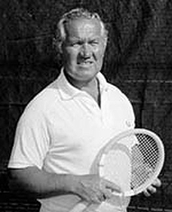
Joseph G. Sobek

The National Paddle Rackets Association (NPRA) was formed in early 1952 by Sobek, which provided a code of rules. The rules were printed and distributed to encourage participation. Sobek had an easy time promoting the sport, as there were at least 40,000 existing handball courts, which could be used to play the new sport. Sobek and Robert Kendler, the head of the United States Handball Association, joined forces in 1969, and founded the International Racquetball Association (IRA).

The first professional racquetball tournament was held in 1974. The organization of a professional tournament also leads to the formation of the International Racquetball Federation (IRF). Coupled with the fitness boom of the late 20th century, racquetball reached nearly 3 million participants by the early 1970s. This lead to an increase in the demand for more courts, as well as racquetball-specific equipment. The popularity of the sport continued to increase through the 1980s. In fact, it was estimated that nearly 6 million Americans participated in recreational or professional racquetball play during this time .

The IRA eventually became the American Amateur Racquetball Association (AARA). In the late 1990s, it was renamed the United States Racquetball Association (USRA), to reflect other Olympic Sport associations.

Equipment

Racquetball has minimal needs for equipment and requires a moderate-sized space to play the game.

1. The Racquet and Strings:
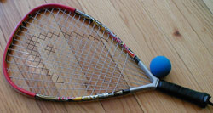
The racquet for this sport is very different than in all other racquet sports. A racquetball racquet has a very short handle, and the total length of the racquet must not exceed 22 inches (58.9 cm). The racquet can be made of many different materials (fiberglass, graphite, titanium, tungsten, etc), though most new ones are made of composite materials. Racquets vary in weight; light racquets are good for speed, control and easy maneuverability. A heavier racquet is better for power. The racquet grip size varies from 3 5/8 to 3 15/16 inches. Smaller grips allow players to snap their wrists more easily, which allows for an increase in power as the ball strikes the racquet. The racquet will be attached to an athlete’s wrist by a cord during competition.
The racquet strings are just as important as the racquet frame. Strings are comprised of nylon, gut, Kevlar, polyester, zyex or plastic. The two main types of strings are mono- and multifilament strings. Monofilament strings have a single core with a wear layer. In contrast, the multifilament strings have thousands of small fibers which are interwoven. Monofilament strings are typically more durable and resistant to a loss of tension. The multifilament strings are better if you require an increase in power, control and comfort, and are not concerned with durability. String thickness varies; 15-16 gauge are thick strings, 17-18 gauge represent thinner strings. A thick string is desired for durability.

2. The Ball:
A racquetball is a lively rubber ball. The ball is 2 ¼ inches (5.7 cm) in diameter. The ball should weigh approximately 1.4 ounces (40 g). There are many different choices available for use in racquetball. In the United States, typically players use Penn-brand balls, either Blue Pro Penn or the Pro Penn Greens. In international play, the International Racquetball Federation will use the ball that is sanctioned by the event; for example, International Pro Racquetball (IRT) uses the Purple Penn HD.
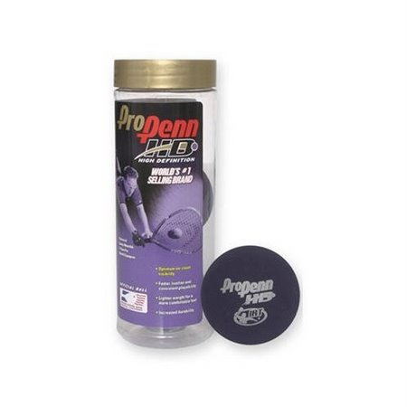

3. Clothing and Accessories:
Racquetball is a very active game and requires the correct attire to maximize your play and enjoyment and prevent injury. Consider the following suggestions.
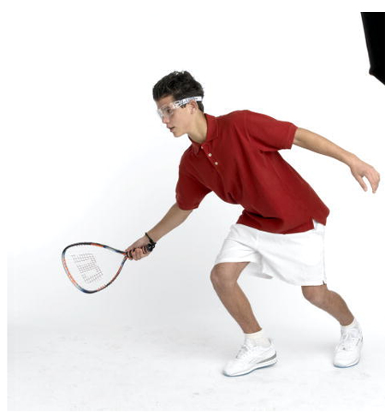
- Whether you play for recreation or competition, wear something in which you are comfortable. Be sure you are not restricted by your clothing. Lightweight clothing is recommended because of the intensity of the sport; you will sweat a lot.
- Good shoes are imperative! Select shoes that provide a good grip, and have great traction on the court. Shoes should be lightweight, flexible and durable. Non-marking shoes are essential.
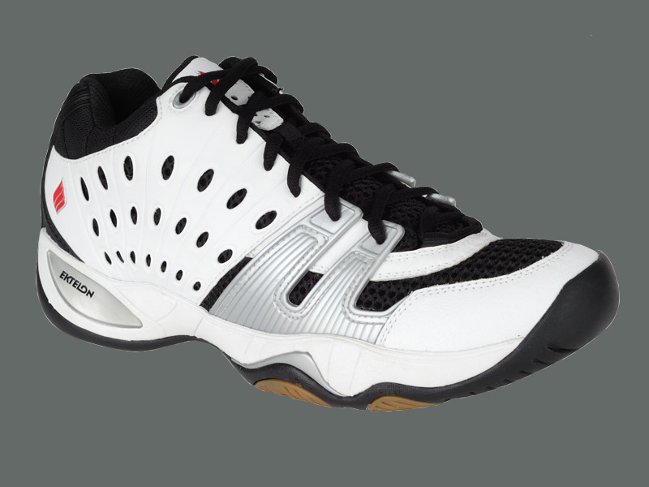
- In tournament racquetball, the ball speed can reach 200+ mph; therefore goggles are mandatory when in the court. For the best protection, choose a pair of lightweight, water-repellant, anti-fog, scratch-resistant, and shatterproof lenses.
- Gloves are often a good investment; this is because it will give you a sufficient grip on the racquet. Racquetball players wear a glove only their racquet hand. Gloves are made of soft, thin, flexible leather or a synthetic fabric. Gloves can be open-mesh, to allow for air to pass through, or breathing. Other gloves are good for moisture control, which will allow you control your racquet. There are also gloves built for comfort, which provide additional padding.

The “Playing” Court/Field:

A full and complete understanding of all parts of the court is essential to your success in the game. The court will establish boundaries for serving and other shots as well as placement of all shots and where you may want to position yourself.

A racquetball court, indoor or outdoor, is a fully enclosed court with a front wall. The standard court is a rectangular area, 40’ x 20’ x 20’, the back wall must be at least 12’ tall.
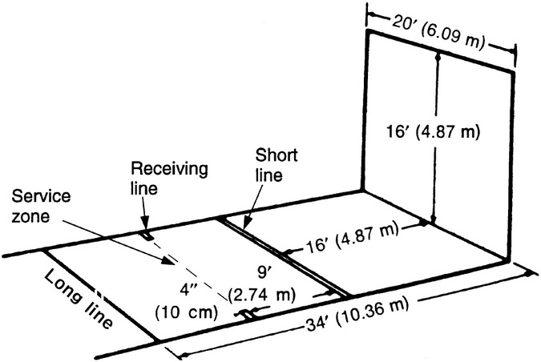
Red lines define the service and serve reception areas on the court.
The service box is an area marked by the short line, a solid red line which extends the width of the court, parallel to the front and back walls. The short line splits the court into two equal 20’ halves. A service line is parallel to the short line. This service line is 15’ from the front wall. Two sets of perpendicular lines are marked in the service box. One set of the perpendicular lines is 18” from each side wall. The other set of perpendicular lines is 36” from each wall. These lines define the area which the server should not enter, especially if the server wants to hit a drive serve between themselves and the side wall.
A receiving line is represented by a dashed line 5’ behind the short line.
A safety zone exists which is a 5’ area between the short line and the receiving zone. This area is only important during the serve.

All lines are 1.5” wide and solid red. No marks are allowed on the walls.
Safety Considerations:

Whether you are a beginner or an experienced racquetball player it is always advised to consider the following safety tips.

1. Sport Specific Warm-ups:
The inclusion of a well-designed warm-up is equally as important for the beginner as for the advanced racquetball player. The game will vigorously work all parts of the body making it essential to spend time in a warm-up to help prevent injury to muscles, tendons and ligaments. Increased flexibility can improve your range of motion and improve your overall play. The warm-up consists of three parts, the cardiovascular component, the static and dynamic stretching component and the sport specific movement. Consider the following parts of the warm-up before any play.
- Cardiovascular warm-up
The first part of any preparation for physical activity should be an activity to get the heart and other parts of the circulatory system working at a higher intensity. Consider the following activities and suggestions for a safe cardio warm-up.
  - A general cardio warm-up should last 2-3 minutes and might include a slow to moderate jog, a variety of calisthenics or rope jumping. The intensity is low at the beginning and moderately increases over time.
  - The cardio warm-up is not intended to tire or exhaust you. Once the heart has increased intensity and the body temperature has risen slightly it is time to do the dynamic stretches.
  - Your cardio warm-up should occur before you step into the court. Once you enter the court, however, take a moment to jog around and get your body used to the court, the lights, etc.
  - A cooperative and friendly rally, hitting the ball can be fun and help to warm you up. Try to take between 5 and 8 serves per player.
- Muscular Skeletal warm-up
The second part of the warm-up preparation should specifically target your muscles and joints. This portion of the warm-up should involve the stretching of the shoulders, back and legs. They should be stretched with both static stretches (slow steady pull) and dynamic stretches (minimal resistance while stretching and relaxing the muscles of a joint). Never use quick jerking or ballistic movements as this may cause injury to the muscles and tissue around the joint. Consider the following activities and suggestions for a safe muscular skeletal warm-up. When stretching, try to hold the stretched position for about one minute. If you experience pain while stretching, you have gone too far!
  - Shoulder circle
- Side bend
- Walking Lunges
- Biceps stretch
- Triceps stretch
- Hip stretch
- Calf stretch
- Skill-Specific warm-up
The third part of the warm-up involves the use of the ball while conducting specific racquetball movements. These warm-up drills are usually conducted with a partner and are performed on a court at varying intensities. Some example skill-specific drills include the ceiling ball, toss and hit, splat and down-the-line, reverse-pinch, scramble, set up, overhead, drive serve, Z-serve, jam serve, and lob serve.
  - Ceiling ball : this is a defensive shot that hits the ceiling at or near the front wall.
    - A drill designed to teach athletes to hit a good ceiling ball. A ceiling ball is one of the most effective defensive shots.
    - Hit a good ceiling ball.
    - Respond by hitting another ceiling ball.
    - Repeat 50 times.
    - To make the drill more difficult, do not count any ball that comes up short or off the back wall.
    - Try to point the strings towards the ceiling about 4 feet in front of the front wall.
  - Down the Line (DTL) : this is a shot hit from near a side wall that strikes the front wall and then bounces back along the same wall.

    - Stand on the dotted line, about three feet from the side wall, facing the side wall.
    - Drop the ball so that it will bounce within 6 inches of the side wall.
    - Do not bounce the ball.
    - Hit a good splat shot (this is a shot hit hard, from near the side wall directly to the side wall).
    - Move two feet closer to the front wall and repeat.
    - Keep moving at two-foot intervals until you are two feet from the front wall.
    - Now bounce the ball into the front wall and hit a DTL shot on the rebound.
    - Move back to the foot fault line.
    - Drop the ball within a foot or so of the side wall and execute the DTL.
    - Keep moving in two-foot intervals until you are behind the dotted line.
  - Toss and Hit
    - Stand in the middle of the court on the dotted line.
    - Hold the ball in your left hand.
    - Toss the ball diagonally towards the right hand side wall. Toss the ball so that is takes a nice bounce.
    - Take a cross-over step (e.g., a step with the right foot (pivot foot) then cross over with the left foot) and execute a down the line shot.
    - Repeat until you have 5 good down the line shots (DTL).
    - Repeat until you have 5 good pinch shots.
    - Repeat until you have 5 good cross-court, wide angle passes.
    - Repeat on the backhand side.
    - Reverse Pinch: this is a low shot into the corner opposite the side of the stroke
      - Stand on the dotted line on the left hand side wall, facing the opposite side wall.
      - Drop and hit a forehand reverse pinch (by a right-handed player, this shot would be hit to the left corner).
      - Take two steps towards the other side wall and repeat.
      - Hit 5 good reverse pinches from the extreme left to the extreme right side of the dotted line.
      - Turn around and repeat with backhand reverse pinches
      - Move to the short line and repeat.
    - Scramble
      - Stand in good center court position about two feet behind the dotted line.
      - Drop and hit a pinch shot, without touching the ball with your hand.
      - Hit 50 good offensive shots.
      - Move to get the ball. Don’t worry about the ball bouncing. Just hit it!
      - You are not allowed to drop and hit. A drop and hit is simply dropping the ball and hitting it.
      - If you skip the ball, deduct a point.
      - Continue until you have 50 good shots.
      - Try 25 forehand and 25 backhand shots for a challenge.
    - Set Up
      - Hit a short ceiling ball on the forehand side.
      - Hit a good DTL.
      - Repeat until you have 5 good DTL shots.
      - Repeat, hitting 5 cross court or wide angle shots.
      - Repeat on the backhand side.
    - Overhead
      - Hit a backhand ceiling ball cross court to the forehand side.
      - Hit a good overhead cross court pass.
      - Repeat 5 times.
    - Drive Serve : this is a hard hit, straight serve, which must be served between the side wall and the three-foot line.
      - Set up in the right hand serve position.
      - Hit 5 good drive serves to the forehand.
      - Be sure the ball strikes the floor behind the short line and bounces twice before it reaches the back wall.
      - Because you are on the right hand side, the serve is a screen and does not count if it hits the back wall more than a foot from the right hand side of the wall.
      - Try to hit the side wall or directly in the corner.
      - Repeat until you hit 5 good serves to the backhand from the same position.
    - Z-serve : this is a shot which hits the front wall, the side wall, the floor, and finally the other side wall. The pattern of this shot should be in the shape of a ‘Z’.

      - Set up as in the drill serve.
      - Hit a drive Z serve from the left and right serving positions.
    - Jam Serve : this is a serve which is aimed directly at the returner’s body, thus it will cause the player to be ‘jammed’ when attempting to return the ball.
      - Set up in the same three positions and hit jam serves to the receiver’s backhand and forehand.
      - The ball should hit the front wall about four feet high and about eight feet from the side wall.
      - It will travel to the side wall and contact about three feet high, near the dotted line.
      - It should take its first bounce 2-3 feet in front of the back wall in the center of the court.
    - Lob Serve : this is a shot which is high and lands just before the back wall.
      - Stand in the left hand serving position
      - The racquet should contact the ball on the midline of the court.
      - Hit lobs, half-lobs, and nick lobs to the forehand and backhand. (The half-lob is a shot that will hit the front wall at least halfway up the wall. This shot should bounce near the dotted line first, and then into a corner. The nick-lob is a shot that should hit the front wall at least ¾ of the way up the wall. This shot will initially bounce at an angle toward the back middle of the court. The second bounce will land just before the back wall.
      - This is also a good cool down exercise.
2. General Safety Considerations
- Maintain your personal space and the personal space of others when playing racquetball. Don’t crowd other players on the court. This rule applies to warm-up, practice and play.
- Use safe and properly functioning equipment. Make it a habit to check the court, your racquet, the ball, your shoes and anything else that you depend upon for safe effective play. Alert instructors and other players of unsafe equipment or facilities.
- Do not watch your opponent make contact with the ball if they are behind or next to you. Be sure to turn your head forward towards the front wall prior to contact.
- You should watch the game through the strings of your racquet. If you are in front of your opponent, place your racquet to the side of your head and look through the strings while your opponent sets up to hit the ball. Turn forward just before your opponent hits the ball. If you sense that you may be hit in the face with the ball, hold your racquet up to avoid injury.
- If you hit the ball off the back wall (as if in defense), try to duck your face towards the floor prior to making contact with the ball.
- Always wear the wrist strap (thong)! This is not a suggestion, it is a rule.
- Adhere to all rules of play and avoid unsafe play (horse play).
- Always warm-up with the appropriate activities prior to practice or play and do not extend beyond your physical capabilities. It is always advised to take the time to conduct a cool-down at the end of moderate to vigorous activity.
- Maintain court etiquette and do not interfere with play in other courts.
3. Common Injuries
Due to the nature of the game players are likely to perform many ballistic movements that put a great deal of stress on skin tissue, joints and muscles. By wearing proper equipment and using all parts of the warm-up you can help prevent serious injury. Most of the injuries you may encounter during play will probably not be serious. You should pay attention to any injury and in the event the injury takes longer than a couple of days to heal you may want to consult a doctor. The following are some of the more common types of injuries and treatment.
- Skin Injuries
  - Include cuts, scrapes, bruises, and blisters.
  - Keep cuts, scrapes and blisters clean and apply antiseptic medicine, if necessary keep them covered with bandages
  - Blisters are caused by excessive friction and are common when you first begin. Properly fitted shoes and good socks can go a long way to prevent the problem.
  - Bruises may be treated with ice packs.
- Muscle and Connective Injuries
  - The most common racquet sport injuries are overuse injuries. These include shoulder, elbow and wrist injuries. Other common racquetball injuries include ankle inversion, especially since the sport requires athletes to decelerate at a rapid pace during lateral movements.
  - Muscle cramps are common and can be prevented by staying hydrated, using a proper warm-up and monitoring your intensity.
  - Stay hydrated with water and sports drinks containing needed minerals.
  - If you get a cramp usually a stretch or firm massage of the area can remove the discomfort.
  - Other injuries include muscle strain, which is a pull or tear of the muscle and muscle sprain, which is a tear of the ligament around a joint. Common joints include the shoulder, elbow, knee and ankle
  - In the event you have either a strain or sprain you should apply the RICEformula immediately. Do not apply heat to injury!
Rest- get off the injury.
Ice- apply ice early and often, ice should not touch skin directly.
Compress- wrap area with elastic bandage.
Elevate- raise the body part to avoid additional swelling.

Rules and Scoring:

Scoring in racquetball can only occur on a server or serving team. A point is scored whenever the opposition does not effectively return the ball or when the server or serving team wins a rally. During a singles game, when the server loses a serve, it results in a sideout. A sideout is any loss of service by a player or a doubles team. When a sideout occurs, the players switch roles (e.g., server becomes the receiver). During doubles play, if the first serve is lost, a handout occurs. If the second serve is also lost, this is a sideout. A server will continue to serve until an illegal serve occurs, two consecutive faults occur, or the server loses the rally. The first player or team to win two of three games will win the match.

For players who want more than indoor singles racquetball, other games and versions exist (e.g., doubles, cutthroat, outdoor, etc.). Doubles racquetball is a game of two players versus two players. This is a great way to increase the competition. Often, when playing a doubles game, teammates play on the same side of the court. Avoid making this mistake. The best doubles partners are concerned about winning the game, not being the best athlete (e.g., making all the winning shots) on the court. It may be difficult to find a doubles partner that is compatible with your game. When playing doubles, it is necessary to determine, who will play the forehand and backhand side of the court. Communication is essential in doubles play; without it, it may be hard to be successful on the court. Doubles rules are similar to those of the singles game, with the exception of a few unwritten rules of etiquette which may make doubles play more enjoyable: serve to your own side of the court, try not to isolate your partner and exclude them from play, try to serve to both opponent players equally (don’t only serve the weaker player), and try to hit to both opponent players equally.

When playing doubles, the first team to serve at the beginning of the game is only allowed a single service opportunity. When a sideout occurs, the teams must rotate, the serving team becomes the receiving team. After the first rotation, both players will serve until the team receives a handout or sideout. The partner on the service team who is not serving must remain in the doubles box, back against the wall during the serve. Players on the serving team must also remain in the service box until the ball passes the short line. After the ball passes the short line, players may occupy any position on the court. Rotation order in doubles games cannot be changed during the game.

Scoring System
- Points are only scored by the serving player, or the serving team in doubles games.
- Points result from winning a rally that follows a successful serve.
- In Open Division competition, a server is allowed one opportunity to put the ball in play. In all other divisions, the server is allowed two opportunities.
- Racquetball matches are a best of three format.
- The game is played until one player or team reaches 15 points. A one-point advantage is necessary for a win (e.g., 15-14).
- If a third game is necessary, the game is played until one player or team reaches 11 points.
  - During play, a player will lose a rally if one of the following occur:
    - The ball bounces on the floor more than one time prior to being struck.
    - The ball does not reach the front wall on the fly.
    - The ball flies into the spectator gallery, an opening in the wall, or out-of-bounds.
    - A slow ball hits another player or the player’s partner.
    - A hindrance which is penalized. A hindrance is defined as any interference which causes an opponent to not have a fair attempt to return the ball (categorized as avoidable and unavoidable).
    - Switching racquet hands during a rally.
    - Not using the racquet thong.
    - Touching the ball with the body or your clothing.
    - Carrying or slinging the ball with your racquet.
Serving and Receiving
Serving is one of the most important aspects of the game; it is the only way you or your team can score points. Serving includes dropping the ball to the floor and making contact with your racquet. The server is allowed to step on the service line. If the player steps completely over the line, a foot fault is called. The server must wait until the ball crosses the short line before returning to the service box. The ball must hit the front wall on the serve. The ball must also pass the short line before it bounces.
When receiving the ball, the player cannot enter the safety zone or cross the receiving line. To make a legal return pass, the ball must be hit after it bounces once, or on the fly if the ball is past the receiving line.
- Dead-ball serves
These serves do not cancel any previous fault serve.
  - Court-hinders: a serve which bounces in an irregular manner. This bounce may be due to a wet spot or irregular surface on the court. Hitting surfaces that have been recognized, by local rules, as out-of-play are also classified as court hinders.
  - Broken ball: when a ball is broken on a serve, a new ball will be used and the serve will be replayed.
- Fault serves
Any of the following faults will result in an out..
  - Foot faults: a motion during the start of service which touches the floor outside the service zone. This can be a motion by the player or the player’s partner. This can also occur at the end of the serve, where the server steps behind the service line prior to the ball crossing the short line.
  - Three-Wall serve: this is any ball served that first hits the front wall, rebounds, and hits both side walls prior to touching the floor.
  - Bouncing Ball Outside Service Zone: this occurs when the server bounces the ball outside of the service zone. This includes touching a side wall as a part of the serving motion.
  - Short serve: this is any ball served which hits the front wall and bounces in front of or on the short line with or without touching the side walls.
  - Long serve: this is any ball served which hits the front wall and rebounds to the back wall before it touches the floor.
  - Ceiling serve: this is any ball served which first hits the front wall and touches the ceiling with or without touching the side walls.
  - Screen serve: this is any ball served which hits the front wall and rebounds too close to the server or the server’s partner. The ball is not in view to the opponent.
- Out serves
Any two of the following faults will result in an out:
  - Two consecutive fault serves
  - Non-front wall serve
  - Touched serve: this is any ball served that touches the server or the server’s racquet before touching the floor. This can also be any ball which is intentionally stopped or caught by the server or the server’s partner.
  - Out-of-court serve: this is any ball served which first hits the front wall and flies out of the court or hits any surface that is out-of-play.
- Hinders
A hinder is any interference with the opponent’s ability to play the ball safely and fairly. Hinders fall into two categories: replay and penalty. A replay hinder is one in which the rally is replayed. A penalty hinder results in a player losing the rally. Hinders for the novice player usually result in replaying the rallying, whereas, as players become more advanced, they try to create any offensive advantage possible. When determining what category of hinder has occurred, think about whether the player attempting to hit the ball had an offensive advantage. If so, a penalty should be called.
  - Court hinder: play is stopped whenever the ball hits a part of the court that is irregular or designated as a court hinder.
  - Ball hits opponent: if your opponent is hit by a return shot, a dead-ball hinder results. However, if the ball does not have the velocity, or angle to hit the front wall, no hinder is called.
  - Body contact with opponent: having contact with your opponent will reduce their ability to return the shot. Incidental contact, which does not result in an advantage, is not called.
  - Screen ball: a ball that rebounds from the front wall too closely to the server or the server’s partner, which prevents your opponent from making an offensive play, is a hinder.
- Failure to move: any player who does not attempt to move to allow their opponent an opportunity to hit the ball results in a hinder.
  - Stroke interference: when a player moves, or fails to move, to allow the opponent to have a free shot results in a hinder.
  - Moving into the ball: if a player moves into the path of the ball and is hit, the point is awarded to the offensive player.
- Other Game Rules and Etiquette
  - The player or team winning the coin toss has the option to select who will serve first during the first game. During the second game, the service order will reverse.
  - Announce the score prior to every serve.
  - The serving player must bounce the ball on the floor at least once prior to serving the ball against the front wall.
  - Players have 10 seconds between rallies to put the ball in play.
  - If you invite another person to play, you should provide the balls.
  - Do not enter the court without knocking on the door first.
  - All players on the court are responsible for calling serves in/out and for calling violations.
  - Call faults, violations, and hinders when they happen.
  - Do not ask spectators to make a call for you.
  - Try to avoid hitting other players on the court; this is a hinder.

Fundamentals of the Game of Racquetball:

There are three fundamental skills in the game of racquetball: forehand, backhand, and serving. In addition to these skills, athletes should have proper footwork techniques. Regardless of your skill level, it is necessary for all athletes to maintain or increase their skill level for these fundamentals. During a game of racquetball, athletes do not have much time to think, and therefore, must master the basic fundamentals. The following guidelines and drills should be understood and practices often to perfect your racquetball game.

1. Court position and watching the ball
A racquetball court is 800 square feet. Keep in mind, you will not, and should not try to cover the entire area! You should consider covering the easy shots. Your goal should be to make your opponent execute tough or high percentage shots. Your opponent may make some of the tough shots; however, they are more likely to fail to execute the majority of the tough shots.
- Try not to run close to the walls; allow for at least an arm’s length (with outstretched racquet) away from the wall.
- When the ball is touching the wall, you may get closer.
- Hard hit kill shots rebound deeper than you may realize. A second bounce should be around the short line. Therefore, you should remain behind the 5’ line.
- It is easier to move forward, than to move backward to cover a shot. Try not to allow your opponent to hit a pass around you by staying behind the 5’ line.
- Covering more shots is easier if you position yourself one step out of the middle of the court, on the opposite side of the court from your opponent. This will allow you to be in a better position to set up, execute and put pressure on your opponent.
- When you are positioning yourself, consider the following three theories:
  - Shade (or cover the area) slightly, a step, opposite your opponent. Turn you body at a 45° angle. This will allow you to see what is behind you.
  - Shade slightly, a step, toward your opponent. Turn you body at a 45° angle. This will allow you to cover the down the line shot.
  - Do not shade at all. Stay in the middle of the court. Place your feet wide, toes forward, upper body and head should be turned to look behind you.
- Always cover the cross-court shot. This is the simplest shot in racquetball, so you need to ensure your opponent cannot use it!
- Keep your eye on the ball.
Additional Considerations
- Since center court is the best place to rally, try to gain center court position. If you must move, your opponent will probably move in.
- Don’t admire your shot. Hit the shot and move toward center court.
- Sacrifice good form for good center court position.
- Try not to commit to the ball too soon.
Court Positioning Drills
#1.1 Solo Front-Wall Setup Drill. Standing in the safety zone. From either the forehand or backhand position, hit the ball straight to the front wall. As the ball returns, adjust your feet, set up, and hit the ball using any shot you want. Don’t worry about how many times the ball bounces. Work on your small footwork, making adjustments to set up and hit the ball. As you get better at this drill, you will be able to set up and hit the ball consistently off of one bounce. As you increase your skill you will allow time to move farther back in the court and eventually drill from the deep backcourt. This drill should be completed in 3 sets of 10 repetitions each for the forehand and backhand.

2. Basic Footwork and Body Positioning
Having your feet positioned correctly and in the correct location of the court is as important as anything you will do. This preferred body positioning is commonly referred to as the “ready position”. In the ready position you will be able to move quickly and efficiently allowing you to be in the right spot to execute the best shot. Equally important is how you move your feet into position to return shots and quickly return to a good ready position.
- The Ready Position
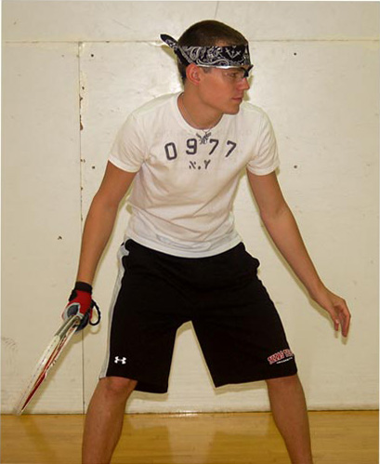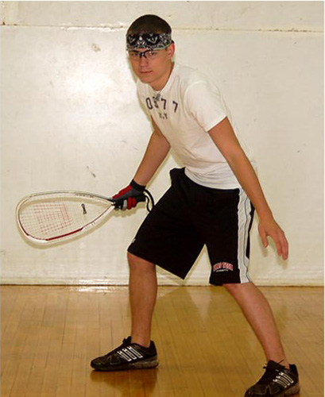
  - Your feet should be shoulder width apart with your weight evenly distributed on the balls of your feet. You may wish to have your feet slightly staggered with the dominant foot slightly in front.
Your knees should be slightly bent with your arms extended in front of you about waist high.
3. Forehand Mechanics
The forehand swing should be consistent. Understanding the forehand may help you to expose your opponent’s weaknesses. The forehand is typically a natural stroke for beginning and novice level athletes. There may be a tendency for this stroke to dominate your playing.

The mechanics for the forehand and backhand strokes are fundamentally similar. The difference is, the forehand stroke players swing across their body, whereas in the arm leads the body during the backhand. The stroke can be divided into five important phases: stance, grip and early racquet preparation (ERP), weight transfer, swing, and follow-through.
- Stance
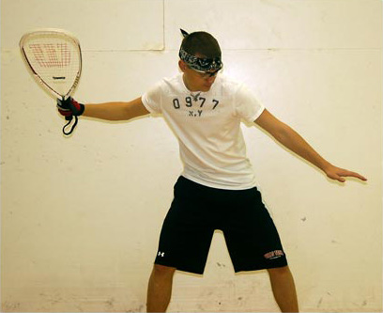
  - Turn facing a side wall, if possible. For example, a right-handed player would turn to face the right wall. The opposite is true for a left-handed player.
  - Feet should be shoulder-width apart.
  - Knees, hips, and back should be flexed slightly; you will be lower to the ground.
  - This position allows you to rotate your hips, while maintaining your balance.
- Grip and Early Racquet Preparation (ERP)
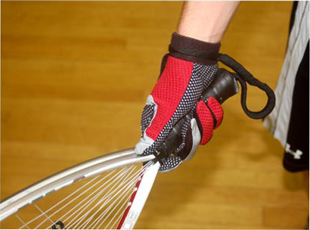
  - Once your feet are set, it is time to get the racquet into position.
  - Grip the racquet like you are shaking hands with someone, not like you are holding a hammer.
  - For a right-handed player, the racquet is gripped so your index finger and thumb rest along the top, right edge of the grip.
  - Get the racquet in a high position, arm flexed at a 90° angle at the elbow.
  - Strings should face the wall with your wrist cocked.
  - Getting the racquet into ready position early allows time to hit the ball effectively.
- Weight Transfer
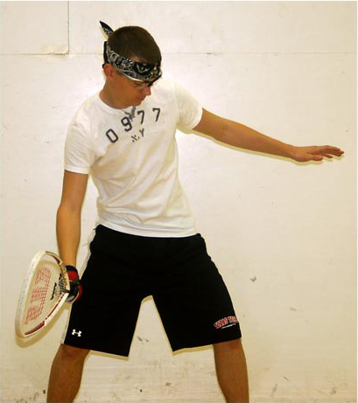
  - A low, balanced stance is the key to weight transfer.
  - As the swing begins, transfer your weight from the back foot to the front foot.
  - This may require you to take a step towards the target.
  - As weight is shifted, the hips and torso will begin to rotate. This will force the arm and racquet to come around.
- Swing
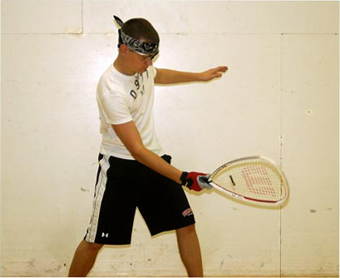
  - As the hips and torso begin to rotate, the arm and racquet will follow a similar path.
  - The elbow will drop, which leads the motion.
  - When full extension is reached, the wrist will snap over, bringing the racquet along.
  - Try to make ankle to waist-high contact with the ball with the arm full extended.
- Follow-through
  - This is the final stroke phase.
  - The racquet and body should be allowed to fully rotate around.
  - The body’s natural deceleration helps add control to the shot.
  - With proper follow-through, the player should end facing the front wall with their racquet at or below the height of the shoulder.
- Forehand Drills
It is important to note a couple of safety issues prior to beginning all hitting drills. Be sure the thong is securely fastened. Wear your eyewear. An unskilled player will not always be able to control the ball’s direction. Be prepared to follow the ball and return it.
#2.1 Mirror Drill. This drill is a simple, but effective way to evaluate your stroke mechanics. It provides instant feedback, helps build muscle memory, and can be done anywhere you can watch your swing.
Stand in front of a mirror or large plate window. Go through the various steps of the forehand: grip, racquet preparation, stance and balance, backswing, swing motion, ball contact, and follow-through.
As you go through each phase of the forehand, watch your reflection and check your body position and mechanics. Breaking the mechanics down into separate segments will make it easier to evaluate and correct any errors. Once you are comfortable with a segment, move to the next segment until you complete the entire stroke. After you go through each step, put it all together and watch your stroke in its entirety. Perform 10 repetitions of the full forehand stroke. You will need to slow your stroke in order to effectively evaluate your mechanics in the mirror.
#2.2 Forehand Toss and Catch. Do this drill with a partner. It helps you develop good footwork and hand-eye coordination. Begin by standing approximately 10 feet away from your partner. Your partner will have one racquetball in one hand. Stand in the ready position without a racquet. Your partner tosses the ball so it bounces off the floor to your forehand side. With your opposite-side foot, step across your body and forward and catch the ball with your racquet hand. Keep your eye on the ball and try to catch it in the power zone. Toss the ball so it bounces off the floor and back to your partner. Repeat.
This drill can be modified to decrease the level of difficulty. Use a wall instead of a partner. Toss the ball to the floor so it ricochets off the wall and back to the floor. Catch the ball.
#2.3 Drop and Hit.
Begin this drill by straddling the safety line. This puts you up in the court closer to the front wall so you do not have to hit the ball quite as hard. The line as a reference for where to drop and hit in the power zone.
Visualize the stroke. Stand about 3 feet from the side wall and straddle the safety line, with the line centered between your feet. Check your grip and move your racquet to the ready position. Get in your ready position. Initiate the backswing. Drop the ball at arm’s length so it bounces at the safety line. Keep your eye on the ball. Begin your swing motion. Contact the ball with your knees bent and the body in a balanced position. Hold your pose at the end of the follow-through. Complete 10 repetitions.
This drill can be modified by adding a step or a shuffle.
4. Backhand Mechanics
The backhand swing should be consistent. It is important to understand this stroke to ensure your opponent does not expose it as your weakness. The backhand is a less natural stroke for beginning and novice athletes. There may be a tendency to avoid this stroke during your playing.

The mechanics for the forehand and backhand strokes are fundamentally similar. The difference being, the forehand stroke players swing across their body, whereas in the backhand, the arm leads the body. The stroke can be divided into five important phases: stance, grip and early racquet preparation (ERP), weight transfer, swing, and follow-through.
- Stance
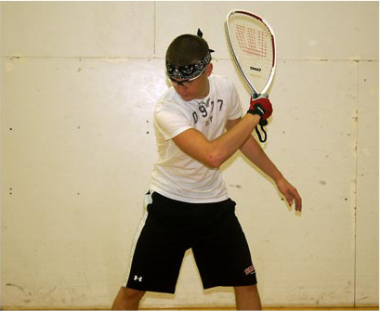
  - Turn facing a side wall, if possible. For example, a right-handed player would turn to face the left wall. The opposite is true for a left-handed player.
  - Feet should be shoulder-width apart.
  - Knees, hips, and back should be flexed slightly; you will be lower to the ground.
  - This position allows you to rotate your hips, while maintaining your balance.
- Grip and Early Racquet Preparation (ERP)
  - Once your feet are set, it is time to get the racquet into position.
  - Grip the racquet like you are shaking hands with someone, not like you are holding a hammer.
  - For a right-handed player, the racquet should be rotated counter-clockwise so the point where the index finger and thumb meet is pointed downward along the top-left edge of the grip. The opposite should be used by left-handed players.
  - Get the racquet in a high position, arm flexed at a 90° angle at the elbow.
  - Strings should face the wall with your wrist cocked.
  - Getting the racquet into ready position early allows time to hit the ball effectively.
- Weight Transfer
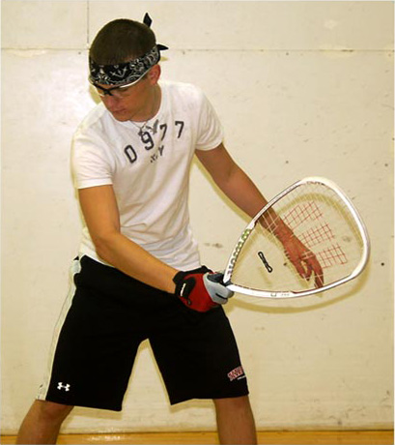
  - A low, balanced stance is the key to weight transfer.
  - As the swing begins, transfer your weight from the back foot to the front foot.
  - This may require you to take a step towards the target.
  - As weight is shifted, the hips and torso will begin to rotate. This will force the arm and racquet to come around.
- Swing
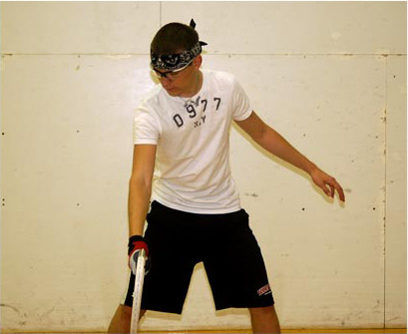
  - As the hips and torso begin to rotate, the arm and racquet will follow a similar path.
  - The elbow will drop, which leads the motion.
  - When full extension is reached, the wrist will snap over, bringing the racquet along.
  - Try to make ankle to waist-high contact with the ball with the arm full extended.
- Follow-through
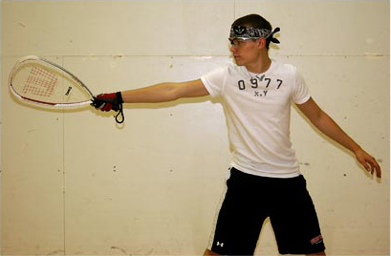
  - This is the final stroke phase.
  - The racquet and body should be allowed to fully rotate around.
  - The body’s natural deceleration helps add control to the shot.
  - With proper follow-through, the player should end facing the front wall with their racquet at or below the height of the shoulder.
- Backhand Drills
#3.1 Mirror Drill. This drill is a simple. It is an effective way to check your stroke mechanics. It provides immediate feedback, helps build muscle memory, and can be done outside of a court.
Just as in the forehand drill, watch your reflection to evaluate your body position and mechanics through each segment of the swing. Once you feel comfortable with each segment, move to the next. After you have completed each segment, put them together to complete your stroke in its entirety. Slow down your stroke in order to evaluate your mechanics in the mirror.
#3.2 Backhand Toss and Catch. Like the forehand version, this drill is done with a partner. It will help you develop good footwork and hand-eye coordination. Stand about 10 feet away from your partner. Your partner will hold the ball in one hand. Stand in an athletic stance but without a racquet. Your partner tosses the ball so it bounces off the floor to your backhand side. Pivot on your non-dominant foot. Step forward with your dominant foot and catch the ball with your dominant hand. Toss the ball so it bounces off the floor and back to your partner. Keep your eye on the ball and try to catch it in the power zone.
#3.3 Drop and Hit. Like the forehand version of this drill, begin by straddling the safety zone, with the safety line just inside your forward or dominant thigh. This puts you up in the court closer to the front wall so you won’t have to hit the ball so hard. Use the line as a reference for where to drop and hit in the power zone.
Visualize the stroke. Get into the ready stance. Initiate your backswing. Gently toss the ball with your non-dominant hand at arm’s length on the safety line. This puts the ball in the middle of the power zone. Keep your eye on the ball. Begin your swinging motion. After the ball bounces off the floor, hit it at its peak, or on the way downward. Remember to stay low and bend your knees. Hold the pose at the end of the follow-through. Complete 10 repetitions.
This drill can be modified to include a step or a shuffle.
5. Shot Selection
- Offensive shots
  - Down-the-line (DTL) Pass or Kill

    - This shot travels from the front to back walls on the same side of the court.
    - The ball will typically bounce twice before hitting the back wall.
    - Select a target on the front wall, 4-8 feet from the side wall.
    - Try to hit the wall a foot or two above the floor, this prevents the ball from bouncing and rebounding off the back wall.
    - Hit the ball at a right angle to the body.
    - Your racquet face should be square to the front wall.
  - Cross Court (CC) Pass or Kill
    - This shot will hit the front wall about 4 feet from the center of the wall and rebounds to the opposite back wall corner.
    - Try to hit the ball a foot or two high on the front wall to ensure it will bounce twice prior to reaching the back wall.
    - The contact point should be in front of the body (slightly) or at a similar point for the DTL shot.
  - Pinch/Reverse-Pinch

    - The pinch shot will hit the near side wall about two feet or lower within 4 feet of the front wall.
    - The ball hits low on the front wall and rebounds sideways. It will bounce twice before hitting the opposite side wall.
    - This shot may bounce twice before the short line for a kill.
    - The reverse-pinch is the mirror of the pinch shot.
    - It will hit the opposite side wall two feet or lower within 4 feet of the front wall.
    - The contact point for this shot should be farther from the body.
  - Splat
    - This shot is a modified pinch shot, characterized by a loud “splat” sound when it hits the wall.
    - This shot is best when the ball is within six inches of the side wall.
    - Hit the ball with the tip of the racquet, so the ball will almost immediately hit the side wall.
    - The ball hits low on the front wall and bounces.
- Defensive shots
  - Ceiling ball

    - This shot strikes the ceiling 4-8 feet in front of the front wall, hits high on the front wall, lands in the front or mid court, takes an extremely high bounce and dies on or near the back wall.
    - A perfect shot: the ball hits the crack between the floor and the back wall and dies!
    - A good shot: lands on the floor within a foot of the floor crack or below the two foot line on the back wall.
    - Harder hit shots will hit the ceiling further from the front wall.
    - Softer hit shots will hit closer to the front wall.
    - This shot will allow you to dominate center court.
    - You do not have to play deep to hit this shot. A good strategy is to position yourself around the dotted line.
    - This shot can be used time and time again to test the patience of your opponent. Continually hitting this shot may force your opponent to try to hit a deep court winner, a low percentage shot.
    - To hit forehand ceiling shot: Turn your shoulders away from the front wall. Wait for the ball to drop about head high, on your forehand side. With an open-faced racquet (strings pointing at the target), rotate your shoulders towards the front wall. Partially extend your arm. Step forward. Lift the ball to the target. Move your racquet from low to high. Follow through below the shoulder. Try to make contact at the midline of your body. This shot is about control, NOT power.
    - To hit backhand ceiling shot: Mirror what the movements of the forehand shot. Turn towards the side wall. Move the racquet into the ready position. Turn your shoulders away from the front wall. When the ball is about shoulder height, step towards the front wall and lift the ball towards your target. Move your racquet from low to high. Follow through below the shoulder. Contact the ball at the midline of the body.
    - To hit underhand ceiling shot: You may use one of two approaches to the underhand shot. You may want to snap your wrist straight up, in effect flicking the ball towards the ceiling. This should be used when you are jammed at mid court. An additional way to execute this shot is to use a standard, open-faced racquet to force the ball upward. Flick the wrist to push the ball towards the ceiling. This should be used when you are returning a good drive.
  - Z-shot

    - Hit the ball like a “Z” upwards toward the opposite corner.
    - Strike the front wall near the side wall.
    - The ball will hit the side wall and travel to the opposite wall.
    - It will land in the deep back court.
    - This does not have to be a hard hit ball to be effective.
    - A second way to hit this shot is to reverse a ceiling ball.
  - Lob
    - If the ceiling ball is cut off, this is a shot you may want to use.
    - Your opponent will probably run up the dotted line, racquet overhead.
    - Try to catch the ball as it is rebounding off the floor.
    - Direct the ball low into the front wall.
    - This shot requires tremendous energy, which is why it is seldom used.
    - From behind the service box, direct the ball to one of the back corners.
  - Round the world
    - Hit this shot high on the side wall, high on the front wall, and then high on the opposite side wall.
    - The ball will bounce at mid court and rebound to the opposite side wall, and finally dies on the back wall.
    - This shot is not recommended, as it is easily cut off.
  - Back wall-Front wall
    - Use this shot as a last resort, when you are desperate.
    - With an open-faced racquet, hit the ball into the back wall.
    - The ball will rebound high towards the front wall.
    - There is no need to hit this ball hard. You are just trying to keep the ball in play.
    - Beginners overuse this shot.
6. Serving
The serve is a unique aspect of the game. You have complete control over it (speed, height, spin). Putting the ball in play is the object of the serve. Also, as a server, you should try to cause an unforced error or poor return by the opponent. As the server, players should pay attention to the opponent’s position on the court, and try to expose any weaknesses in their game. Try to master different serves, as they will provide different strategies during competition.
- Drive serves
  - Place your feet on the short line.
  - Bend your knees to lower your body to the floor.
  - Place the racquet as if you were performing a backswing.
  - Take a cross-over step with your back foot towards the front wall.
  - Step towards the front wall with your front foot.
  - Continue to remain low.
  - Rotate your hips and turn your back knee toward the front wall.
  - Toss the ball into the power zone.
  - Keep your eye on the ball.
  - Continue to rotate your hips.
  - Swing through the ball.
  - Try to contact the ball below the knee.
  - Maintain weight balance.
  - Follow-through with the racquet crossing the body to your non-dominant side.
- High or Half Lobs

  - Begin by standing square to the side wall.
  - Feet should be shoulder width apart.
  - Remain relaxed, slightly bent at the knees.
  - Using a backhand grip, choke up on the racquet.
  - Maintain a firm wrist.
  - Keep your elbow close to the body.
  - Have the racquet in the backswing position, at the height of your waist.
  - Hold the ball in front of you at shoulder height.
  - Drop the ball in front of your body.
  - Step towards the front wall with your toes (on your front foot) facing the corner.
  - The ball should be in the power zone after you step.
  - Rotate your hips and shoulders.
  - Bring the racquet out and in a position that is parallel to the floor.
  - Maintain an elbow position that is close to the body.
  - Maintain a firm wrist.
  - Contact should occur at the top of the bounce of a little after.
  - Keep your eye on the ball.
  - Continue rotation through ball contact.
  - Your follow-through should be slightly upward.
  - Finish with your hips and shoulders facing the front wall
  - The racquet should end at your side or a little above the shoulder.
- Serving Drills
#4.1 Ball Toss. Tossing the ball isn’t a difficult skill to master; but it may be hard to do it correctly with consistency.
Stand approximately 6 feet away from the side wall, like it were the front wall. Get into your beginning low-drive-serve stance and practice the service motion steps with the ball toss. Practicing your serving motion and toss will make it easier to retrieve the ball; you won’t have to chase the ball. The ball should hit the wall after the second bounce. Swing the racquet, but try to avoid contacting the ball. Make sure you are bringing the racquet to the proper height and closeness to the body.
This drill can be used for the drive, lob, and z-serve.
#4.2 Dry Serves to Full Serves. Visualize your next serve. Practice the footwork for the drive serve with a two-step approach in the service zone. Practice this without the ball. Once you have the footwork mastered, introduce the ball to the drill. Put the entire service motion together. Practice hitting the drive serve to the left and right. Stay balanced at the end of the serve so you can recover with ease and move to center court.
This drill can be used for the drive, lob, and z-serve.
#4.3 Recovery. After you have all elements of the serve mastered, practice your recovery to center court. In order to recover with ease, you need to make sure you position your body weight properly. If your service motion carries you past the service line, or you fall while serving, you will need to recover. Recovery should take no more than a couple of steps. Remember harder hit balls are returned sooner than softer hit balls. This will determine the amount of time you will need to get to center court.

  - Behavior Change
  - Preparing and Recovering from Exercise
  - Nutrition
  - Racquetball
    - Introduction to Racquetball
    - The History of Racquetball
    - Equipment
    - The “Playing” Court/Field:
    - Safety Considerations
    - Rules and Scoring
    - Play the Game
    - Fundamentals of the Game of Racquetball
    - Racquetball - Assessment

Racquetball - Assessment

1. The _____________________________________ was formed in early 1952 to provide a code of rules for paddle rackets (racquetball).
National Paddle Rackets Association (NPRA) (answer)
National Paddle Rackets League (NPRL)
North American Paddle Rackets League (NAPRL)
North American Paddle Rackets Association (NAPRA)

2. This man, along with Sobek founded the International Racquetball Association (IRA):
Robert Cress
William G. Morgan
Robert Kendler (answer)
Mark Malowitz

3. Robert Kendler was the head of which organization?
United States Handball Association (answer)
United States Tennis Association
International Paddle Rackets Association
All of the above

4. In addition to the initial racquetball tournament, this was formed:
International Racquetball Federation (IRF) (answer)
National Paddle Rackets Association (NPRA)
United States Handball Association (USHA)
None of the above

5. The first racquetball world champions for doubles competition were:
Mark Malowitz and Jeff Kwartler
Mary Ann Cluess and Karen Borga
Joseph G. Sobek and Mark Malowitz
Mary Ann Cluess and Cindy Baxter
A and B (answer)
B and C

6. The first men’s racquetball singles world champion was:
Mark Malowitz
Jeff Kwartler
Ed Andrews (answer)
Joseph G. Sobek

7. The first women’s racquetball singles world champion was:
Mary Ann Cluess
Cindy Baxter (answer)
Karen Borga
Mary Baxter

8. Monofilament strings:
Have a single core with a wear layer
Are composed of thousands of small fibers which are interwoven
Typically are more durable and resistant to a loss of tension
Are good if you require an increase in power, control and comfort
A and C (answer)
All of the above

9. Multifilament strings:
Are composed of thousands of small fibers which are interwoven
Have a single core with a wear layer
Are good if you require an increase in power, control and comfort
Typically are more durable and resistant to a loss of tension
A and C (answer)
All of the above

10. The dimensions of the racquetball court are
40’ x20’ x20’ (answer)
20’ x 20’ x 20’
20’ x 40’ x 20’
20’ x 20’ x 40’

11. The short line splits the court into two equal halves of:
12’
15’
20’ (answer)
40’

12. The ______________________________ is 15 feet from the front wall.
Service line (answer)
Short line
Service box
Safety zone

13. The _________________________ is identified by two sets of perpendicular lines; one set it 18” from each sidewall, the other set is 36” from each wall.
Service line
Short line
Service box (answer)
Safety zone

14. This is one of the most effective defensive shots:
Ceiling ball (answer)
Down the line (DTL)
Splat shot
Reverse pinch

15. During doubles play, if the first serve is lost:
A sideout occurs
A handout occurs (answer)
The ball is replayed
The server becomes the receiver

16. The best doubles partners:
Are concerned about being the best athlete (e.g., making all the winning shots) on the court
Are compatible
Are concerned with winning the game
All of the above
B and C (answer)

17. During doubles play, after the first rotation:
Both players will serve until the team receives a handout
Both players will serve until the team receives a sideout
Both A and B (answer)
Neither A nor B

18. Which of the following do not cancel any previous fault serve:
Court hinders
Broken balls
Fault serves (answer)
All of the above

19. Which of the following are NOT classified as court hinders?
A serve which bounces in an irregular manner
Hitting any surface that has been recognized as out-of-bounds
A broken ball (answer)
A ball which hits a wet spot or irregular surface on the court

20. This is any ball served that first hits the front wall, rebounds, and hits both side walls prior to touching the floor:
Foot faults
Three-wall serve (answer)
Long serve
Short serve

