MISdb
User Guide
version 0.05a

MISdb is a resource management system for MIS administrators. The main screen consists of four tabs: users, assets, licenses, and drops. Clicking on each tab will bring up the screen for that table. The data for MISdb resides in a SQL Server database on BC-SQL2 and requires an ODBC object set up on the local machine to run the program.

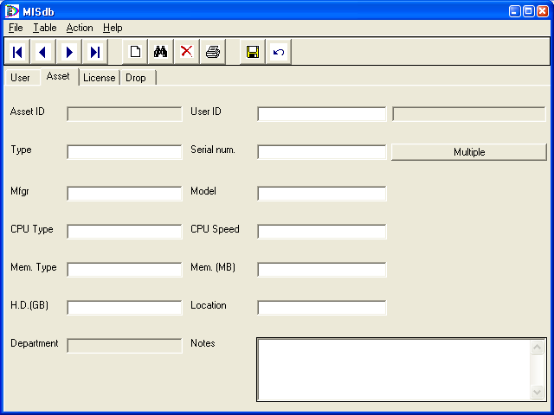

To enter new data for any one of the four tabs, click the blank paper icon. The title bar will indicate that you are creating a new record. Complete as much information as you can and click the floppy disk icon to save.

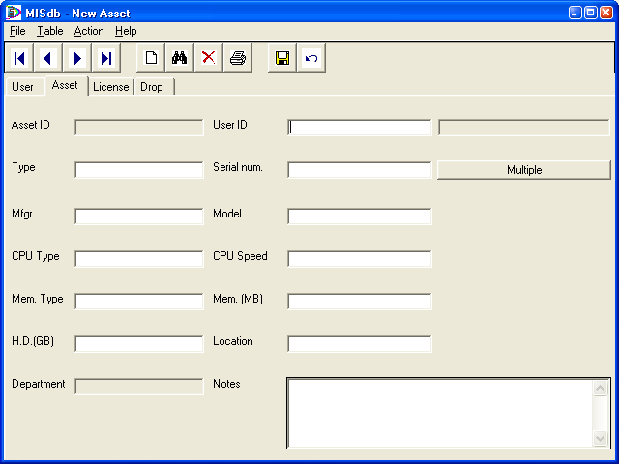
On the Asset tab in the User ID field, and on the License tab in the Asset field, you can right-click to bring up an autocomplete window to find the desired user id or asset id.

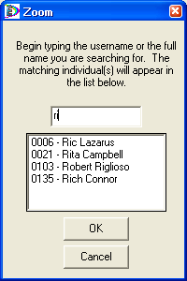
For users, as you start typing, the Zoom window will show a list of all users who have a first name, last name, or username beginning with the entered text. However, if two people have the same first name and you start to type the last name also, the results list will be blank since the window does not look at full names. Pressing “Enter” while typing will put the first result in the entry fields on the main window.

For assets, you should type as much of the serial number of the asset you are looking for.

In either case, you can always click the result you want and click the OK button to send it back to the main window.
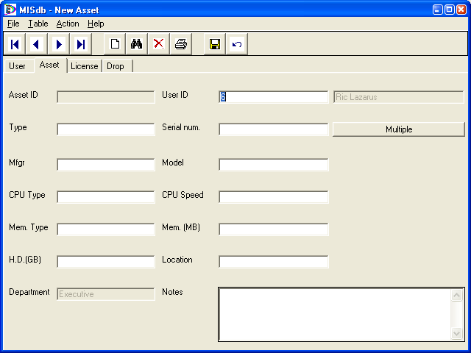
If you have a number of assets of the same type that you wish to add to the database, begin by entering all the common information first, except serial number. For User ID, you should use 138 for UNASSIGNED until you know who will actually be in possession of the asset. Once the common information has been entered, click the “Multiple” button instead of the floppy disk icon.

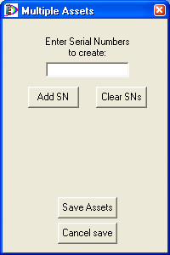

For each serial number in the set, enter it into the box and click “Add SN.” If you make a mistake, you can “Clean SNs” and start over. When all of the serial numbers have been entered, click the “Save Assets” button to add all the units to the database in one shot. If you change your mind and no longer want to do this, or need to change information on the Assets tab, click “Cancel save.”
Searching has been significantly enhanced in this version. To begin a search, click the binoculars at the top of the screen. The title bar will reflect that you are searching. You can now perform wildcard searches on just about any field. Use asterisk (*) for any number of characters and question mark (?) for a single character.

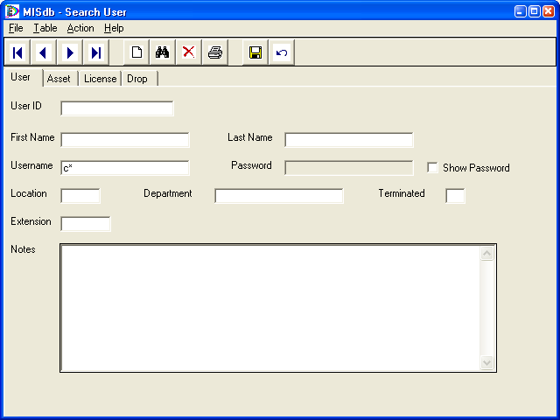

Click either the binoculars or the floppy disk icon to apply your filter. Use the VCR buttons to navigate the returned options. The title bar will reflect which record you are looking at and how many records are in the result set.

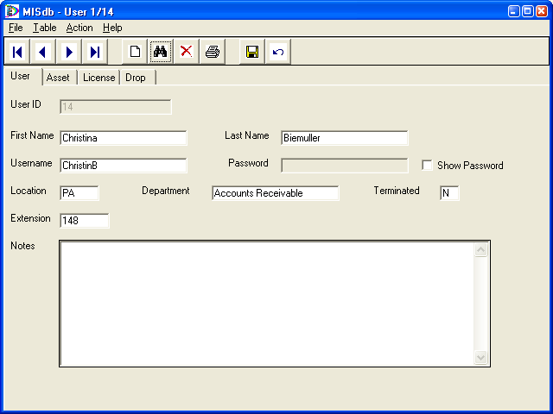

By default, all passwords are hidden from view on the User tab. Checking the Show Password box will reveal the password and allow you to change the field. To save password changes, the Show Password box must be checked. Removing the check hides the field.

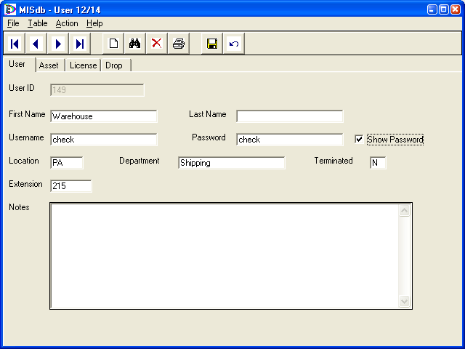
While browsing, you can delete the current entry by clicking the red X. The program will ask for a confirmation.

Here are some features that have not yet been added:
- Reports
- the Undo button
- Exports to CSV or Excel
- Printing of any kind
- Deleting drops

