X12 Finder 2.12 User Guide
21 April 2006

This program is designed to make locating, comparing, and printing EDI raw data (X12 documents) faster and easier. Please report any bugs or desired features to mikes@notations.com. They will be addressed as quickly as reasonably possible. New features in version 2.12 are highlighted in yellow.

To begin, double-click the X12Finder icon.
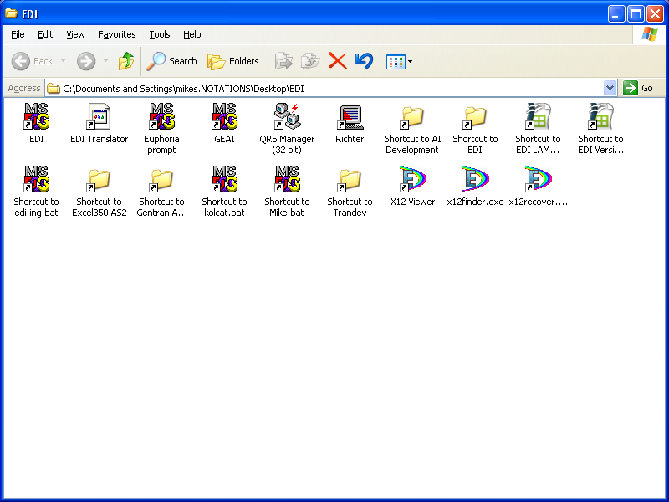

The first thing you need to enter is the location of the EDI documents you are looking for. You can add subdirectory information from the location selected in the drop-down box to the base path just by typing in the box.

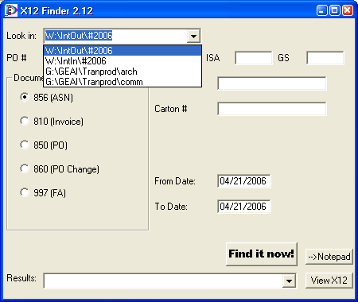
Next, fill in your date range. Dates must be entered as MM/DD/YYYY.

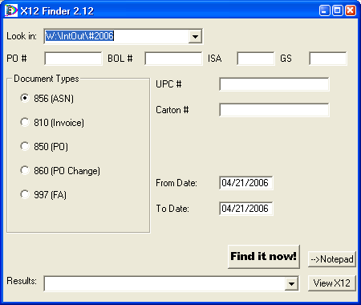
Next, fill in whatever information you know from the Purchase Order #, the BOL #, the ISA control number, or the GS control number. PO# will work for any document except 997, BOL # will work for 810s and 856s, and ISA control number will work for any document at all. The GS control number is the ID of the document except on 997s. For 997s, the GS control number is the ID of the document being acknowledged, rather than the ID of the acknowledgment itself. New in version 2.12: Now you can also search by UPC# or carton#. UPC will work in all documents except 997, but carton # will only work on 856s.

Lastly, select the document type you are looking for. You can search for ASNs, Invoices, POs, and FAs. New for version 2.12: You can also search for PO Changes.

Now all you need to do is click “Find it now!” The area above the button will display the status as the program is performing its search. The results will appear in a list, by filename, in the drop-down list below the “Find it now!” button.

If you are lucky, only one document will appear. More likely, there will be several, and you will have to look at each one individually to see if it is the one you are looking for. This is not as time consuming as it sounds, and future versions of this program will improve the accuracy of the searches. To view the selected document, click the “View X12” button.
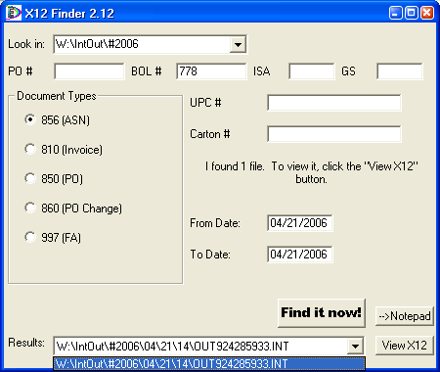
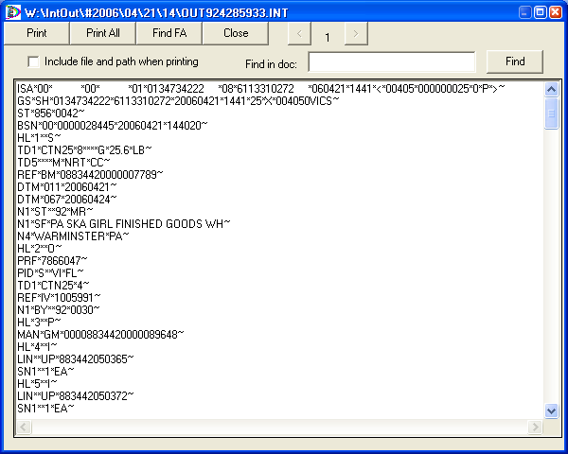
Here you can see that the number circled in blue is the BOL # we were searching for. You can print this page by clicking the “Print” button at the top of the screen. To print the entire document, click the “Print All” button. If you want to see the filename and path (and page numbers) on the printed version, simply place a checkmark in the box (circled in dark blue). The number circled in green is the GS control number, which we will use to search for a corresponding 997. There is a 32KB limitation for files being viewed; so now, larger EDI documents will be split into multiple pages. Click the right and left arrows (circled in red) to browse through the pages. Another enhancement in version 2.12 is the automatic search of a matching FA through the “Find FA” button. When you click the button, the text on it will read “.Searching.” until it has found the document it is looking for. It will only look in the date range you originally selected, so if you plan to use “Find FA,” be sure to include a wide enough date range for both the document and the FA. A warning message will appear if more than one possible FA is found or if none are found. Just click OK. If you are browsing an FA already, the “Find FA” button will be grayed out.

When you are finished reviewing the document, click the “Close” button.

If you need to open the file in Notepad, simply click that button instead of the “View X12” button.

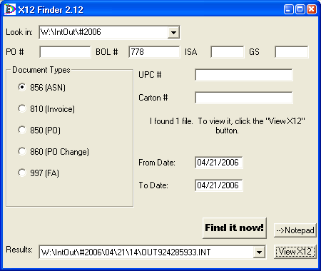

One other enhancement in version 2.12 is the use of a configuration file. In the same directory as X12finder.exe, create a new text document named x12finder.ini. This file should have two sections. An example file is listed below.

[DIRLIST]
W:\IntOut\#2006
W:\IntIn\#2006
G:\GEAI\Tranprod\arch
G:\GEAI\Tranprod\comm

[LASTSEARCH]
path=W:\INTOUT\#2006
dtype=856
fdate=04/21/2006
tdate=04/21/2006
ISA=
GS=
PO=
BOL=
UPC=
UCC=

To customize the list of directories that appear in the drop-down list, place each directory you would like to choose on a line by itself in the proper order beneath “[DIRLIST]”. The “[LASTSEARCH]” section is created automatically by X12finder when you close the program. It saves the filters you were using so you don't have to re-enter them if you unintentionally quit X12finder. The autosave, however, only occurs if an x12finder.ini file already exists in the directory. The program will not create a new one.

This is a fairly straightforward program, but it is significantly faster and more accurate than Windows search or Gentran. Hopefully, this program will make life in the EDI world almost manageable.

