A Minor Project II Proposal on

**BOOKAFY**

Submitted in partial fulfillment of the requirements for the degree of

Bachelor of Engineering in Software Engineering at Pokhara University

***By***

**SAFAL BHANDARI**

**SIDDHARTHA JAISI GAUTAM SUJIT KHANAL**



##### Department of Research and Development GANDAKI COLLEGE OF ENGINEERING AND SCIENCE

Lamachaur, Kaski, Nepal

**(May 2023)**

# ABSTRACT

In the digital age, social media platforms have revolutionized communication and information sharing. Concurrently, note sharing web applications have emerged as valuable tools for knowledge dissemination and collaboration. This abstract explores the key aspects and implications of developing a social media and note sharing web application. Firstly, the social media component of the web application facilitates user interactions, enabling individuals to connect, communicate, and build online communities. Users can create profiles, share multimedia content such as text, images, videos, and links, and engage in discussions through comments, likes, and shares. The social aspect of the platform fosters connections, promotes user engagement, and encourages information exchange. Secondly, the note sharing functionality offers users a platform to create, store, and share their thoughts, ideas, and knowledge in a structured manner. Users can create notes, organize them into categories or topics, and make them public or private. This feature allows users to collaborate, seek feedback, and gain insights from a diverse range of individuals. The note sharing aspect enhances learning, knowledge sharing, and collective intelligence

**Table of Contents**

ABSTRACT 2

Chapter 1 5

INTRODUCTION 5

1.1. Background 5

1.2. Problem Statement 5

1.3 OBJECTIVES 5

1.4 IMPLICATION 6

Chapter 2 LITERATURE REVIEW 7

2.1.1 Facebook (Facebook, 2023): 7

2.1.2 Punotes (Punotes, 2023): 8

2-1.3 Udemy (Udemy, 2023): 9

3.2.3 ENTITY RELATIONSHIP DIAGRAM 13

Chapter 4 TIMELINE CHART 14

Chapter 5 WIREFRAMES 15

Bibliography 16

**List of Figures**

Figure 3.2.1: Use Case Diagram (UCD) of Bookafy ................................................... 11

Figure 3.2.2: System Sequence Diagram (SSD) of Bookafy ...................................... 12

Figure 3.2.3: Entity Relationship Diagram (ERD) of Bookafy…… ........................ ...13

Figure 4.1: Gantt Chart ................................................................................................ 14

Figure 5.1: Signup Page ............................................................................................... 15

Figure 5.2: Home Page ................................................................................................ 15

# Chapter 1

# INTRODUCTION

## 1.1. Background

Bookafy is a social media platform for sharing notes. Basically, Bookafy is an interface where two students can save and share their notes with their friends and also has an edit feature to modify them in the future. Bookafy, a social media and note sharing web application combines the benefits of social media platforms and notetaking tools. It offers a versatile platform for individuals to connect, share knowledge, collaborate, and engage in meaningful interactions. By considering the technical, societal, and ethical aspects, developers can create a powerful and inclusive digital space that promotes learning, creativity, and community building.

## 1.2. Problem Statement

Today’s generation has come so far that people are more dependent on online platforms for most of their basic work. Many of our students have faced problems maintaining their notes over the years. Managing their daily notes and referring to them faster in the future is one of the challenges they faced every day. So our Bookafy is one the major developments in the field of technology which plays a large role in everyday life activities. This project keeps track of all the notes a student has made earlier. Its feature includes inserting a note and labeling it where a student can insert multiple notes and delete them. Bookafy provides an interface where all levels of students can interact and share their notes. With most online sites providing only a piece of particular information, Bookafy provides overall information regarding a particular topic. Bookafy also simplifies the way of sharing notes.

## 1.3 OBJECTIVES

The objective of this project is to design and develop a comprehensive social media and note sharing web application that combines the features of social media platforms and note-taking tools. The main objectives are as follows:

* Enable users to create, store, and share notes in various formats, such as text, images, and multimedia.
* Implement social networking features such as user profiles, friend/follower connections, newsfeeds, and notifications to facilitate user interactions.
* To reduce the time associated with traditional note making methodology.

## 1.4 IMPLICATION

Bookafy is a social media platform where sharing notes is considered most priority. It may have similar functions to other sites but it has some distinguished factor which stands among other .

* Knowledge Sharing and Collaboration: The web application “Bookafy” enables users to share their expertise, insights, and knowledge with a wider audience. This promotes collaborative learning, fosters intellectual growth, and facilitates the exchange of diverse perspectives and ideas.
* Enhanced Learning and Personal Growth: Users can leverage the web application to engage in active learning and personal growth. By accessing shared notes, participating in discussions, and collaborating with others, individuals can expand their knowledge base, gain new insights, and develop critical thinking skills.

# Chapter 2 LITERATURE REVIEW

Many web applications and mobile applications have already been developed in the market which provides a platform for Social media and note providing. Some of them are listed below:

### 2.1.1 Facebook (Facebook, 2023):

Facebook is a website which allows users, who sign-up for free profiles, to connect with friends, work colleagues or people they don't know, online. It allows users to share pictures, music, videos, and articles, as well as their own thoughts and opinions with however many people they like.

The comparison between the “Facebook” and our proposed “Bookafy” is tabulated as below:

|  |  |  |
| --- | --- | --- |
| **Features** | **Facebook** | **Bookafy** |
| Login/sign-up | ✔ | ✔ |
| communication | ✔ | ✔ |
| Play music | ✔ | ✖ |
| Sharing notes | ✖ | ✔ |
| Saving notes | ✖ | ✔ |

**Table 2.1.1. Literature Review of Facebook**

### 2.1.2 Punotes (Punotes, 2023):

Punotes offer a variety subject, free courses, PDF notes, Exam Question, Syllabus and other projects specially from Pokhara university.

The comparison between the “Punotes” and our proposed “Bookafy” is tabulated as below:

|  |  |  |
| --- | --- | --- |
| **Features** | **Punotes** | **Bookafy** |
| Login/sign-up | ✖ | ✔ |
| communication | ✖ | ✔ |
| Sharing notes | ✔ | ✔ |
| Saving notes | ✔ | ✔ |

**Table 2.1. Literature Review of Punotes**

## 2-1.3 Udemy (Udemy, 2023):

Udemy is an online learning platform that offers both paid and free courses to students around the world. From a computer or mobile device, students can learn web development, machine learning, and data analytic. Both free and paid courses offer excellent curriculum.

The comparison between the “Udemy” and our proposed “Bookafy” is tabulated as below:

|  |  |  |
| --- | --- | --- |
| **Features** | **Udemy** | **Bookafy** |
| Login/sign-up | ✔ | ✔ |
| communication | ✖ | ✔ |
| Sharing notes | ✔ | ✔ |
| Saving notes | ✖ | ✔ |

**Table 2.1. Literature Review of Udemy**

**Chapter 3**

**TOOLS AND METHODOLOGY**

##### 3.1 REQUIRED TOOLS

For the development of our project, we will be using the following tools:

|  |  |
| --- | --- |
| Tools | Description/Purpose |
| Django | Django is a high-level Python web framework that encourages rapid development and clean, pragmatic design. Built by experienced developers, it takes care of much of the hassle of web development, so you can focus on writing your app without needing to reinvent the wheel. |
| Html,  CSS | system for displaying material retrieved how HTML elements are to be displayed on screen, or in other media |
| Redis | The open source, in-memory data store used by millions of developers as a database, cache, streaming engine, and message broker |
| Vs code | Visual Studio Code is a lightweight but powerful source code editor which runs on your desktop and is available for Windows, macOS and Linux. |
| GitHub | code hosting platform for version control and collaboration |

**Table 3.1 Tools Required for Sell-Cell**

##### 3.2 APPROACHES

The project will be developed by using suitable design patterns and solid principles.

**3.2.1 USE CASE DIAGRAM**

In the Unified Modeling Language (UML), a use case diagram can summarize the details of your system's users (also known as actors) and their interactions with the system. To build one, you'll use a set of specialized symbols and connectors. An effective use case diagram can help your team discuss and represent:

* Scenarios in which your system or application interacts with people, organizations, or external systems.
* Goals that your system or application helps those entities (known as actors) achieve.
* The scope of our system.

The high-level use case diagram of our project is

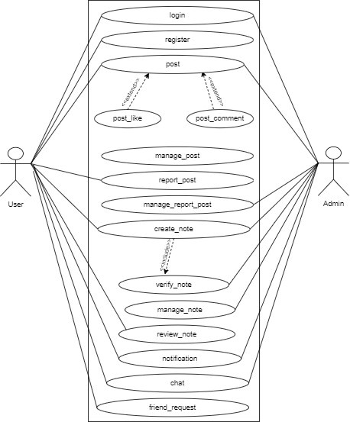

**Figure 3.2.1: Use Case Diagram (UCD) of Bookafy**

##### 3.2.2 SYSTEM SEQUENCE DIAGRAM

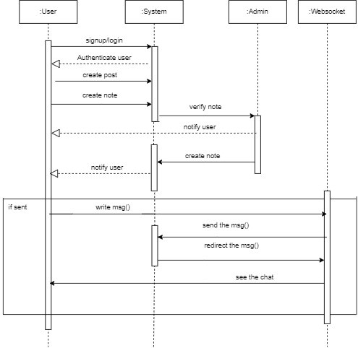

**Figure 3.2.2: System Sequence Diagram (SSD)**

#### 3.2.3 ENTITY RELATIONSHIP DIAGRAM

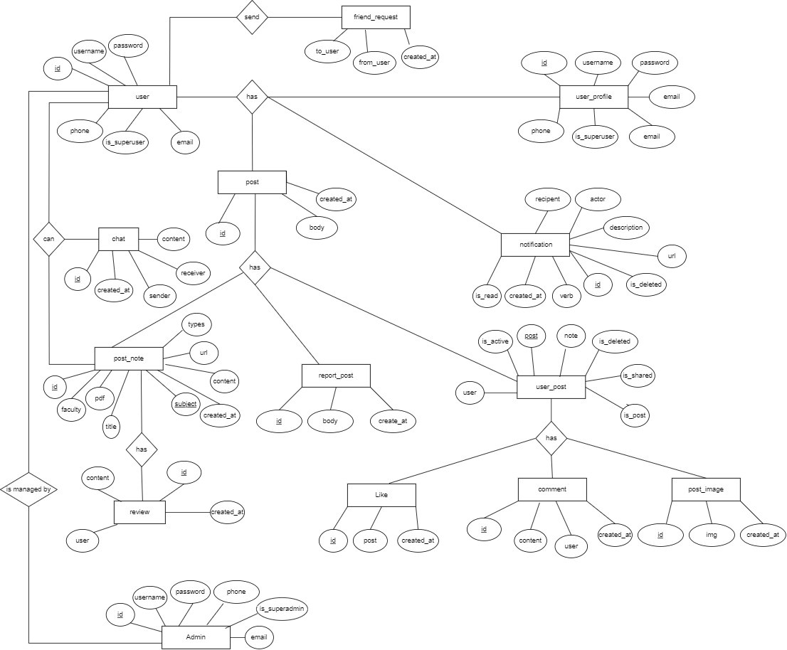

**Figure 3.2.3: Entity Relationship Diagram (ERD) of Bookafy**

# Chapter 4 TIMELINE CHART

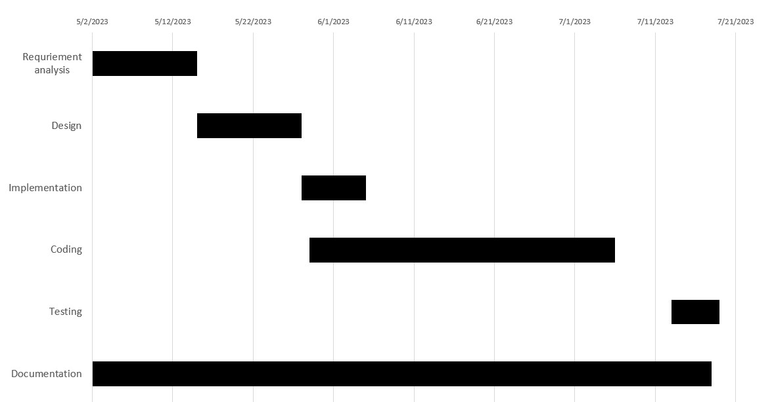

**Figure 4.1: Gantt Chart**

# Chapter 5 WIREFRAMES

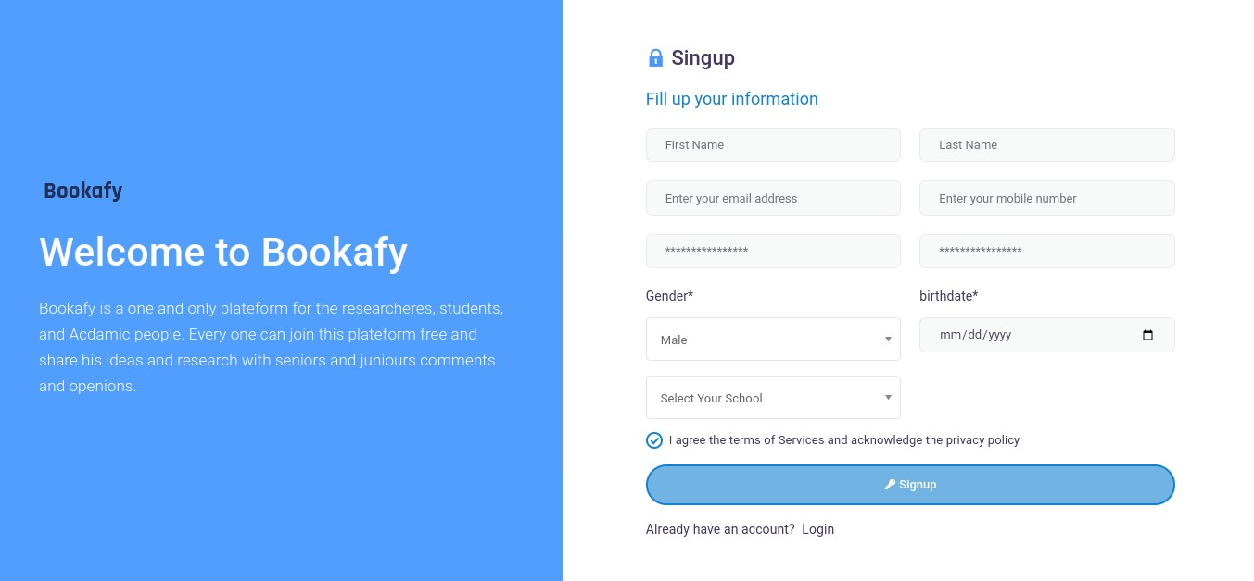

**Figure 5.1: Signup Page**

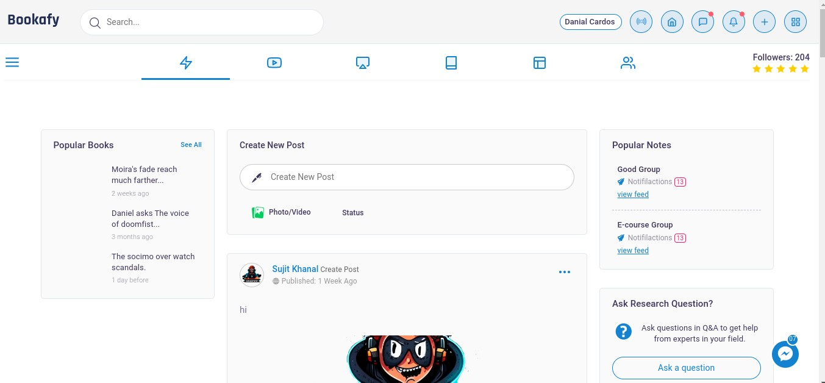

**Figure 5.2: Home Page**

15

# Bibliography

documentation, D. (2023). *Home Page*. Retrieved from Django documentation: https://docs.djangoproject.com/en/4.2/

DrawIO. (2023). *Home Page*. Retrieved from Draw IO: https://app.diagrams.net/

Facebook. (2023). *Home Page*. Retrieved from Facebook:

https://www.facebook.com/home.php

*Home Page*. (2023). Retrieved from Stack Overflow: https://stackoverflow.com/

Overflow, S. (2023). *Home Page*. Retrieved from Stack Overflow:

https://stackoverflow.com/

Punotes. (2023). *Home Page*. Retrieved from Punotes: https://punotes.ml/

Udemy. (2023). *Home Page*. Retrieved from Udemy: https://www.udemy.com/

16