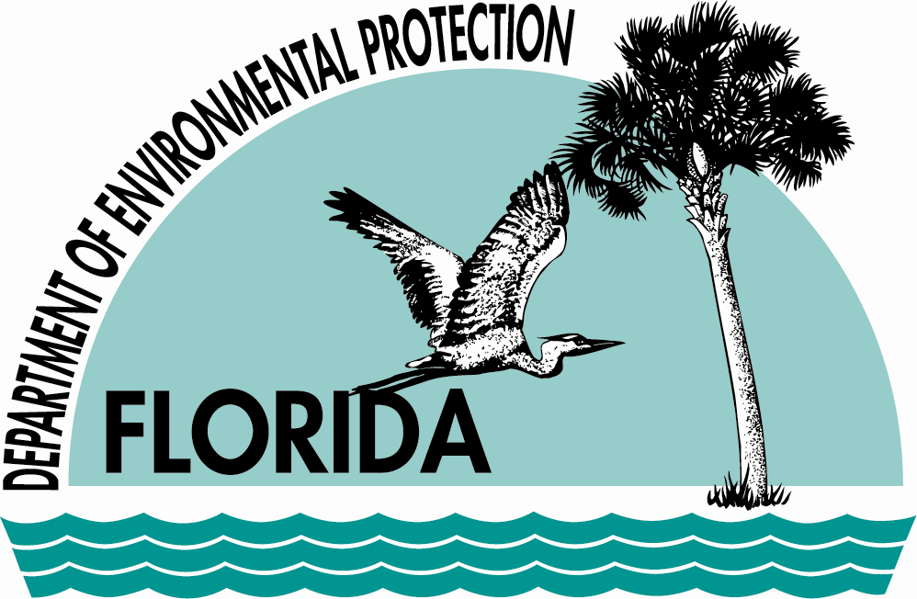 | FLORIDA DEPARTMENT OF  ENVIRONMENTAL PROTECTION  Fort Cooper State Park  Withlacoochee State Trail  3100 S. Old Floral City Rd.  Inverness, FL 34450  (352) 726-0315 | RICK SCOTT  GOVERNOR  JENNIFER CARROLL  LT. GOVERNOR  HERSCHEL T. VINYARD JR.  SECRETARY
January 24, 2013

Lynne Daniels
1003 Cheyenne St.
Jupiter, FL 33458

Dear Lynne:

Please find enclosed a copy of your cash register and credit card receipts for your reservation deposit for campsite #1 on February 9, 2013. Be sure to pick up your original receipts when you check in at the ranger station upon arrival.

Below you will find directions to the campground since Fort Cooper State Park closes at 6:30 p.m. during the month of February. The gate at the campground will be closed and look like it is locked. It has a padlock on it, but if you reach around the back of the chain you will find a dog clip that you can open the gate with. Please close the gate upon entering or leaving the campground if it has been closed by the rangers. You may also disregard the “Restricted Area” sign that is posted to keep non-campers out. If you have any questions, give us a call at the park @ 352-726-0315. In the case of an emergency you can contact our park manager, Harry Mitchell on his cell @ 352-586-2501.

If you need to cancel this reservation for any reason, please let us know within 48 hours of your reserved date.

We look forward to having you with us and hope you enjoy your time at the park.

Sincerely,

Tammy Roberts

Tammy Roberts
Administrative Assistant
Fort Cooper State Park

Directions to the campground:

From Fort Cooper State Park – you go east on Old Floral City Rd. to Fort Cooper Rd. (the first road to the right past Fort Cooper State Park) Turn right on Fort Cooper Rd. and go about 200 yards. You will see a galvanized gate on the right and the Invasive Plant Mgmt. building (a double-wide). The gate will be closed but not locked. Once you enter be sure and close the gate behind you and follow the signs to the camping area.

FORT COOPER
STATE PARK

PRIMITIVE CAMPING REGULATIONS

THIS IS STRICTLY A TENTS ONLY CAMPING AREA

In order to insure the protection and wise use of the park, all primitive group campers are requested to comply with the following regulations:

PETS - Dogs and other fur-bearing pets are prohibited.

ADULT LEADERS should remain with the group at all times.

ANIMALS & PLANTS- All animal and plant life is protected. Do not feed or molest any animal. Do not bend, break, cut, or deface with initials any plants.

FIRES- One campfire per campsite is permitted. You must supply your own firewood. Firewood cannot be collected in the park. Campfires should be built in the designated fire circle. During drought conditions, specific restrictions may apply.

GARBAGE- All trash & garbage should be placed in the dumpsters near the primitive camping main entrance.

EMERGENCY SITUATION- During normal operating hours, notify a Ranger, after hours call 9-1-1-. Included you will find a map showing the location of the nearest phone, Citrus Memorial Hospital, and the Citrus County Sheriff’s Department.

QUIET TIME- Campers should be in the camp and quiet by 10:00 p.m.

SANITARY FACILITIES- Campers must use privy facilities provided by the park. Temporary latrines or pits are prohibited.

CHECK-OUT TIME- Check out time is at 1:00 p.m. The site must be vacated promptly by
1:00 p.m. to ensure availability for the next group coming in.

NO SWIMMING- at the primitive camping area.

PARKING - NO parking in the campsite area. Park in designated area only. ONLY two (2) vehicles are allowed per campsite. All other vehicles must be parked in the designated overflow parking area.

LENGTH OF CAMPING STAY – Camping stay is limited to seven (7) days. You may return after six (6) months.

We appreciate your full cooperation in following the above regulations and thank you for camping at FORT COOPER STATE PARK.
