Pain:
Design uses more DSP units (258) that the PYNQ-Z2 FPGA can offer (220), and time violation still exists if clock cycle is set to 7ns.
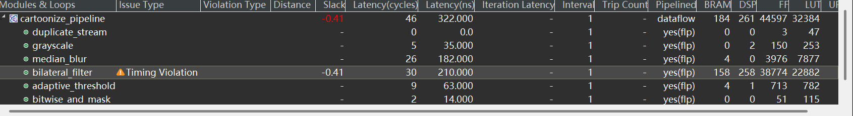

Optimization (all on bilateral filter module):

Shrink the size of sliding window from 11 to 5:
Smaller size window can reduce the use of DSP and other HW resources to form operation units, which helps to save more resources and areas. According to the test on python and verified on streamulator output, visual effects of smaller size reduce the blurring intensity but remain acceptable.

Shrink the size of reciprocal LUT:
Thanks to the smaller size of window, range of sum of weights also decreases. Note that the maximum values of color weights and spatial weights are all 1 regardless what sigma is, meaning that the maximum value of the sum of weights is the number of units in the sliding window. For size=5, the maximum value of sum of weights is 25, which means the reciprocal LUT can be reduced to 32 elements (2^6, close to 25 yet provide extra spaces for safety) to save more memory.

Update spatial and colour array with sigma=100:
Although this may not help to ease the pains mentioned above, it is change to sigma=100 version to make the spatial weights look “useful”. The original version is set sigma to 350, which gives a more blurred effects but the spatial weights distribution is nearly flat, which does not show the values of spatial filter.
This version set sigma to 100 to verify the design in a way with larger range of spatial filter weights, and the overall effects remain cartoonized enough.
Additional notes will be, if you want a more blurred effects by setting sigma to a large value > 100, considering the size of the window is already small, it means that the range of spatial weight will be relatively identical and close to 1. In this case you can even consider remove the step of W_{spatial}*W_{colour} and directly use W_{colour} as the final weight, which may save you even more area and time.

Results
As seen in the screenshot, HW resources are largely saved and no more time violation exists, making it ready to be deployed on board (theoretically, hopefully).
