1. Attention

Before start in unity choose android platform and use portrait ration!

1. Entry

Writing this documentation, I understand that I will not finish it properly.

This is my first match 3 game and I never thought that It so pleasure to do such games. I threw myself into this project and found many things that was very interesting for me.

I cannot say that this project is finished. I need to improve many things. I need to add new features and rewrite bad parts.

There is a chance that I will finish it and upload it in the store.

1. About task

I finished all task with exception that I made 3 - 4 elements game (not 5 how was in the task). It was design decision. New element can be easily add inside game settings.   
  
Task was interesting and fresh for me.

1. Game Settings

Almost all game settings are inside Assets/Data/Settings folder

They are scriptable objects that describe levels, game modes, elements

1. Game structure

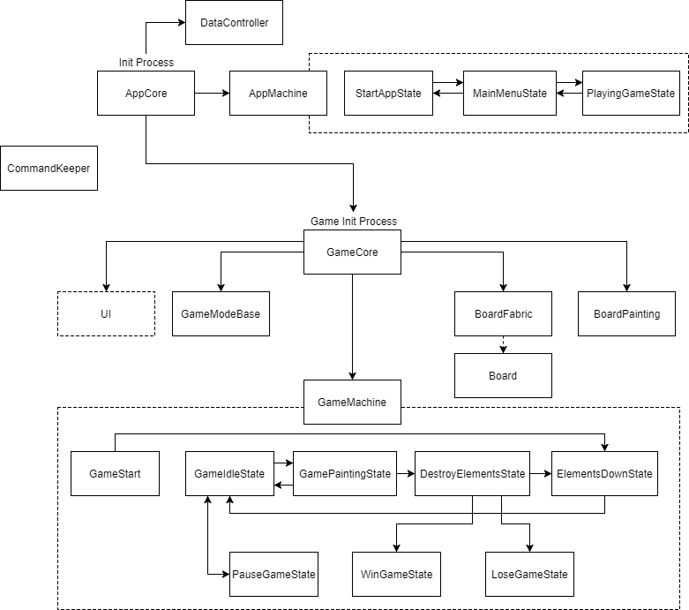

1. Things that I want to improve (someday)

* Moving elements down algorithm
* Improve elements touch
* Bake board mesh after creation
* Put images on atlases
* Change a bit architecture
* Add new features (new Game Modes (almost finished), new Special elements, boosts, etc..)
* Spend time to optimize game
* Refactoring