

PRACTICAL TRAINING REPORT

AT

(Organization Name & Address)

PREPARED BY

Student name
(Student ID)

PRESENTED TO

FACULTY OF COMPUTER AND MATHEMATICAL SCIENCES
UNIVERSITI TEKNOLOGI MARA (UiTM)
KEDAH BRANCH

DIPLOMA IN COMPUTER SCIENCE (CDCS110)

DATE OF SUBMISSION

(date)
APPROVAL SHEET

APPROVED BY

………………….

(academic supervisor’s name)

COLLEGE OF COMPUTING, INFORMATICS & MATHEMATICS
UNIVERSITI TEKNOLOGI MARA (UiTM)
PERLIS BRANCH

ACKNOWLEDGEMENTS

Provide your acknowledgement here…

TABLE OF CONTENTS
ACKNOWLEDGEMENTS 3
CHAPTER 1: INTRODUCTION 6
  - Background of Practical Training 6
  - Objective of the Practical Training and the Report 6
CHAPTER 2: BACKGROUND OF THE ORGANIZATION 7
  - Introduction 7
  - Vision, Mission and Objectives of the Organization 7
  - Organizational Chart 7
CHAPTER 3: MAIN PROJECT 8
  - Introduction 8
  - Objectives 8
  - Hardware & Software Requirements 8
    - Software A 8
    - Hardware Requirements 9
  - Results of Main Project 12
    - Point A 12
    - Point B 15
    - Point C 15
    - Point D 15
CHAPTER 4: OTHER TASKS 23
  - Task A 23
  - Task B 23
CHAPTER 5: CONCLUSION AND RECOMMENDATION 25
  - Conclusion 25
  - Recommendation 25
APPENDIX A: SAMPLE OF APPENDIX 26

CHAPTER 1: INTRODUCTION

Background of Practical Training

Practical training is a compulsory course for all students of the Diploma of Computer Science. It is important to complete this course to complete the diploma and to graduate from university as a student of computer science. Training refers to the job experience that must be related to what the student has learned from the past semester.
A 24-week duration of Diploma of Computer Science shall be allocated for training at the training center selected by the student itself. There was no limitation on whether the student chose to work for government agencies or private companies. Students are expected to operate under the supervision of professional personnel. For the practical training, grade students will be based on a report prepared by the student.

Objective of the Practical Training and the Report

The main objective for the student to perform practical or industrial training is to give them working experience with specific tasks that was given by an organization. The other objectives of practical training are:
    - To build students confidence after graduation.
    - Improve both soft and hard skills.
    - Improve communication and management skills.
    - To expose the real world of working environment to the students.

The student who has completed the practical training in the given time will prepare this report. Students must provide a written report according to the standards given by the University. This is to evaluate the effectiveness of their skills during the given period. This report will also provide evidence for students who attend practical training and as a guideline for future use. This report, on the other hand, will also train students to comply with the laws and regulations in their daily lives.

CHAPTER 2: BACKGROUND OF THE ORGANIZATION

Introduction

Enter your organization background here…

Vision, Mission & Objectives of the Organization

Enter your organization vision here…

Organizational Chart

Enter your organization mission here….

CHAPTER 3: MAIN PROJECT

Introduction

Please provide some introduction background for your main project here…System Development/Multimedia or Network.

Objectives

Please provide objectives for your main project here…

Hardware & Software Requirements

Please provide objectives for your main project here…

Results of Main Project

System Development

Explain elements related to system development cycle (planning, analysis, implementation, testing)
eg. DFD, ERD, Use Case

Multimedia

Explain each and every multimedia requirements needed for this multimedia project. Describe each and every technique implied for the development for multimedia projects. Students need to further elaborate knowledge of multimedia technique to complete this section

Eg. Flowchart, Storyboard

Network

Diagram/Network design, Firewall/Router setup

Main Project Interface

The following Figure 1 shows a sample interface for…

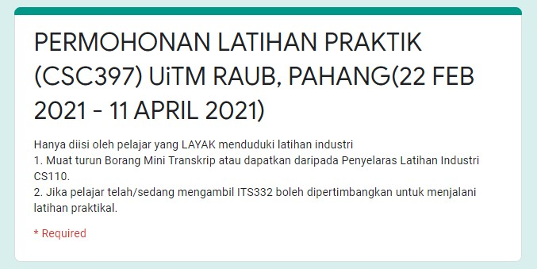

Figure 1: Sample Permohonan Interface (TNR, 11)

Example of labeling the table in the text (Table Design >> Grid Table 4).

Table 1: Global Error for Problem 1 (TNR, 11)

Step size  (h) | Explicit Two-step  Hybrid Method | Singly Diagonally  Hybrid Method | Implicit Singly Diagonally  Hybrid Method
0.01 | 3.29949x10⁻⁷ | 1.13312x10⁻⁸ | 3.65703x10⁻¹⁰
0.0625 | 8.06137 x10⁻⁵ | 2.73627x10⁻⁶ | 9.35346x10⁻⁸
0.1 | 3.31331 x10⁻⁴ | 1.2251x10-5 | 1.52888x10-6
0.125 | 6.46571 x10⁻⁴ | 2.033555x10-5 | 2.54506x10-6
0.25 | 5.156673 x10⁻³ | 1.75805 x10-4 | 1.48155 x10-5
0.5 | 4.0561619 x10⁻² | 1.283957x10-3 | 7.57578x10-5

CHAPTER 4: OTHER TASKS

Task A: …………….

Google Sites is a free website builder from Google. It allows us to create website with collaborators by giving another Google user edit access. It is compatible with other Google services like Docs, Sheets, Forms, and Slides. It uses your Google Drive account to store images and files we share on our site up to 15GB of files for our sites for free, shared with our other Google apps.
4.1.1 Objectives
4.1.2 Results of Task A

Task B: …………….

Google Sites is a free website builder from Google. It allows us to create website with collaborators by giving another Google user edit access. It is compatible with other Google services like Docs, Sheets, Forms, and Slides. It uses your Google Drive account to store images and files we share on our site up to 15GB of files for our sites for free, shared with our other Google apps.

4.2.1 Objectives
4.2.2 Results of Task B

CHAPTER 5: CONCLUSION AND RECOMMENDATION

Conclusion

Please conclude here….

Recommendation

    - To the university, I would suggest to secure internship placements for students. This is because some students could not find a place to do internship.
    - Increase the internship period. The university should at least adjust to the period students go for internship. The period should be at least 4 months and above.

APPENDIX A: SAMPLE OF DETAILED FORM

Provide appendix here

(Sample interface/tools or coding etc.) do not forget to mention in paragraph.

