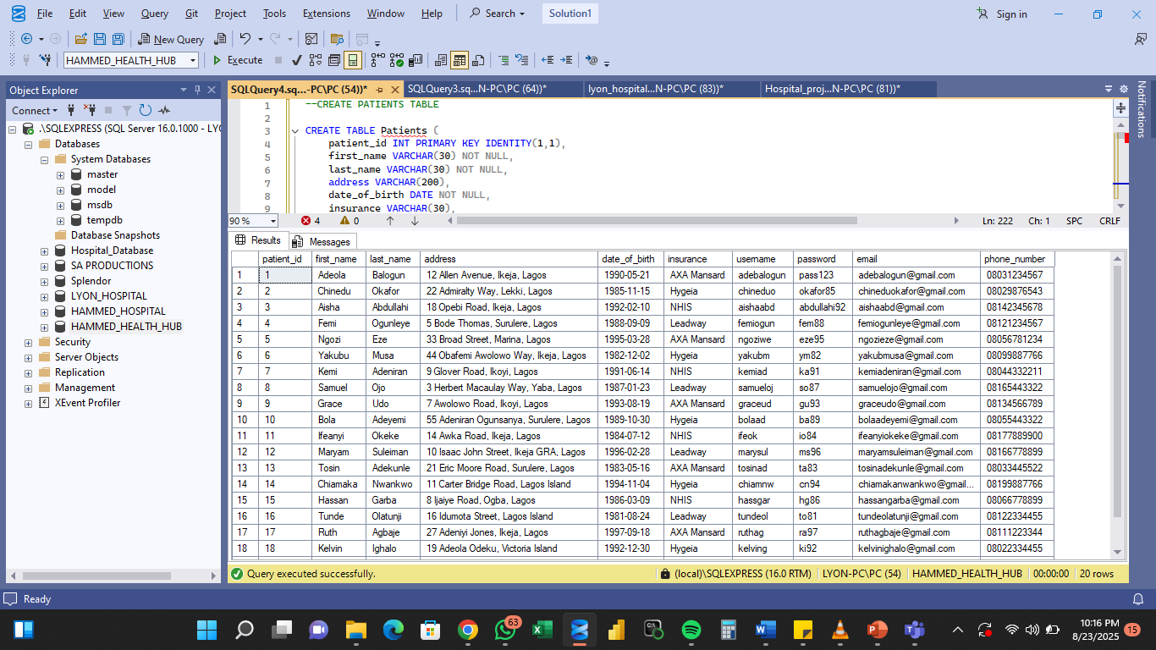PATIENTS TABLE SCHEMA & CODE

DOCTORS TABLE SCHEMA & CODE

DEPARTMENT TABLE SCHEMA & CODE

APPOINTMENTS TABLE SCHEMA & CODE

MEDICAL RECORDS TABLE SCHEMA & CODE

**CODES USED TO CREATE (PATIENTS TABLE AND DOCTORS TABLE)**

E**

**DEPARTMENTS** **TABLE**

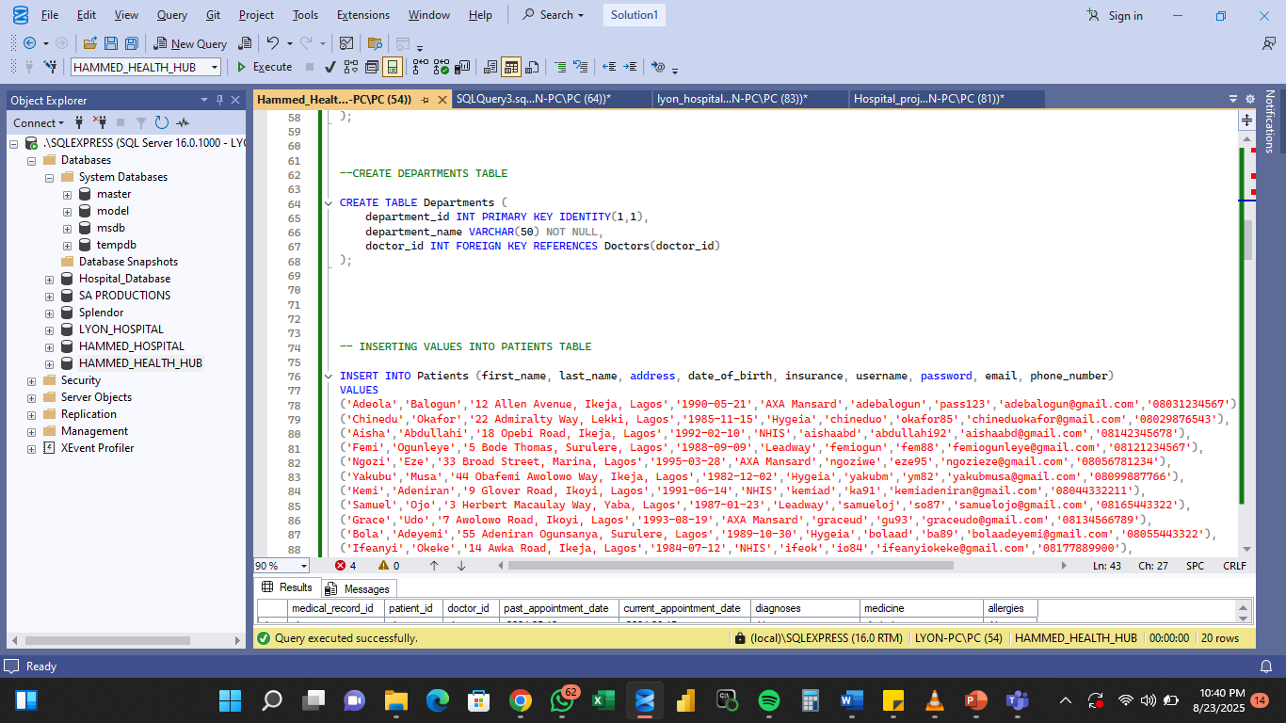**INSERTING** **VALUES** **INTO** **DOCTORS** **TABLE**

**INSERTING VALUES INTO DEPARTMENTS TABLE**

**INSERTING VALUES INTO APPOINTMENTS TABLE**

**INSERTING VALUES INTO MEDICAL RECORDS TABLE**

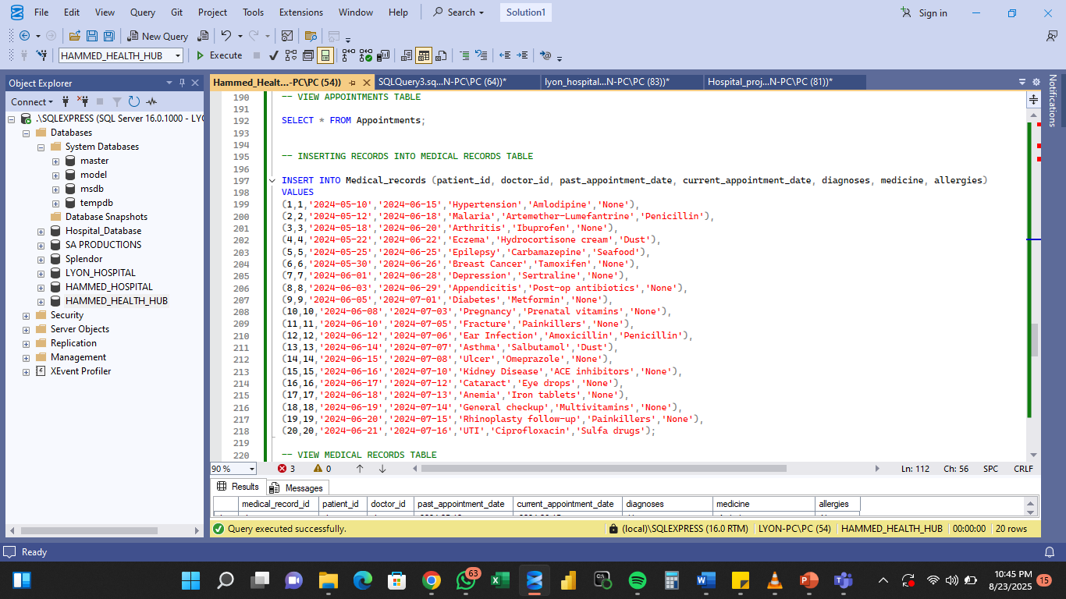

**DATABASE DIAGRAM**