# CVPR 2018. Impressions and 15 interesting papers CVPR 2018年。印象和15篇有趣的论文

This was great in the sense of meeting new people and de-virtualize with others. Regarding new cool results — not so much. I mean, lots of good papers, but nothing that ground-breaking, at least in areas of my interest.  
这在认识新的人和与其他人一起去虚拟化方面是很好的。关于新的酷结果 - 没那么多。我是说，有很多好的论文，但没有什么突破性的，至少在我感兴趣的领域。

1. If you present graphics-related poster, e.g. debluring, super-resolution, etc, DO NOT PRINT IT ON CLOTH. Especially on coarse fabric.  is nice work, but you cannot see anything due to cloth texture :(  
   如果您展示与图形相关的海报，例如去模糊、超分辨率等，请不要将其打印在布料上。尤其是在粗糙的布料上。做工不错，但由于布料的质地，你看不到任何东西：(

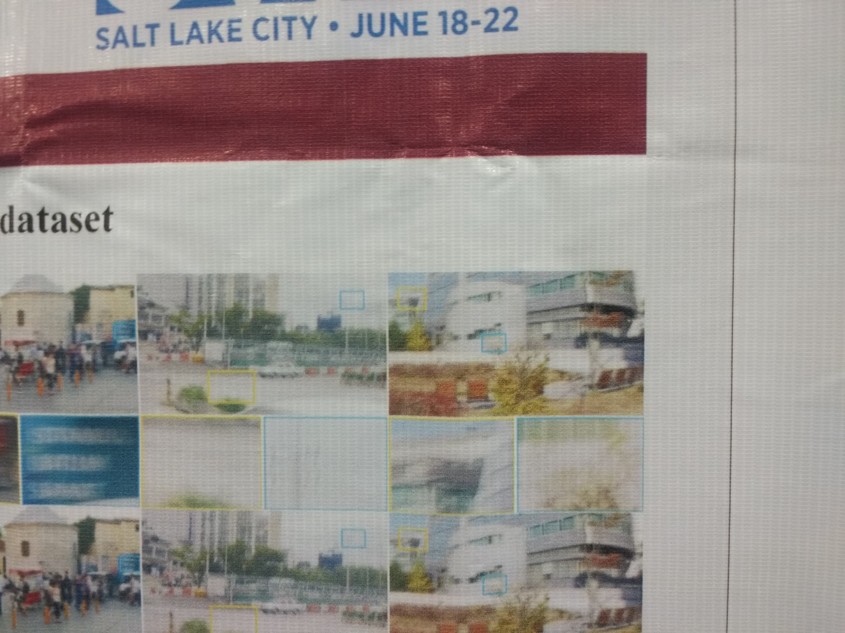

1. GANs, domain adaptation, autonomous driving and very minor architectural tricks are everywhere.  
   GANs、领域适应、自动驾驶和非常小的建筑技巧无处不在。
2. East Europe is still badly represented, but grows. Hungary, Ukraine, Romania, Poland, Turkey. Not many papers, but at least some and the number is increasing. That is great.  
   东欧的代表性仍然很差，但仍在增长。匈牙利，乌克兰，罗马尼亚，波兰，土耳其。论文不多，但至少有些，而且数量还在增加。太好了。
3. Workshop “” was surprisingly cool. Especially, “What is good research” by Vladlen Koltun and “Calendar, not lists” by Devi Parikh. All slides and videos are available at link above  
   “工作坊”出奇的酷。尤其是弗拉德伦·科尔顿的《什么是好的研究》和德维·帕里克的《日历，而不是清单》。所有幻灯片和视频都可以在上面的链接中找到
4. Graph neural networks of various flavors were discovery for me. Good tutorial by   
   各种口味的图形神经网络是我发现的。优秀导师
5. Workshop paper “”. Simple idea — add additional random input variable to control desired output and then you can control conditionally control output at test time.  
   研讨会论文。简单的想法 - 添加额外的随机输入变量来控制所需的输出，然后可以在测试时有条件地控制输出。

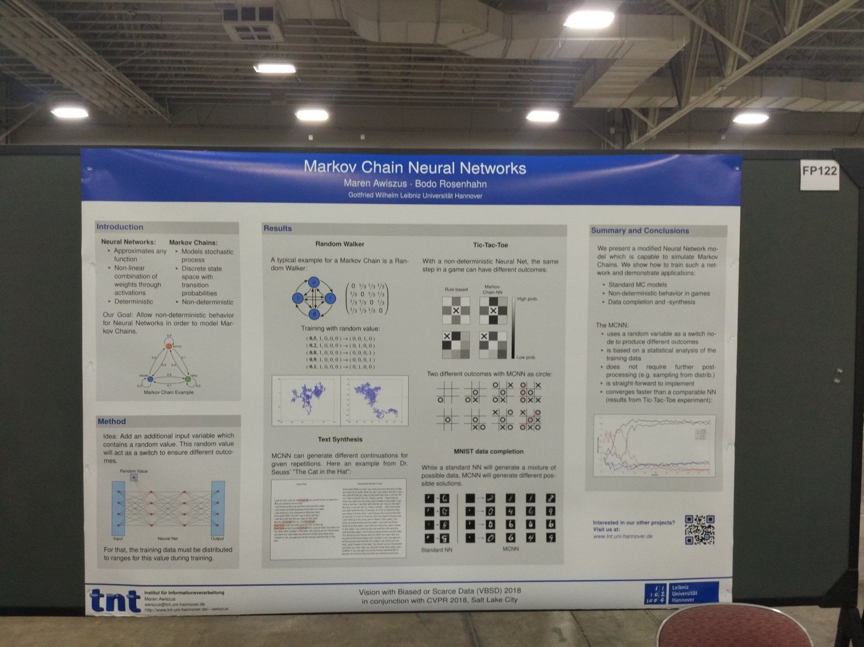

1. Three versions of differentiable SLAM:   —  from Oxford  — NVIDIA MapNet “”.   — DeepSLAM from Salakhutdinov‏ group:   
   可微SLAM的三个版本： - 来自牛津 - NVIDIA MapNet. - 来自Salakhutdinov group的DeepSLAM：
2. RANSAC is still improving. Two cool papers: and   
   RANSAC仍在改善。两份很酷的文件：和
3. Workshop on : key take-away messages: global features work good enough, but pooling and ensembling could be improved. If you need local features — go for DELF. Here are twitter-translations:   
   研讨会主题：关键的外卖信息：全球功能运行良好，但池和集成可以改进。如果您需要本地功能，请选择DELF。以下是twitter翻译：

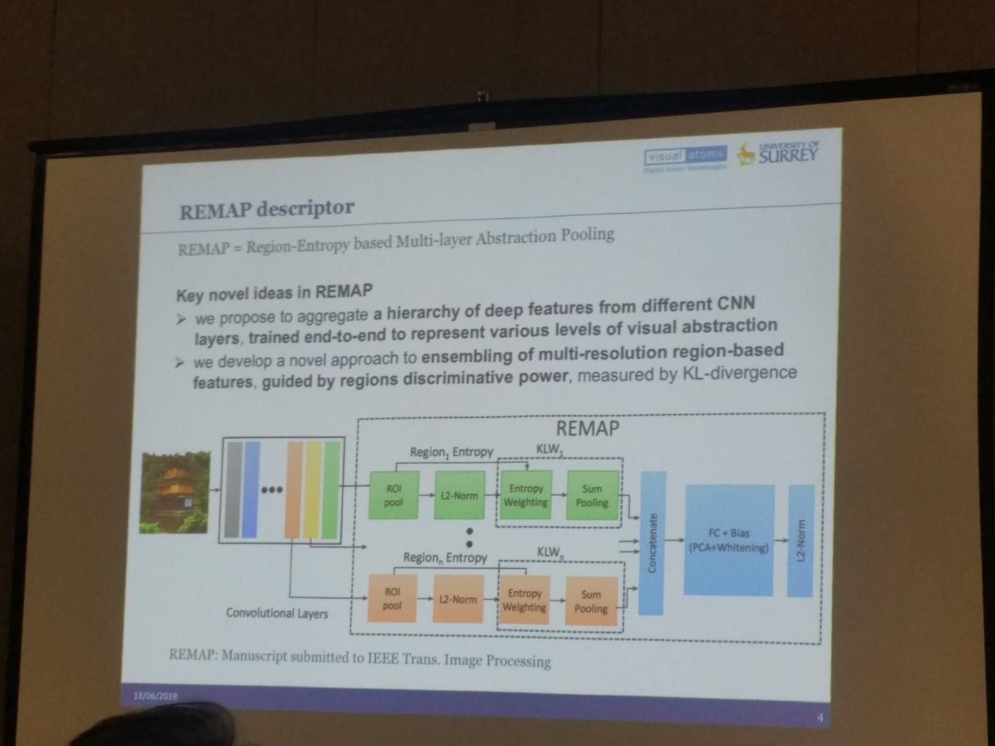

1. In contrast, and papers say different: local features are cool, but you need to be dense, not sparse  
   相比之下，和报纸上说的不同：地方特色很酷，但你需要密集，而不是稀疏
2. Local features-related papers thread —   
   地方特色相关论文线索 -

Other papers I like:  
我喜欢的其他报纸：

* . You cannot have, e.g. both nice details AND be close to ground truth in your reconstruction if information was lost, need to select. The next question is how to get algorithm given your priorities and where exactly trade-off lies.  
  . 你不可能既有好的细节，又在你的重建接近地面的真相，如果信息丢失，需要选择。下一个问题是，如何根据你的优先级和具体的折衷点来获得算法。
* Parallel between SGD and PID controller, which enables to re-use known control theory approaches for learning.  
  SGD与PID控制器之间的并行，使其能够重复使用已知的控制理论方法进行学习。
* : turn easy negatives into hard by GAN style-feature transfer. One of the few non-boring GAN papers.  
  ：通过GAN式特征转换，将容易的底片转换为难的底片。为数不多的非无聊的GAN文件之一。
* . Network learns to perform visual question answering by learning to ask questions itself.  
  . 网络通过学习提问本身来学习进行视觉问答。
* 2 papers about rank-based losses: two papers about optimizing average precision: here is a .  : authors don`t use close form, but propose efficient evaluation by exploiting quick-search-like algorithm.  
  关于基于秩的损失的两篇论文：关于优化平均精度的两篇论文：这里是一篇：作者不使用封闭形式，而是利用类似快速搜索的算法提出了有效的评估方法。
* learning features by predicting matchability.  
  通过预测匹配性来学习特征。
* : steerable filters on first layers, 1st level DCT for fully-connected, BoW-based pooling for the pre-FC layers. Improved VGGNet and ResNet.  
  ：第一层上的可控滤波器，完全连接的第一级DCT，前FC层的基于弓的池。改进了VGGNet和ResNet。
* New motion deblur task formulation: it is better and easier to extract frame sequence, which produced blurred image, than single deblured image.  
  新的运动去模糊任务公式：与单一的去模糊图像相比，提取产生模糊图像的帧序列更加容易。
* Atlanta world: if you have 4 kinds of dominant orientations in your 2D world, use 4D coordinate systems, not minimal 2.  Paper: [Globally Optimal Inlier Set Maximization for Atlanta Frame Estimation](http://openaccess.thecvf.com/content_cvpr_2018/html/Joo_Globally_Optimal_Inlier_CVPR_2018_paper.html)

P.S. Another interesting report from CVPR 2018 <https://olgalitech.wordpress.com/2018/06/30/cvpr-2018-recap-notes-and-trends/>