* Setting: In a magical Forrest.
* Goal: to reach a castle.
* Scoring: The player will score depending on how close they are to the castle.

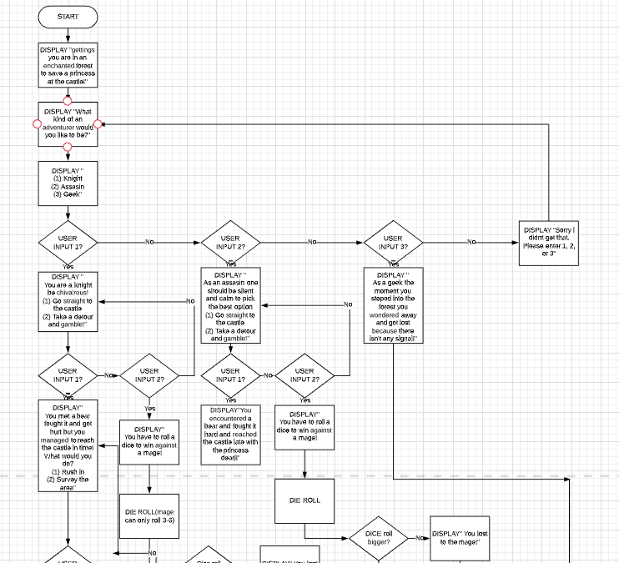

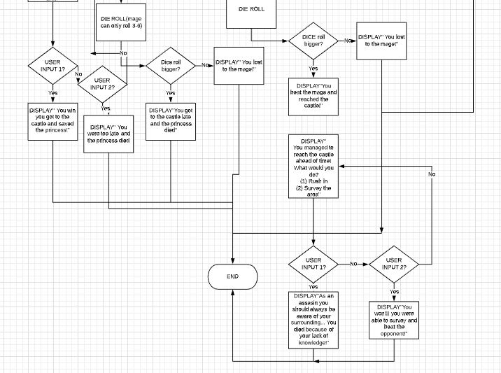

|  |  |  |
| --- | --- | --- |
| Test Case setting | Player input | Expected result |
| DISPLAY “  Greetings you’re in an enchanted forest to save a princess at the castle!  What kind of an adventurer would you like to be? (1) Knight  (2) Assassin  (3) geek  “ | 1 | DISPLAY “  You’re a knight, be chivalrous!  (1) go straight to the castle  (2) take a detour and gamble” |
| DISPLAY “  Greetings you’re in an enchanted forest to save a princess at the castle!  What kind of an adventurer would you like to be? (1) Knight  (2) Assassin  (3) geek  “ | 2 | You are an assassin! BE CUNNING!  (1) Take the road that leads straight to the castle!  (2) Find a different path through the forest! |
| DISPLAY “  Greetings you’re in an enchanted forest to save a princess at the castle!  What kind of an adventurer would you like to be? (1) Knight  (2) Assassin  (3) geek  “ | 0 | I dont get you...  Your score is 1  Atleast you tried!  Do you want to play again (Enter 1 for yes)?” |
| DISPLAY “  Greetings you’re in an enchanted forest to save a princess at the castle!  What kind of an adventurer would you like to be? (1) Knight  (2) Assassin  (3) geek  “ | 1.0 | You are a knight! BE CHIVALROUS!  (1) Take the road that leads straight to the castle!  (2) Find a different path through the forest! |
| Do you want to play again (Enter 1 for yes)? | 1 | You are in an enchanted forest to save a princess in a castle!  What kind of adventurer would you like to be?  (1) Knight  (2) Assassin  (3) Geek  Your choice: |
| Do you want to play again (Enter 1 for yes)? | 0 | flip1 ~/CS161/Assignments/Assignment2 578$ |
| You are a knight! BE CHIVALROUS!  (1) Take the road that leads straight to the castle!  (2) Find a different path through the forest! | 2 | You took the forest path and marched through swamps...  When you got to the castle..  You heard a loud bang, and when you looked for the room you see that a troll is eating her from the head down...  ONLY IF YOU WERE A TINY BIT FASTER!  Your score is 10  Do you want to play again (Enter 1 for yes) ? |
| You are a knight! BE CHIVALROUS!  (1) Take the road that leads straight to the castle!  (2) Find a different path through the forest! | 3 | Wrong choice buddy...  Your score is 10  Do you want to play again (Enter 1 for yes)? |