**Describe**

Problem:

Understand: We have to ask the user to input a string and allow them to choose the 5 operations that they would like to perform on their string until they would like to quit then the program will quit.

Assumptions:

* The user will enter something that has lesser than 1027 characters
* The user might enter an option that is invalid for the 5 operations
* The user will enter an integer value for operation options

Goals:

* 1st function – count if vowels and consonants equal
* 2nd function – changes a character to another
* 3rd function – prints out the array backwards
* 4th function – checks frequency of characters of array 2 that appears at array 1
* 5th function – Caesar shift

**Flowchart**

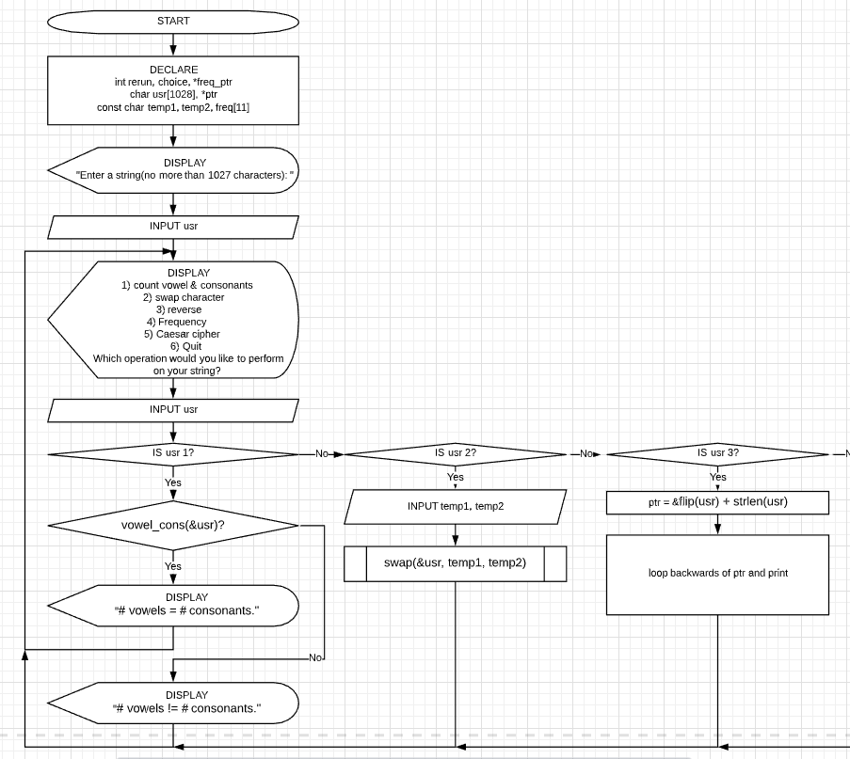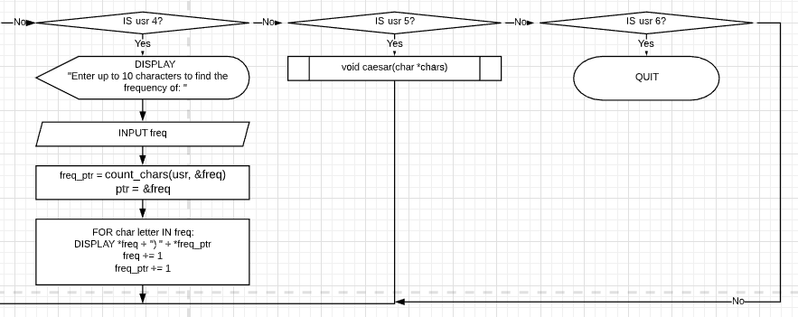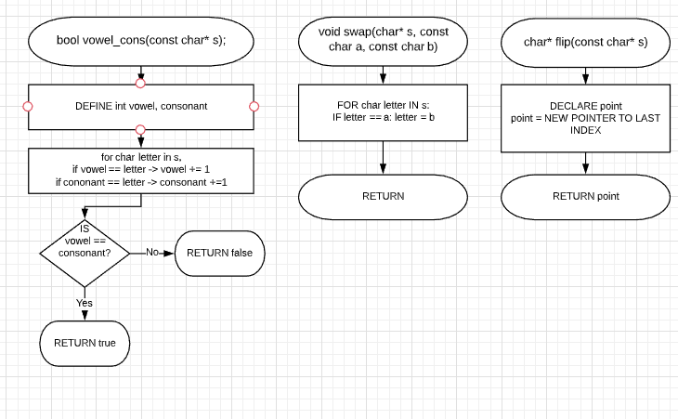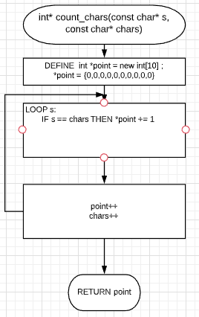

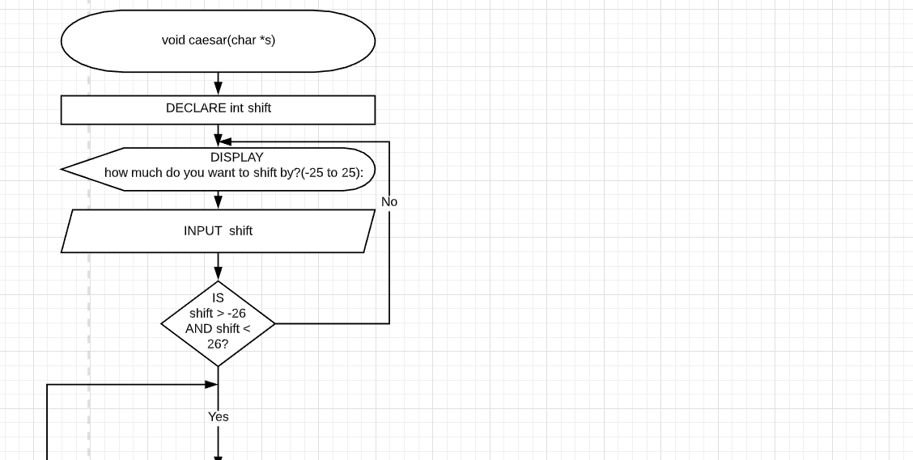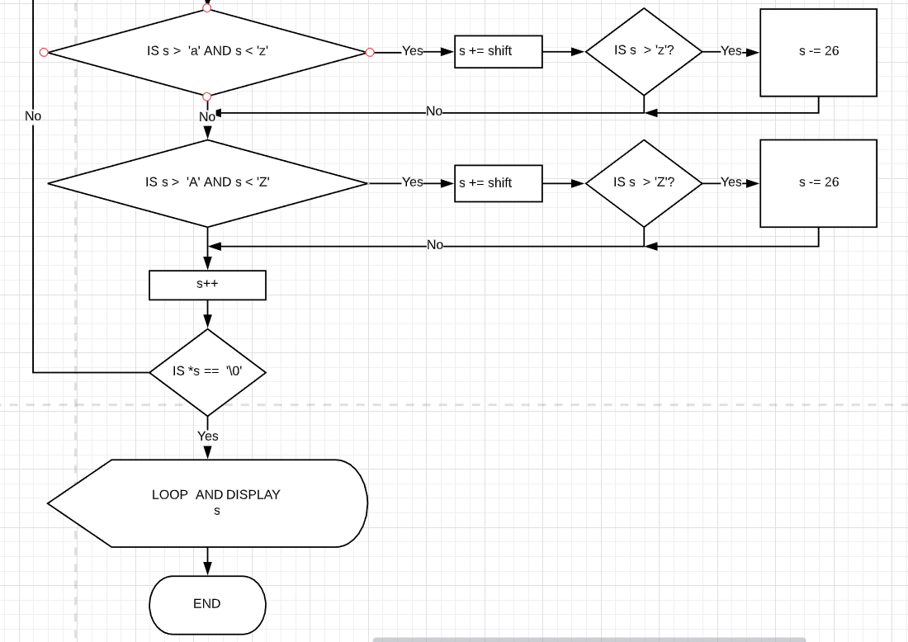

**Test case**

|  |  |  |
| --- | --- | --- |
| DISPLAY | USER INPUT | EXPECTED |
| DISPLAY "Enter a string(no more than 1027 characters): " | “ “ | DISPLAY  1) count vowel & consonants  2) swap character  3) reverse  4) Frequency  5) Caesar cipher  6) Quit  Which operation would you like to perform on your string? (Every output performed will be “ “ because no letters can be used to operate on) |
| DISPLAY "Enter a string(no more than 1027 characters): " | “AAAAAAAAAAAAAAAAAAAAAAAAAAAAAAAAAAAAAAAAAAAAAAAAAAAAAAAAAAAAAA” (1028 CHARACTERS) | DISPLAY  1) count vowel & consonants  2) swap character  3) reverse  4) Frequency  5) Caesar cipher  6) Quit  Which operation would you like to perform on your string? |
| DISPLAY  1) count vowel & consonants  2) swap character  3) reverse  4) Frequency  5) Caesar cipher  6) Quit  Which operation would you like to perform on your string? | 1 | DISPLAY  vowel_cons(&usr)? "# vowels = # consonants.": # vowels != # consonants." |
| DISPLAY  1) count vowel & consonants  2) swap character  3) reverse  4) Frequency  5) Caesar cipher  6) Quit  Which operation would you like to perform on your string? | 0 | DISPLAY  1) count vowel & consonants  2) swap character  3) reverse  4) Frequency  5) Caesar cipher  6) Quit  Which operation would you like to perform on your string? |
| DISPLAY  1) count vowel & consonants  2) swap character  3) reverse  4) Frequency  5) Caesar cipher  6) Quit  Which operation would you like to perform on your string? | 6 | exit |
| DISPLAY  1) count vowel & consonants  2) swap character  3) reverse  4) Frequency  5) Caesar cipher  6) Quit  Which operation would you like to perform on your string? | 2 | DISPLAY  Swapped string |
| DISPLAY  1) count vowel & consonants  2) swap character  3) reverse  4) Frequency  5) Caesar cipher  6) Quit  Which operation would you like to perform on your string? | 3 | DISPLAY  Reversed string |
| DISPLAY  1) count vowel & consonants  2) swap character  3) reverse  4) Frequency  5) Caesar cipher  6) Quit  Which operation would you like to perform on your string? | 4 | DISPLAY  “Enter up to 10 characters to find the frequency of: " |
| DISPLAY  1) count vowel & consonants  2) swap character  3) reverse  4) Frequency  5) Caesar cipher  6) Quit  Which operation would you like to perform on your string? | 5 | DISPLAY  how much do you want to shift by?(-25 to 25): |
| DISPLAY  how much do you want to shift by?(-25 to 25): | -26 | DISPLAY  how much do you want to shift by?(-25 to 25): |
| DISPLAY  how much do you want to shift by?(-25 to 25): | -25 | LOOP AND DISPLAY  s |
| DISPLAY  how much do you want to shift by?(-25 to 25): | 0 | LOOP AND DISPLAY  s |