API description template

*Please see the template tables (for each verb) that you can use to create the API specification that fits the given API (posted on Blackboard). To see an example for each Verb, see the result for the Server-side homework week 1.*

*Instead of this document and templates, you can use other tools to create the API specification as well. An example of such a tool is the Swagger Editor (*[*https://editor.swagger.io/*](https://editor.swagger.io/)*).*

Table of Contents

1. Class diagram 3

2. GET requests 4

3. POST requests 5

4. PUT requests 6

5. DELETE requests 7

# Class diagram

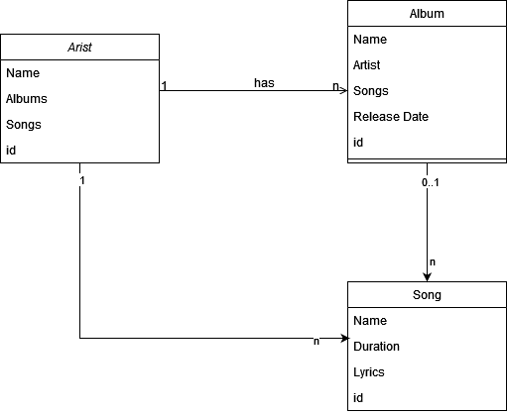

Alle classes hebben een unieke ID.  
  
Een artiest heeft een naam, albums, nummers en een unieke ID.  
Een artiest kan 0 of meer albums hebben en 0 of meer nummers.  
Een nummer kan bij 0 of 1 album horen.  
Een album kan meerdere nummers hebben.

# GET requests

Template GET table:

|  |  |  |  |  |
| --- | --- | --- | --- | --- |
| **GET** | **/api/artists/{id}** | | | |
| Gets one artist, based on given id | | | | |
|  | | | | |
| **Parameters:** | | **Name** | **Type** | **Description** |
| *\*required* | | Id * | path | Id of artist to find |
| **Responses:** | | **Code** | **Description / example if successful** | |
|  | | 200 | Sends the artist class as JSON of 1 artist | |
| 404 | Sends JSON with 404 error code | |

|  |  |  |  |  |
| --- | --- | --- | --- | --- |
| **GET** | **/api/albums/{id}** | | | |
| Gets one album, based on given id | | | | |
|  | | | | |
| **Parameters:** | | **Name** | **Type** | **Description** |
| *\*required* | | Id * | path | Id of album to find |
| **Responses:** | | **Code** | **Description / example if successful** | |
|  | | 200 | Sends the album class as JSON of 1 album | |
| 404 | Sends JSON with 404 error code | |

|  |  |  |  |  |
| --- | --- | --- | --- | --- |
| **GET** | **/api/songs/{id}** | | | |
| Gets one songs, based on given id | | | | |
|  | | | | |
| **Parameters:** | | **Name** | **Type** | **Description** |
| *\*required* | | Id * | path | Id of song to find |
| **Responses:** | | **Code** | **Description / example if successful** | |
|  | | 200 | Sends the song class as JSON of 1 song | |
| 404 | Sends JSON with 404 error code | |

# POST requests

Template POST table:

|  |  |  |  |  |
| --- | --- | --- | --- | --- |
| **POST** | **/api/artists** | | | |
| Adds an artist with the given name, albums and songs will be empty, id is automatically generated | | | | |
|  | | | | |
| **Parameters:** | | **Name** | **Type** | **Description** |
| * *required* | | Name * | body | The artist is added. Could be send in JSON or Plain based on the content-type header |
| **Responses:** | | **Code** | **Description / example if successful** | |
|  | | 201 | Created successfully, will send a response in plain or JSON based on the content-header with a response code | |
| 500 | If something goes wrong with executing this request it will send a JSON or plain text response with the error code. | |

|  |  |  |  |  |
| --- | --- | --- | --- | --- |
| **POST** | **/api/albums** | | | |
| Adds an album with the given name, only JSON will be accepted | | | | |
|  | | | | |
| **Parameters:** | | **Name** | **Type** | **Description** |
| * *required* | | Name * | body | The album name |
| * *required* | | Artist * | body | The artist id which has to be linked to the album |
| * *required* | | Release Data | body | The release date of the album |
|  | | Song ids | body | Song ids to directly add to the album, the songs can be added later with a put request |
| **Responses:** | | **Code** | **Description / example if successful** | |
|  | | 201 | Created successfully, will send a response in plain or JSON based on the content-header with a response code | |
| 500 | If something goes wrong with executing this request it will send a JSON or plain text response with the error code. | |

|  |  |  |  |  |
| --- | --- | --- | --- | --- |
| **POST** | **/api/songs** | | | |
| Adds a song with the given name, duration and lyrics | | | | |
|  | | | | |
| **Parameters:** | | **Name** | **Type** | **Description** |
| * *required* | | Name * | body | Name of the songs |
| * *required* | | Duration | body | Duration of the song in seconds |
|  | | Lyrics | body | Lyrics of the song, not required, can also be added later. |
| **Responses:** | | **Code** | **Description / example if successful** | |
|  | | 201 | Created successfully, will send a response in plain or JSON based on the content-header with a response code | |
| 500 | If something goes wrong with executing this request it will send a JSON or plain text response with the error code. | |

# PUT requests

*Add your requests here. Copy-paste the template for each different request.*

Template PUT table:

|  |  |  |  |  |
| --- | --- | --- | --- | --- |
| **PUT** | **/url/{pathParam}** | | | |
| [description here. Explain what the request does when executed successfully.] | | | | |
|  | | | | |
| **Parameters:** | | **Name** | **Type** | **Description** |
| *Add a * to the name of required parameters.* | |  | (path / body) |  |
|  | (path / body) |  |
|  | (path / body) |  |
|  | (path / body) |  |
|  | (path / body) |  |
| **Responses:** | | **Code** | **Description / example if successful** | |
|  | |  |  | |
|  |  | |
|  |  | |
|  |  | |
|  |  | |

# DELETE requests

*Add your requests here. Copy-paste the template for each different request.*

Template PUT table:

|  |  |  |  |  |
| --- | --- | --- | --- | --- |
| **DELETE** | **/url/{pathParam}** | | | |
| [description here. Explain what the request does when executed successfully.] | | | | |
|  | | | | |
| **Parameters:** | | **Name** | **Type** | **Description** |
| *Add a * to the name of required parameters.* | |  | path |  |
|  | path |  |
|  | path |  |
|  | path |  |
|  | path |  |
| **Responses:** | | **Code** | **Description / example if successful** | |
|  | |  |  | |
|  |  | |
|  |  | |
|  |  | |
|  |  | |