Summary: Take questions like

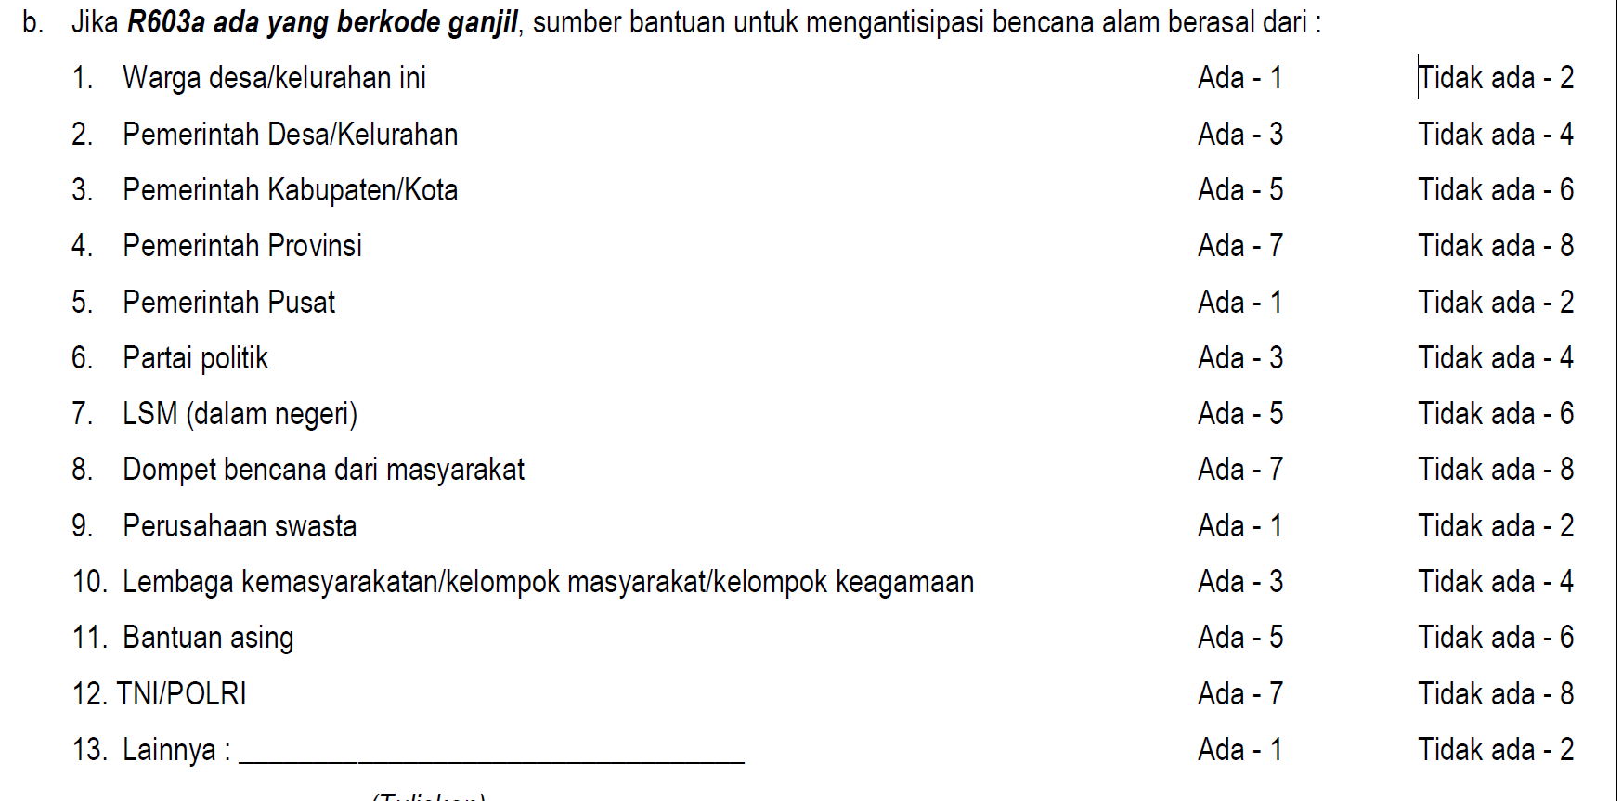

Input

NOTE: No column of variables just values

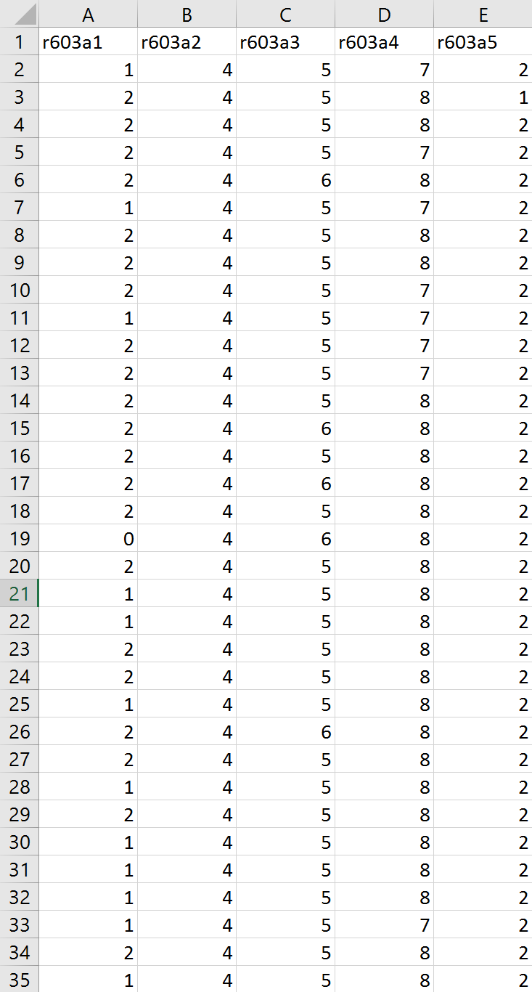

Output: Boolean True/False

1 = Yes

0= No

