Summary: Will take question like

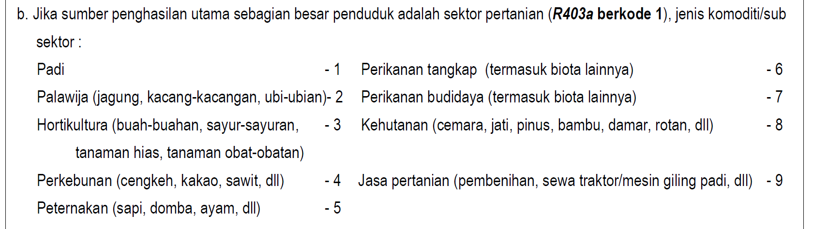

and output a percentage chart based on the amount of time a number occurs.

Input Rules

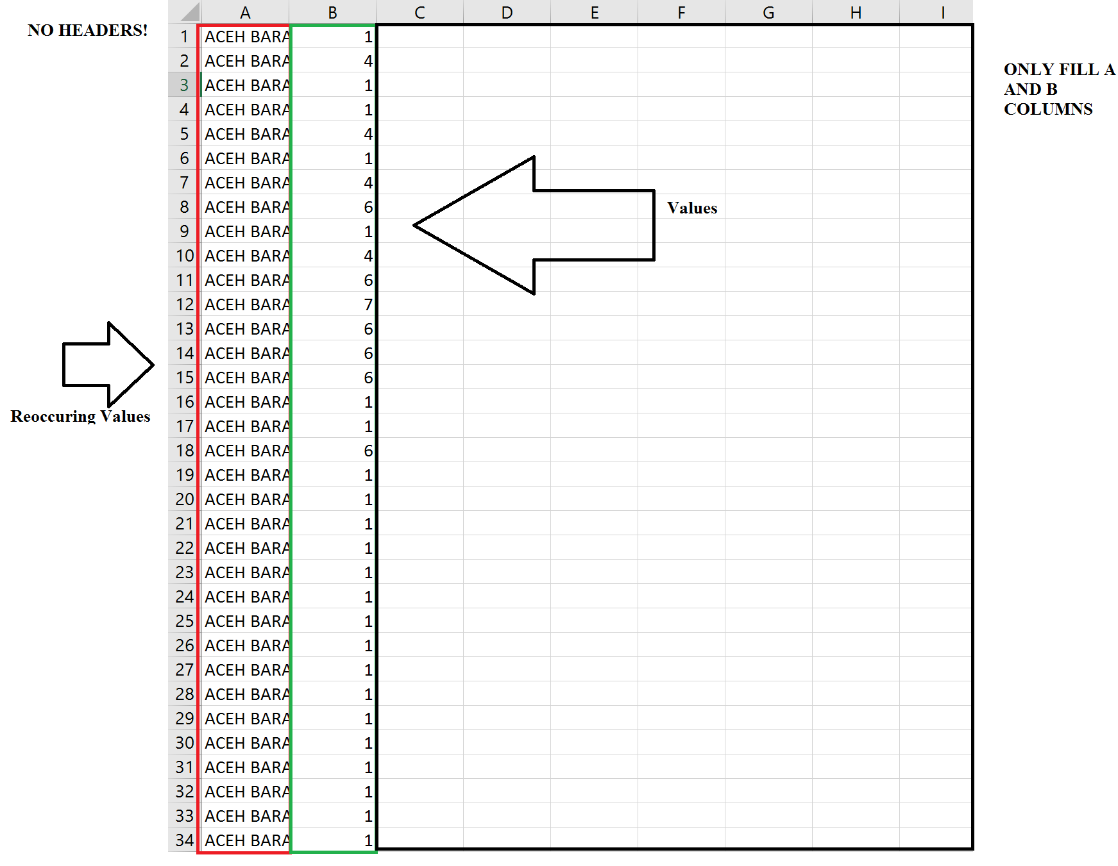

Make sure your column values don’t occur again example:

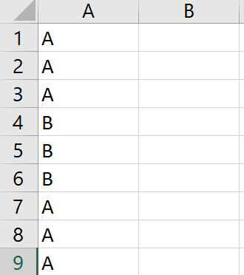

The best way to avoid this is to sort your values in Alphabetical Order

Output:

