Instructions: Place data needed in “input.csv” under this format

NOTE: Make sure your row or column variables don’t have any **commas** in them. Code is dynamic, place any amount of rows and columns as long as there are enough numbers within the row x column area

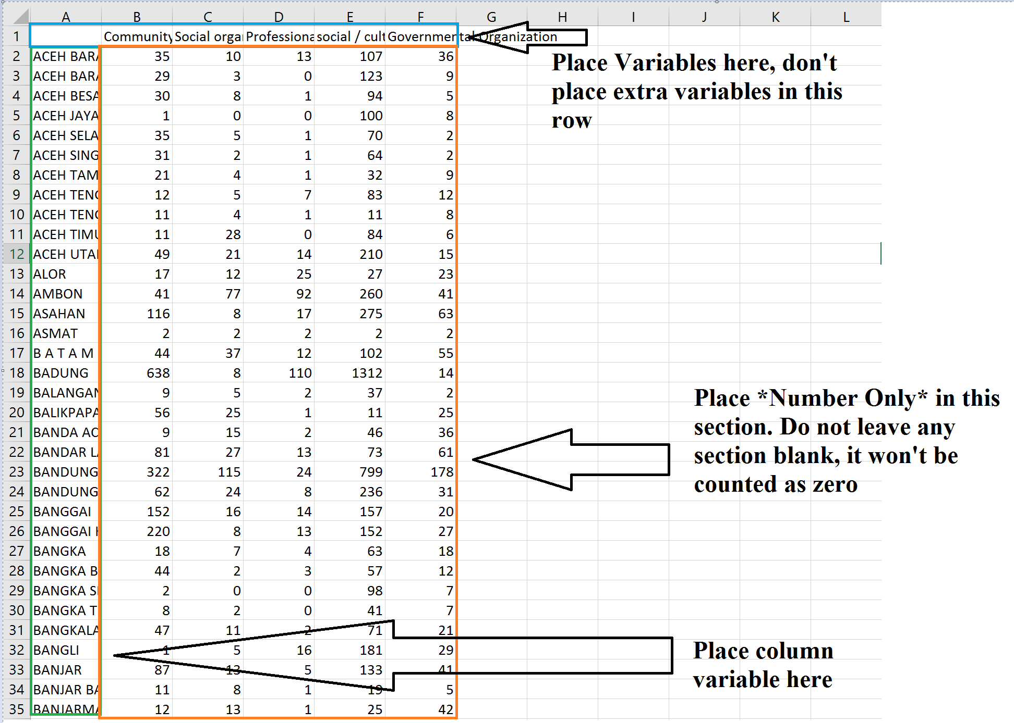

Will work for discrete or continous variable

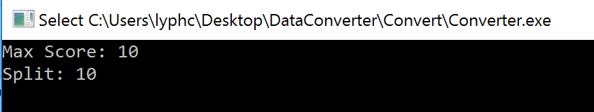

Input your max score and your split to get a proper percentile based on your input

Ex 10, 10 points: (1,2,3,4,5,6,7,8,9,10)  
  
Ex 5,3 points: (1,3,5)

Output

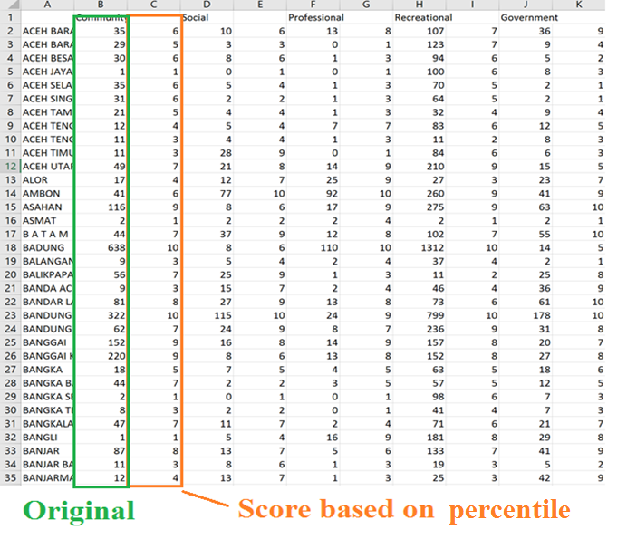

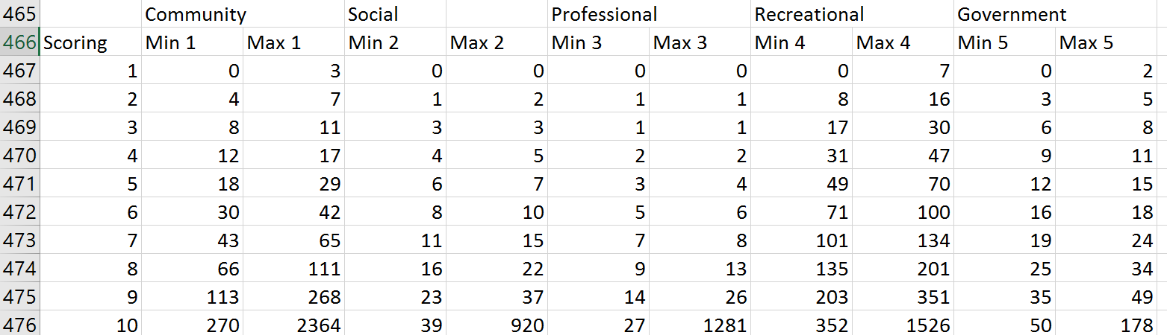

Min/Max score on each percentile