CHUONG 3: TRIEN KHAI KHO DU LIEU VA TRUC QUAN HOA

3.1. Kien truc Data Warehouse (DWH)
He thong ap dung mo hinh Star Schema, gom Fact_Sales (ban hang) va cac Dim_Product, Dim_Customer, Dim_Time.

3.2. Quy trinh ETL
Trich xuat 5000 don hang tu WebHoaTuoiDb sang HoaTuoi_DWH qua Stored Procedure.

3.3. Bieu do thong ke (MÃ´ phá»ng Power BI)

Doanh thu theo thang
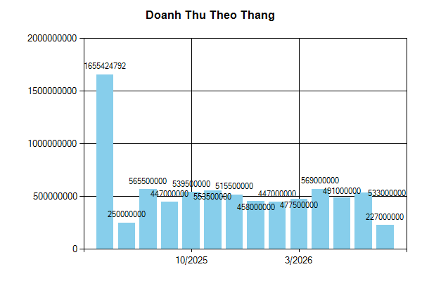

Top 5 Hoa Ban Chay
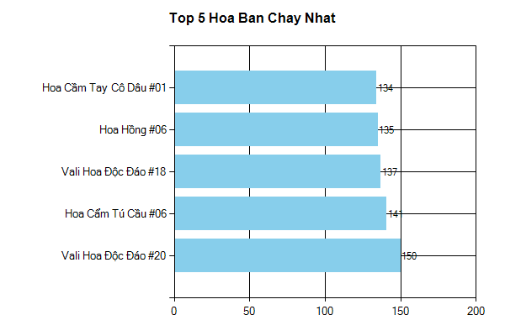

Phan Khuc Khach Hang
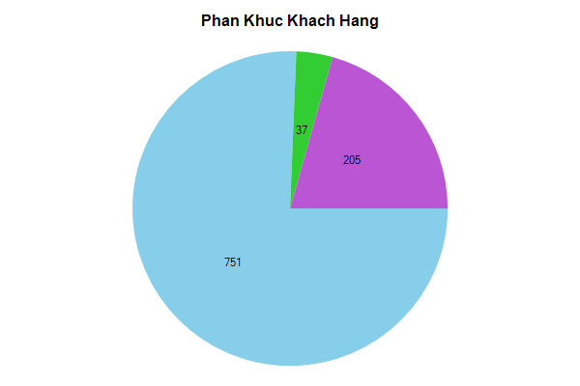

CHUONG 4: KET LUAN

4.1. Ket qua dat duoc
Da hoan thanh tich hop Kho du lieu vao he thong ban hoa tuoi, ho tro tot viec ra quyet dinh.

