Availability to food drives phenological changes in pygmy blue whales in the middle of the Indian Ocean

Junlin Huang, Emmanuelle Leroy, Gary Truong, Tracey Rogers

Abstract

Introduction

Material and Methods

Results

3.1 Overall trend of the DG whale calls and environmental factors

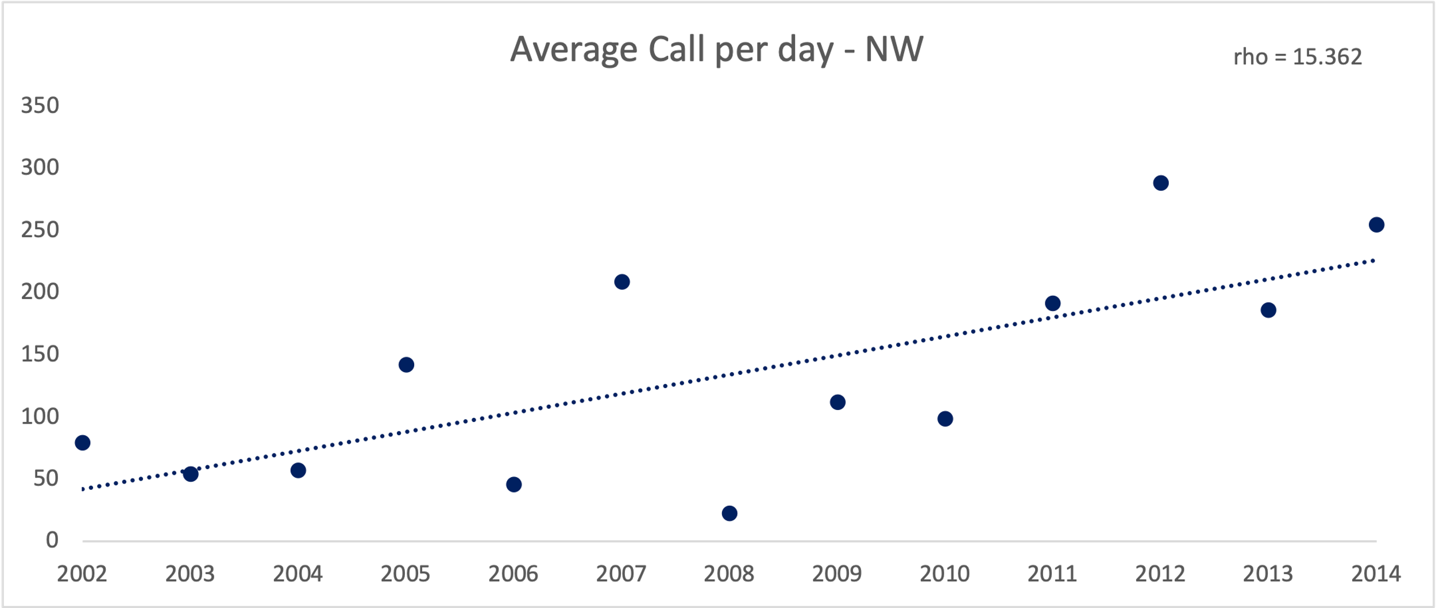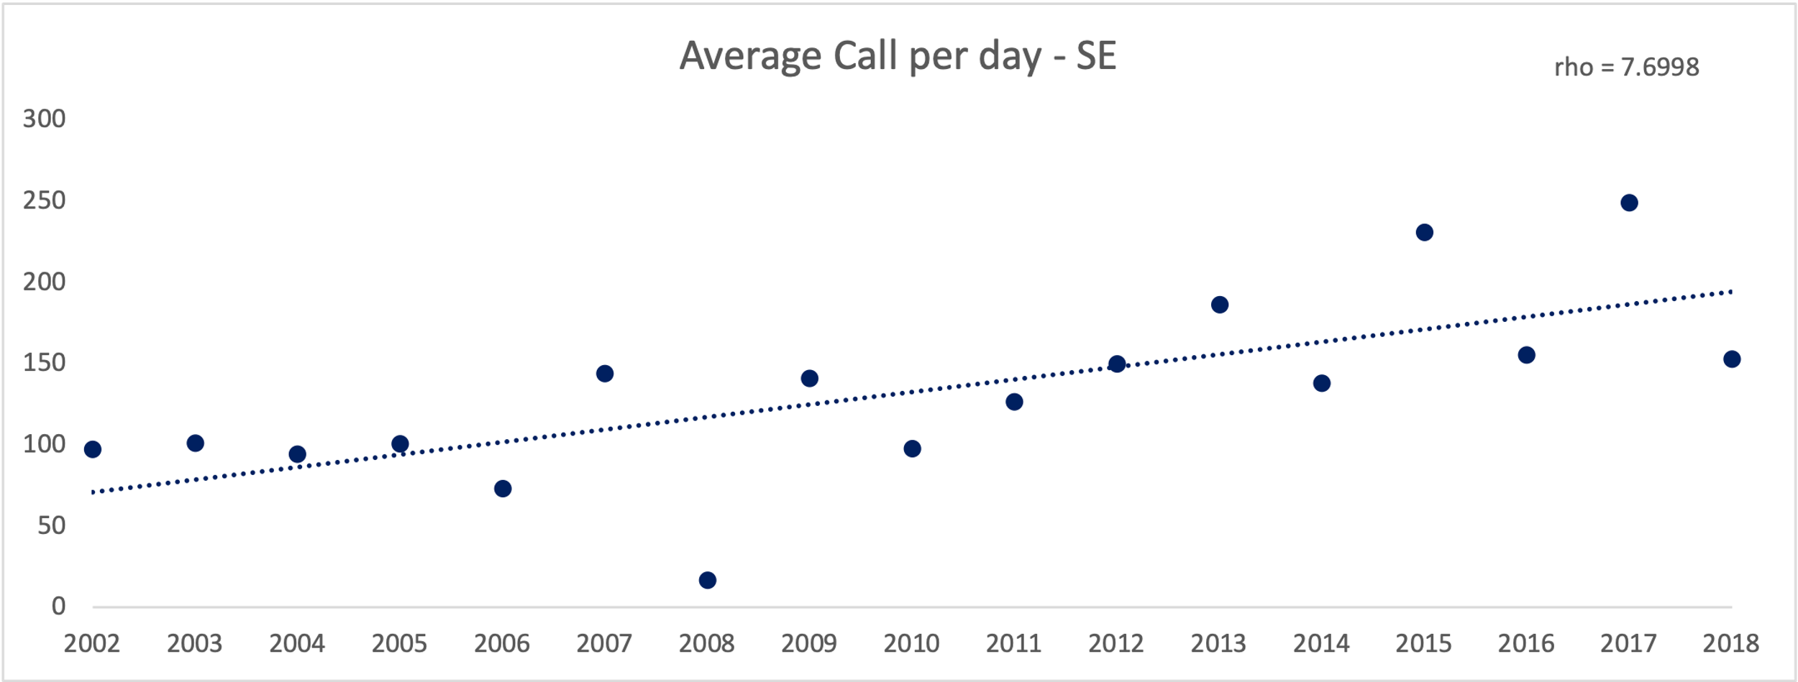

In total, around 500,000 DGW calls are recorded in the NW site over twelve years and more than 700,000 DGW calls are detected in the SE site during the 16-year period. The average call per hour is higher in the SE site (5.57 per hour) than the NW site (5.27 per hour). Increasing trends of the DGW calls are observed at both the northwest site and the southeast site through the entire study period. The increasing rate is higher at the northwest site (increasing 15.4 calls per day per year on average) comparing to the southeast site (7.7 calls per day per year on average). It is noticeable that in the year of 2008, at both sites the least average DGW calls were recorded as well as total number of calls among the entire study period.

|  |  |  |
| --- | --- | --- |
|  | NW | SE |
| Mean SST | 0.0154 | 0.0187 |
| Min SST | 0.0183 | 0.0388 |
| Mean | -0.0025 | -0.0007 |

At the same time, average SST and minimum SST have overall increasing trends at both sides of Diego Garcia. The mean concentration of chl-a has been more stable with a slight decreasing trending at either site.

(cap) Mean whale presence over the entire study period at both sites. Missing data is not taken into account.

The mean peak whale presence is higher in the SE site than in the NW site. There are more whales at the NW site in the warmer season (June to October). In the cooler time of November to May, there are more whale presence in the SE site.

3.3 Correlation with SST and chl-a concentration

3.3 Peak seasons of the DG whale calls

At the NW site, we detected 15 peak seasons over 13 years and the average time period is 74 days. The end date of the last peak cannot be determined due to missing data. Most peaks started between October to December and finished in January or February. However, two extra peaks were found in 2005 and 2010 respectively and one extra peak was detected in 2006,2010 and 2014. Peak seasons are in similar patterns during 2002 to 2004. There are more and longer peak seasons in 2005. However, information is limited in 2006 and 2007 due to missing data. There is no peak found in 2008. In 2009 and 2010, peaks were similar to the previous pattern. Longer and stronger peak seasons were observed from 2011 and 2013. The peak season analysis is not complete in 2014 due to missing data.

At the SE site, 24 peak seasons are identified with the 17 years and the mean duration is 62 days.

Discussion

4.1

4.2 Assumption of migrating reasons

On the NW site, the yearly average chl-a concentration is 0.14 mg/m3 and on the SE site, the yearly average is 0.13 mg/m3. The average concentration on the SE site varies between seasons while on the NE site the difference is not as significant.

Acknowledgement

References

Supporting Information