Figures –

Fig 1 Map of the study area

Fig 2 Average Chagos whale call per day on the NW and SE site in Diego Garcia over the study period.

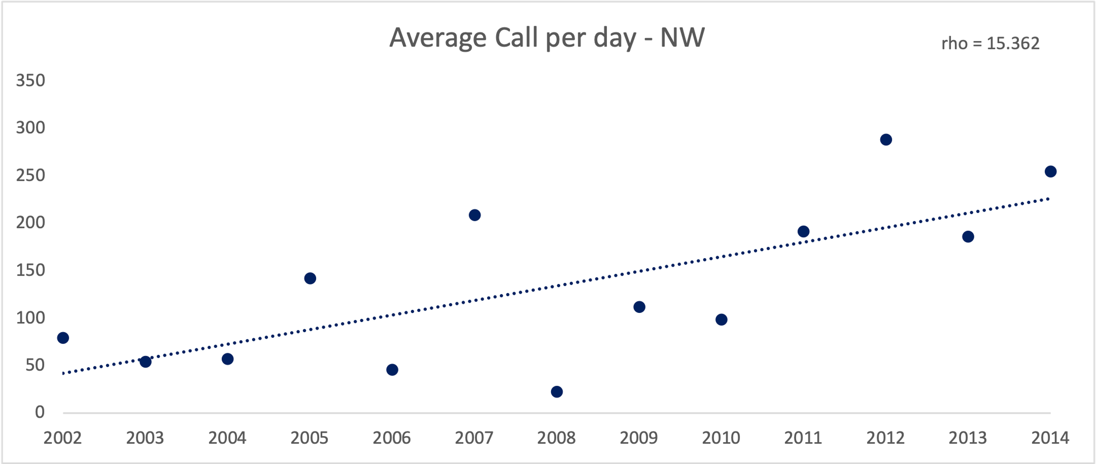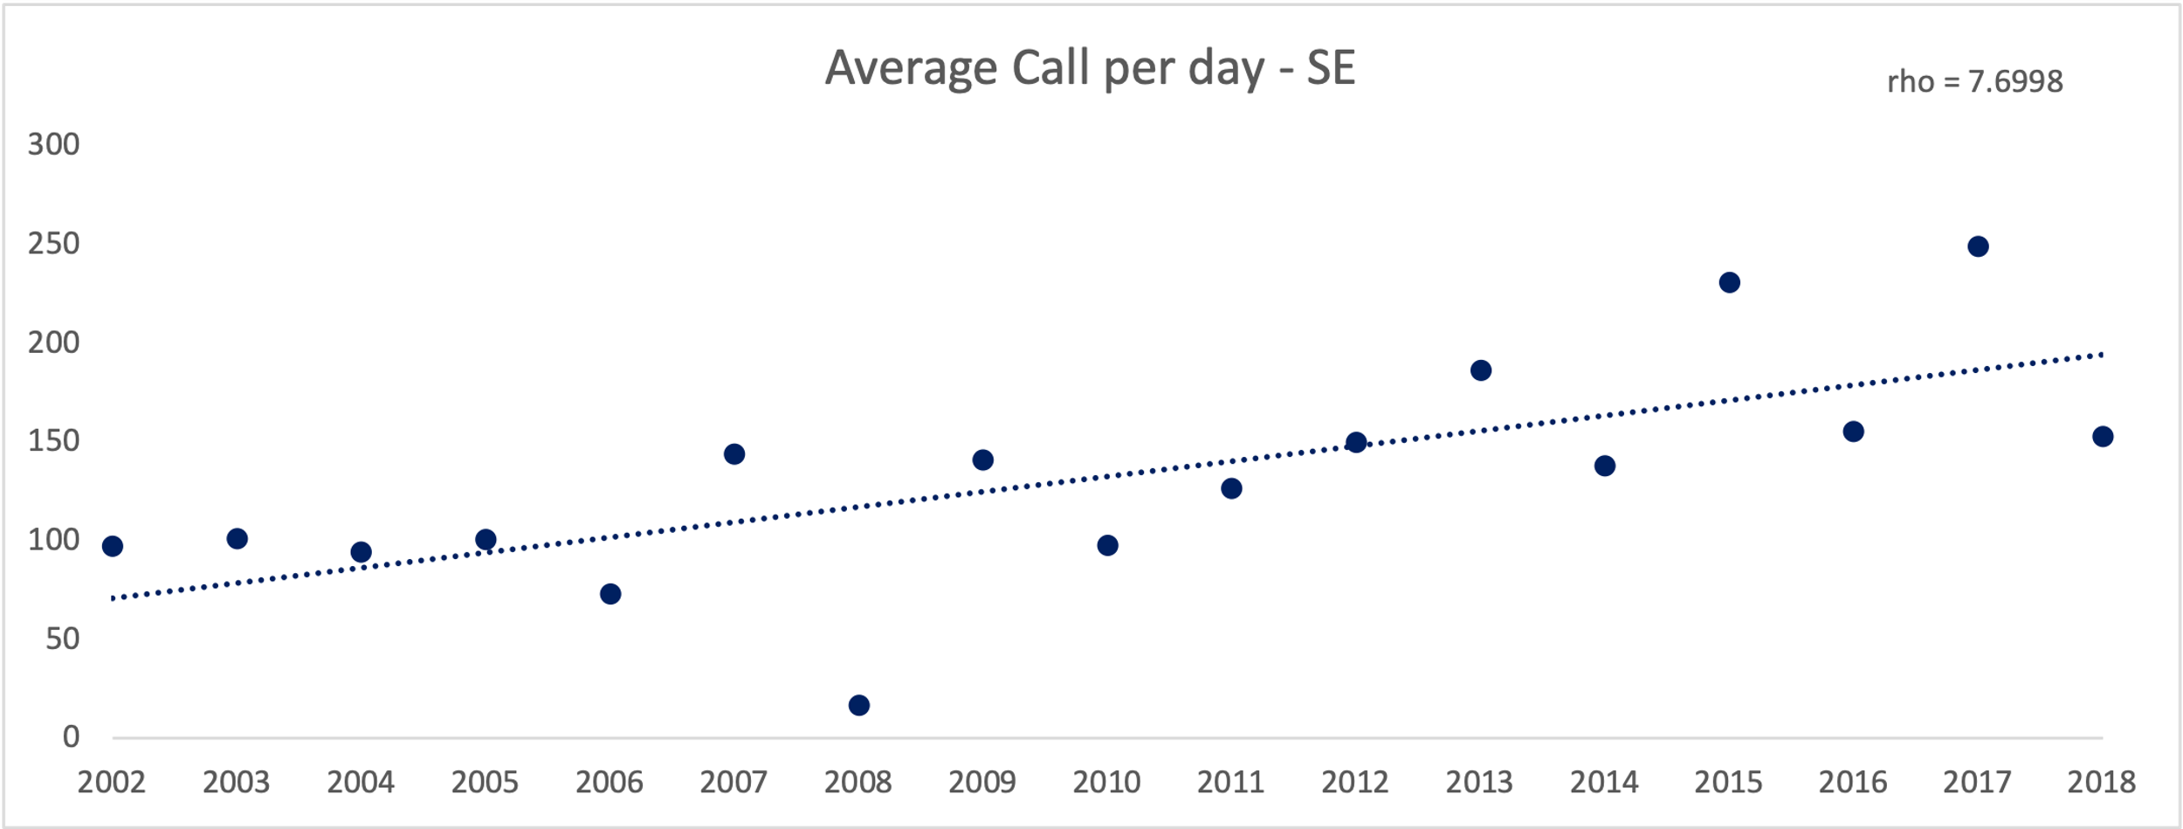

* Change to box plot
* Rho- change to spearman rank coefficient? Add p values

Fig 3 Mean Chagos whale presence on the SE and NW site for each eight-day period (46 bins) during the study period (2002- 2014 on the NW site, 2002- 2018 on the SE site). Vertical bars (blue bars for SE site, red bars for NW site) represent the average whale presence.

* Add variance bar
* Add N=? # of bins

Fig 4 Mean chagos whale presence

Fig 5 &6 Peak seasons at NW and SE

Figure 7 Migration chart

Fig 8 chlorophyte-a box plot

Discussion

* Summary
* Why our research is significant and meaningful
  + Long-term monitoring
  + By discussing how the changing environmental condition is affecting this large marine mammal migration pattern, as a case study to understand the large-scale marine eco system shifting
* Whale calls across all years
  + They are the residents of the CIO, comparing with other acoustic studies using CTBTO data
  + Increasing trend of whale calls (fig2), Consist with the Antarctic blue whale increasing trend (may add one more figure?)
* Seasonal variance of the Chagos whale
  + Why we use the two sites as acoustic independent site (fig 1)
  + Significant difference (add wilcoxon rank-sum test)
  + Where they are in the different seasons (consist with previous studies)
  + SST shifting vs chagos whale peak seasons (fig 5,8)
* Chagos whale vs chlorophyte-a concentration
  + Migration pattern (clockwise) (fig 8)
  + Chlorophyte-a variance across seasons on both sites (fig 7)
  + Correlation between the whale presence and chlorophyte-a, comparing with the SST (fig 4)
  + Possible feeding at the vicinity of se, but still low chlorophyte-a concentration + feeding on patches, why are they here all time?
  + Are they feeding here, or are they fasting? Blue whales feed sparsely rather than patches? (paper)
  + Where they may be during March – May Kimberley/Sri Lanka
  + Do they fast when they are singing?
  + Note that the chlorophyte-a is not measured at the same layer of blue whales, but they may be influencing the whales (paper)
  + Other indirect oceanographic features
* Potential impact
  + Wildlife conservation
  + Understand how marine environmental changes are influencing this vulnerable energetically costly animal