1.DOCKERFILE
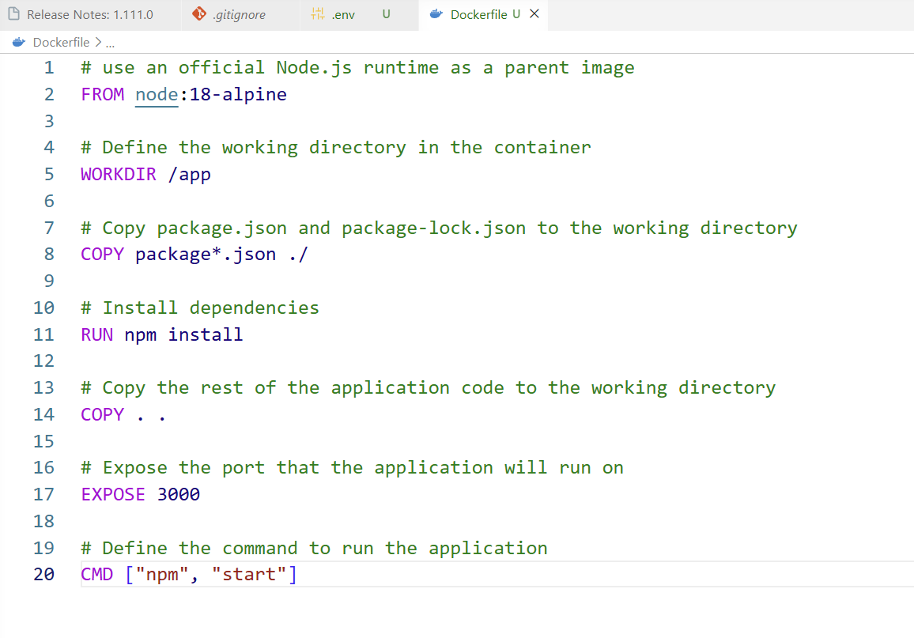
2. .ENV FILE
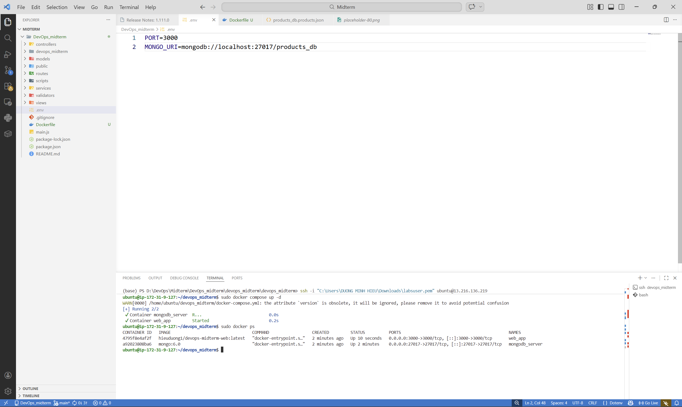

3. Terminal logs validating the successful local execution of the docker build and docker push commands.
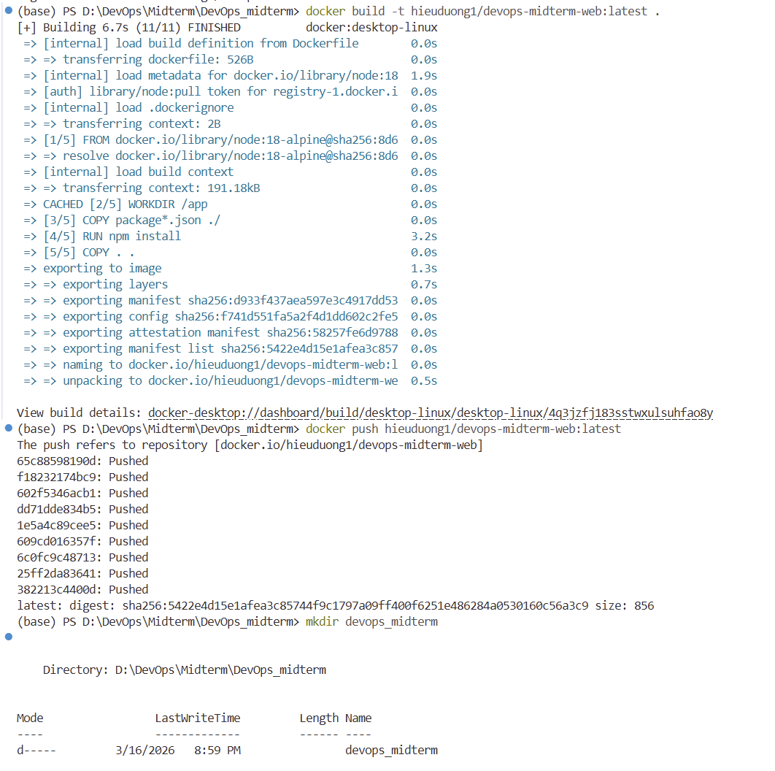

4. Verification of the published Docker image (hieuduong1/devops-midterm-web) hosted securely on the public Docker Hub registry.
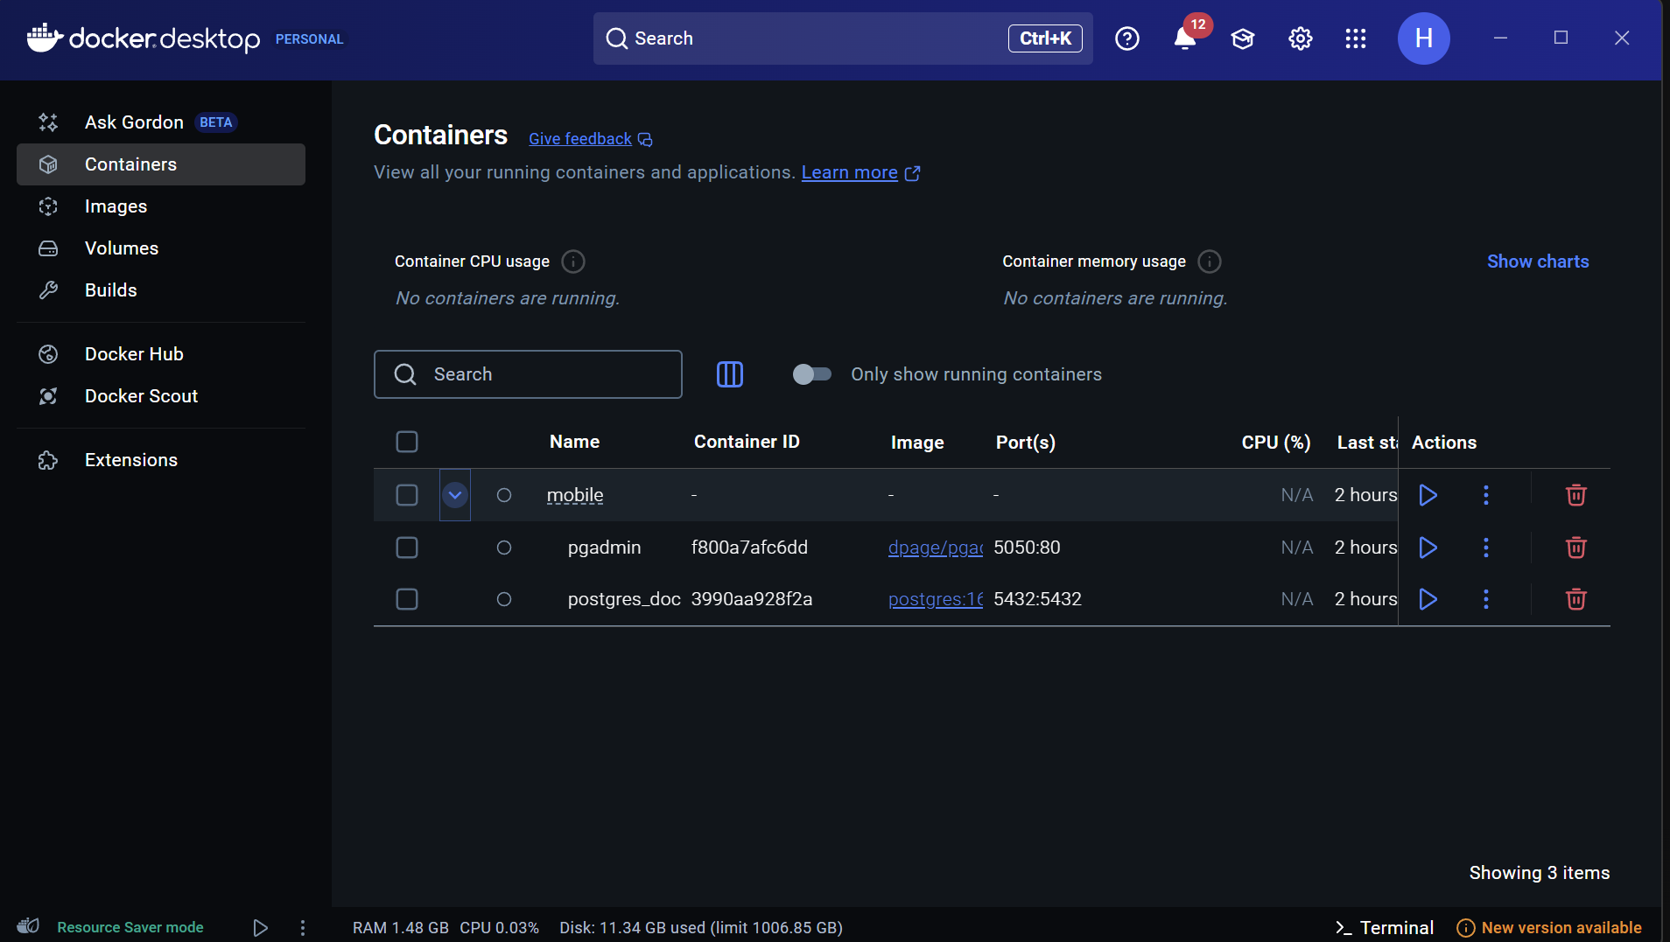
5. Detailed Docker Hub image management interface confirming the successful deployment and active status of the latest tag.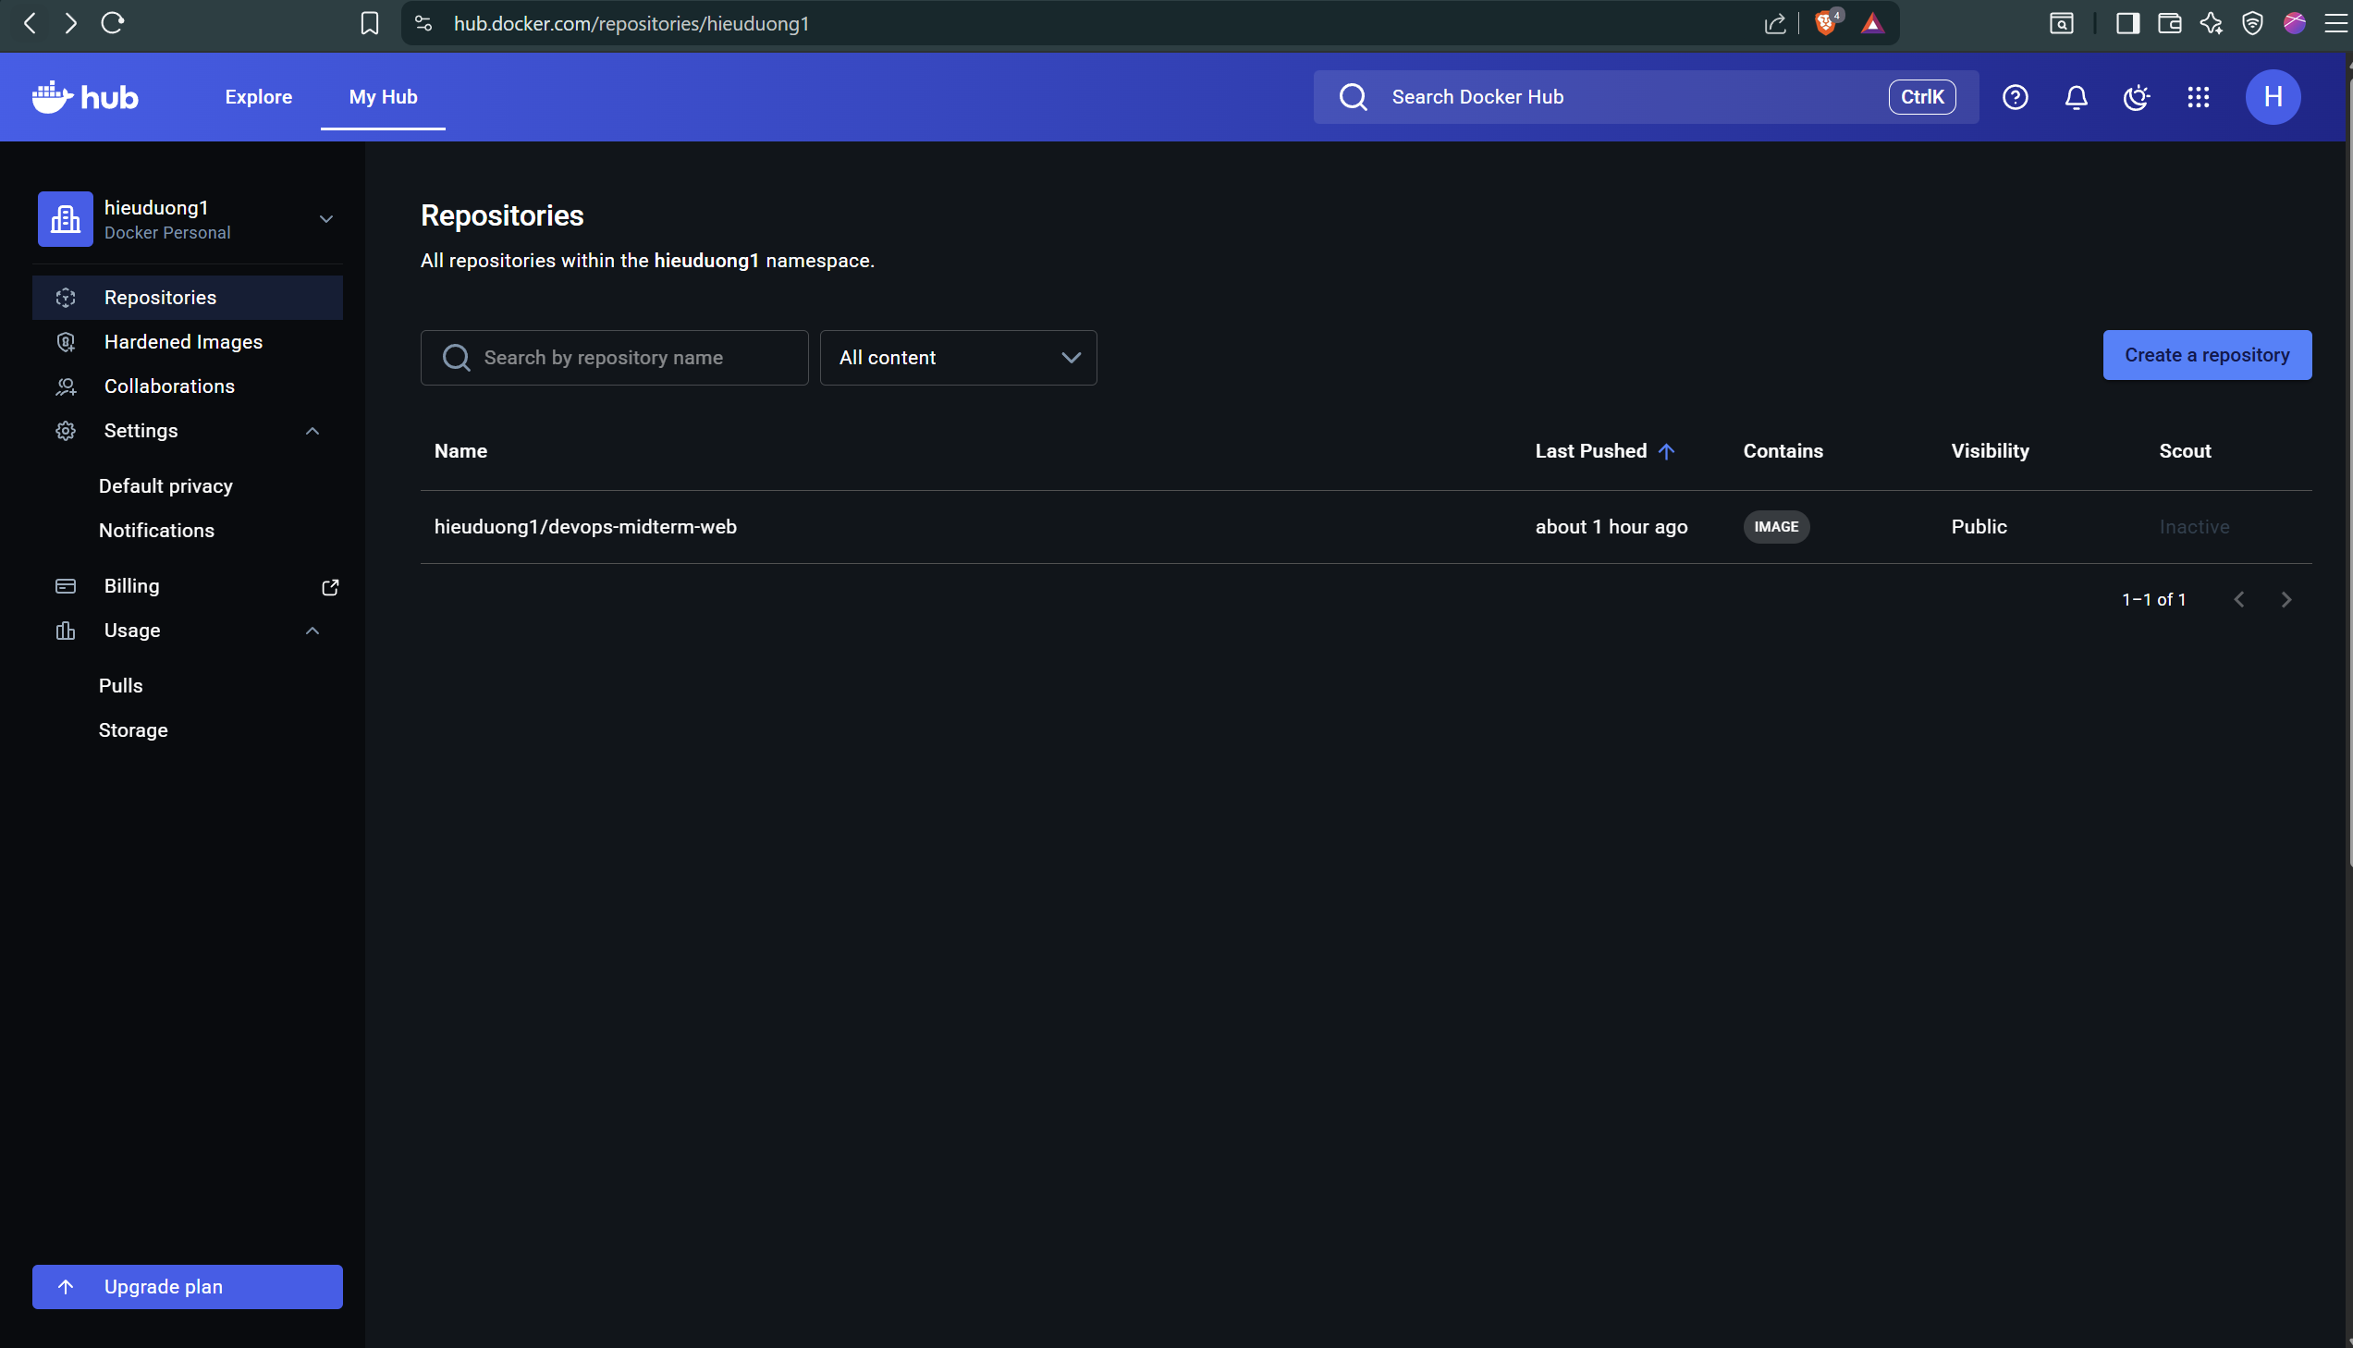
6. Terminal output demonstrating the successful initialization of containerized web and database services using the docker compose up -d command.
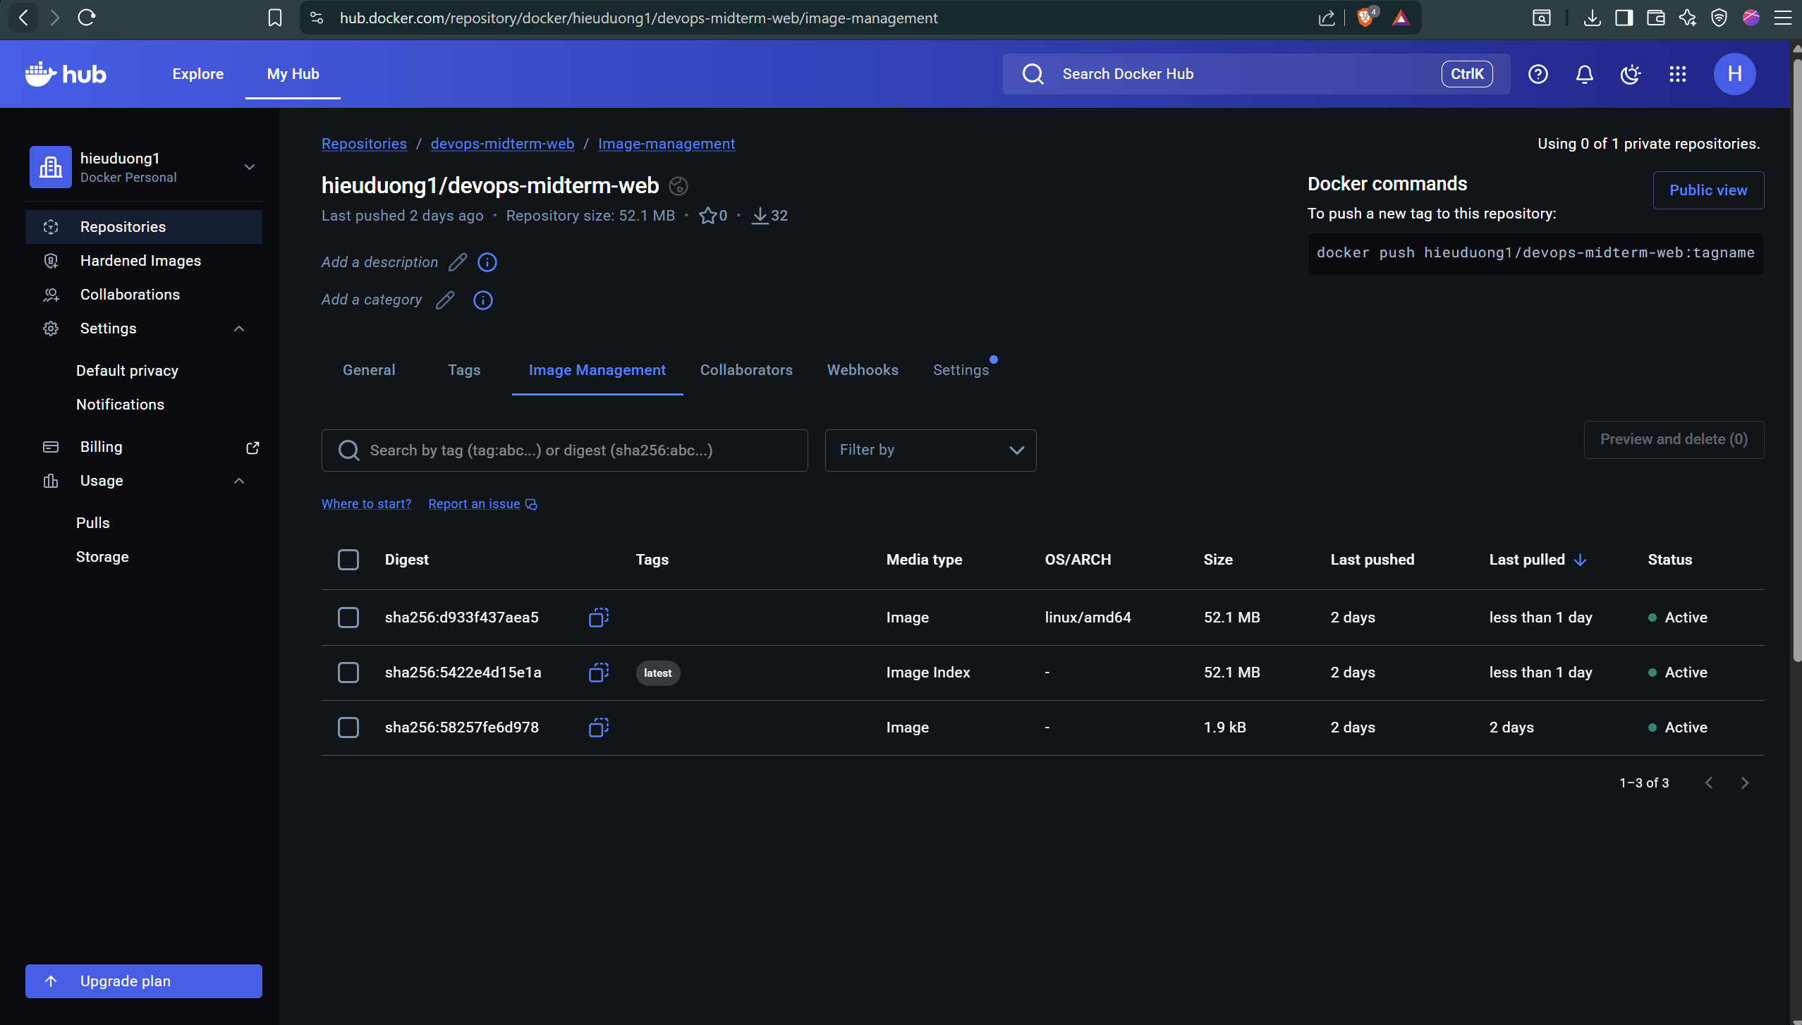
7. Verification of active container states, port mappings, and continuous uptime via the docker ps command.
8. Verification of persistent storage allocation using the docker volume ls command, confirming the successful creation of the dedicated database volume.
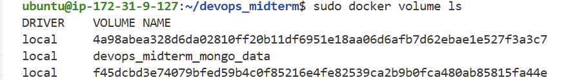
9. AWS Elastic IP configuration ensuring a persistent public IPv4 address for the EC2 instance to maintain stable DNS routing.
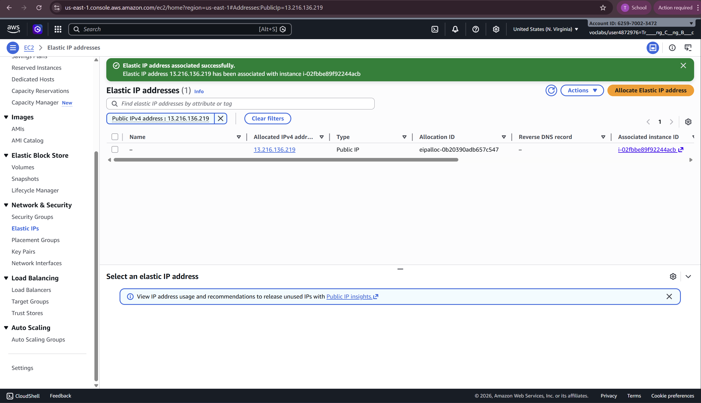

10. The live web application successfully serving database records and uploaded media content over a secure HTTPS connection (devoops.shop).
