# CHAPTER 3: SYSTEM DESIGN AND ANALYSIS

# 3.1 Introduction

Scientific research has been playing an important role in the progress and enrichment of new age technology. This chapter highlights a basic summary of the methodology that would be implemented for the proposed system with the goal of analysing and designing a feasible system that meets user requirements. The focus shall be on various tasks such as requirements elicitation, data analysis, logical and physical design, system architecture and may include sequence and class diagrams as well.

# 3.2 System Development Methodology

The end product of this research project is to come up with an automated COVID-19 scanning system which successfully reads passenger’s temperature and opens and closes the E-Gate if there temperature is normal. Therefore, prototyping would be suitable to implement as the system development methodology as these would allow rigorous testing and changes to be made onto the application up until it can be considered accurate and correct in its detections.

The advantages of prototyping that this project would like to leverage on include:

* High acceptance rate by the users
* Reduction of development time

The logics of the algorithm help to identify whether a passenger is okay to enter the country by checking their temperature. Further, logics and decision-making conditions help decide whether to open the gate or not, and when to alert the port health official. The user gets the status of their temperature and acceptance into the country after they scan their QR code, and their temperature is taken. First the IR sensor senses the passenger temperature. The output of the reading is in the analog form. The ADC of the Nodemcu converts the output of the IR sensor into digital form. The digital value is then sent to the google firebase through the Nodemcu WIFI module which relates to our database which decides whether the passenger temperature is okay and sends the feedback to passenger as a popup and as well acts on the decision, if the temperature is okay then the E-gate is opened. If not, an alert is sent to the port health officer and a buzzer goes off.

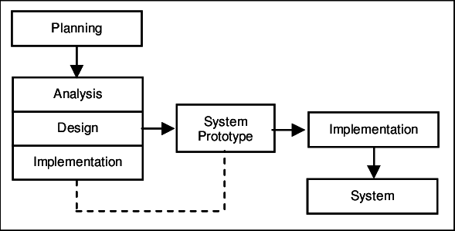

Figure 2: Prototyping

# 3.3 Feasibility Study

Before embarking on the development of what would be a useful application for passengers and port health officials, a feasibility study will to be conducted.

## 3.3.1 Economic Feasibility

This involves the assessment of the viability of this research in terms of costs and benefits before financial resources are allocated. Being a web application, it will need hosting. The application will be hosted in the airports servers with will help in reducing the hosting fees. Since the system does not consist of huge multimedia transfer such as music/videos, bandwidth required for its operation should be low. The system will follow free software standards thus no cost will be charged to the port health department. Bug fixes and maintenance tasks will have an associated cost. Besides the associated cost, there will be numerous benefits for the users with the ones coming up top being the ability to automate the passenger scanning process. From these, the project is economically feasible.

## 3.3.2 Legal Feasibility

This involves getting to know whether the project to be undertaken conforms to legal laws and ethical requirements. The project will use freely available development tools and provide the system as an open-source system. Due to its non-proprietary nature things such as software licenses will not be a bother thus ensuring development is done in an ethical manner without the use of cracked tools and such.

## 3.3.3 Technical Feasibility

In this study the focus will be on investigating whether there are adequate technical resources to carry out the project. It being a web-based application the following technologies will be used: HTML, CSS, Python, Sublime Text as well as diagram drawing tools for drawing wireframes and mock-ups such as Pencil software, flowcharts etc. All the technologies mentioned are freely available and the technical skills are manageable (Yarali, 2018).

Initially, the website will be hosted on an IoT platform which is a free web hosting service with a sufficient bandwidth and controlled traffic. All that is required of end users is a device with internet connectivity to fill there Jitenge form and the generated QR code. The project can thereby be considered technically feasible.

# 3.4 Requirements elicitation

## 3.4.1 Data collection

The data collection method to be implemented for this project is the use of the questionnaire with the goal of leveraging on its advantages such as the ability to reach a large number of people in a short period of time as well as in a cost effective manner and the ability to quantify the data and analyse it more scientifically and objectively to draw comparisons and contrasts albeit its demerits such as no way to tell how truthful a respondent is being (Yarali, 2018).

The JKIA port health have employees who work full time at the organization and in shifts for the 24 hours in a day. The use of questionnaires will therefore help in recording information from the employees. A subset of the population is therefore not required since the whole firm can participate in filling in the questionnaires.

Interviews are also used to obtain information directly from the passengers. The interviews will not be conducted for all the passengers since it would be time consuming. Instead, few passengers especially who are arriving in the country are interviewed with focus on their experience with the current scanning process and what they think of the proposed system.

## 3.4.2 Data and System Analysis

In this section, we get to see the responses and analysis of the employees. The graphing of the results is done using Excel.

Based on the data, 84% of the employees view that they need to have a new passenger scanning system in the airport.

*Does the department need a new scanning system?*

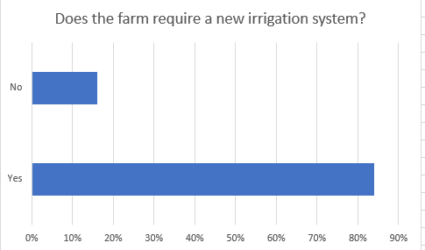

Figure 3: New passenger scanning system Statistics

In determining the results of the major concern in the current passenger scanning system, the following issues were mainly determined: time-consuming (32%), contact between the officer and passenger (46%), difficulty in operation due to system failure like internet loss and low battery tablets (16%) whereas other reasons took up a cumulative 6%. The graph below shows the graphed results:

Figure 4: Major Concerns in the Current Passenger Scanning System

In determining how many people were aware of IoT and its operations, only 26% had a familiarity in the topic whereas 8% had at least heard of the term before but were not aware of what it meant and 66% had no idea what the term was and how it operates.

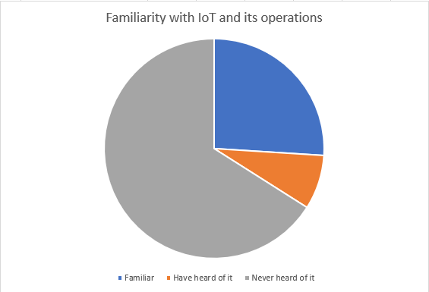

Figure 5: Familiarity with IoT and its Operations

In determining how important passenger scanning automation is in the airport, there were four main answers which were included in the closed questionnaire. In evaluating the results, it can be identified that 64% of the employees think it is very important to have a new automated scanning system, 22% think that it is important, 4% do not think it is that important and 10% are not sure of the new automated system.

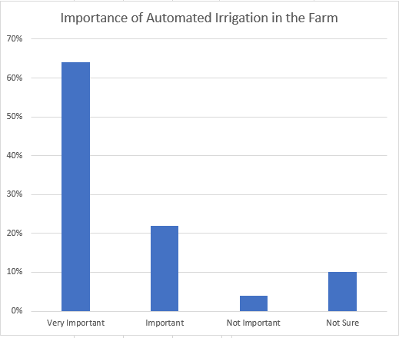

Figure 6: Importance of Automated Scanning system in the Airport

This is an important phase in the project as it shows just how relevant the project undertaken is.

# 3.5 System Requirements and Specification

System requirement specification gives the complete description of the behavior of the system developed. This includes specification of functional and non-functional requirements of the application. The interaction of the users with the application is represented with the help of use cases and their analysis. This also includes the description about feasibility, risk analysis and external interface requirements to accomplish this project.

## 3.5.1 Functional Requirements

The functional requirements will describe the features and functionality of the system. Functional requirements record the operation that must be done. Functional requirements are based for non-functional requirements.

The system will allow the port health department to automate the passenger scanning from the browser.

The system will allow passengers to scan there generated QR scanner

The system will take passenger temperature using the IR scanner

The system will display the passenger temperature

The system will check passenger temperature and confirm that the temperature value is the required value

The system will open the E-gate when the passenger temperature is normal, else it will not open the gate.

The system will alert the port health officer if a passenger temperature is abnormal.

The system will generate reports based on required values to the port health head and the system admin.

## 3.5.2 Non-Functional Requirements

The non-functional requirements define how the system will do certain operation. Nonfunctional requirements are usually called as “quality attributes”. The system should also meet the non-functional requirements along with the functional requirements. Non-functional requirements for this project are:

1. System Security

This could be achieved through password hashing. Password hashing is basically like password encryption, but the difference is that in password encryption you can reverse the encryption by having a secret key to decrypt the code while in password hashing once you encrypt your data, it cannot be decrypted therefore it is irreversible.

1. Accessibility

The system will be hosted on an intranet therefore accessed through a specific network for security reasons. This will enable the system to be secure and safe from breaches that lead to data manipulation.

1. Accuracy

This refers to the correctness of data. The kind of data that will be input and output from the system must be accurate therefore enhancing efficiency.

1. Usability

The system should not be complicated to use since many people will be using it and some of the people might not be proficient in technology.

1. Reliability

Reliability determines how often the software fails. The measurement is expressed in Mean Time Between Failures (MTBF). The system is completely tested for robustness before the deployment. The module developed thus maintains data consistency.

1. Fault Tolerance

The system should be able to continue operating despite failures or malfunctions. Just before a flight lands, the system should download the passenger details on that flight so if there will be a network issue, the system is not affected.

# DESIGN

# 3.6 Logical Design

The logical design pertains to an abstract representation of the data flows, inputs and outputs of the system often conducted via modelling an abstract model of the actual system. It is used to show the systems processes. This is achieved through diagrams such as Use Case diagrams.

## 3.6.1 Block Diagram

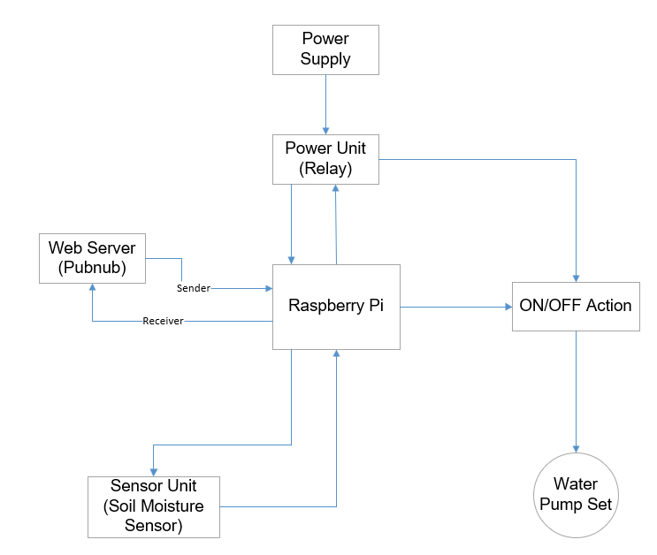

Figure 7: Block Diagram

Nodemcu: The Nodemcu is a low cost, credit-card sized computer. Its capable of doing everything you’d expect a desktop computer to do, from browsing the internet and playing high-definition video, making spreadsheets, and playing games. We shall be using Nodemcu 8266.

Motor: A Motor is a device which converts electrical power into mechanical rotation using the principle of electromagnetism. Electro-magnetism: A wire wound on a ferrite core carrying electric current generates a magnetic field; this principle is called Electro-magnetism. We shall be using a step-up motor as our e-gate

IR Sensor:

QR-Code scanner.

## 3.6.2 Sequence Diagram

Figure 8: Sequence Diagram

## 3.6.3 Database Schema

Figure 9: Database Schema

## 3.6.4 Use Case Diagram

Figure 10: Use Case Diagram

## 3.6.5 Class Diagram

Figure.11 Class Diagram

## 3.6.5 Interface design

The mock-ups of the system to be developed look as follows:

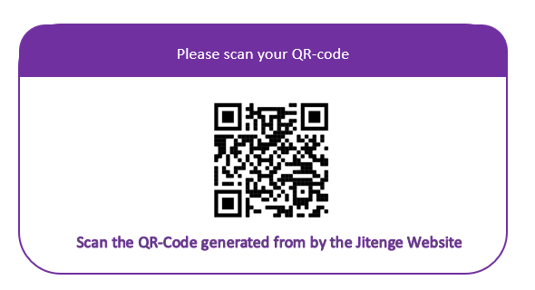

Figure.4 QR-Code scanning Wireframe

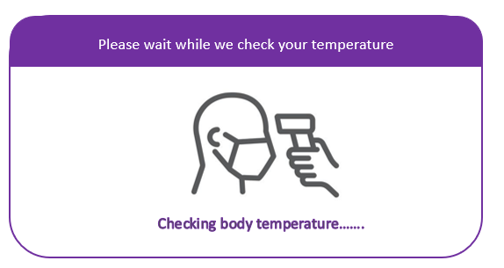

Figure.5 Passenger temperature checking Wireframe

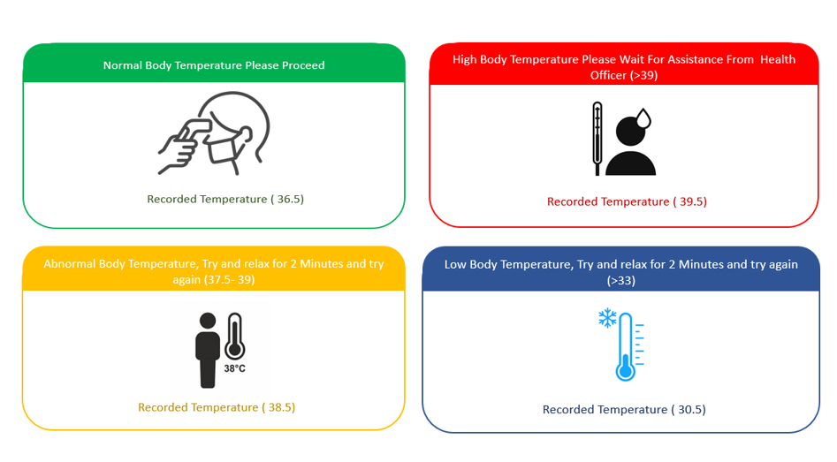

Figure.6 passenger Temperature feedback Wireframe

Figure.7 Jitenge Wireframe

# 3.7 System Architecture

Internet of Things is a combination of the following three:

1. Sensors and Actuators

Sensors measure physical quantities such as temperature, sound, moisture, vibrations, etc and convert this physical quantity into an electrical quantity. These Converted signals pass to the system and then system acts accordingly (Serpanos & Wolf, 2017).

2. Connectivity

The received signals are to be uploaded on the network using different communication media such as Wi-Fi, Bluetooth or BLE, LTE, and many more.

3. People and Process

People and Process are an important part of IoT. Networked inputs are then combined into a bidirectional system that integrates data, people and processes for better decision making.

User can access its result on his mobile/web application.

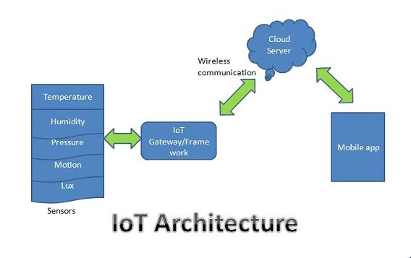

Figure 13: IoT Architecture