The goal of this assignment is to assess your knowledge and skills on Control structures, while developing skills to map requirements to program code. You will find a grading scheme at the end of this document – to guide you on instructor’s expectations while preparing your submission.

# Program Requirements

1. **Nova Scotia’s Income Tax Calculator:** Employees within the province of Nova Scotia are taxed at different levels - Federal and Provincial. Other deductions like Canadian Pension Plan (CPP), Employment Insurance, and Tax amounts are computed according to salary brackets. ([See Payroll Deduction for Nova Scotia Province – Effective January 1, 2021)](https://www.canada.ca/en/revenue-agency/services/forms-publications/payroll/t4032-payroll-deductions-tables/t4032ns-jan/t4032ns-january-general-information.html)

Nova Scotia’s (i.e., provincial) tax rates and thresholds are given in table 1 while that of federal is given in table 2. Other deductions include CPP (Canada Pension Plan) and EI (Employment Insurance). While CPP is 5.25% of the gross income (but to a maximum amount of $2,898.00), EI is 1.58% of the gross income (but to a maximum amount of $856.36).

|  |  |
| --- | --- |
| Annual Taxable Income (range of incomes - $) | Provincial Tax Rate (%) |
| 0 .. 29,590.00 | 8.79 |
| 29,590.01 .. 59,180.00 | 14.95 |
| 59,180.01 .. 93,000.00 | 16.67 |
| 93,000.01 .. 150,000.00 | 17.50 |
| 150,000.01 (and above) | 21.00 |

Table 1: 2021 Nova Scotia’s tax rates and income thresholds

1

|  |  |
| --- | --- |
| Annual Taxable Income (range of incomes - $) | Federal Tax Rate (%) |
| 0 .. 49,020.00 | 15.00 |
| 49,020.01 .. 98,040.00 | 20.50 |
| 98,040.01 .. 151,978.00 | 26.00 |
| 151,978.01 .. 216,511.00 | 29.00 |
| 216,511.01 (and above) | 33.00 |

Table 2: 2021 federal tax rates and income thresholds

You are to note that the computations for provincial and federal taxes have been revised in comparison with the first assignment. For example, if gross income is $92,486.79 the taxes are computed below:

* **Provincial Tax: $12,576.91** = $(2,600.96 + 4,423.70 + 5,552.24)
  + 1st category $29,590 is tax at the rate of 8.79% =⇒ $2,600.96
  + 2nd category ($59,180.00 - $29,590.01) is taxed at the rate of 14.95% =⇒ $4,423.70
  + Remainder (i.e., $92,486.79 - $59,180.01) is taxed at the rate of 16.67% =⇒ $5,552.24
* **Federal Tax: $16,263.69** = $(7,353.00 + 8,910.69)
  + 1st category $49,020.00 is tax at the rate of 15.0% =⇒ $7,353.00
  + Remainder (i.e., $92,486.79 - $49,020.01) is taxed at the rate of 20.5% =⇒ $8,910.69

In addition to the deductions above assuming Nova Scotia’s employees are charged health premiums and that the premiums are based on the following rules:

1. If the taxable income is less than or equal to $22,000.00, the premium is $0.00.
2. If the taxable income is greater than $22*,*000*.*00 and less than or equal to $38*,*000*.*00, the premium is equal to the lesser of: (i) $300*.*00 and (ii) 6% of (taxable income - $22,000.00);
3. If the taxable income is greater than $38*,*000*.*00 and less than or equal to $50*,*000*.*00, the premium is equal to the lesser of: (i) $450*.*00 and (ii) 300 + 6% of (taxable income - $38,000.00);
4. If the taxable income is greater than $50*,*000*.*00 and less than or equal to $74*,*000*.*00, the premium is equal to the lesser of: (i) $600*.*00 and (ii) 450 + 25% of (taxable income - $50,000.00);
5. If the taxable income is greater than $74*,*000*.*00 and less than or equal to $202*,*000*.*00, the premium is equal to the lesser of: (i) $750*.*00 and (ii) 600 + 25% of (taxable income - $74,000.00);
6. If the taxable income is greater than $202*,*000*.*00, the premium is equal to the lesser of: (i) $900*.*00 and (ii) 750 + 25% of (taxable income - $202,000.00).

2. **Tasks:** You are required to do the following:

1. **Write a program that:**
   * **take gross income of** *N* **employees from the user;**
   * **compute their net incomes (i.e., after deducting appropriate provincial and federal level taxes, CPP, EI and health premium);**
   * **compute and display mean (***µ***) and standard deviation (***σ***) of the entire net incomes; and**
   * **display a list of all gross incomes and a list of all net incomes.**

You are to implement your work with the following equations to compute mean and standard deviation of any dataset of your choice:

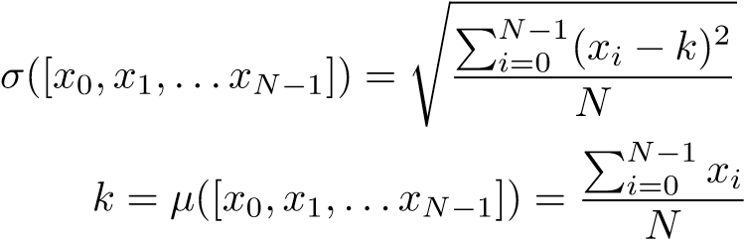 *,* (1)

(2)

**Hint:** Develop your program using Python’s program mode. In particular, write a file for your program and document your program accordingly. Your program would be wrong if it allows negative salary. For each concern, provincial and federal level taxes, health premium, mean *µ*([*x*0*,x*1*,...xN*−1]), and standard deviation *σ*([*x*0*,x*1*,...xN*−1]) - you are to develop separate functions with return statements (where applicable), then couple them in a sensible manner. You can use any in-built function except *mean* and *standard deviation*.

1. A **duplicate (i.e., having the same functionalities)** of the program you have developed in (a) - above, using population mean *µ*([*x*0*,x*1*,...xN*−1]) and standard deviation *σ*([*x*0*,x*1*,...xN*−1]) functions imported from the **statistics module**.
2. You will notice that I have inserted test cases. Tests are introduced to verify correctness of your code. You will be automatically graded with these test cases. Then, your points will be deducted for any missing instructions in (i.) or (ii.) (e.g., if a duplicate program is missing) above.

An example test run of the program is given in figure 1. Thus, your program should produce the following output (using the same format and set of taxable incomes) if everything is right:

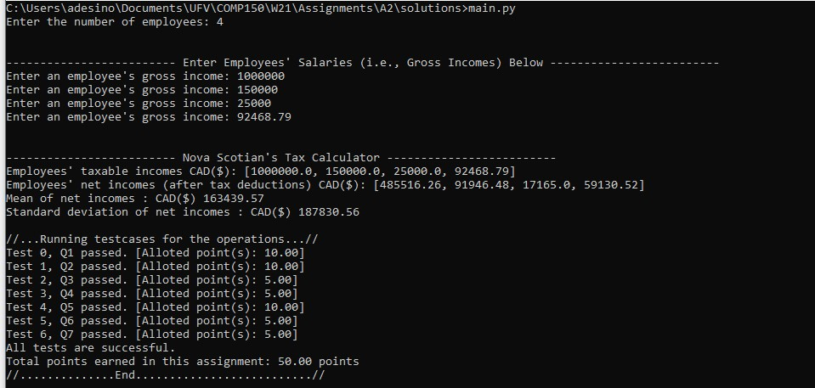

Figure 1: Expected Output - if your program works correctly.

Please note that the program has been developed such that the entry-point for program execution is *main.py*. This is the coordinating file - by executing this file, you are indirectly executing other files (in order to realize the program objectives). We have relied on the power of *modules* to integrate the system.

# Grading Scheme

The following scheme will be used to grade your submission. Therefore, you may also use it as a guide in preparing your deliverable.

|  |  |
| --- | --- |
| **Grade Item** | **Weight** |
| A syntactically and semantically correct program. | **50** |
| A program with detailed program design - see examples in my video lectures (it was embedded as comments in the video). I am enforcing program design this time. | **15** |
| A flowchart of your program must be included. This must represent your program. You can use pen and paper for drawings. You may also decompose the problem into separate components, draw them each and show how the components will be coupled to realize your code. | **20** |
| Program efficiency. That is, using efficient but correct control structures. | **5** |
| A program with detailed program documentation and uses sensible variable names. Your program’s file name and other files should be zipped and named in the following format - [first-  Name lastName studentID] | **10** |
| **Total** | **100** |