# System Development Methodology

## Introduction

Scientific research has been playing an important role in the progress and enrichment of new age technology. This chapter highlights a basic summary of the methodology that would be implemented for the proposed system. The chapter will be covering the following areas: development methodology coma justification of the methodology, functional and non-functional requirements, as well as tools and techniques.

## Development Methodology

The system development methodology refers to the structure that is followed in creation of a new system. The structure involves the most suitable methods that will be implemented following a series of chronological processes to develop the proposed system.

### Prototyping

Rapid Prototyping is a fundamental development methodology in the software development field as it is in other engineering fields. Satzinger, et al., states that prototyping is used in almost every software development project in some way. The methodology is based on an iterative mechanism that allows users to be involved in the formulation of the system. The best feature of this methodology is that it solves a couple of issues that normally occur when using the waterfall methodology (TatvaSoft, 2021).

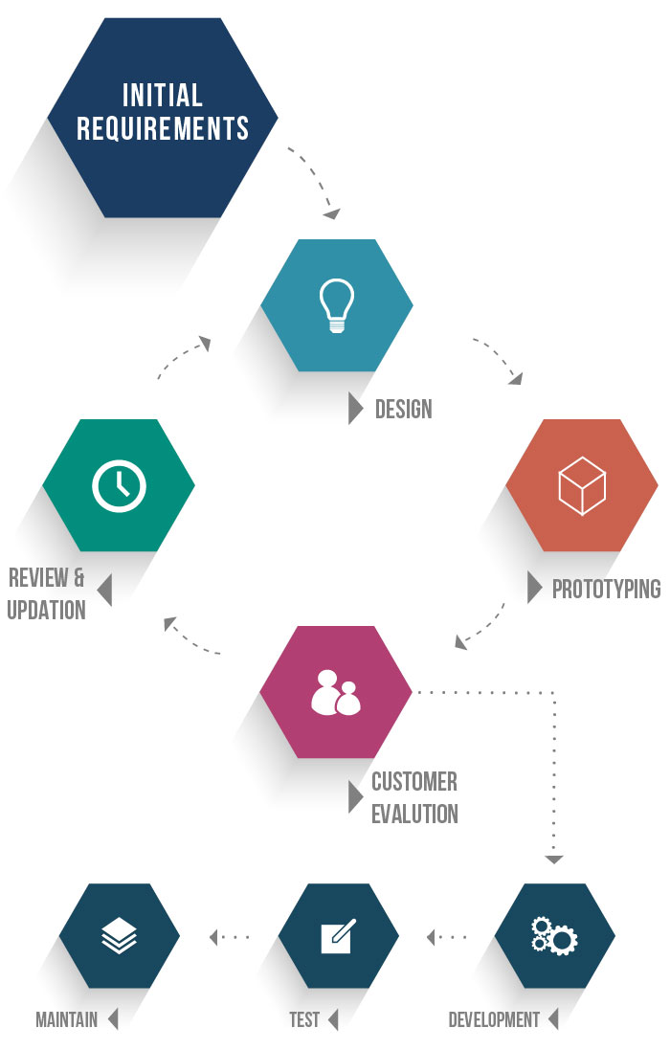

Figure 3.1: A Prototype model as represented by (TatvaSoft, 2021)

The following are steps in Rapid prototyping:

1. Initial requirements- this is where the customer gets to justify the need to have the system in place by saying what is required of the system.
2. Design- this is where the idea is conceptualized by showing the actual concepts and how the functions will perform.
3. Prototyping- this is bringing the concepts to life by developing a model of the actual system.
4. Customer evaluation- this is involving the customer by presenting the models that have been developed for the customer to analyse whether they have met their requirements.
5. Review- this is the last stage in the prototyping methodology where any amendments made by the customer are implemented.

## Justification of Methodology

As explained earlier by (TatvaSoft, 2021), prototyping is the best system development methodology because it allows for the involvement of clients throughout the development process whereby, they get to make amendments based on the system requirements before developing the actual system. this methodology is best suit for the proposed system as it allows for the software and hardware to be fully tested before full production of the system.

## Functional Requirements

A functional requirement according to (Guru99, 2021), is a description of what the software or system has to offer, describing the system and its components. A function can be further simplified as an input, its behaviour, and outputs. These can also be calculations, data manipulation, business process and any other specific functionality defining the functions a system will perform.

### Authentication

Authentication is the process or action of verifying the identity of a user or process. This is done through the user login and user registration. The login screen allows registered users to login to the site. If they type in their username and password and click submit the user’s credentials are validated and if correct, they are logged in. Otherwise, an error message is displayed on the screen. If the user is a new member, he has first to register to the system. Once the user’s details are saved in the database, he/she is now able to login to the system.

### QR Code Reader

The system will have a QR code reader to allow input from the QR codes to the system for the purposes of getting the passenger information.

### Thermal Scanner

The system will fundamentally use a thermal scanner that will take the temperature readings of the passengers and the readings will be input into the system.

### Buzzer

This is a device that beeps in case of an error, or a high temperature has been detected.

### Time Stamp

The system should be able to generate an audit trail of when the QR code was scanned to avoid the QR code being used again.

## Non-functional Requirements

The non-functional requirements specify the criteria that will be used to judge the operation of a system. They define specific behaviours and functions.

### System Security

This could be achieved through password hashing. Password hashing is basically like password encryption, but the difference is that in password encryption you can reverse the encryption by having a secret key to decrypt the code while in password hashing once you encrypt your data, it cannot be decrypted therefore it is irreversible.

### Accessibility

The system will be hosted on an intranet therefore accessed through a specific network for security reasons. This will enable the system to be secure and safe from breaches that lead to data manipulation.

### Accuracy

This refers to the correctness of data. The kind of data that will be input and output from the system must be accurate therefore enhancing efficiency.

### Usability

The system should not be complicated to use since many people will be using it and some of the people might not be proficient in technology.

## Tools and Technologies Used

The tools and technologies are the key ingredients to coming up with the interlibrary loaning system. These include Sublime Text, Bootstrap, MySQL and Github.

### Arduino Uno

This is a microcontroller board with a microchip that is equipped with a set of analog and digital input and output pins.

### Java

This is an object-oriented programming language that is used to develop desktop, mobile and embedded systems.

### MySQL

This is a relational database management platform used to deploy cloud-native applications. The platform is based on the Standard Query Language (SQL).

### Github

This is a platform where programmers from all over the world store, share and build codes. Github enables programmers to build good software by enabling them to share codes. We chose to use this platform because it is readily available and that it encourages collaboration with other developers and teambuilding therefore enabling one to have good and effective codes.

### Arduino IDE

This is the environment that will allow the Arduino uno microcontroller to be programmed to whatever specifications.

## Milestones and Deliverables

### Assigning of Supervisors

The activity of assigning supervisors took a week whereby students were given the list of supervisors to choose from and thereafter get into contact with them.

### Idea Generation

A problem was identified and a solution to the problem was thought of.

### Presentation of the Idea to the Supervisor

With the idea of the solution in hand, the supervisor was sought for the approval of the idea.

### Proposal

With an approved idea, the proposal of the project began which is subdivided into three chapters. Frequent visits to the supervisor ensured quality of the document.