Examenportfolio Software Developer Enschede
Game Design Document



Voor- en achternaam: Collin kloppenburg
Leerlingnummer: 1319476
Datum: 20/05/2026
Versie: 1

Inhoud
Inleiding 3
Overzicht 4

Inleiding
This document is created as part of an individual project. Although the structure is based on a standard team-oriented Game Design Document, all content in this version is written, developed, and delivered by a single developer. Sections may be removed, expanded, or adapted as needed, and it is acceptable for non-critical parts to remain empty if they are not relevant to the scope of the project.

Overzicht
Titel/ Werktitel van het spel: | Magecraft
Genre: | RPG
Thema: | Magic, Fantasy
Perspectief/View: | 3D, 3rd person
Doel van het spel: | Defeat enemies using crafted magical bullets, unlock new spell types, and expand your arsenal through progression and experimentation.
Art Stijl: | 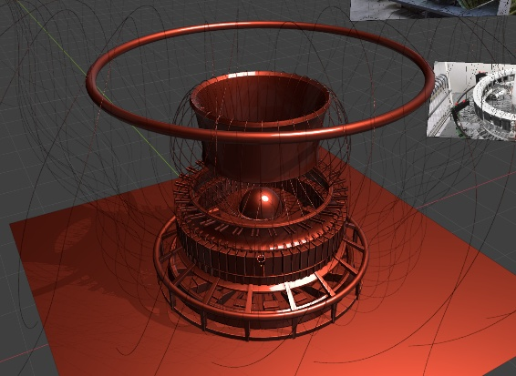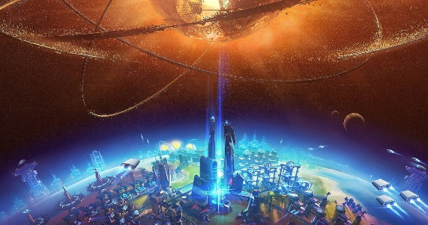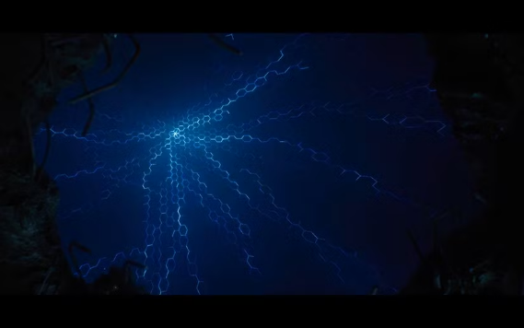
Originaliteit/USP (Unique Selling Point): | Spells are magical bullets you craft in batches and load into your spell-focus before combat. Each bullet is single-use, encouraging tactical planning, improvisation, and mid-battle creativity, while base magic and dropped fragments ensure you’re never stuck without a way to fight.
Korte Samenvatting (maximaal 2 zinnen): | Magecraft is a 3D RPG where spells are crafted as magical bullets that you load, fire, and combine in combat. Prepare your loadout, improvise with fragments and base magic, and master a system to grow your power and defeat your enemies.

