**Social Media for Human spaceflight Project**

*Pierre Bertrand, Lucy Shen, Yinghua (Kelly) Shen*

**MISSIONS**

1. **Data Collection**
2. Gather table for each account with general analysis (*see Figure 1*)
   1. Date of creation
   2. Number of followers
   3. Number of following
   4. Number of Tweets
   5. Number of favorites
3. Gather table for each account with tweet analysis (last 200 tweets) *see* *Figure 2*
   1. Number of retweets made
   2. Number of replies
   3. Number of tweets with video/picture
   4. Number of retweets from others
   5. Number of favorites from others
4. Collect nationality of followers
5. Collect hashtags for each account
6. **Data Analysis and Visualization**
7. Analysis of I.2. for 2014 only
8. Network analysis for 2014
9. Visualization of followers nationality
10. Visualization of hashtags
11. Develop real time analysis web application

**TIMELINE**

For the **data collection**, as the code is already written, I think it would be good to have all the data we will need by **February 25th**. There are 4 main data set to collect; I think we could split it between the two of you, if you feel equally confident in the data collection. If not, please let me know and we should consider an alternative more focused on data collection vs. data analysis.

For the **data analysis**, the policy is more that, all the things that can be done before spring break are things we will not have to do after and thus, I will really let you easy for the end of the semester. I am much more flexible on that part since it is not on the critical path for my thesis. I think it would be nice to have done part of the easy work (visualization (since the code exists already) and analysis on 2014) by spring break, and to deal wit the real time web app and the network analysis for the end of the semester.

To summarize:

|  |  |
| --- | --- |
| **Task** | **Date** |
| Data collection | February, 25th |
| Data Analysis (I) | March, 18th |
| Data Analysis (II) | May, 6th |
| End of the UROP | May, 21st |

**TO DO LIST FOR FRIDAY**

1. Read proposal and start thinking what you would prefer to do
2. Come up with your own ideas for the project, what you think is good what you think we could improve. Please look at the existing site to see what could be better: [www.socialmedia4spacexploration.com](http://www.socialmedia4spacexploration.com)
3. Start exploring Savannah’s code on the dropbox, for both data collection, and visualization, and come up with questions for her
4. Enjoy the snow days

**FIGURES**

Fig. 1: General Analysis

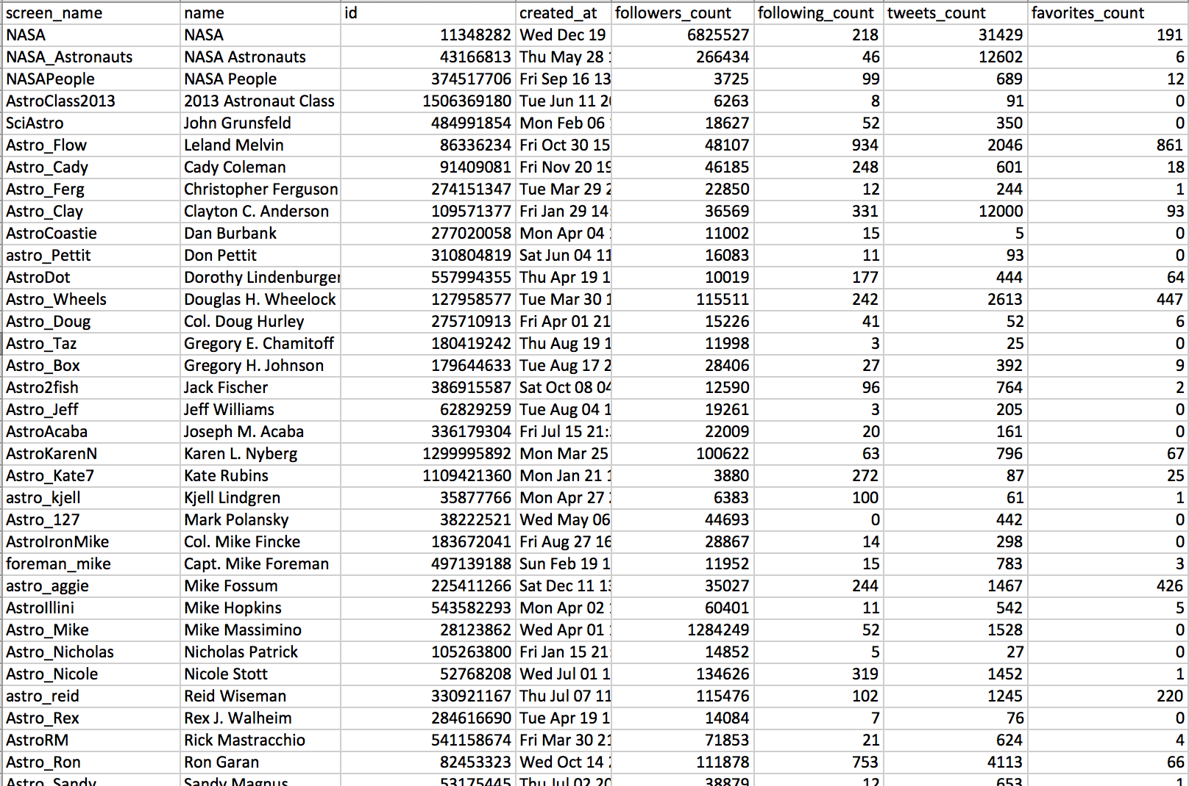

Fig. 2: Tweets content analysis

