Online Retail Segmentation using RFM

By Tommy Flasza (S4092115)

Affiliations: RMIT School of Computing technologies – Practical Data Science with Python
Contact Details: s4092115@student.rmit.edu.au
24th May 2026

I certify that this is all my own original work. If I took any parts from
elsewhere, then they were non-essential parts of the assignment, and they
are clearly attributed in my submission. I will show I agree to this honor
code by typing “Yes”: Yes

Table of Contents
Summary 3
Introduction: 3
Methodology 3
Results - Exploration 4
Results: K-Means 6
Results: DBscan 8
Discussion 9
Conclusion 10
References 10

Summary

This report presents a customer segmentation analysis of the UCI Online Retail dataset using RFM (Recency, Frequency and Monetary) analysis. After properly looking and shifting through and then cleaning any errors by removing orders that may have been cancelled and fixing missing values, two clustering models were applied (K-means and DBSCAN), K-Means with K=4 produced four clean customer segments while DBSCAN identified 7 clusters with some noise appearing on the plots. Based on the evaluation metrics K-means was seen as the best model for analysing the retail dataset.

Introduction:
The main goal of this project is to segment customers of the UK based online retail store into meaningful groups when regarding their purchasing behaviour. Understanding these groups allows the business to see what sells well and change their marketing to give a boost in accordance with customer retention. When looking at the dataset I chose a clustering approach as the dataset had no predefined labels which could allow hidden patterns in the data to be seen rather than predict an outcome.

Methodology
The dataset supplied from the UCI machine learning repository contained over 500,000 total transactions from a singular store based in the UK recorded between December 2010 until December 2011. 8 Attributes that stood out were InvoiceNO, StockCode, Description, Quantity, InvoiceDate, UnitPrice, CustomerID and Country. The dataset was originally in an Excel format but was converted to a csv for a faster approach for the script to analyse.
During Preprocessing the dates were still seen as excel serail numbers so using pandas, I forced a command to allow for it to be converted. When removing the cancellations, missing customerIDs and invalid rows, the main RFM table was built for each customer. Outliers were capped at the 99th percentile and data was also standardised before being fed into the clustering models.
Ten columns were then explored individually using descriptive statistics and visualisations. Histograms were mostly used for variables such as Quantity and UnitPrice, Bar charts for categorical variables such as Country and StockCode and line charts for a monthly revenue trend. Ten pairs of attributes were also explored using scatter plots and heatmaps to display and outline relationships.
Two clustering models were then trained using RFM. K-means partitioned customers into k clusters by minimizing the within-cluster sum of squares. The best k was selected by using the elbow method, silhouette score and the Davies-Bouldin score. DBSCAN was also used as it can identify clusters that can be seen as dense regions without needing to use k. The optimal eps were selected using k-distance and min_samples was set to 5 respectively.

Results - Exploration
Figure 1 shows the total amount of revenue per month from December 2010 to December 2011. Revenue coming into the retail store remained stable in the first half of the year but then near the end of the year starting from august we see a massive jump until November peaking around 1.1 million GBP. This could be due to the holiday period which is consistent with how the business sells unique gifts for every holiday. There is a decline in December as the dataset cuts off after 9 days of the month.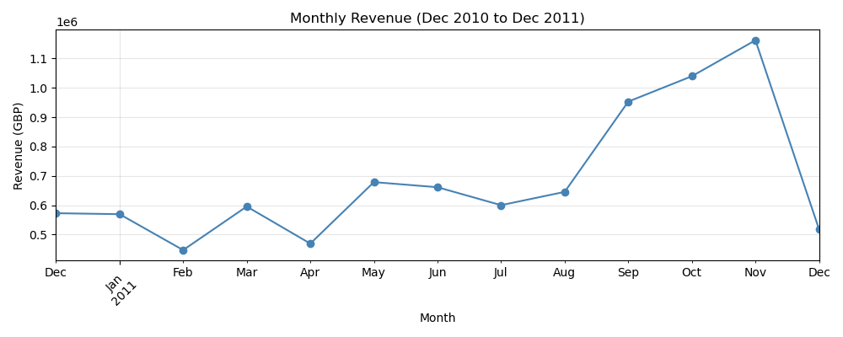
Figure 1: Monthly Revenue Chart (December 2010 to December 2011)

Figure 2 shows the distribution of each RFM feature across all customers. Recency is skewed to the right with many customers purchasing more recently than later in the year, this can give an idea that the business has grown, and more people have been buying. Frequency is also heavily skewed to the right with most customers placing around 1-3 orders with some customers ordering more frequently. In terms of monetary like the other graphs is skewed to the right with most of the customers spending little amounts of money. These distributions distinguish and confirm that the need for outlier capping to be introduced before clustering can happen otherwise the results will be incorrect and distorted. 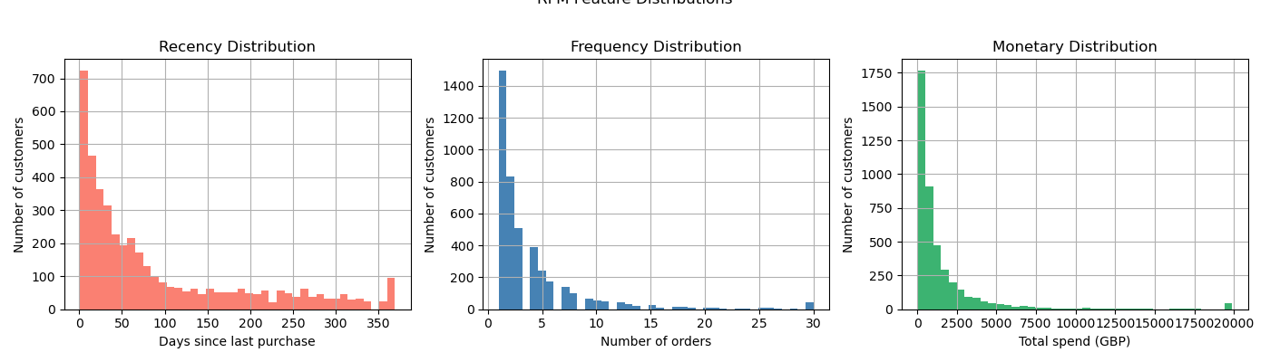
Figure 2: RFM diagram
A correlation heatmap (Figure 3) between the 3 RFM features displays that there is a strong positive correlation within Frequency and Monetary with a score of 0.79. This displays that customers who order more tend to spend more at the business. Recency has a negative correlation with both Frequency at -0.37 and Monetary at -0.27 which confirms that more recent customers tend to order more and spend more. This allows for the RFM to be validated and to set features to allow for customer segmentation.
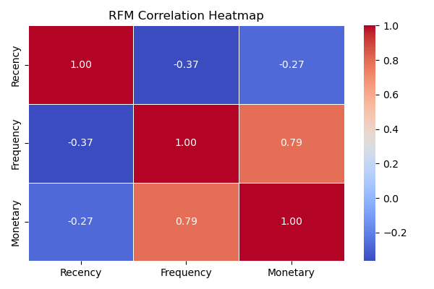
Figure 3: RFM Heatmap

When looking at Figure 4 this graph displays the top 10 countries by revenue. Since the company is a UK based it would make sense that it dominated with around 7 million GBP in total revenue. The Netherlands and Ireland (EIRE) are 2nd and 3rd respectively but have a total value between them of around 2 million GBP. This displays that the company is stronger in the United Kingdom where sales are more likely to be finalized over the small proportion of total revenue in the international markets.
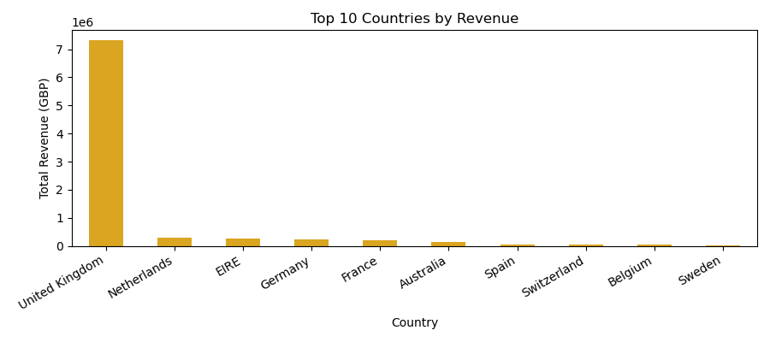
Figure 4: Top 10 Countries by Revenue

Results: K-Means
Using K-means we can see in Figure 5 that three metrics are being used to select and identity the optimal number of clusters. The elbow method applied shows a curve that begins to flatten around k =4 indicating results diminishing. The highest silhouette score was at k=2 but then slowly decreases as k increases. Although k=2 has the best silhouette score, it does not provide enough to allow for a meaningful business segmentation. K=4 was selected as it represents a clear elbow in the curve and produces four interpretable customer segments that align with the RFM.
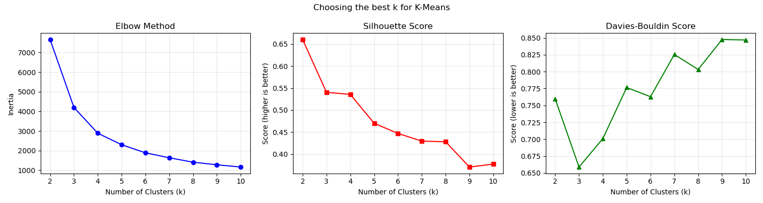
Figure 5: Discovering the best K

With Figure 6 we can properly visualize the four K-means customer segments. The segments were divided into Champions (Customers who buy often and spend the most), Loyal Customers (Active customers and still buy regularly), At-Risk (Haven’t bought in a while and don’t spend a lot) and Lost/Inactive (Customers who haven’t bought in over 250 days and are less likely to splurge).
The Recency vs Frequency plot displays where the champions cluster in the top left with a lower recency but a higher frequency while inactive customers are more spread to the right of the graph with a higher recency and lower frequency with orders. The frequency vs monetary plot displays where Champions are clearly separated at the top with higher spending while customers in the At-Risk or Lost clusters are near the bottom with a lower frequency and monetary values. The clear visual separation between the two segments confirms that k=4 produces the most adequate and perfectly defined clusters.
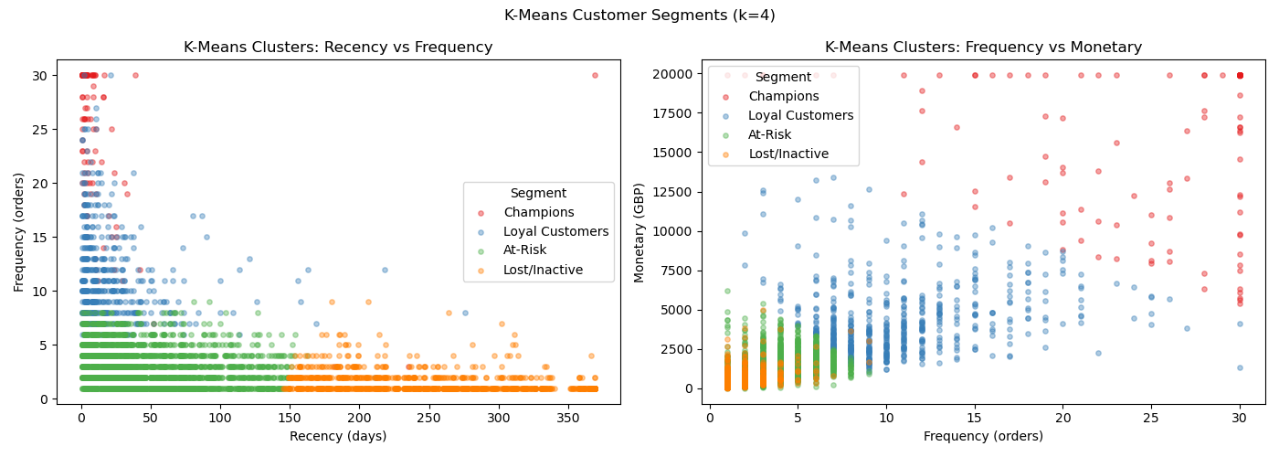
Figure 6: K-means Customer Segments using k=4

Using the model with k-means it provided the four segments. Champions made up 2.5% of the total spend with 15,280GBP and ordered 24 times on average. Loyal customers represented just under 13% of total customers with a moderate frequency of spending. At-risk customers were higher with 60.8% of total customers with a lower average frequency and a lower average monetary. Lost and inactive customers represented just under 24% of the total customers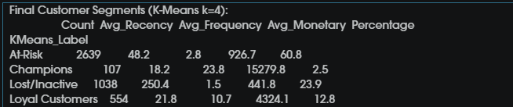

Results: DBscan
When selecting the optimal epsilon value for DBscan a k-distance graph was used (Figure 7). For each point in the retail dataset, the distance to the nearest 5th neighbour was calculated and plotted in descending order. The elbow of the curve occurs at approx. 0.5. This value was selected as the epsilon as points beyond the threshold would be in regions that could create noise and display totally different results. A parameter sweep across the multiple epsilon values also confirmed that 0.5 produced the more meaningful number of clusters with acceptable noise.
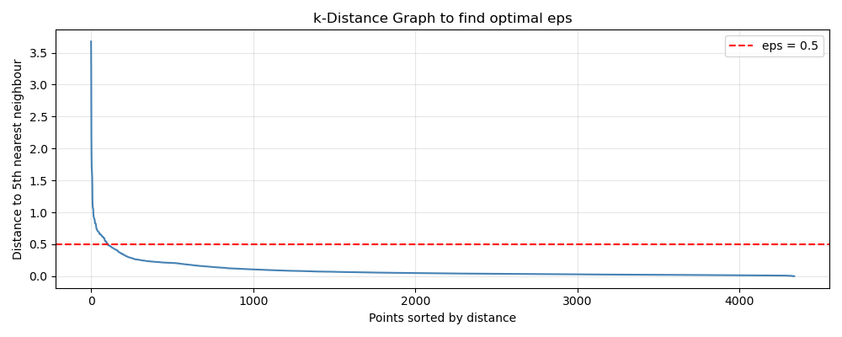
Figure 7: k-Distance Graph to find optimal eps
Figure 8 shows the DBscan customer segments. Unlike K-Means, DBscan identified 7 total clusters with noise points shown in grey. The more dominant cluster contained the majority of customers at 4198 out of 4,338 while the remaining other clusters are smaller. This reveals a limitation with DBscan when using this specific dataset. The density of the RFM space causes most customers to be grouped into one large undifferentiated cluster which is making it less useful for the business.

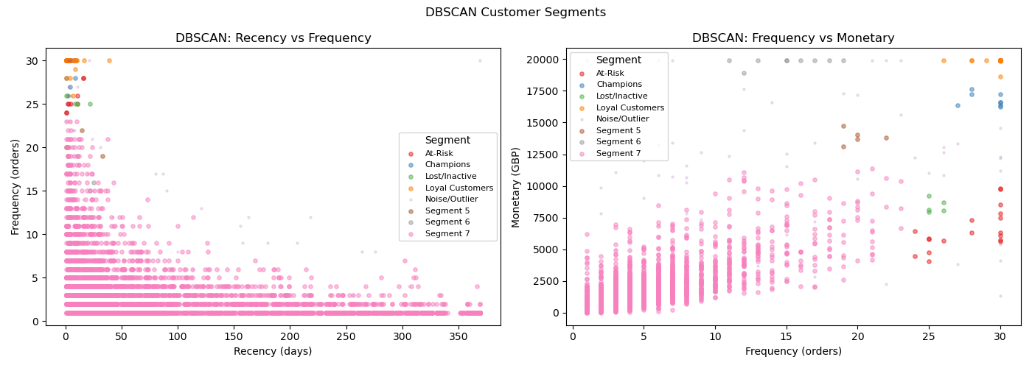
Figure 8: DBSCAN analysis with Segments\

Discussion
The model comparison compares the three methods for evaluation for K-means and DBSCAN. We can see that the silhouette score is better with the DBSCAN method and features a lower Davies-Bouldin score which can suggest that the clusters are denser and are spread locally. K-means however has a higher Calinski-Harabasz score which indicates that the clusters are more compact and are well defined across all segments. Due to the business using these 4 segments it is recommended that K-means is to be used as the model of choice. 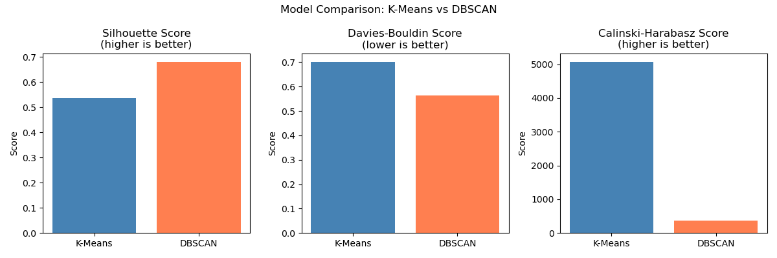
Figure 9: Model Comparison
The last Figure displays the confusion matrix which compares the K-means and DBSCAN segment labels. The matrix displays that almost At-Risk customers are being mapped to the dominated cluster while Champions are being spread across more within DBSCAN. The majority label in each column was used to interpret the meaning of the clusters, and the matrix confirms that both models are identifying similar structure in the data. K-means comes out on top due to it producing a more balanced and actionable segments. DBSCAN had a better silhouette and Davies-Bouldin score than K-means but it placed the customers into a singular cluster which is difficult to use due to the customers being seen the same way. K-means however produced four correctly balanced segments that have a clear meaning behind them. For the more Champions that can have special offers and a VIP experience, Loyal customers can have regular sent emails so they can stay notified about the store, Customers at-risk should be supplied with promotions to bring them back into the store and Inactive accounts can send special promotions or discounts to bring them back.
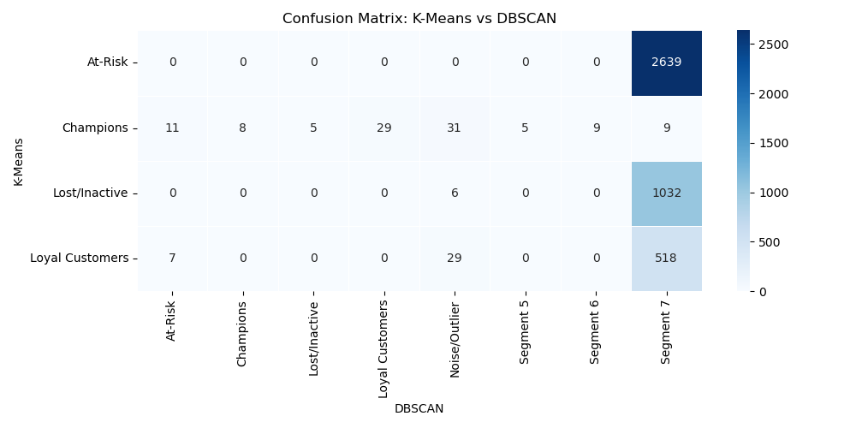
Figure 10: Confusion Matrix

Conclusion
This project successfully segmented the customers in this dataset by using RFM analysis and incorporating clustering models. K-means with K=4 was found to be the best model as the segments were interpretable and balanced. The analysis also done shows that a small group of customers bring in a large amount of revenue and are seen as frequent shoppers whereas some customers could benefit from a little incentive to re-engage with the business. The business should also investigate seeing what category sells more to further refine the findings in this report

References
UCI Machine Learning Repository (2015) Online Retail Dataset https://archive.ics.uci.edu/dataset/352/online+retail

