Answers to questions in

Lab 3: Image segmentation

Name: ___________Lyu Lin & Yuhao Lin______________ Program: ________TMAIM____________

**Instructions**: Complete the lab according to the instructions in the notes and respond to the questions stated below. Keep the answers short and focus on what is essential. Illustrate with figures only when explicitly requested.

Good luck!

___________________________________________________________________________

**Question 1**: How did you initialize the clustering process and why do you believe this was a good method of doing it?

Answers:

The centers of clusters are pixels that are randomly chosen in the image. The color of these random pixels exist in the image obviously, which can avoid the situation when the color of a randomized 3D vector does not contained in certain image.

___________________________________________________________________________

**Question 2**: How many iterations L do you typically need to reach convergence, that is the point where no additional iterations will affect the end results?

Answers:

In order to test when the clustering process reach convergence, we tested all the four images with different number of clusters K. The convergence threshold is set to be “the maximum value in the absolute difference between cluster center matrices is less than 0.01”. The following table shows the iterations each image need to reach convergence.

|  |  |  |  |  |
| --- | --- | --- | --- | --- |
| K | Orange | Tiger1 | Tiger2 | Tiger3 |
| 2 | 7 | 6 | 9 | 10 |
| 3 | 10 | 19 | 36 | 19 |
| 5 | 24 | 30 | 64 | 102 |
| 7 | 55 | 45 | 49 | 87 |
| 11 | 86 | 109 | 138 | 148 |

___________________________________________________________________________

**Question 3**: What is the minimum value for K that you can use and still get no superpixel that covers parts from both halves of the orange? Illustrate with a figure.

Answers:

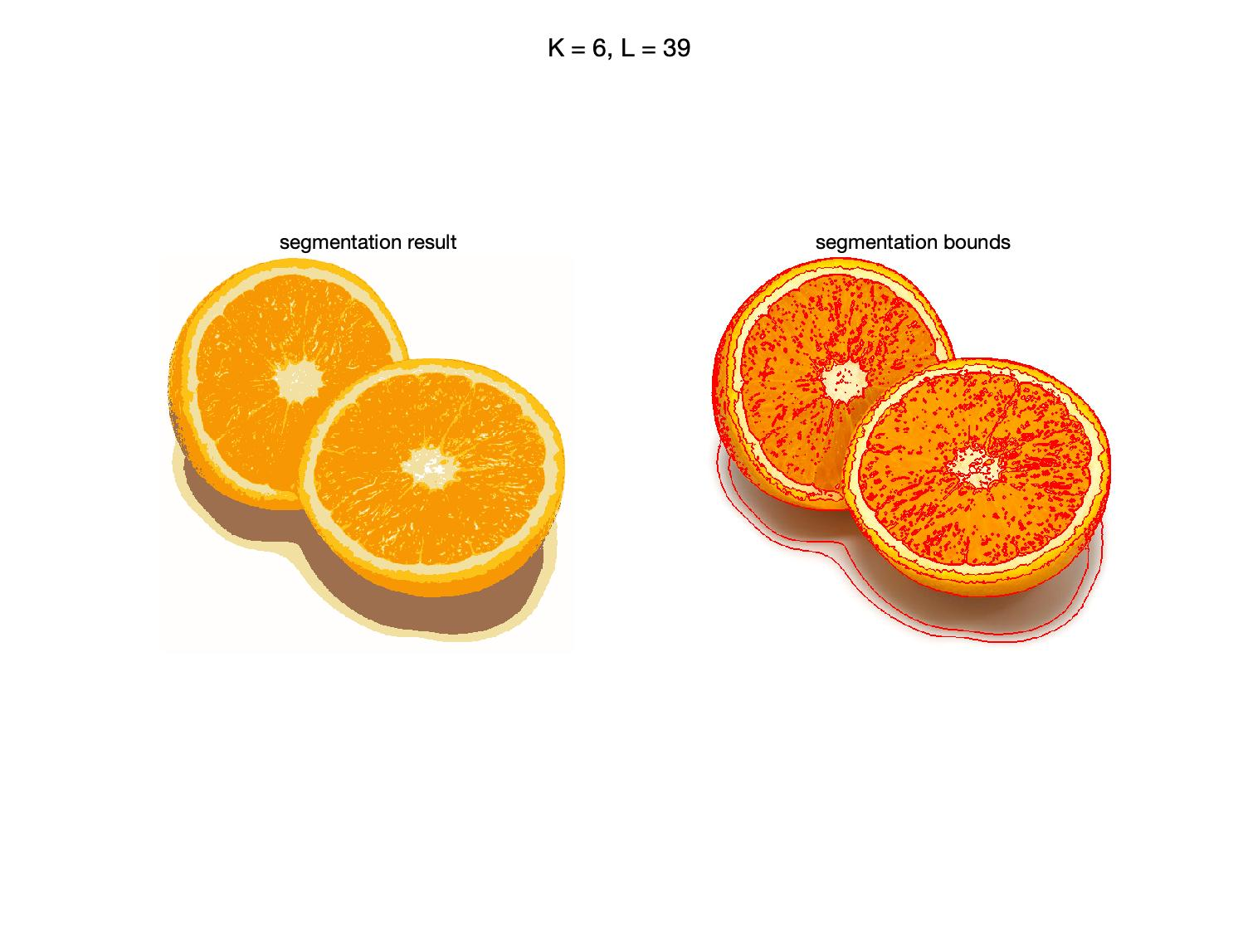

Figure 1. Segmentation result with K = 6

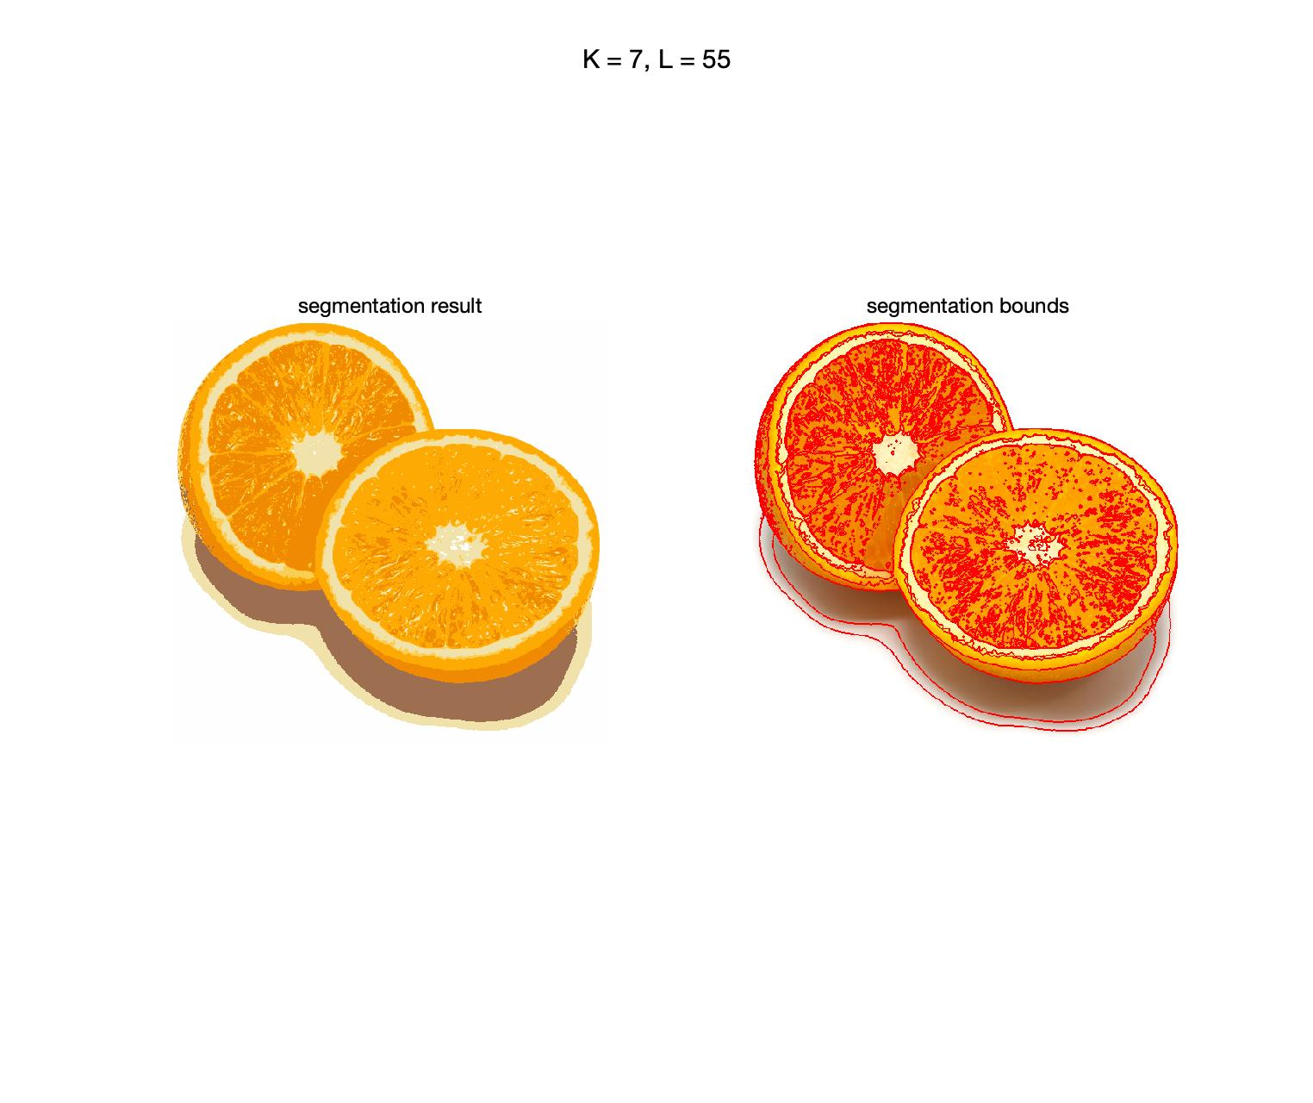

Figure 2. Segmentation result with K = 7

As we can see in the right sub-figure in Figure 1, there is a vague line at the edge between two half oranges but there is still super-pixels overlap the true edge. And as we increase K to 7, the edge in the segmentation bound is clear and it is obvious that two half oranges are split apart in Figure 2.

___________________________________________________________________________

**Question 4**: What needs to be changed in the parameters to get suitable superpixels for the tiger images as well?

Answers:

The tiger images are more complex with more colors and objects, thus, we have to increase K for more colored clusters. Meanwhile, as the number of clusters increases, the number of iterations L has to be increased as well for the extra clusters to reach convergence with more iterations.

___________________________________________________________________________

**Question 5**: How do the results change depending on the bandwidths? What settings did you prefer for the different images? Illustrate with an example image with the parameter that you think are suitable for that image.

Answers:

Figure 3 and Figure 4 shows the reason with same color bandwidth and different spatial bandwidth. Increasing the spatial bandwidth means increasing the radius of the region of interest, which can be observed in the figures that Figure 3 have less modes and segments than Figure 4.

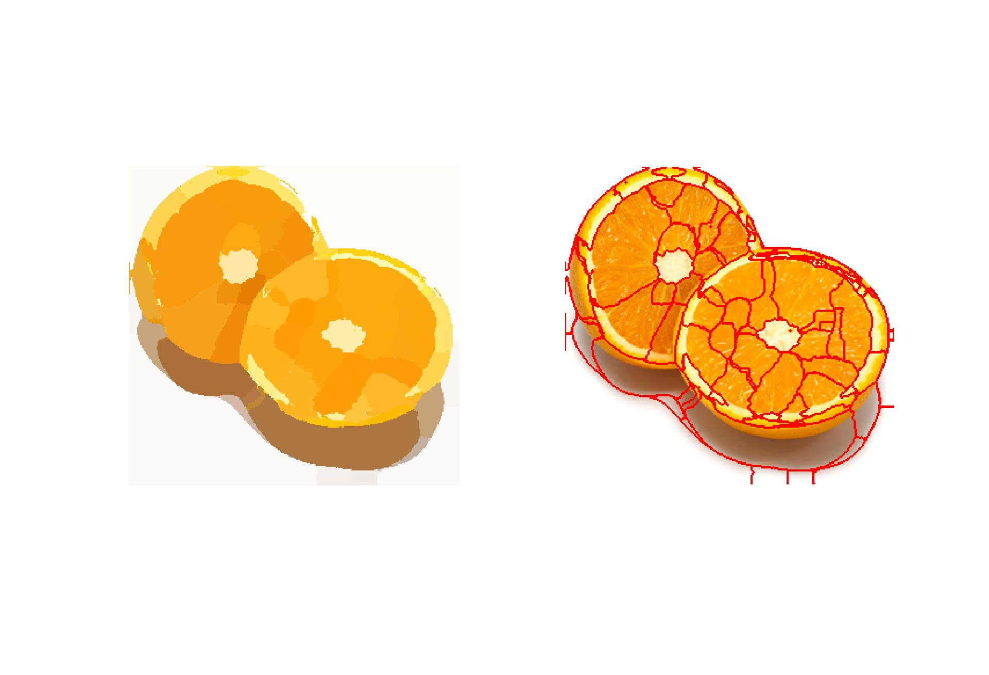

Figure 3. Segmentation result with spatial_bandwidth = 10 and color_bandwidth = 5

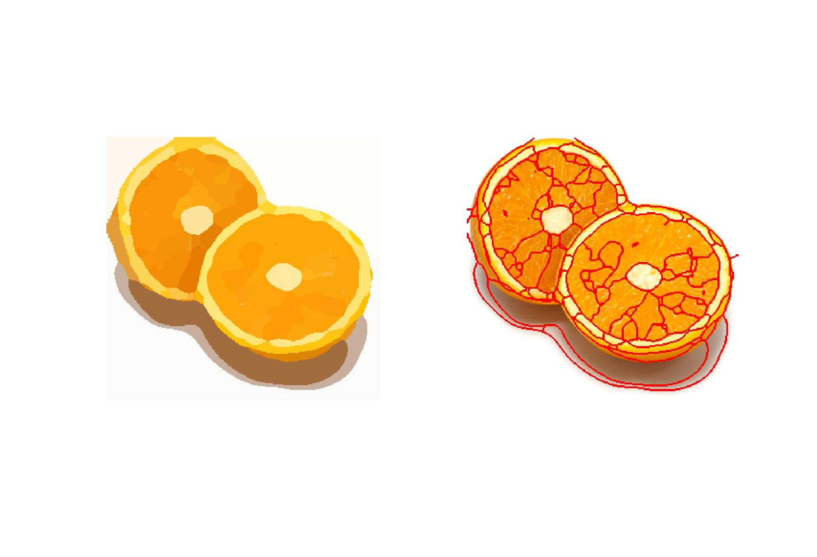

Figure 4. Segmentation result with spatial_bandwidth = 5 and color_bandwidth = 5

Comparing different color bandwidth, Figure 5 and Figure 6 shows that increasing color bandwidth decreases modes for different colors and generates less segments.

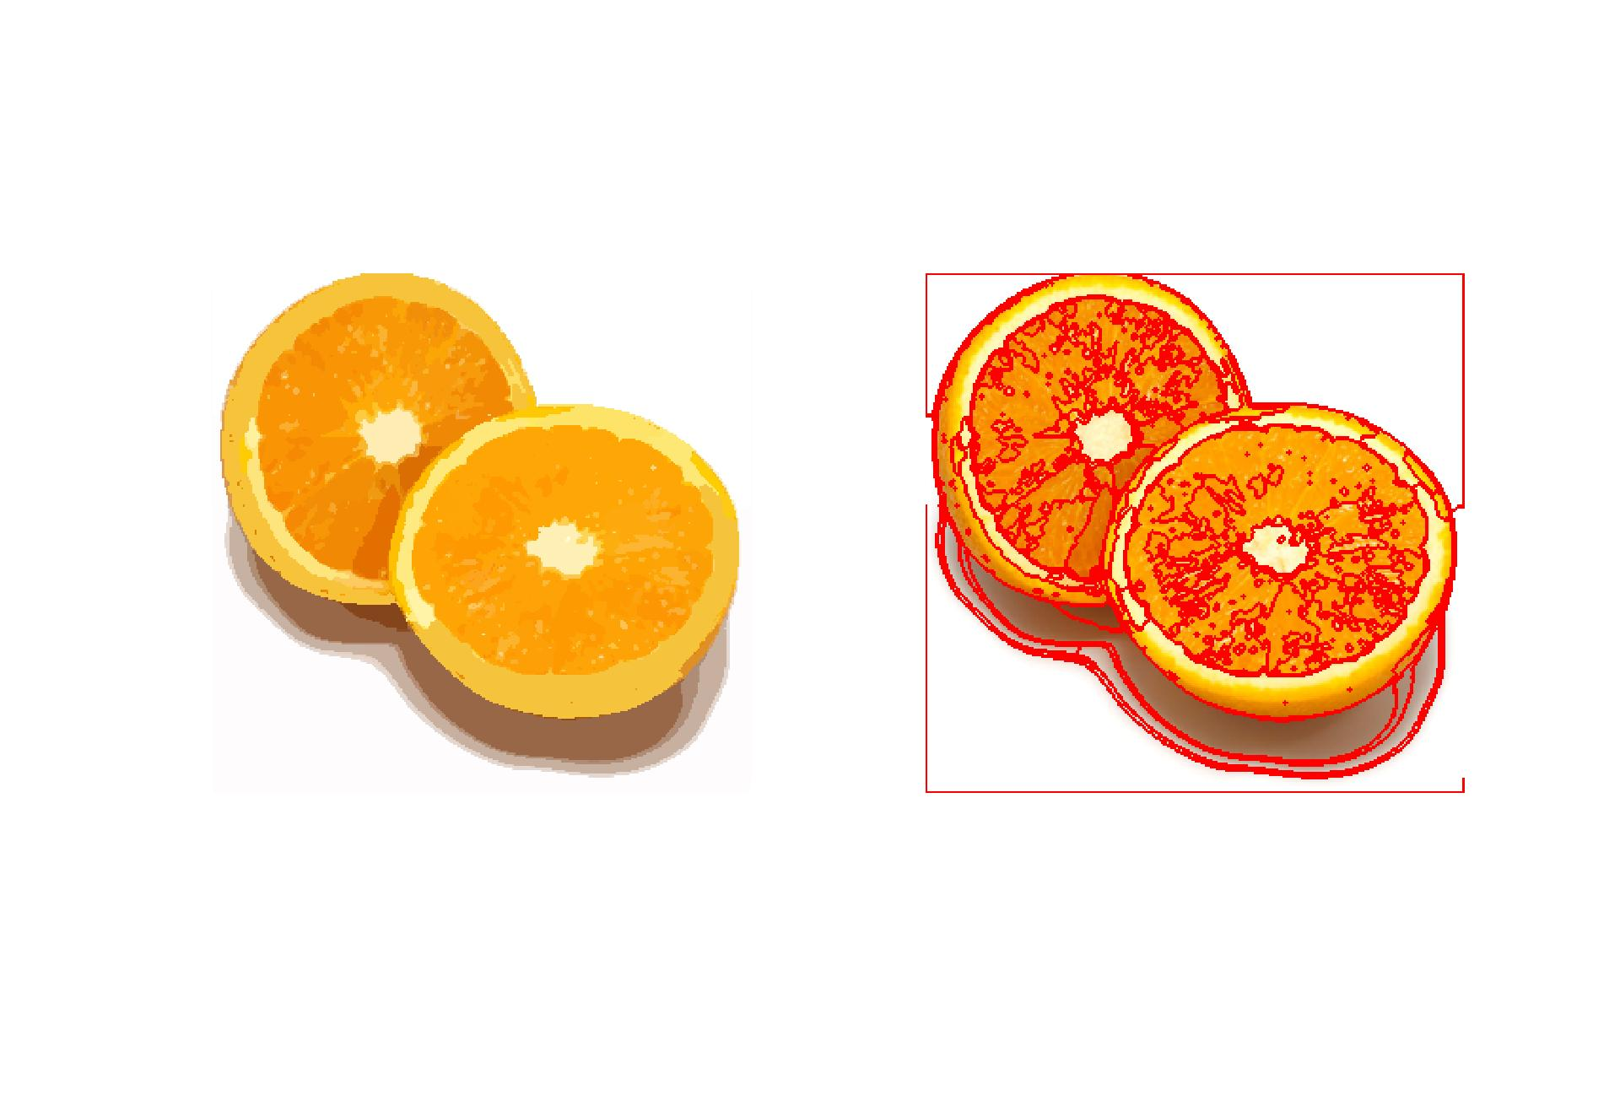

Figure 5. Segmentation result with spatial_bandwidth = 5 and color_bandwidth = 0.5

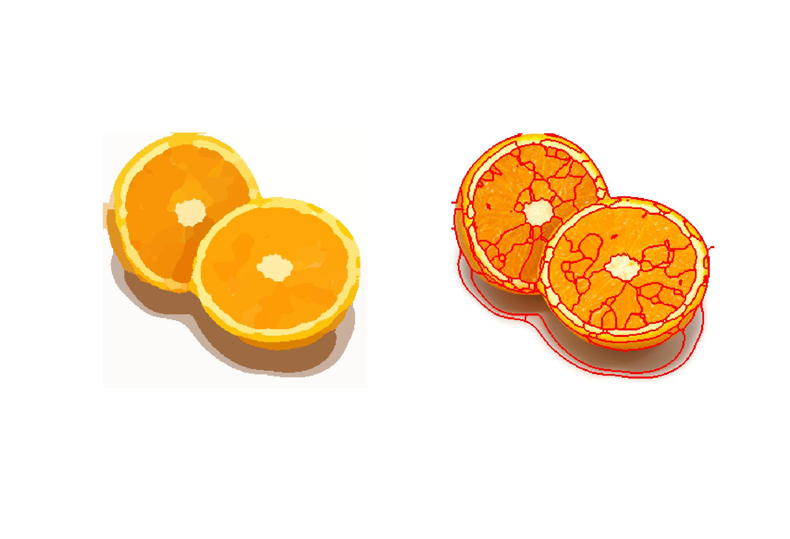

Figure 6. Segmentation result with spatial_bandwidth = 5 and color_bandwidth = 15

___________________________________________________________________________

**Question 6**: What kind of similarities and differences do you see between K-means and mean-shift segmentation?

Answers:

Similarities: They both consider color for segmentation.

Differences: 1. Mean-shift takes spatial information in consideration.

2. K-means controls number of clusters while mean-shift controls both color and spatial bandwidth.

___________________________________________________________________________

**Question 7**: Does the ideal parameter setting vary depending on the images? If you look at the images, can you see a reason why the ideal settings might differ? Illustrate with an example image with the parameters you prefer for that image.

Answers:

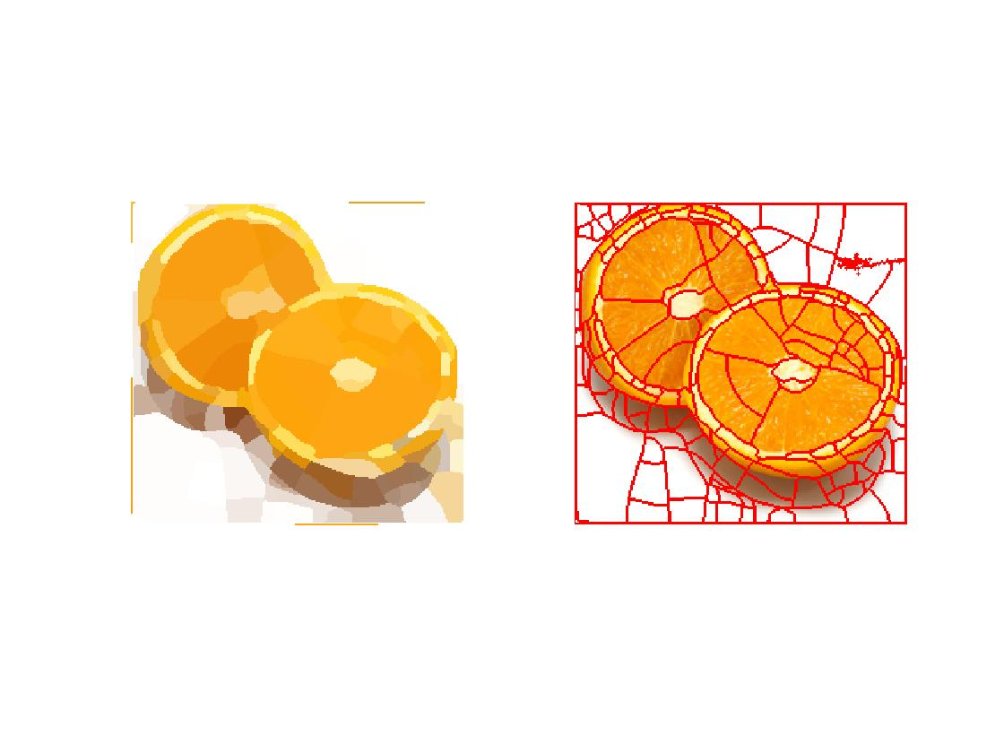

Figure 7. Normal cut with ncuts_thresh = 0.4, min_area = 50, max_depth = 8

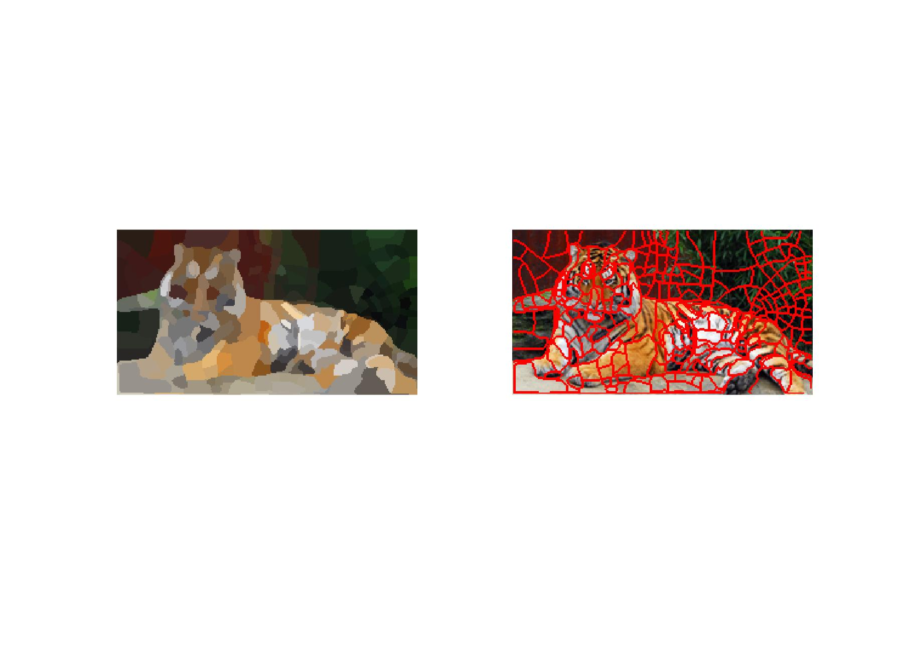

Figure 8. Normal cut with ncuts_thresh = 0.4, min_area = 20, max_depth = 8

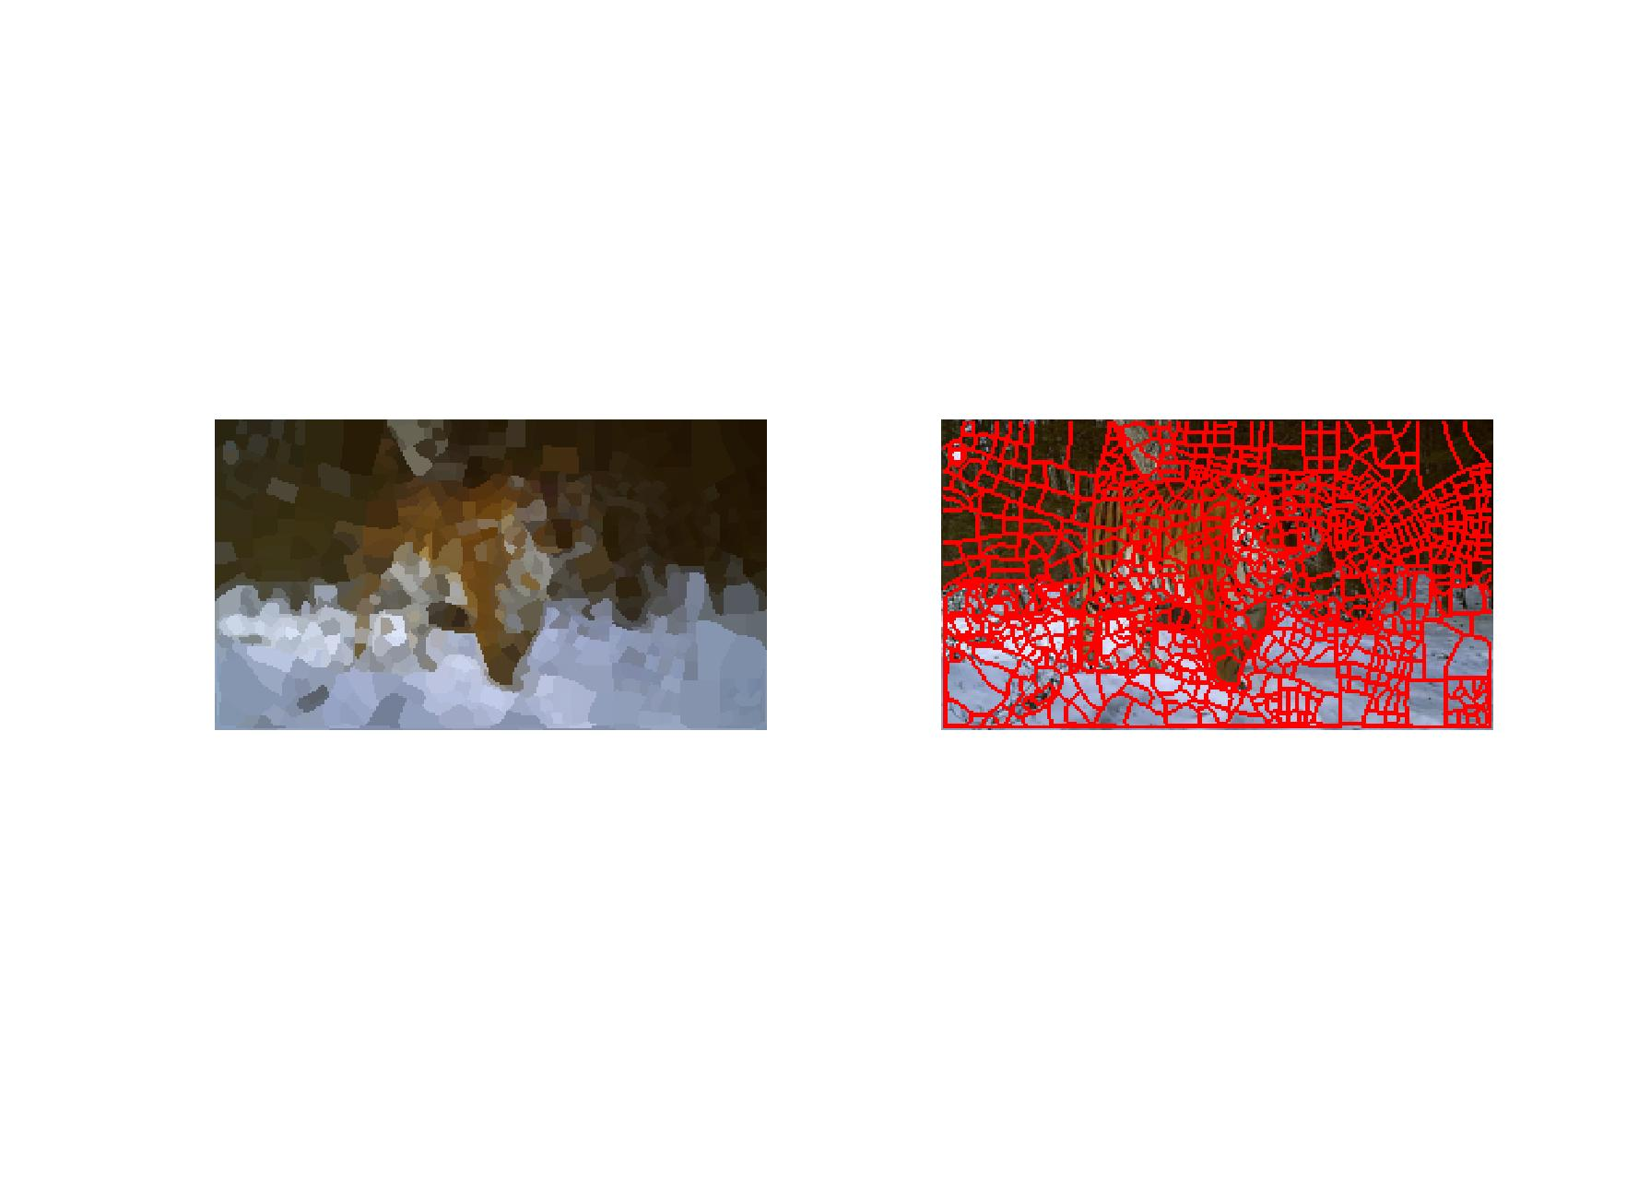

Figure 9. Normal cut with ncuts_thresh = 0.7, min_area = 20, max_depth = 10

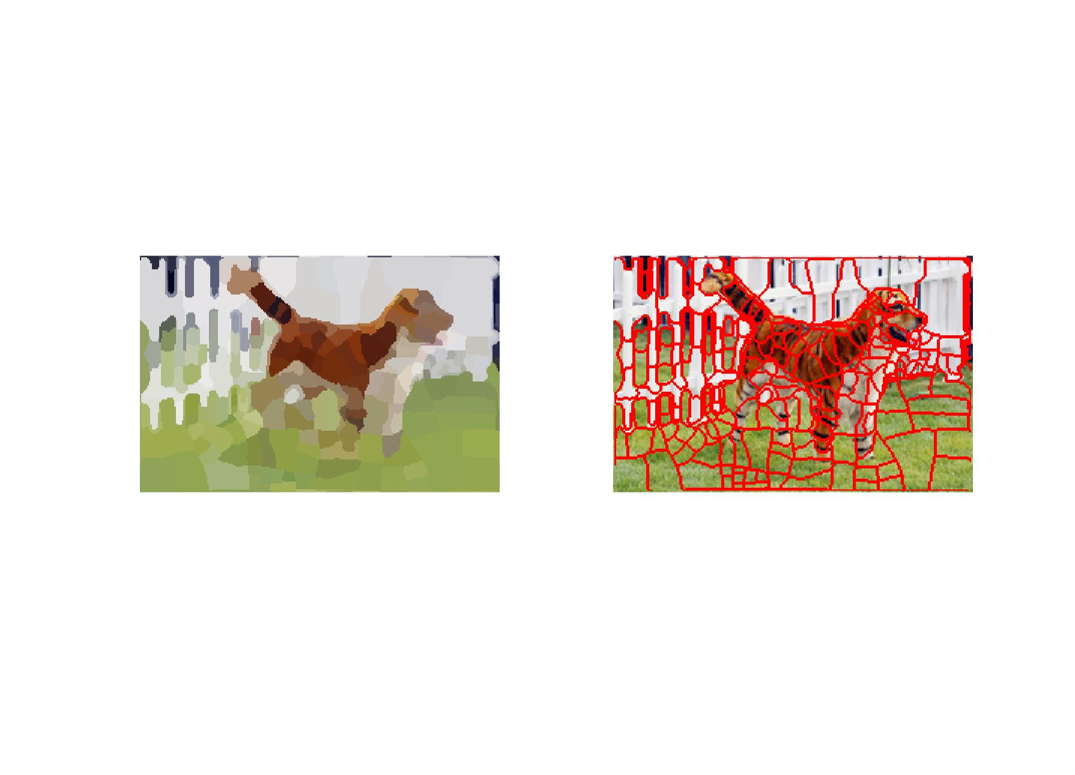

Figure 10. Normal cut with ncuts_thresh = 0.5, min_area = 10, max_depth = 8

The ideal parameters vary depending on the input image. Ncuts_thresh controls the maximum allowed value for a cut to take place which means it controls how similar subareas will be generated, min_area controls the minimum size of a segment and max_depth that limits the depth of recursion. Thus, for more complex images like the tigers, we have to increase ncuts_thresh and max_depth together with decreasing min_area to get a nice segmentation.

___________________________________________________________________________

**Question 8**: Which parameter(s) was most effective for reducing the subdivision and still result in a satisfactory segmentation?

Answers:

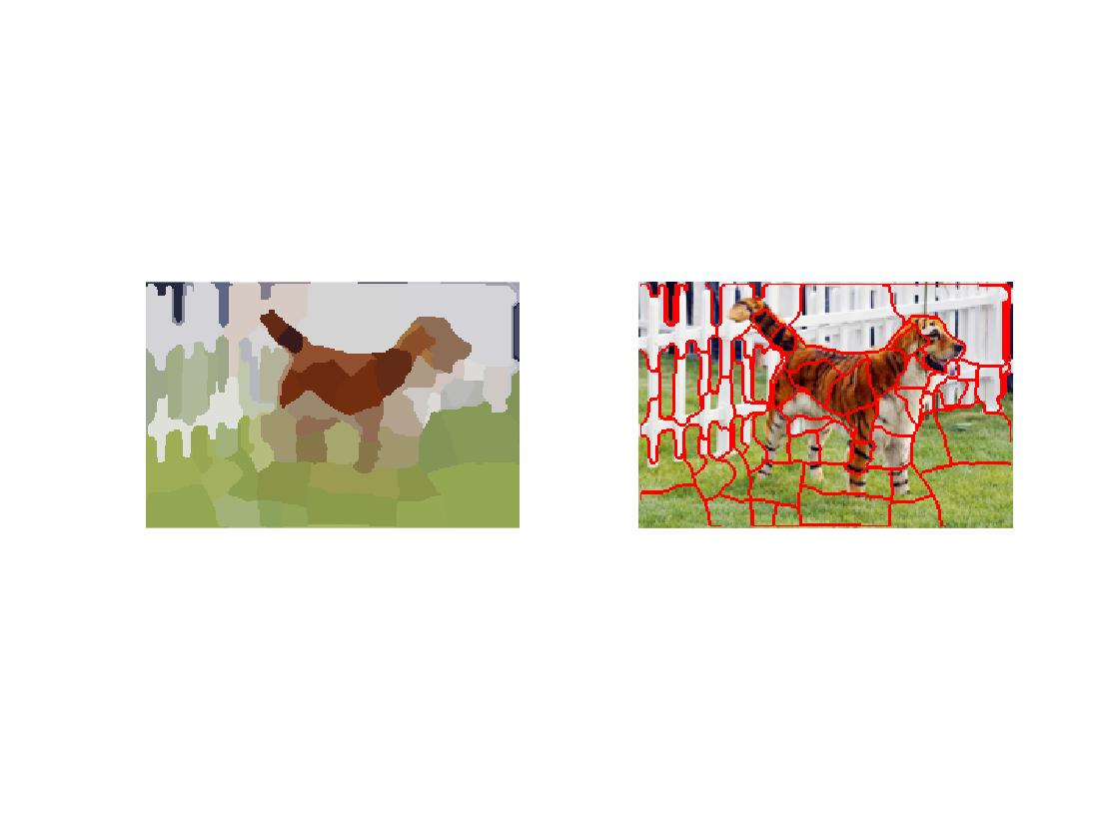

Figure 11. Normal cut with ncuts_thresh = 0.5, min_area = 10, max_depth = 6

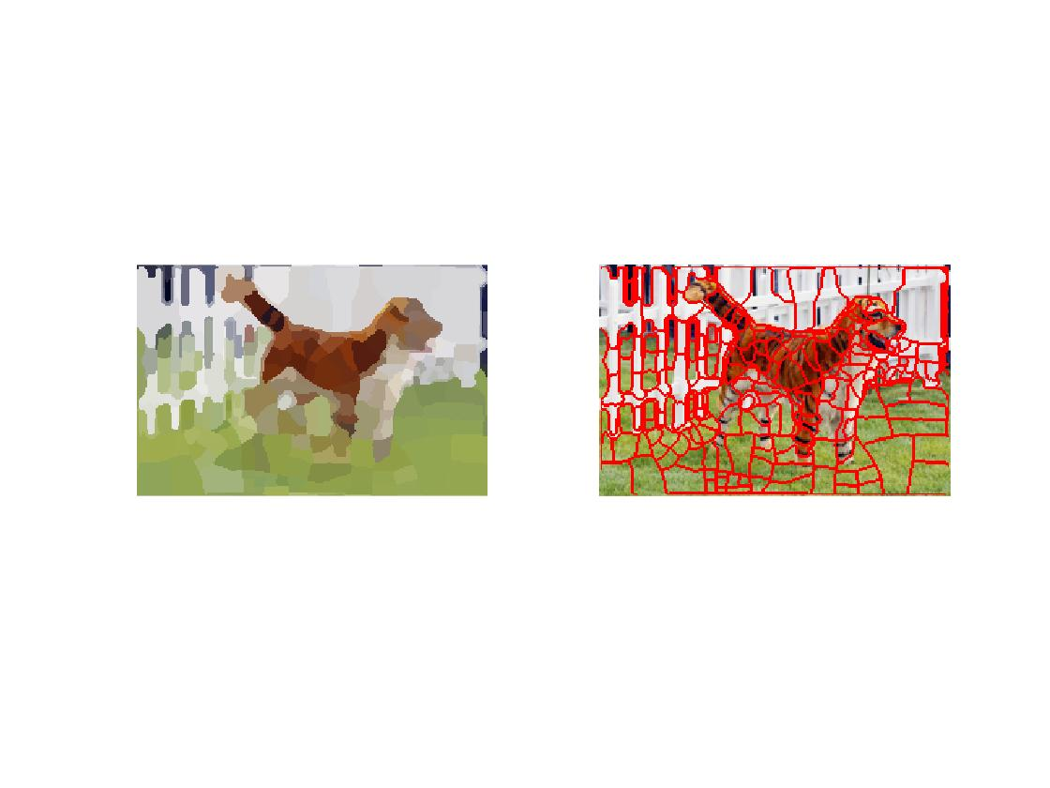

Figure 12. Normal cut with ncuts_thresh = 0.5, min_area = 10, max_depth = 8

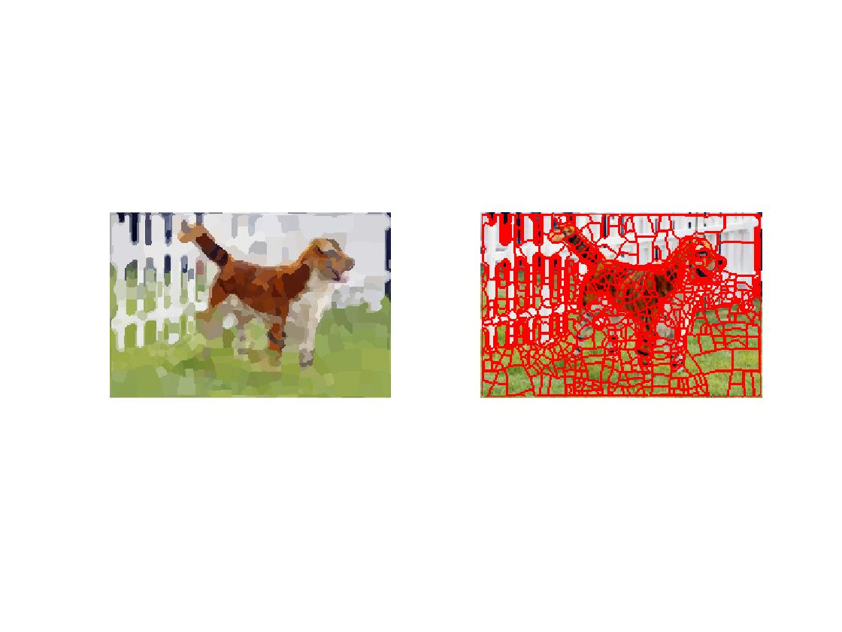

Figure 13. Normal cut with ncuts_thresh = 0.5, min_area = 10, max_depth = 10

As we can see in Figure 11-13, max_depth is the only changed parameter. The subdivisions are less with lower max_depth, but all of the three results show good segmentation.

___________________________________________________________________________

**Question 9**: Why does Normalized Cut prefer cuts of approximately equal size? Does this happen in practice?

Answers:



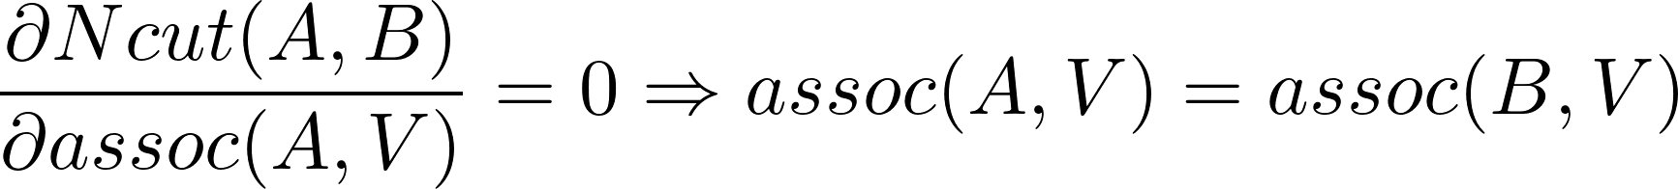

Since it is a NP-hard problem, in practice, we can not find the optimal solution directly. Thus, this does not happen in practice.

___________________________________________________________________________

**Question 10**: Did you manage to increase *radius* and how did it affect the results?

Answers:

Increasing radius will take more neighbors into computation, which increases the computation time, gets larger segments, but the color of segments will be strange sometimes.

___________________________________________________________________________

**Question 11**: Does the ideal choice of *alpha* and *sigma* vary a lot between different images? Illustrate with an example image with the parameters you prefer.

Answers:

The ideal choice of alpha and sigma varies between images. Since alpha and sigma controls the cost between pixels with different color. Larger alpha and sigma lead to smoother segment contour and become more sensitive to color. Different images have different color distribution and object shape, thus the ideal choice differs.

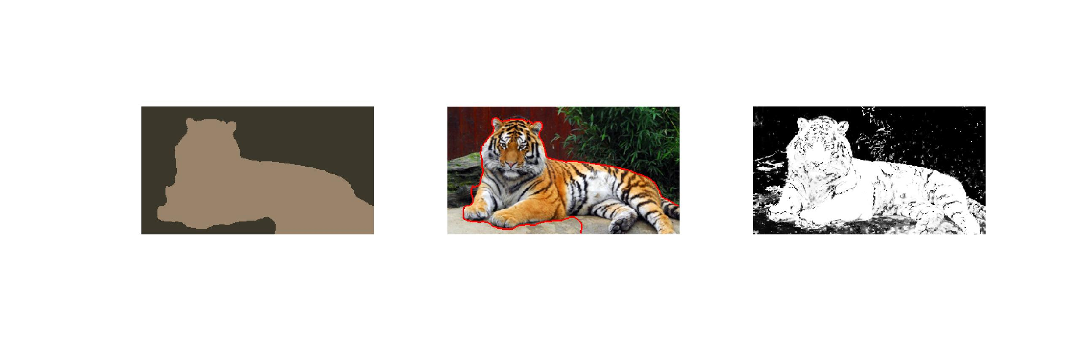

Figure 14. Graph cut with alpha = 20, sigma = 20

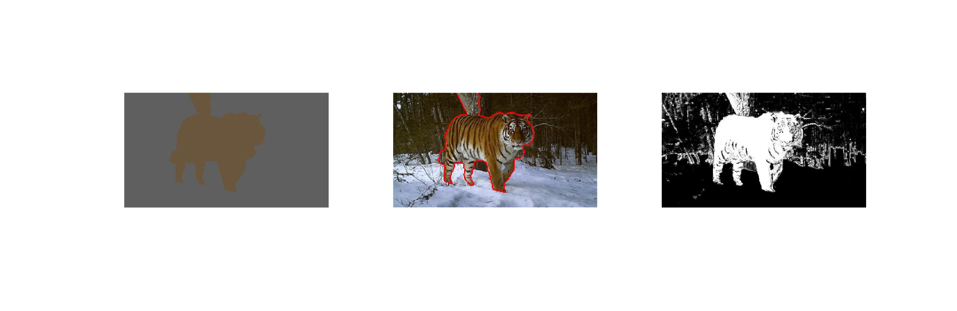

Figure 15. Graph cut with alpha = 10, sigma = 10

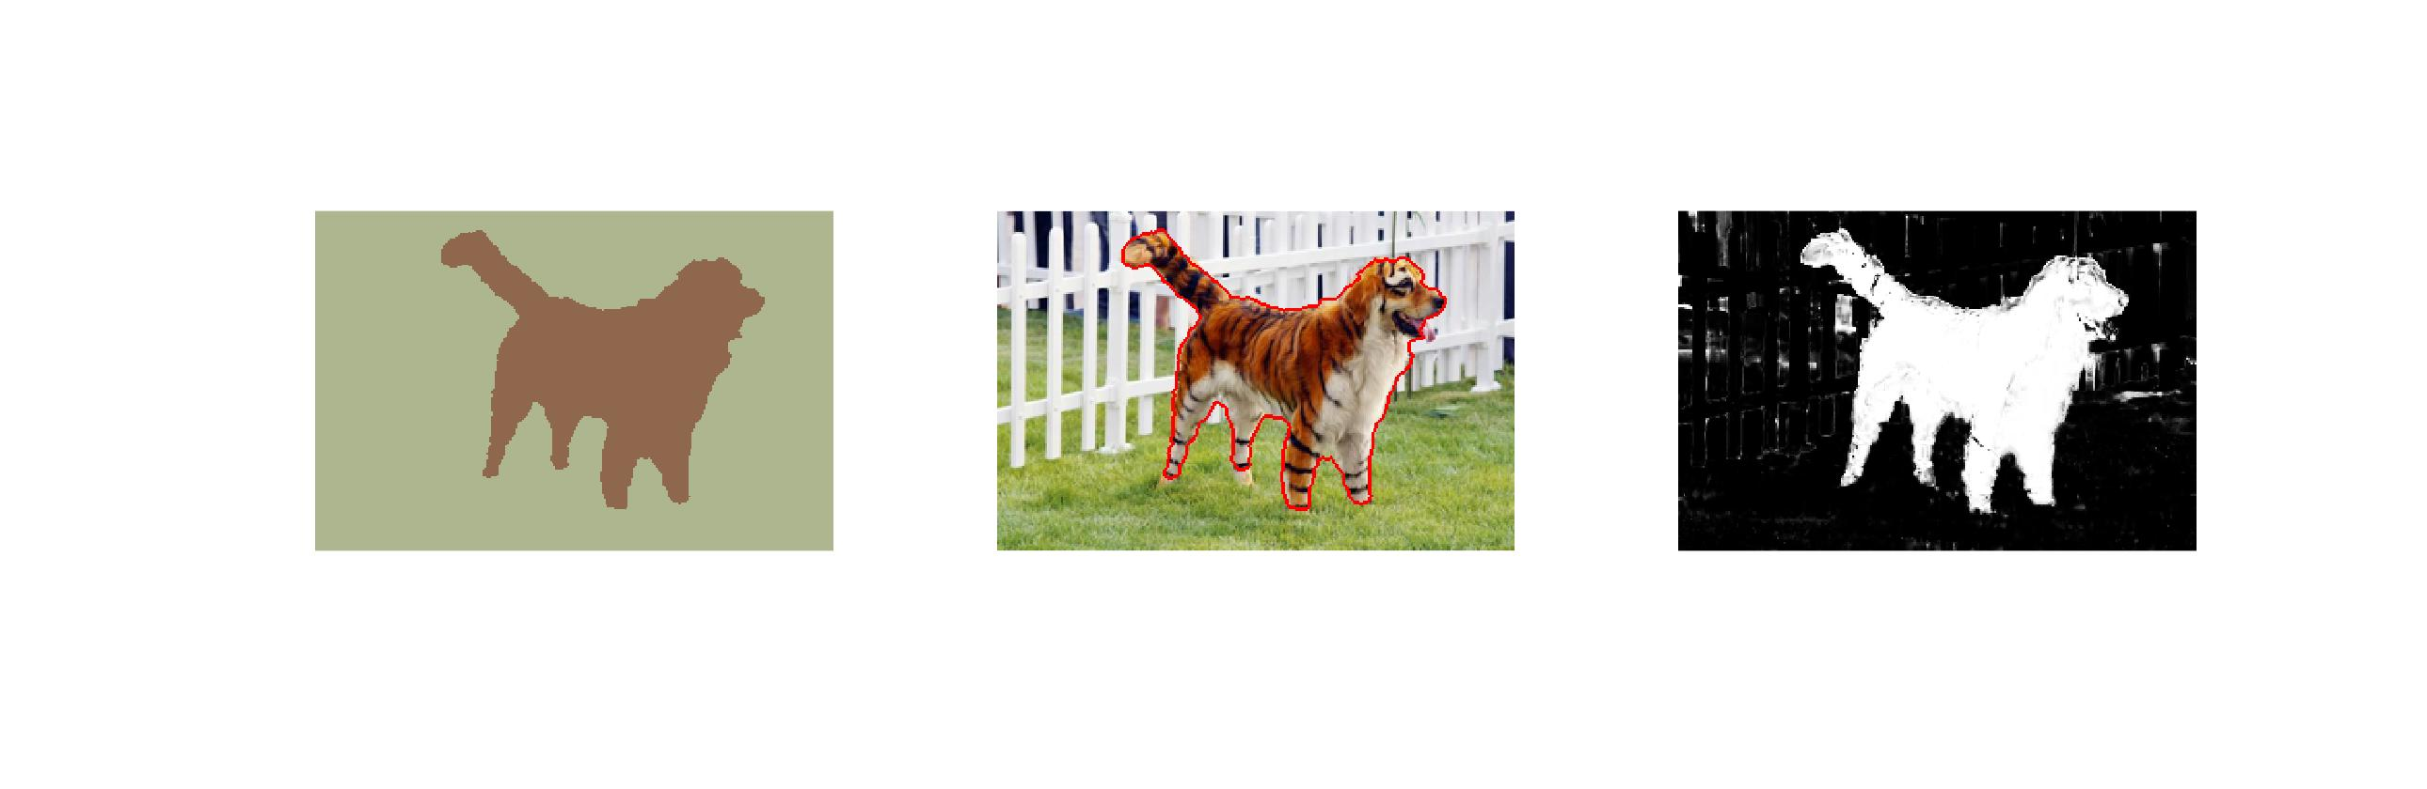

Figure 16. Graph cut with alpha = 10, sigma = 30

___________________________________________________________________________

**Question 12**: How much can you lower K until the results get considerably worse?

Answers:

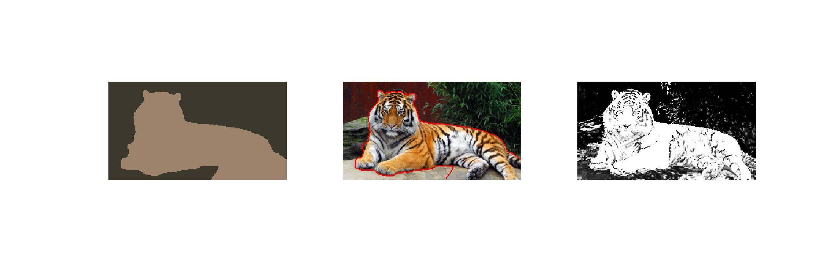

Figure 17. Graph cut with alpha = 20, sigma = 20, k = 3

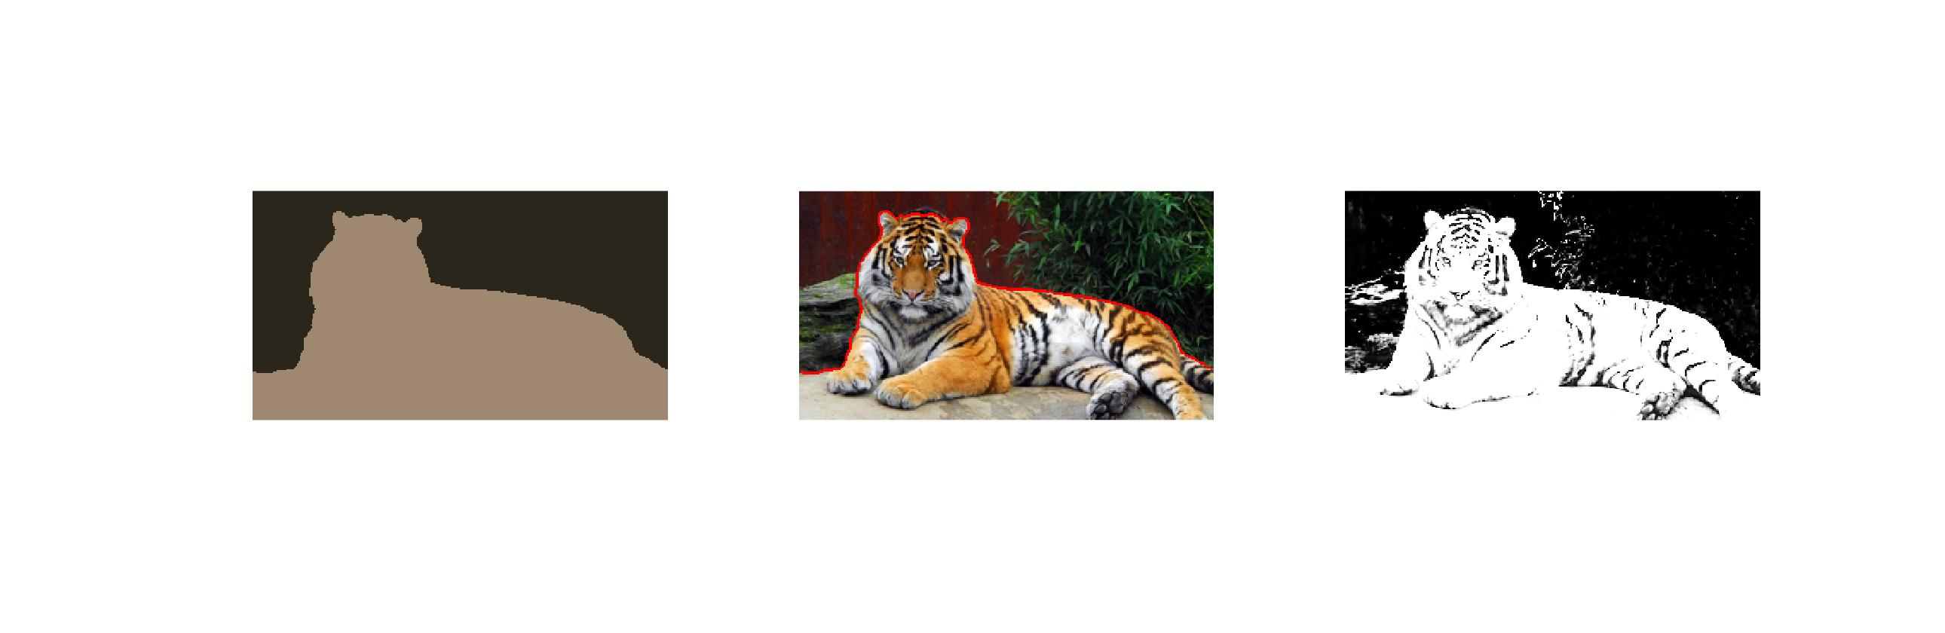

Figure 18. Graph cut with alpha = 20, sigma = 20, k = 2

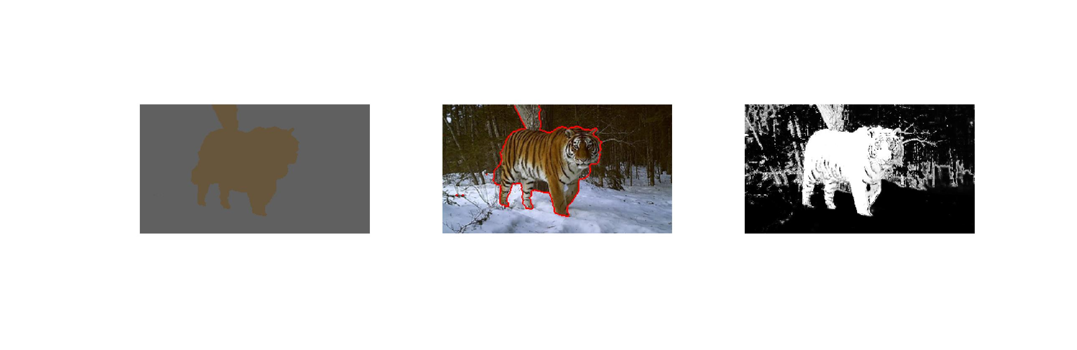

Figure 19. Graph cut with alpha = 10, sigma = 10, k = 3

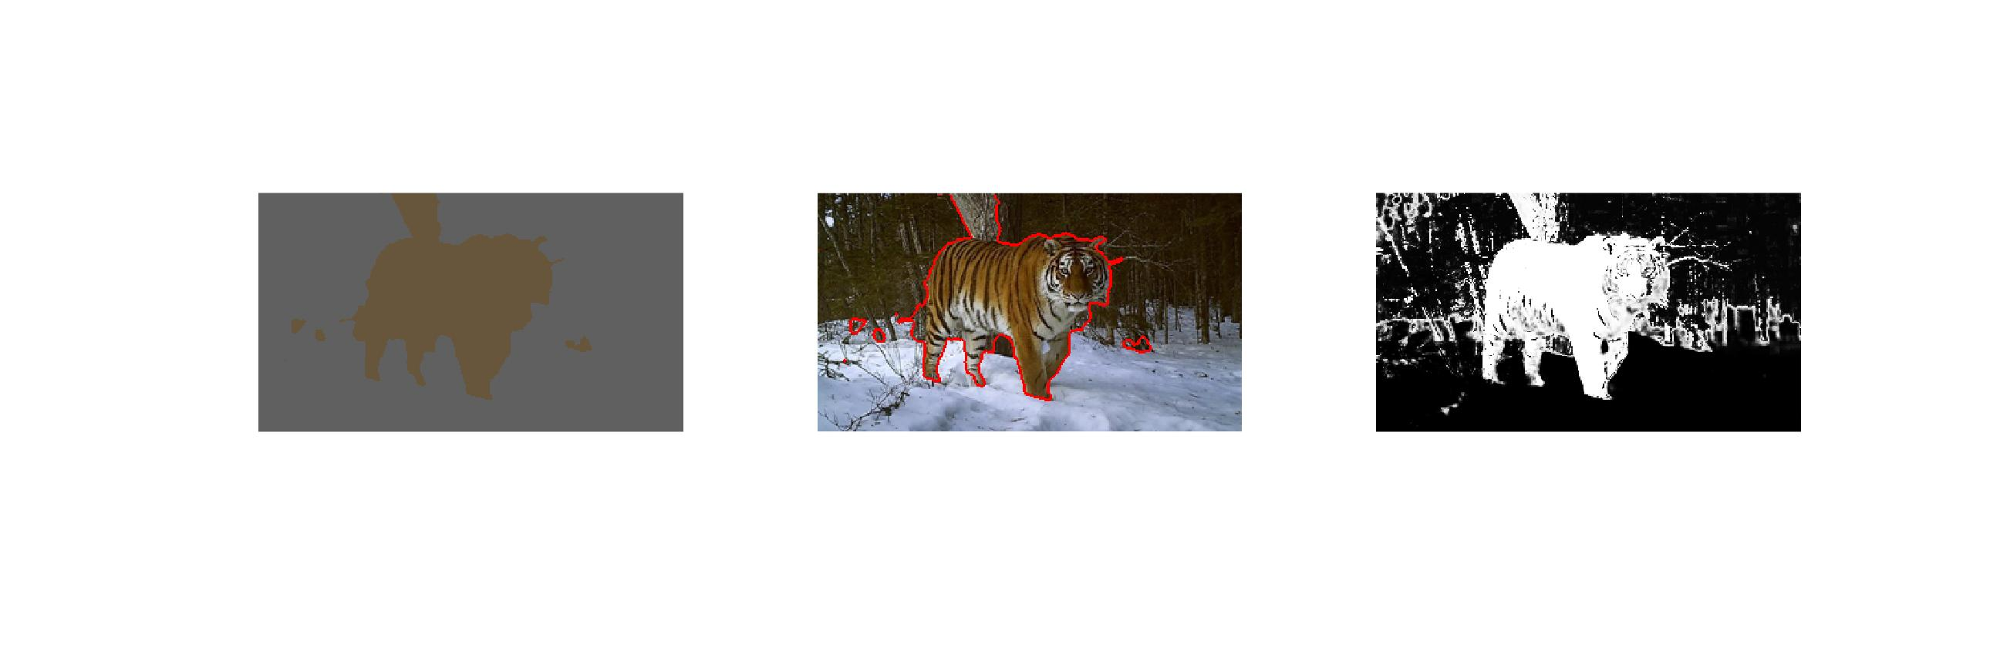

Figure 20. Graph cut with alpha = 10, sigma = 10, k = 2

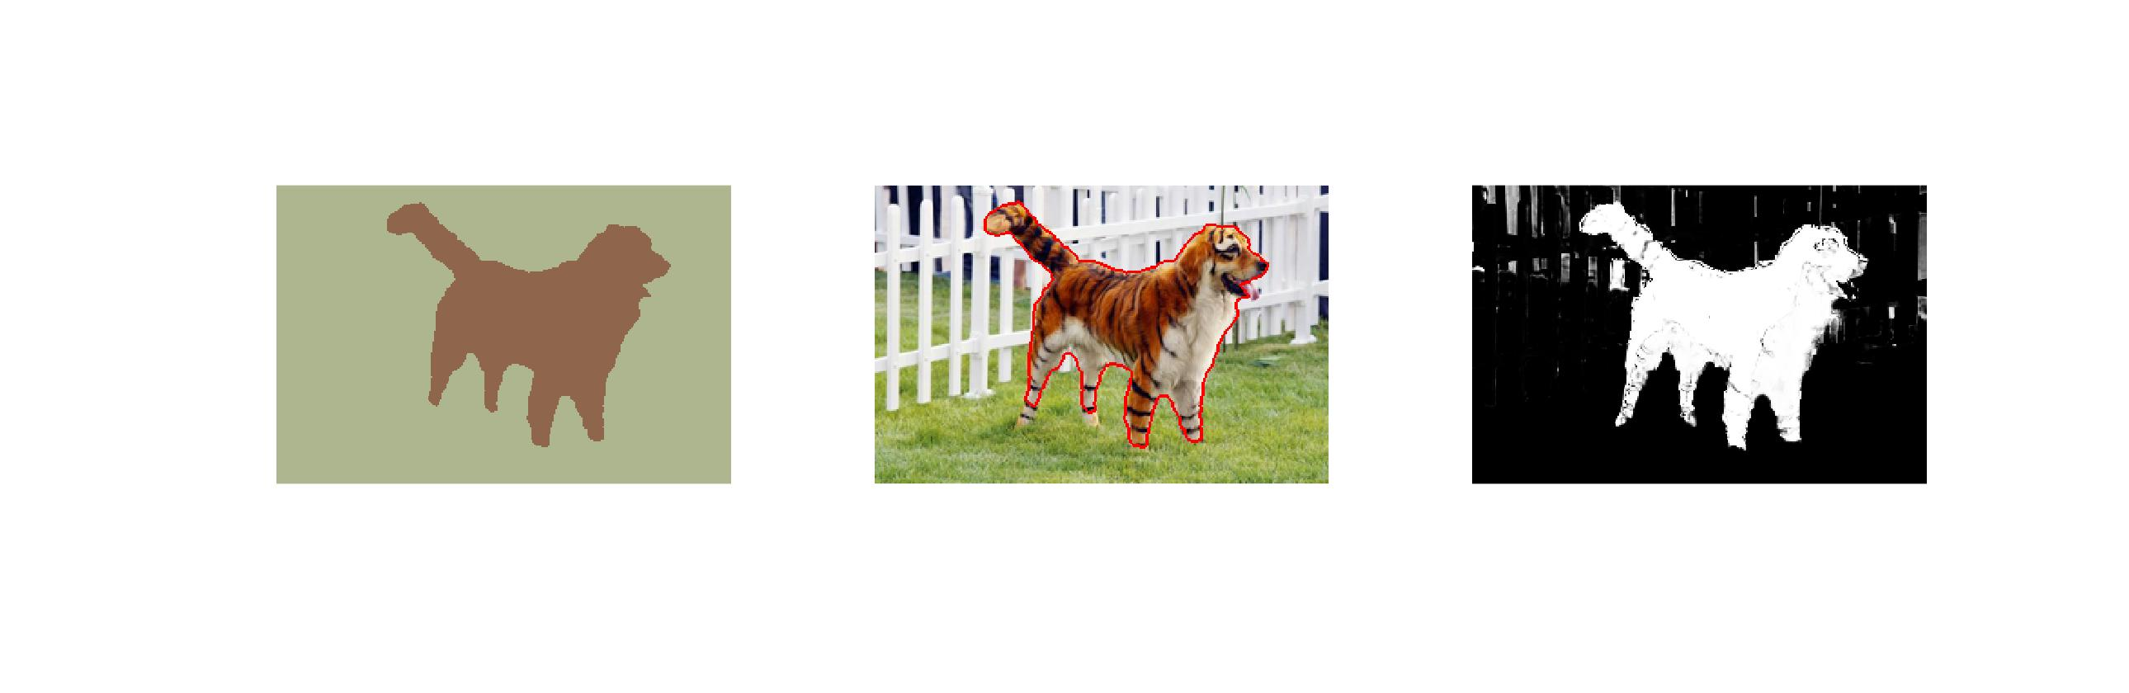

Figure 21. Graph cut with alpha = 10, sigma = 30, k=3

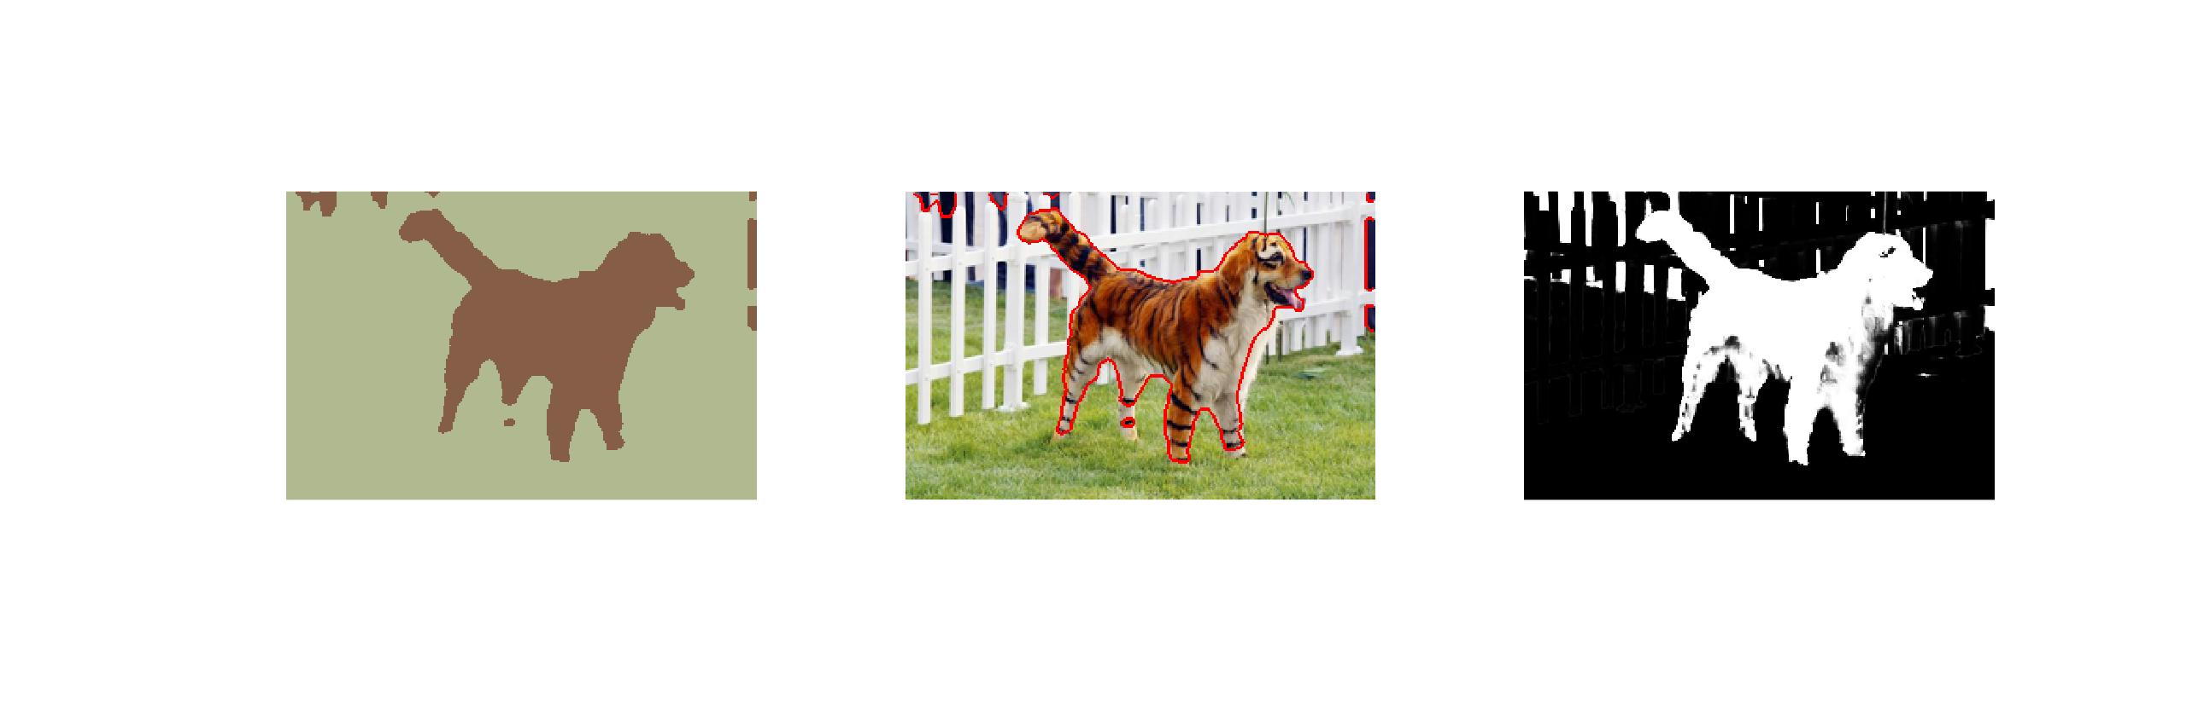

Figure 22. Graph cut with alpha = 10, sigma = 30, k=2

**Question 13**: Unlike the earlier method Graph Cut segmentation relies on some input from a user for defining a rectangle. Is the benefit you get of this worth the effort? Motivate!

Answers:

It definitely helps getting the better result. The earlier methods only generate segments with similar color with/without spatial information, while Graph Cut segmentation is able to identify the object in foreground or background with a defined foreground rectangle. And when the rectangle is well defined without too much background pixels, the segmentation result is almost perfect with a little computation costs.

___________________________________________________________________________

**Question 14**: What are the key differences and similarities between the segmentation methods (K-means, Mean-shift, Normalized Cut and energy-based segmentation with Graph Cuts) in this lab? Think carefully!!

Answers:

___________________________________________________________________________