**ФЕДЕРАЛЬНОЕ АГЕНТСТВО СВЯЗИ**

Федеральное государственное бюджетное образовательное учреждение

высшего образования

«Поволжский государственный университет телекоммуникаций и информатики»

**КОЛЛЕДЖ СВЯЗИ**

**Hardware, Software and Programming Essentials**

**Учебное пособие по дисциплине «Иностранный язык»**

для специальностей:

09.02.03 - Программирование в компьютерных системах

09.02.04 - Информационные системы (по отраслям)

**Составила:**

**Преподаватель Назаренко М.К.**

Самара, 2019

|  |  |
| --- | --- |
| Рассмотрено на заседании П(Ц)К  **Общеобразовательных и гуманитарных дисциплин**  пр. №______ «_____» _________________ 2019 г.  Председатель П(Ц)К ________________ Никифоров М.М. | Утверждено:  Зам. директора по УВР  ___________________ Логвинов А.В.  «____» ___________________ 2019 г. |

**Hardware, software and programming essentials.** Учебное пособие. Составлено преподавателем КС ПГУТИ Назаренко М.К., Самара, КС ПГУТИ, 2019 г. – 6,5 п.л.

**СОДЕРЖАНИЕ:**

1. **UNIT 1. Everything you need to know about hardware…………………………………………4**
2. **UNIT 2. What is a computer case? Part I…………………………………………………………7**

**What is a computer case? Part II………………………………………………………...9**

1. **UNIT 3. Central processing unit. Part I…………………………………………………………..11**

**Central processing unit. Part II…………………………………………………………13**

1. **UNIT 4. Motherboard…………………………………………………………………………….15**
2. **UNIT 5. Random access memory………………………………………………………………...18**

**Extra reading task: Playing video games – good or bad……………………………....20**

1. **UNIT 6. Hard disk drive. Part I………………………………………………………………….21**

**Hard disk drive. Part II………………………………………………………………….24**

**Extra reading task: Solid state drive (SSD)…………………………………………….26**

1. **UNIT 7. Monitors………………………………………………………………………………….27**

**Extra reading task: What is a computer mouse? ………………………………………29**

1. **UNIT 8. Keyboards……………………………………………………………………………….30**

**All-in-one units…………………………………………………………………………..33**

1. **UNIT 9. Network hardware. Part I………………………………………………………………34**

**DSL………………………………………………………………………………………36**

**Network hardware. Part II. The definition and purpose of a network firewall.........37**

**Wi-Fi……………………………………………………………………………………...39**

**REVISION………………………………………………………………………………40**

1. **UNIT 10. What is software? ……………………………………………………………………..41**

**Extra reading task: What is software piracy? ……………………………………….44**

1. **UNIT 11. Operating systems. Part I………………………………………………………………45**

**Operating systems. Part II……………………………………………………………..47**

1. **UNIT 12. Programming and programming languages………………………………………….49**
2. **ЛИТЕРАТУРА……………………………………………………………………………………52**

**Unit One**

**Everything you need to know about computer hardware**

***Read the vocabulary:***

1. Hardware ['hɑːdweə] – аппаратное обеспечение, «железо»
2. Install [ɪn'stɔːl] – устанавливать
3. Unless [ən'les] – если не, пока не
4. Software ['sɔftweə] – программное обеспечение, «софт»
5. Data ['deɪtə] – данные
6. Housing ['hauzɪŋ] – корпус
7. Tablet ['tæblət] – планшет
8. Integrate ['ɪntɪgreɪt] – включать, интегрировать
9. Network ['netwɜːk] hardware – сетевое оборудование
10. Auxiliary [ɔːg'zɪlɪ(ə)rɪ] hardware – вспомогательное / дополнительное оборудование

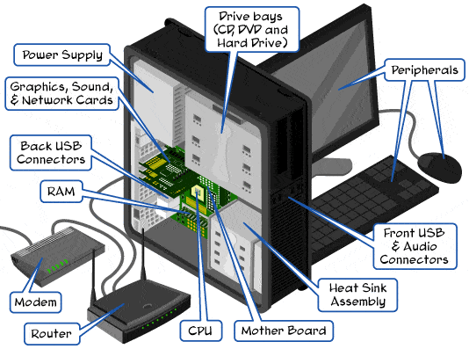

Computer hardware refers to the physical components that make up a computer system. There are many different kinds of hardware that can be installed inside, and connected to the outside, of a computer. Computer hardware may sometimes be seen abbreviated as computer hw.

**Note:**

A computer system isn't complete unless there's also software, which is different than hardware. The software is data that's stored electronically, like an [operating system](https://www.lifewire.com/operating-systems-2625912) or a video editing tool, which runs on the hardware.

### List of computer hardware

Here are some common individual computer hardware components that you'll often find inside a modern computer. These parts are almost always found inside the [computer's housing](https://www.lifewire.com/what-is-a-computer-case-2618149):

***(Write down the following words in your copy-book with their translations)***

* [Motherboard](https://www.lifewire.com/motherboards-system-boards-and-mainboards-2618154)
* [Central Processing Unit](https://www.lifewire.com/what-is-a-cpu-2618150) (CPU)
* [Random Access Memory](https://www.lifewire.com/what-is-random-access-memory-ram-2618159) (RAM)
* [Power Supply](https://www.lifewire.com/power-supply-unit-2618158)
* [Video Card](https://www.lifewire.com/what-is-a-video-card-2618161)
* [Hard Drive](https://www.lifewire.com/what-is-a-hard-disk-drive-2618152) (HDD)
* Solid-State Drive (SSD)
* [Optical Drive](https://www.lifewire.com/what-is-an-optical-disc-drive-2618157) (e.g. BD/DVD/CD drive)
* Card Reader (SD/SDHC, CF, etc.)

Here is some common hardware that you might find connected to the outside of a computer, although many [tablets](https://www.lifewire.com/what-is-a-tablet-4157433), laptops, and netbooks integrate some of these items into their housings:

***(Write down the following words in your copy-book and find their translations)***

* [Monitor](https://www.lifewire.com/what-is-a-monitor-2618155)
* [Keyboard](https://www.lifewire.com/what-is-a-keyboard-2618153)
* [Mouse](https://www.lifewire.com/what-is-a-mouse-2618156)
* [Battery Backup](https://www.lifewire.com/what-is-a-battery-backup-2618164) (UPS)
* [Flash Drive](https://www.lifewire.com/what-is-a-flash-drive-2625794)
* Printer
* Speakers
* [External Hard Drive](https://www.lifewire.com/what-is-an-external-drive-2625867)
* Pen Tablet

Here are some less common individual computer hardware devices, either because these pieces are now usually integrated into other devices or because they've been replaced with newer technology:

***(Write down the following words in your copy-book and find their translations)***

* [Sound Card](https://www.lifewire.com/what-is-a-sound-card-2618160)
* [Network Interface Card](https://www.lifewire.com/definition-of-nic-817866) (NIC)
* Expansion Card ([Firewire](https://www.lifewire.com/what-is-firewire-2625918), [USB](https://www.lifewire.com/universal-serial-bus-usb-2626039), etc.)
* Hard Drive Controller Card
* Analog Modem
* Scanner
* Projector
* [Floppy Disk Drive](https://www.lifewire.com/what-is-a-floppy-drive-2618151)
* Joystick
* Webcam
* Microphone
* Tape Drive
* Zip Drive

The following hardware is referred to as ​network hardware, and various pieces are often part of a home or business network:

***(Write down the following words in your copy-book and find their translations)***

* Digital Modem (e.g. Cable Modem, DSL Modem, etc.)
* [Router](https://www.lifewire.com/what-is-a-router-2618162)
* [Network Switch](https://www.lifewire.com/what-is-a-network-switch-2618163)
* [Access Point](https://www.lifewire.com/wireless-access-point-816545)
* [Repeater](https://www.lifewire.com/definition-of-repeater-816359)
* Bridge
* Print Server
* [Firewall](https://www.lifewire.com/definition-of-firewall-817568)

Network hardware isn't as clearly defined as some other types of computer hardware. For example, many home routers will often act as a combination router, switch, and firewall.

In addition to all the items listed above, there's more computer hardware called auxiliary hardware, of which a computer might have none, or several, of some kinds:

***(Write down the following words in your copy-book and find their translations)***

* Fan (CPU, GPU, Case, etc.)
* Heat Sink
* Data Cable
* Power Cable
* [CMOS Battery](https://www.lifewire.com/what-is-cmos-2625826)
* Daughterboard

Some of the devices listed above are called *peripheral [pə'rɪf(ə)r(ə)l] devices*. A [peripheral device](https://www.lifewire.com/peripheral-device-2625951) is a piece of hardware (whether internal or external) that isn't actually involved in the computer's main function. Examples include a monitor, video card, disc drive, and mouse.

**Exercise 1. Find the English equivalents of the following words and word combinations.**

Физические компоненты; быть частью/составлять; соединять; полный/целостный; хранить при помощи электронных устройств; видео редактор; отдельные компоненты; внутри; снаружи; хотя; ноутбук; заменять; различные части; чётко определённый; сочетание; некоторые/несколько; включать в себя.

**Exercise 2. Answer the questions below.**

1. What is computer hardware?
2. Is computer hw complete in itself?
3. What is computer software? Set some examples of the software.
4. What are the main hardware components that are found inside of a computer?
5. What are the main hardware components that are connected to the outside of a computer?
6. Why isn’t network hardware as clearly defined as other types of computer hardware?
7. What is the definition of peripheral devices of a computer system?

**Exercise 3. Learn the vocabulary and the words you have written out form the text by heart.**

**Exercise 4. Retell the text using your answers (ex. 2).**

**Unit two**

**What is a computer case? (Part I)**

***Read the vocabulary:***

1. Bundle ['bʌndl] – поставлять в комплекте
2. Since [sɪn(t)s] – (*здесь*) так как
3. Chassis ['ʃæsɪ] – шасси, ходовая часть, (*здесь*) – компьютерный блок
4. Form factor [fɔːm 'fæktə] – форм-фактор (конструктивная характеристика, определяющая геометрическую форму и габаритные размеры устройства)
5. Compatible [kəm'pætəbl] with – совместимый
6. Assume [ə's(j)uːm] – допускать, предполагать
7. Double ['dʌbl] – выполнять двойную функцию
8. Vent [vent] – вентиляционное отверстие
9. Malfunction [ˌmæl'fʌŋkʃ(ə)n] – неисправность
10. Accessible [ək'sesəbl] – доступный, удобный

The computer case serves mainly as a way to physically contain all of the actual components inside of a computer. They typically come bundled with a [power supply](https://www.lifewire.com/power-supply-unit-2618158). The housing of a laptop, netbook, or [tablet](https://www.lifewire.com/what-is-a-tablet-4157433) is also considered a case but since they aren't purchased separately, the computer case tends to refer to the one that's part of a traditional desktop PC.

**Note:** The computer case is also known as a tower, box, system unit, base unit, enclosure, housing, chassis, and cabinet.

Motherboards, computer cases, and power supplies all come in different sizes called [*form factors*](https://www.webopedia.com/DidYouKnow/Hardware_Software/motherboard_form_factors.asp). All three must be compatible to work properly together.

There are several reasons why we use computer cases. One is for protection, which is easy to assume because it's the most obvious. Dust, animals, toys, liquids, etc. can all damage the internal parts of a computer if the hard shell of a computer case doesn't enclose them and keep them away from the outside environment.

Do you always want to be looking at the disc drive, hard drive, motherboard, cables, power supply, and everything else that makes up the computer? Probably not. Hand-in-hand with protection, a computer case also doubles as a way to hide all those parts of the computer that nobody really wants to see each time they look in that direction.

Another good reason to use a computer case is to [keep the area cool](https://www.lifewire.com/ways-to-keep-your-computer-cool-2624713). Proper airflow over the computer components is one more benefit to using a computer case. While the case has special vents to allow some of the fan air to escape, the rest of it can be used to cool down the [hardware](https://www.lifewire.com/computer-hardware-2625895), which would otherwise get pretty hot and possibly overheat to the point of malfunction.

Keeping [noisy computer parts](https://www.lifewire.com/fix-a-computer-fan-thats-loud-or-making-noise-2624890), like the fans, in a closed space within the computer case is one way to reduce the noise that they make.

The structure of the computer case is also important. The different parts can fit together and become easily accessible to the user by being compacted in a case to hold it all together. For example, [USB](https://www.lifewire.com/universal-serial-bus-usb-2626039) ports and the [power button](https://www.lifewire.com/power-button-and-on-off-symbols-2625969) are easily accessible and the disc drive can be opened at any time.

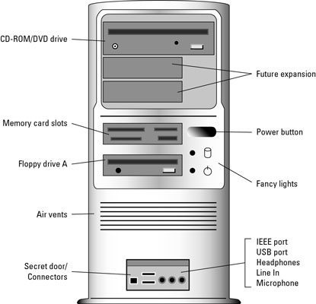

**Exercise 1. Find the English equivalents of the following words and word combinations.**

Содержать/вмещать в себя; покупать; настольный; быть представленным в различных размерах; работать должным образом; для защиты; очевидный; повреждать; оболочка; рука об руку; каждый раз; правильный поток воздуха; охлаждать; перегреваться; уменьшить уровень шума; кнопка питания.

**Exercise 2. Learn the vocabulary.**

**Exercise 3. List (перечислите) five main reasons to use a computer case (in writing).**

**Exercise 4. Retell the text using your answers (ex. 3).**

**What is a computer case? (Part II)**

***Read the vocabulary:***

1. Instead [ɪn'sted] – вместо
2. Styrofoam [sta͟ɪ͟ərəfoʊm] – стирофом (пенопластовый материал)
3. Rectangular [rek'tæŋgjələ] – прямоугольный
4. Case modding [keɪs mɔdin] – моддинг системного блока
5. Custom ['kʌstəm] – сделанный на заказ
6. Inch [ɪnʧ] – дюйм (2,54 см)
7. Expansion bay [ɪk'spæn(t)ʃ(ə)n beɪ]– отсек, часть системного блока, предназначенная для установки встраиваемых накопителей
8. Mount [maunt] - монтировать
9. Power cord ['pauə kɔːd] – шнур питания
10. Attach to [ə'tæʧ] – присоединять к…

The computer case itself can be constructed from any material that allows the internal devices to be supported. This is usually steel, plastic, or aluminum but might instead be wood, glass, or styrofoam. Most computer cases are rectangular and black. Case modding is the term used to describe the styling of a case to personalize it with things like custom internal lighting, paint, or a liquid cooling system.

The front of the computer case contains a power button and sometimes a reset button. Small LED lights are also typical, representing the current power status, [hard drive activity](https://www.lifewire.com/what-is-a-hard-drive-activity-light-2625894), and sometimes other internal processes. These buttons and lights connect directly to the motherboard which is secured to the inside of the case.

Cases usually contain multiple 5.25 inch and 3.5 inch expansion bays for optical drives, floppy disk drives, hard drives, and other media drives. These expansion bays are located at the front of the case so that, for example, the DVD drive can be easily reached by the user when in use.

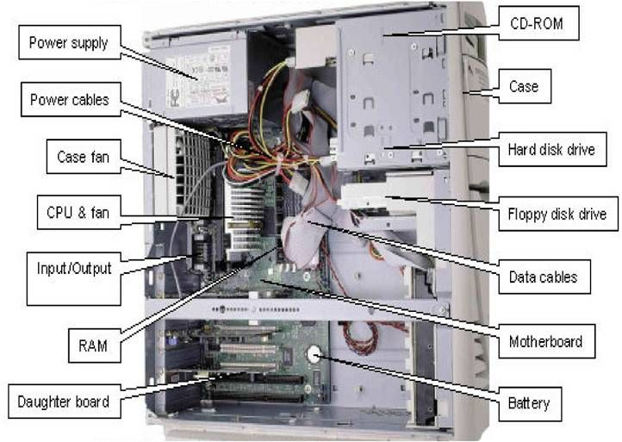At least one side of the case, perhaps both, slide to allow access to the internal components. The rear of the computer case contains small openings to fit the connectors contained on the motherboard which is mounted inside. The power supply is also mounted just inside the back of the case and a large opening allows for the connection of the power cord and use of the built-in fan. Fans or other cooling devices may be attached to any and all sides of the case.

**Exercise 1. Find the English equivalents of the following words and word combinations.**

Поддерживать; художественное оформление системного блока; внутренняя подсветка; система жидкостного охлаждения; кнопка перезагрузки; светодиоды; внутренние процессы; соединяться напрямую; многочисленные; так, чтобы; по меньшей мере; скользить; отверстия; встроенный.

**Exercise 2. Learn the vocabulary.**

**Exercise 3. Answer the following questions.**

1. What are the main materials used for computer case construction?
2. What is the usual form factor and color of computer cases?
3. What is case modding?
4. Where are power and reset buttons usually located?
5. Why are the expansion bays located at the front of the case?
6. How can a user get access to the internal components of the case?
7. What is placed on the rear side of the case?

**Exercise 4. Retell the text using your answers (ex. 3).**

**Unit 3**

**Central processing unit (CPU) (Part I)**

***Read the vocabulary:***

1. Interpret [ɪn'tɜːprɪt] – интерпретировать
2. Execute ['eksɪkjuːt] – выполнять
3. Rounded ['raundɪd] – закруглённый
4. Pin [pɪn] – контакт, штырёк, ножка (разъёма и/или микросхемы)
5. Socket ['sɔkɪt] – гнездо
6. Dissipate ['dɪsɪpeɪt] – рассеивать
7. Phase change unit [feɪz ʧeɪnʤ 'juːnɪt]– элемент изменения фазы
8. Handle ['hændl] – (здесь) брать в руки
9. Clock speed [klɔk spiːd]– тактовая частота (процессора)
10. Extrapolate [ɪk'stræpəleɪt] – экстраполировать (здесь – переносить на…)

The central processing unit (CPU) is the computer component that's responsible for interpreting and executing most of the commands from the computer's other [hardware](https://www.lifewire.com/computer-hardware-2625895) and software. All sorts of devices use a CPU, including desktop, laptop, [tablet](https://www.lifewire.com/what-is-a-tablet-4157433) computers, smartphones and even flat-screen television sets. [Intel](https://www.intel.com/content/www/us/en/homepage.html) and [AMD](https://www.amd.com/en) are the two most popular CPU manufacturers for desktops, laptops, and servers, while [Apple](https://www.apple.com/), [NVIDIA](http://www.nvidia.com/content/global/global.php), and [Qualcomm](https://www.qualcomm.com/) are big smartphone and tablet CPU makers.

### Image result for CPUWhat a CPU looks like and where it's located

A modern CPU is usually small and square, with many short, rounded, metallic connectors on its underside. Some older CPUs have pins instead of metallic connectors. The CPU [attaches directly to a CPU "socket"](https://www.lifewire.com/tour-inside-a-desktop-pc-2624588) (or sometimes a "slot") on the [motherboard](https://www.lifewire.com/motherboards-system-boards-and-mainboards-2618154). The CPU is inserted into the socket pin-side-down, and a small lever helps to secure the processor.

After running even a short while, modern CPUs can get very hot. To help dissipate this heat, it's almost always necessary to attach a heat sink and a fan directly on top of the CPU. Typically, these come bundled with a CPU purchase. Other more advanced cooling options are also available, including water cooling kits and phase change units.

As mentioned above, not all CPUs have pins on their bottom sides, but in the ones that do, the pins are easily bent. The user must take great care when handling, especially when installing onto the motherboard.

### CPU clock speed

The clock speed of a processor is the number of instructions it can process in any given second, measured in gigahertz (GHz). For example, a CPU has a clock speed of 1 Hz if it can process one piece of instruction every second. Extrapolating this to a more real-world example: a CPU with a clock speed of 3.0 GHz can process 3 billion instructions each second.

**Exercise 1. Find the English equivalents of the following words and word combinations.**

Квадратный; металлические коннекторы; ни нижней стороне; вместо; подключать напрямую; контактной стороной вниз; рычаг; даже короткое время; радиатор; обычно; идти в комплекте с; доступный; нижний; быть очень осторожным; количество инструкций; выполнять; в заданную секунду; пример из реального мира; миллиард.

**Exercise 2. Work in pairs: make a dialogue using these questions.**

* Do you have a computer, laptop or smartphone?
* Do you know its CPU manufacturer?
* What is the clock speed of the CPU?
* Are you satisfied with it?

**Exercise 3. Learn the vocabulary.**

**Exercise 4. Retell the text.**

**Central processing unit (CPU) (Part II)**

***Read the vocabulary:***

1. Apparent [ə'pær(ə)nt] – явный, видимый, очевидный
2. Simultaneously [ˌsɪm(ə)l'teɪnɪəslɪ] – одновременно
3. Performance [pə'fɔːmən(t)s] – производительность
4. Hyper-Threading ['haɪpə θredɪn]– гиперпотоковая технология
5. Referred to… [rɪ'fɜːd] – классифицируемые как…
6. Thread [θred] – поток, тред
7. Determine [dɪ'tɜːmɪn] – определять
8. CPU-demanding [si: piː ju: dɪmɑ:ndɪŋ] program – процессорозависимая программа
9. Cache [kæʃ] – кэш, сверхоперативная память
10. Data ['deɪtə] – данные

### CPU cores

Some devices have a single-core processor while others may have a dual-core (or quad-core, etc.) processor. As might already be apparent, having two processor units working side by side means that the CPU can simultaneously manage twice the instructions every second, drastically improving performance.

Some CPUs can virtualize two cores for every one physical core that's available, known as [Hyper-Threading](https://www.intel.com/content/www/us/en/architecture-and-technology/hyper-threading/hyper-threading-technology.html). Virtualizing means that a CPU with only four cores can function as if it has eight, with the additional virtual CPU cores referred to as separate threads. Physical cores, though, do perform better than virtual ones.

### More information on CPUs

Neither clock speed, nor simply the number of CPU cores, is the sole factor determining whether one CPU is "better" than another. It often depends most on the type of software that runs on the computer – in other words, the applications that will be using the CPU.

One CPU may have a low clock speed but is a quad-core processor, while another has a high clock speed but is only a dual-core processor. Deciding which CPU would outperform the other, again, depends entirely on what the CPU is being used for.

For example, a CPU-demanding [video editing program](https://www.lifewire.com/top-video-editing-software-1081918) that functions best on multiple CPU cores is going to work better on a multicore processor with low clock speeds than it would on a single-core CPU with high clock speeds. Not all software, games, and so on can even take advantage of more than just one or two cores, making any more available CPU cores useless.

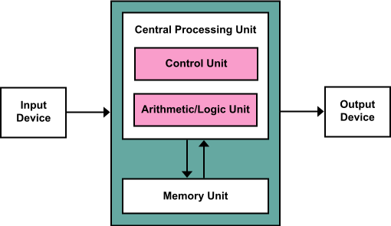Another component of a CPU is cache. CPU cache is like a temporary holding place for commonly used data. Instead of calling on random access memory ([RAM](https://www.lifewire.com/what-is-random-access-memory-ram-2618159)) for these items, the CPU determines what data you seem to keep using, assumes you'll want to keep using it, and stores it in the cache. Cache is faster than using RAM because it's a physical part of the processor; more cache means more space for holding such information.

**Exercise 1. Find the English equivalents of the following words and word combinations.**

Одноядерный процессор, двухъядерный процессор, четырёхъядерный процессор, многоядерный процессор; бок о бок; вдвое; резко; виртуализировать; физическое ядро; дополнительный; единственный фактор; приложение (программа); превосходить по техническим характеристикам; использовать в своих интересах; бесполезный; временное хранилище; обращаться к оперативной памяти; предполагать; сохранять.

**Exercise 2. Ask ten questions about CPUs (according to the text).**

**Exercise 3. Translate these words and find their synonyms in the text.**

* mechanism -
* at the same time -
* command -
* accessible –
* to operate –
* extra –
* single –
* program –
* completely –
* element –
* information –
* to save -

**Exercise 4. Learn the vocabulary.**

**Exercise 5. Retell the text.**

**Unit 4**

**Motherboard**

***Read the vocabulary:***

1. Via ['vaɪə ], [viːə] - посредством
2. Backbone ['bækbəun] – главная опора
3. Appropriately [ə'prəuprɪətlɪ] – уместно
4. Logic board ['lɔʤɪk bɔːd] – плата с логическими схемами
5. Solder ['səuldə] - припаивать
6. Jumper ['ʤʌmpə] – навесная перемычка / переключатель для изменения аппаратной конфигурации
7. Capacitor [kə'pæsɪtə] - конденсатор
8. Screw hole [skruː həul] – винтовое отверстие
9. With respect to… [wɪð rɪ'spekt] - что касается
10. Guidance ['gaɪd(ə)n(t)s] – руководство
11. Incorporate [ɪn'kɔːp(ə)reɪt] – включать в себя

The motherboard serves to connect all of the parts of a computer together. The [CPU](https://www.lifewire.com/what-is-a-cpu-2618150), [memory](https://www.lifewire.com/what-is-random-access-memory-ram-2618159), [hard drives](https://www.lifewire.com/what-is-a-hard-disk-drive-2618152), and other ports and expansion cards all connect to the motherboard directly or via cables.

The motherboard is the piece of computer [hardware](https://www.lifewire.com/computer-hardware-2625895) that can be thought of as the "backbone" of the PC, or more appropriately as the "mother" that holds all the pieces together.

Phones, tablets and other small devices have motherboards too but they're often called logic boards instead. Their components are usually soldered directly onto the board to save space, which means there aren't [expansion slots](https://www.lifewire.com/expansion-slot-2625870) for upgrades like you see in desktop computers.

The IBM Personal Computer that was released in 1981, is considered to be the very first computer motherboard.

### Motherboard components

Everything behind the [computer case](https://www.lifewire.com/what-is-a-computer-case-2618149) is connected in some way to the motherboard so that all the pieces can communicate with each other. This includes [video cards](https://www.lifewire.com/what-is-a-video-card-2618161), [sound cards](https://www.lifewire.com/what-is-a-sound-card-2618160), hard drives, [optical drives](https://www.lifewire.com/what-is-an-optical-disc-drive-2618157), the CPU, RAM sticks, [USB](https://www.lifewire.com/universal-serial-bus-usb-2626039) ports, a [power supply](https://www.lifewire.com/power-supply-unit-2618158), etc. On the motherboard are also expansion slots, [jumpers](https://www.lifewire.com/what-is-a-jumper-2625910), capacitors, device power and data connections, fans, heat sinks, and screw holes.

### Important motherboard facts

Motherboards vary greatly with respect to the types of components they support. For example, each motherboard supports a single type of CPU and a short list of memory types. Additionally, some video cards, hard drives, and other [peripherals](https://www.lifewire.com/peripheral-device-2625951) may not be compatible. The motherboard manufacturer should provide clear guidance on the compatibility of components.

In laptops and tablets the motherboard often incorporates the functions of the video card and sound card. This helps keep these types of computers small in size. However, it also prevents those built-in components from being upgraded.

Devices connected to a motherboard often need [device drivers](https://www.lifewire.com/what-is-a-device-driver-2625796) manually installed in order to make them work with the operating system.

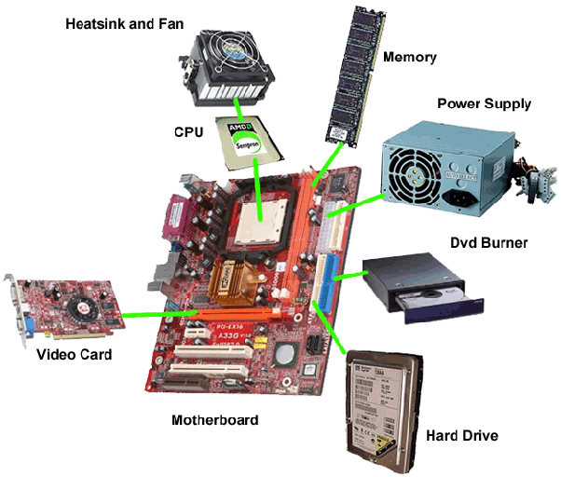

**Exercise 1. Find the English equivalents of the following words and word combinations.**

Соединять; карты расширения; слоты расширения; экономить место; самый первый; общаться друг с другом; подключение питания и передачи данных устройств; значительно различаться; совместимый; предотвращать; встроенные компоненты; модернизировать; драйверы устройств; устанавливать вручную.

**Exercise 2. Answer the questions.**

1. What does a motherboard serve for?
2. How different parts of the computer can be connected to the motherboard?
3. What does the word “backbone” mean in this context?
4. What is a logic board? Does it usually have any expansion slots?
5. What device was released in 1981?
6. What computer components may be connected to the motherboard?
7. What else can we see on the motherboard?
8. Each motherboard supports all the types of CPUs and memory sticks, doesn’t it?
9. What should a good motherboard manufacturer do?
10. Why do the motherboards in laptops and tablets often incorporate the functions of the video card and sound card? What is the main disadvantage of this incorporation?

**Exercise 3. Extra activity: find the correct translation of the following word combinations.**

|  |  |
| --- | --- |
| 1. bridge connection 2. cascade [kæs'keɪd] connection 3. conference connection 4. hardwired connection 5. in-cut connection 6. intercircuit connection 7. long-lived connection 8. plug-type connection 9. session connection 10. virtual connection 11. wireless connection 12. network connection |  |

**Exercise 4. Insert the necessary terms** *(case modding, clock speed, performance, motherboard, peripheral device, drivers, computer case, CPU, hardware, cache)***.**

1. Computer _________________ refers to the physicalcomponents that make up a computer system.
2. A _________________ is a piece of hardware that isn't actually involved in the computer's main function.
3. A modern _______________ is usually small and square, with many short, rounded, metallic connectors on its underside.
4. The ________________ of a processor is measured in gigahertz (GHz).
5. A system unit is an alternative name of a ______________.
6. ________________ is the term used to describe the styling of a computer case to personalize it with things like internal lighting, paint, or a liquid cooling system.
7. CPU _______________ is like a temporary storage for commonly used data.
8. Every component inside the [computer case](https://www.lifewire.com/what-is-a-computer-case-2618149) is connected to the _________________ so that all the pieces can communicate with each other.
9. CPU ___________________often depends most on the type of software that runs on the computer – in other words, the applications that will be using the CPU.
10. **____________________** are programs that control the operation of devices such as a printer or scanner.

**Exercise 5. Learn the vocabulary.**

**Exercise 6. Retell the text.**

**Unit 5**

**RAM (Random access memory)**

***Read the vocabulary:***

1. RAM [ræm] – оперативное запоминающее устройство; оперативная память
2. Dramatic [drə'mætɪk] – значительный, существенный, резкий
3. Stick [stɪk] – модуль
4. Rotation speed [rə'teɪʃ(ə)n spiːd] – частота вращения (жёсткого диска)
5. GB ['gɪgəbaɪt] – гигабайт, единица измерения количества информации и ёмкости памяти компьютера (= 1024 мегабайта)
6. Erase [ɪ'reɪz] – стирать
7. Hibernation [ˌhaɪbə'neɪʃ(ə)n] – гибернация (режим пониженного энергопотребления)
8. Capacity [kə'pæsətɪ] – ёмкость, объём
9. Heavy gaming ['hevɪ ge͟ɪmɪŋ] – ресурсоёмкая игра
10. Streaming ['striːmɪŋ] – потоковая передача данных (способ воспроизведения аудио- и видеоматериалов из интернета без их предварительного скачивания в компьютер)

Random access memory, or RAM, is the physical [hardware](https://www.lifewire.com/computer-hardware-2625895) inside a computer that temporarily stores data, serving as the computer's "working" memory. Additional RAM allows a computer to work with more information at the same time, which usually has a dramatic effect on total system performance.

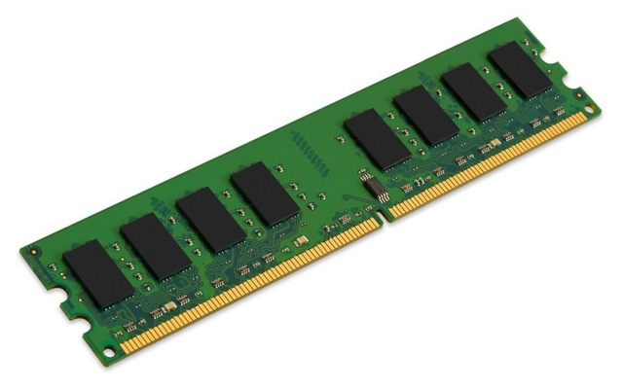**Note:** RAM is also known as main memory, internal memory, primary storage, primary memory, memory "stick", and RAM "stick".

All the data actively used on a computer is temporarily stored in RAM. This type of memory provides much faster read/write times than using a hard drive. Most hard drives are considerably slower than RAM due to physical limitations like rotation speed.

### RAM works with the hard drive (but they're different things)

RAM is typically referred to simply as "memory" even though other types of memory may exist inside a computer. RAM has nothing at all to do with the amount of [file](https://www.lifewire.com/what-is-a-file-2625878) storage a hard drive has. For example, 1 GB of memory (RAM) isn't the same thing as 1 GB of hard drive space. Unlike a hard drive, which can be powered down and then back on without losing its data, the contents of RAM are always erased when a computer shuts down. This is why none of the programs or files are still open when the computer is turned back on. One way to get around this limitation is to put a computer into hibernation mode. Hibernating a computer just copies the contents of RAM to the hard drive when the computer shuts down and then copies all of it back to RAM when powered back on.

### RAM capacity

Just like with a [CPU](https://www.lifewire.com/what-is-a-cpu-2618150) and hard drive, the amount of memory you need for your computer depends entirely on what you use, or plan to use, your computer for. For example, if you're buying a computer for heavy gaming, then you'll want enough RAM to support smooth gameplay. Having just 2 GB of RAM available for a game that recommends at least 4 GB is going to result in very slow performance if not total inability to play such games. On the other hand, if you use your computer for light internet browsing and no video streaming, games, memory-intensive applications, and so on, you could easily succeed with less memory. It’s possible to find out how much RAM a specific program will require in a "system requirements" area of the website or product box.

**Exercise 1. Find the English equivalents of the following words and word combinations.**

Временно сохранять данные; рабочая память; общая системная производительность; основная память; первичная память; модуль памяти; время считывания/записи данных; значительно медленнее; физические ограничения; объём файлового хранилища; в отличие от; отключить питание жёсткого диска; включить питание компьютера; содержание оперативной памяти; обойти ограничения; погружение компьютера в режим гибернации; скопировать обратно; объём оперативной памяти; плавный игровой процесс; просмотр файлов в интернете; системные требования; упаковка программного продукта.

**Exercise 2. Translate these words and insert them into the text below:** *volatile, expensive, prevalent, static, feature, dynamic, virtual memory, affect, increase.* **Translate the text.**

[There are many types of RAM](https://www.lifewire.com/types-of-ram-4150713), but the two main types are ( … ) RAM (SRAM) and ( … ) RAM (DRAM). Both types are ( … ). SRAM is faster but more ( … ) to produce than DRAM, which is why DRAM is more ( … ) in today's devices. However, SRAM is sometimes seen in small doses in various internal computer parts, like with the CPU and as hard drive cache memory. Some operating systems can utilize what's called ( … ), which is the opposite of a RAM disk. This is a ( … ) that sets aside hard disk space for use as RAM. While doing so can ( … ) the overall available memory for applications and other uses, it may negatively ( … ) system performance due to the fact that hard drives are slower than RAM sticks.

**Exercise 3. Extra activity: find the correct translation of the following word combinations.**

|  |  |
| --- | --- |
| 1. data acquisition 2. data administrator [əd'mɪnɪstreɪtə] 3. database 4. data array [ə'reɪ] 5. data backup 6. data bulk 7. data communications 8. data control 9. data conversion 10. data deletion 11. data domain 12. data entry 13. data export/import 14. data integrity 15. data link 16. data network 17. data protection 18. data recovery 19. analog data 20. digital data |  |

**Exercise 4. Learn the vocabulary.**

**Exercise 5. Retell the text.**

# *Extra reading task: Playing video games – good or bad?*

*Translate the following sentences and divide them into two columns:*

|  |  |
| --- | --- |
| **advantages of playing computer games** | **disadvantages of playing computer games** |
| ***…*** | ***…*** |

1. Games train the brain to come up with creative ways to solve puzzles and other problems in short terms.
2. People who play more violent video games are more likely to have increased aggressive thoughts and decreased positive behavior.
3. This process requires a great deal of eye-hand coordination and visual-spatial ability to be successful.
4. In many games players are rewarded for being more violent.
5. The player learns to manage resources that are limited, and decide the best use of resources, the same way as in real life.
6. Players may also practice riskier behaviors such as reckless driving, binge drinking, smoking etc.
7. Strategy games force the player to be flexible and quickly change tactics.
8. The World Health Organization in June 2018 declared gaming addiction as a mental health disorder.
9. The study suggests that playing action video games primes the brain to make quick decisions and to act quickly without losing accuracy.
10. People addicted to video games see their work performance suffer.
11. Defense News reported that the Army include video games to train soldiers to improve their situational awareness in combat.
12. A 2017 study suggests that playing action video games may physically harm the brain.
13. Using math skills is important to win in many games that involve managing resources.
14. Higher levels of a game demand perseverance: the player usually fails the first time around, but he keeps on trying until he succeeds and move on to the next level.
15. Too much game playing makes people socially isolated.  They spend less time in other activities such as reading, sports, and interacting with the family and friends.
16. Some video games teach the wrong values.
17. The gamer uses in-game maps or builds maps in his head to navigate around virtual worlds.
18. Games can confuse reality and fantasy.
19. People who play video games on a regular basis are better at registering visual data and are therefore quicker visual learners.
20. Many students admit that their video game habits are often responsible for poor school grades.
21. Winning in any game involves a player’s courage to take risks. Most games do not reward players who play safely.
22. Video games may also have bad effects on people’s health, including fatness, eyesight problems, postural, muscular and skeletal disorders, such as nerve compressions and many others.
23. Many multiplayer games involve cooperation and team work with other online players in order to win.
24. Several trainer games teach players some foreign languages and so on.
25. When playing online, sometimes people automatically pick up bad language and behavior from other players.
26. Young people need time to daydream, deal with anxieties, process their thoughts and share them with friends and parents, who can provide reassurance. All this is impossible if the free time is completely devoted to playing video games.

**Unit 6**

**Hard Disk Drive (HDD) (Part I)**

***Read the vocabulary:***

1. Designate ['dezɪgneɪt] – называть, обозначать
2. Partition [pɑː'tɪʃ(ə)n] – раздел (диска)
3. Primary ['praɪm(ə)rɪ] – основной
4. Track [træk] – магнитная дорожка (жёсткого диска)
5. Platter ['plætə] – круглая пластина диска
6. Actuator arm ['ækʧueɪtə ɑːm] – рычаг привода
7. Spin [spɪn] – вращаться
8. Basically ['beɪsɪk(ə)lɪ] – по существу, в своей основе
9. Whereas [(h)weə'ræz] – тогда как
10. Handle ['hændl] – иметь дело с…

The hard disk drive is the main, and usually largest, data storage [hardware](https://www.lifewire.com/computer-hardware-2625895) device in a computer. The [operating system](https://www.lifewire.com/operating-systems-2625912) and most other [files](https://www.lifewire.com/what-is-a-file-2625878) are stored in the hard disk drive.

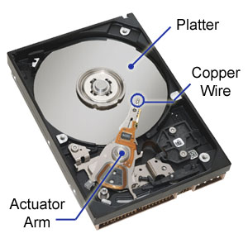The hard drive is sometimes referred to as the "C drive" due to the fact that Microsoft Windows, by default, designates the "C" drive letter to the primary [partition](https://www.lifewire.com/what-is-a-partition-2625958) on the primary hard drive in a computer. While this is not a technically correct term to use, it is still common. For example, some computers have multiple drive letters (e.g., C, D, and E) representing areas across one or more hard drives.

### How a hard drive works

Unlike volatile storage like [RAM](https://www.lifewire.com/what-is-random-access-memory-ram-2618159), a hard drive keeps a hold of its data even when powered off.

Inside the hard drive are [sectors](https://www.lifewire.com/what-is-a-sector-2626003) located on tracks, which are stored on rotating platters. These platters have magnetic heads that move with an actuator arm to read and write data to the drive.

### Kinds of hard drives

The common [flash drive](https://www.lifewire.com/what-is-a-flash-drive-2625794) has a hard drive, too, but it doesn't spin like a traditional hard drive. Flash drives have [solid-state drives](https://www.lifewire.com/solid-state-drive-833448) built-in and connect to the computer through [USB](https://www.lifewire.com/universal-serial-bus-usb-2626039).

Another USB hard drive is the [external hard drive](https://www.lifewire.com/what-is-an-external-drive-2625867), which is basically a regular hard drive that's been put into its own case so that it's safe to exist outside the computer case.

An external enclosure is a housing for an internal hard drive. You can use one if you want to "convert" an internal hard drive into an external one to [make your own external hard drive](https://www.lifewire.com/build-your-own-external-hard-drive-2260169).

### Storage Capacity

The hard disk drive capacity is a huge factor in determining whether someone will buy a particular device like a laptop or phone. If the storage capacity is rather small, it means it will fill up with files faster, whereas a drive that has lots and lots of storage can handle much more data.

[**Terabytes, gigabytes, and petabytes: how big are they?**](https://www.lifewire.com/terabytes-gigabytes-amp-petabytes-how-big-are-they-4125169)

All of these computer technology storage units of measurement are based on the *byte*, which is the amount of storage required to store a single character of text:

* An **exabyte** ['eksə baɪt] (EB) is larger than a...
* **petabyte** ['petə baɪt] (PB), which is larger than a...
* **terabyte** ['terəˌbaɪt] (TB), which is larger than a...
* **gigabyte** ['gɪgəbaɪt](GB), which is larger than a...
* **megabyte** ['megəbaɪt] (MB), which is larger than a...
* **kilobyte** ['kɪləbaɪt] (KB), which is larger than a...
* **byte** [baɪt] (B)

Less helpful in the real world is the smaller **bit** (there are 8 bits in 1 byte) and the larger **zettabyte** [ˈzɛtə baɪt] and **yottabyte** [ˈjɒtə baɪt], among some others.

To convert from one unit to another, just know that for every level you go up, you multiply by 1,024.

### So, how many gigabytes (GB) are there in a terabyte (TB)?

There are 1,024 GB in 1 TB. A single TB is a lotof space. Most new, average priced computer hard drives are in the **1 to 3 TB range**.

**Byte comparison table**

|  |  |  |
| --- | --- | --- |
| ***Metric (метрика/единица изм.)*** | ***Value (величина)*** | ***Bytes (количество байт)*** |
| *Byte (B) - байт* | *1* | *1* |
| *Kilobyte (KB) - килобайт* | *1,0241* | *1,024* |
| *Megabyte (MB) - мегабайт* | *1,0242* | *1,048,576* |
| *Gigabyte (GB)- гигабайт* | *1,0243* | *1,073,741,824* |
| *Terabyte (TB) - терабайт* | *1,0244* | *1,099,511,627,776* |
| *Petabyte (PB)- петабайт* | *1,0245* | *1,125,899,906,842,624* |
| *Exabyte (EB) - эксабайт* | *1,0246* | *1,152,921,504,606,846,976* |
| *Zettabyte (ZB) - секстибайт* | *1,0247* | *1,180,591,620,717,411,303,424* |
| *Yottabyte (YB) - септибайт* | *1,0248* | *1,208,925,819,614,629,174,706,176* |

**Exercise 1. Find the English equivalents of the following words and word combinations.**

элемент аппаратного обеспечения для хранения данных; по умолчанию; главный раздел диска; технически корректный термин; энергозависимое хранилище данных; секторы, размещённые на магнитных дорожках; вращающиеся пластины; магнитные головки; записывать данные на диск; встроенный; подсоединять через USB-порт; внешний жёсткий диск; внешний корпус; ёмкость жёсткого диска; заполнять файлами; гораздо больше данных; объём памяти; текстовый символ; среди прочих; конвертировать; умножать; сравнение.

**Exercise 2. Answer the questions.**

1. What is a hard disk drive?
2. Is it the same as the “C drive”?
3. What is located inside a hard drive enclosure?
4. Does a flash drive work like a traditional hard drive?
5. Why do we usually use an external hard drive?
6. What is one of the most important factors when choosing an HDD?
7. How big is a byte?
8. How can we convert from one storage unit of measurement to another for one level up?
9. How many terabytes are there in a petabyte?
10. How many zettabytes are there in a yottabyte?

**Exercise 3. Learn the vocabulary.**

**Exercise 4. Retell the text.**

**Hard Disk Drive (HDD) (Part II)**

***Read the vocabulary:***

1. User ['juːzə] – пользователь
2. Format ['fɔːmæt] - форматировать
3. Fragmented [fræg'mentɪd] – фрагментированный
4. Securely [sɪ'kjuəlɪ] – безопасно, без риска
5. Accomplish [ə'kɔmplɪʃ] – выполнять, завершать
6. Troubleshooting [trʌ̱b(ə)lʃuːtɪŋ] – диагностика, поиск и устранение неисправностей
7. Error ['erə] – ошибка
8. Version ['vɜːʃ(ə)n] – версия, издание
9. Ultimately ['ʌltɪmətlɪ] – в конечном счёте
10. Seek time [siːk taɪm] – время поиска (нужной дорожки диска)

### Common HDD tasks

One simple task that the user can do with a hard drive is [change the drive letter](https://www.lifewire.com/how-to-change-a-drive-letter-2626069). Doing this lets the user refer to the drive using a different letter. For example, while the main hard drive is normally called the "C" drive and can't be changed, it is possible to change an external hard drive's letter from "P" to "L" (or any other acceptable letter).

Something else that's really easy to do with a hard drive is [check how much free space is left on it](https://www.lifewire.com/how-to-check-free-hard-drive-space-in-windows-2619187). The user can [uninstall programs](https://www.lifewire.com/free-uninstaller-programs-2625188) and delete files, or [copy them elsewhere](https://www.lifewire.com/how-do-i-copy-a-file-in-windows-2619210).

It may be needed to [format the drive](https://www.lifewire.com/how-to-format-a-hard-drive-2626077) or [partition the drive](https://www.lifewire.com/how-to-partition-a-hard-drive-2626081) into sections before an operating system is installed.

When dealing with a [fragmented](https://www.lifewire.com/what-is-fragmentation-defragmentation-2625884) hard drive, [free defrag tools](https://www.lifewire.com/free-defrag-software-tools-2619172) ​are available that can help reduce the fragmentation. Defragging a hard drive can sometimes make the computer run faster.

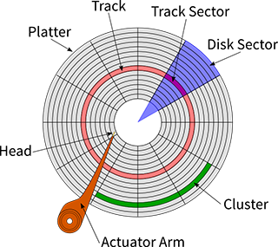Since a hard drive is where all the data in a computer are actually stored, it's a common task to want to [securely erase the data from the drive](https://www.lifewire.com/how-to-wipe-a-hard-drive-2624527), like before selling the hardware or reinstalling a new operating system. This is usually accomplished with a [data destruction program](https://www.lifewire.com/free-data-destruction-software-programs-2626174).

### HDD troubleshooting

The hard drive in the computer is used over and over, each time the user is doing something that involves reading or writing data to the disk. It's normal, but eventually may cause problems with the device.

One of the most common issues is a [hard drive that's making noise](https://www.lifewire.com/what-to-do-when-your-hard-drive-is-making-noise-2624891), and the best first step in troubleshooting a hard drive malfunction of any kind is to [run a hard drive test](https://www.lifewire.com/how-to-test-hard-drive-for-problems-2626130). Windows includes a built-in tool called chkdsk (checkdisk) that helps identify and maybe even correct various hard drive errors. There is [the graphical version of this tool](https://www.lifewire.com/how-to-scan-a-hard-drive-using-error-checking-2624497) in most [versions of Windows](https://www.lifewire.com/what-version-of-windows-do-i-have-2624927).

Lots of [free programs can test a hard drive](https://www.lifewire.com/free-hard-drive-testing-programs-2626183) ​for issues that might ultimately lead to the need to [replace the drive](https://www.lifewire.com/how-to-replace-a-hard-drive-2626200). Some of them can also measure performance like the [seek time](https://www.lifewire.com/what-does-seek-time-mean-2626007).

**Exercise 1. Find the English equivalents of the following words and word combinations.**

простая задача; обращаться к диску; изменить букву в названии внешнего жёсткого диска; проверить остаток свободного места на диске; деинсталлировать программы; копировать файлы; разбить диск на разделы; бесплатная программа для дефрагментации; работать быстрее; перед продажей; переустановка операционной системы; программа уничтожения данных; снова и снова; в конечном счёте; неисправность (сбой в работе); проверка диска; выявить и исправить ошибки; измерять производительность.

**Exercise 2. Translate the sentences.**

* Пользователь может изменить букву в названии раздела диска или внешнего жёсткого диска.
* Может быть необходимо отформатировать жёсткий диск перед установкой новой операционной системы.
* Специальные программы уничтожения данных помогают безопасно стереть информацию с жёсткого диска.
* Постоянное чтение и запись данных могут рано или поздно привести к возникновению проблем с диском.
* Графическая версия программы для проверки диска встроена в большинство версий Windows.

**Exercise 3. Learn the vocabulary.**

**Exercise 4. Retell the text.**

**Extra reading task: Solid state drive (SSD)**

*Insert the necessary words from the list into the text and translate the text in writing:*

* technology –
* launch -
* storage –
* moving –
* fail -
* integrated circuits –
* efficient –
* embedded –
* power -

Five to ten years ago, you didn’t have much of a choice in terms of _______________ for your new computer. The only option was to use a mechanical hard drive. However, nowadays, you have another option for storage: a solid state drive.

A solid state drive (more commonly referred to as an SSD) serves the exact same purpose as a traditional mechanical hard drive, it just uses different _______________ to do its job a whole lot better. A solid state drive is a data storage device that uses _______________ to store persistent data. Naturally, an SSD can be thought of as a sophisticated and oversized version of a USB memory stick. It has no _______________ parts and information fed into it is stored in microchips. An SSD uses a non-volatile memory. As a result, the disk does not “forget” the information stored on it even when turned off. Data in an SSD is stored in form of blocks. Therefore, its processes seem to be more _______________ and direct unlike those in the HDD. An SSD relies on an _______________ processor to read and write data since it does not have a mechanical arm.

### SSDs vs. Hard Drives

* *Battery Life/Power Consumption*: SSDs need less _______________ in comparison to a traditional hard drive.
* *Cost*: SSDs are relatively expensive. HDDs remain less expensive since they are older and employ a more established technology.
* *OS Boot Time and Speed*: The SSD shines over the HDD in speed. PCs with an SSD _______________ apps faster and have a higher overall performance.
* *Noise and Vibration*: An SSD does not have moving parts as does an HDD. As a result, there is no sound or vibration when the PC is processing data. Audible clicks, spinning and vibrations are a common scenario in PC’s with an HDD.
* *Durabilit*y: An SSD is likely to store data safely even in the toughest conditions since it has no moving parts. Read/write heads in an HDD have limits and could easily _______________ jeopardizing data stored on it.

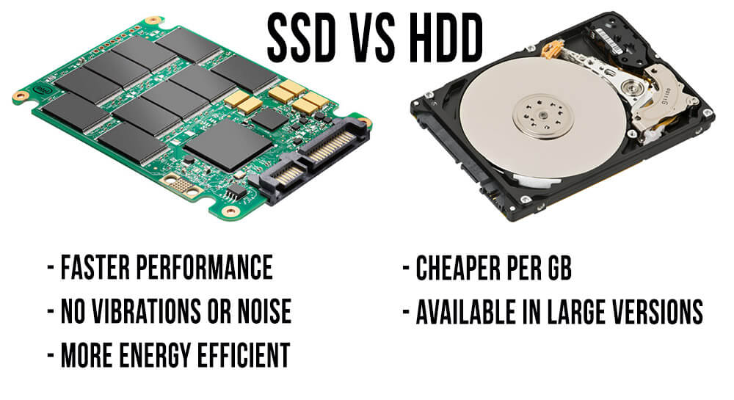

# Unit 7

**Monitors**

***Read the vocabulary:***

1. Display [dɪs'pleɪ] – показывать
2. Resolution [ˌrez(ə)'luːʃ(ə)n] – разрешение (число точек на единицу длины или площади)
3. LCD [ˌelsiː'diː] – ЖК-монитор (жидкокристаллический дисплей)
4. CRT [siːa:'tiː] – монитор на базе ЭЛТ (электронно-лучевой трубки)
5. OLED [ou'led] – ОСИД (органический светоизлучающий диод)
6. Viewing angles [vjuːin 'æŋglz] – угол обзора
7. Obsolete ['ɔbs(ə)liːt] – вытеснить что-либо из употребления
8. Footprint ['futprɪnt] – *(здесь)* опорная поверхность
9. Accessories [ək'sesərɪz] – вспомогательное оборудование
10. Hub [hʌb] – гнездо, порт; хаб

The monitor is the piece of [computer hardware](https://www.lifewire.com/computer-hardware-2625895) that displays the video and graphics information generated by the computer through the [video card](https://www.lifewire.com/what-is-a-video-card-2618161). Monitors are very similar to televisions but usually display information at a much higher [resolution](https://www.lifewire.com/what-is-resolution-2767449). Also unlike televisions, monitors are not usually mounted on a wall but instead sit atop a desk.

Monitors are devices external to the computer case and connect via a cable to a port on the video card or [motherboard](https://www.lifewire.com/motherboards-system-boards-and-mainboards-2618154). Even though the monitor sits outside the main computer housing, it is an essential part of the complete system.

Monitors come in two major types — [**LCD**](https://www.lifewire.com/what-is-liquid-crystal-display-lcd-2625913) or [**CRT**](https://www.lifewire.com/cathode-ray-tube-crt-2625800), but others exist, too, like [**OLED**](https://www.lifewire.com/oled-organic-led-4151091). CRT monitors look much like old-fashioned televisions and are very deep in size. LCD monitors are much thinner, use less energy, and provide a greater graphics quality. OLED is an improvement on LCD that provides even better color and viewing angles.

Modern LCD monitors have completely obsoleted CRT monitors due to their higher quality, smaller "footprint" on the desk, and decreasing price.

Although monitors are considered output devices since they usually only serve the purpose of outputting information to the screen, some of them are touch screens as well. This type of monitor is usually called an *input/output device*, or an IO device.

Some monitors have integrated accessories like a microphone, speakers, camera, or USB hub.

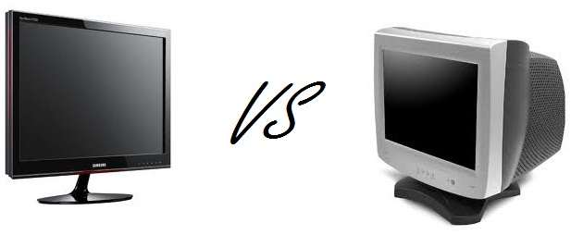

**Exercise 1. Find the English equivalents of the following words and word combinations.**

графическая информация; посредством видеокарты; в гораздо более высоком разрешении; на поверхности рабочего стола; быть неотъемлемой частью целостной системы; устаревший; тоньше; обеспечивать; снижающаяся цена; служить лишь одной цели; колонки.

**Exercise 2. Answer the questions.**

1. What is the main function of a monitor?
2. What does a monitor look like?
3. What type of hardware do monitors represent?
4. Two main types of monitors are LCD and OLED, aren’t they?
5. What is OLED?
6. What can you say about CRT monitors?
7. The main purpose of using monitors is to surf on the Internet, isn’t it?
8. What is an IO device?
9. Which accessories may be integrated into a monitor?
10. What monitor do you have at home? What’s its brand name?

**Exercise 3. Learn the vocabulary.**

**Exercise 4. Retell the text.**

**Extra reading task: What is a computer mouse?**

*Insert the necessary words from the list into the text and translate the text in writing:*

* *scroll wheel –*
* *screen –*
* *instructions –*
* *advanced –*
* *cursor –*
* *wirelessly –*
* *bottom –*
* *device –*
* *surface –*
* *quickly –*
* *installed –*

The mouse, sometimes called a pointer, is a hand-operated input _______________ used to manipulate objects on a computer _______________. It was invented by Douglas Engelbart in 1964. Whether the mouse uses a laser or ball, or is wired or wireless, a movement detected from the mouse sends _______________ to the computer to move the _______________ on the screen in order to interact with [files](https://www.lifewire.com/what-is-a-file-2625878), windows, and other software elements.

The standard mouse has two buttons toward the front (to left-click and right-click) and a _______________ in the center (to _______________ move the screen up and down). However, a computer mouse can have anywhere from one to several more buttons to provide a wide variety of other functions. While older mice use a small ball on the _______________ to control the cursor, newer ones use a laser. Some computer mice instead have a large ball on topof the mouse so that instead of moving the mouse across a _______________ to interact with the computer, the user keeps the mouse stationary and instead moves the ball with a finger. All mice communicate with the computer either _______________ or via a physical, wired connection.

A computer mouse works with a computer only if the proper [device driver](https://www.lifewire.com/what-is-a-device-driver-2625796) is _______________. A basic mouse will work right out of the box because the [operating system](https://www.lifewire.com/operating-systems-2625912) likely already has the driver ready for installation, but special software is needed for a more _______________ mouse that has more functions.



**Unit 8**

**Keyboards**

***Read the vocabulary:***

1. Model after ['mɔd(ə)l 'ɑːftə] – делать по образцу
2. Layout ['leɪaut] – расположение (*здесь:* раскладка клавиатуры)
3. Dvorak keyboard ['dvɔrək 'kiːbɔːd] – клавиатура Дворака (тип клавиатуры с расположением символов по частоте их встречаемости)
4. QWERTY [ˈkwəːti] – клавиатура со стандартной раскладкой
5. Arrow keys ['ærəu 'kiːz] – клавиши-стрелки
6. Numeric keypad [njuː'merɪk ki͟ːpæd] – цифровая клавишная панель
7. Trackball [træ̱kbɔːl] – шаровой манипулятор (трекбол-мышь)
8. Receptacle [rɪ'septəkl] – отверстие
9. On-screen [ˌɔn'skriːn] – экранный (отображаемый на экране)
10. Shortcuts ['ʃɔːtkʌts] – «быстрые» клавиши
11. Modifier keys ['mɔdɪfaɪə 'kiːz] – клавиши-модификаторы
12. Ampersand ['æmpəsænd] – амперсанд, "&" символ, который в английском языке часто заменяет слово “and”

The keyboard is the piece of [computer hardware](https://www.lifewire.com/computer-hardware-2625895) used to input text, characters, and other commands into a computer or similar device. Modern computer keyboards were modeled after, and are still very similar to, classic typewriter keyboards. Many different keyboard layouts are available around the world (like Dvorak and others) but most keyboards are of the [QWERTY type](https://www.lifewire.com/definition-of-qwerty-keyboard-578674).

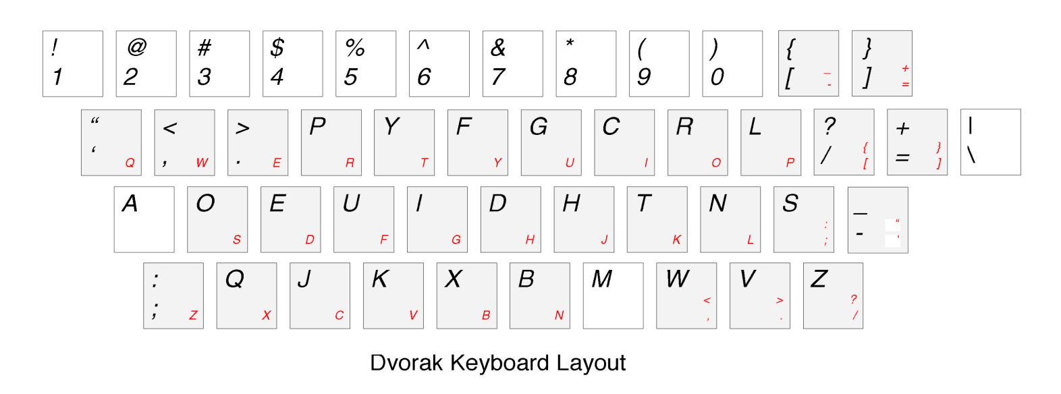

Most keyboards have numbers, letters, symbols, arrow keys, etc., but some also have a numeric keypad, additional functions like volume control, buttons to power down or sleep the device or even a built-in trackball [mouse](https://www.lifewire.com/what-is-a-mouse-2618156) that's intended to provide an easy way to use both the keyboard and the mouse without having to lift your hand off the keyboard.

Many keyboards are wireless. Other wired keyboards connect to the [motherboard](https://www.lifewire.com/motherboards-system-boards-and-mainboards-2618154) via a [USB](https://www.lifewire.com/universal-serial-bus-usb-2626039) cable. Older keyboards connect via a [PS/2](https://www.lifewire.com/ps-2-port-2625972) connection.

Tablets, phones, and other computers with touch interfaces often don't include physical keyboards. However, most do have USB receptacles or wireless technologies which allow external keyboards to be attached.

Like tablets, most modern mobile phones utilize on-screen keyboards to maximize the screen size; the keyboard can be used when needed but then that same screen space can be used for other things like watching videos.

### Keyboard Shortcuts

The Control, Shift, and Alt keys are modifier keys. [Mac keyboards](https://www.lifewire.com/what-are-windows-keyboard-equivalents-to-mac-2260203) use the Option and Command keys as modifier keys. Unlike a normal key like a letter or a number, modifier keys modify the function of another key. The regular function of the **7** key, for example, is to input the number 7, but if you hold down the **Shift** and **7** keys simultaneously, the ampersand (&) sign is produced. Some of the effects of a modifier key can be seen on the [keyboard](https://www.lifewire.com/best-ergonomic-keyboards-4147386) as keys that have two actions, like the 7 key. Keys like this have two functions where the topmost action is activated with the **Shift** key.

**Alt-F4** is another keyboard shortcut. This one instantly closes down the window you're currently using. Whether you're in an Internet browser or browsing through pictures on your computer, this combination will instantly close the one you're focused on.

**Windows key**

Although the common use for the Windows key (also known as *start key, flag key, logo key*) is to open the Start menu, it can be used for many different things. The Win-D is one example of using this key to quickly show/hide the desktop. Win-E is another useful one that quickly opens Windows Explorer.

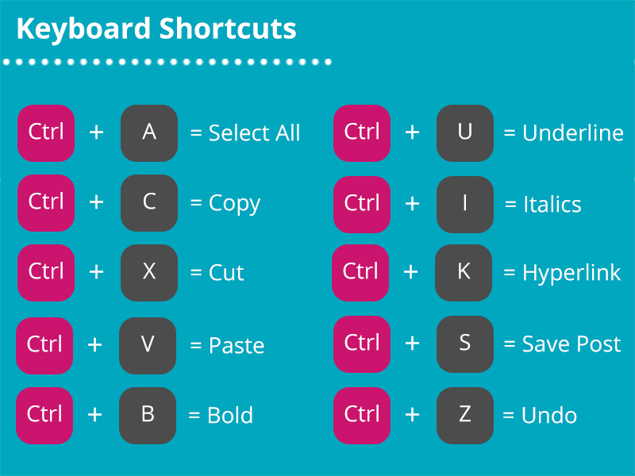

**Exercise 1. Find the English equivalents of the following words and word combinations.**

устройство, используемое для ввода текста; похожее устройство; клавиатура классической печатной машинки; различные раскладки доступны; контроль громкости; беспроводные клавиатуры; сенсорный интерфейс; подключать внешнюю клавиатуру; максимально увеличить размер экрана; использовать пространство экрана для других целей; клавиатура марки «Макинтош»; в отличие от обычной клавиши; удерживать нажатой клавишу Shift; одновременно; самое верхнее действие активируется клавишей Shift; мгновенно закрывает используемое в данный момент окно; клавиша с логотипом; быстро показать или скрыть рабочий стол.

**Exercise 2. Translate into English.**

1. Клавиатура, мышь и монитор являются периферийными устройствами.
2. Клавиатура используется для ввода информации в компьютер.
3. Современные клавиатуры очень похожи на клавиатуры классических печатных машинок.
4. Клавиатура может иметь специальные клавиши для выключения питания или погружения устройства в сон.
5. Проводные клавиатуры подключаются к материнской плате через разъём USB или PS/2.
6. Беспроводные технологии позволяют подключить внешнюю клавиатуру к планшету или смартфону.
7. Экранная клавиатура телефона используется только, когда это необходимо.
8. На всех клавиатурах есть клавиши-модификаторы.
9. Если одновременно нажать и удерживать клавишу Shift и клавишу 5, то появится знак процента %.
10. Чтобы мгновенно закрыть текущее окно, нажмите клавишу Alt+F4.

**Exercise 3. Translate the words and insert them into the text about All-in-one units:**

* *to include –*
* *connection –*
* *Ethernet –*
* *unit –*
* *convincing –*
* *host –*
* *features –*
* *print engine –*

An **All-in-one** is a small desktop ___________________, designed for home or home-office use.

These devices focus on scan and print functionality for home use, and may come with bundled software for organizing photos, simple OCR (optical character recognition) etc. An All-in-one will always _______________ the basic functions of Print and Scan, with most also including Copy functionality and a lesser number with [Fax](https://en.wikipedia.org/wiki/Fax) capabilities.

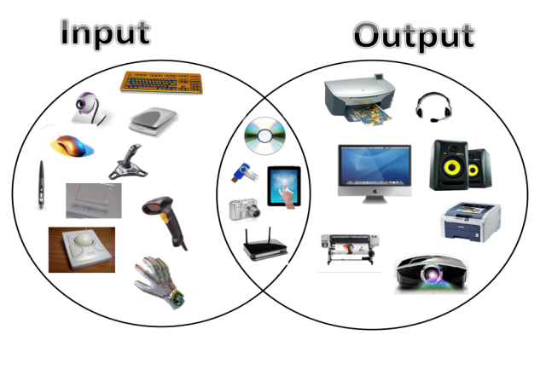In the past, these devices were usually not networked. As of 2013 even inexpensive all-in-one devices support [_______________](https://en.wikipedia.org/wiki/Ethernet) and/or [Wi-Fi](https://en.wikipedia.org/wiki/Wi-Fi) connections. In some cases the wireless devices require connection to a _______________ computer by wire (usually USB) to initialize the device, and once initial setup is done, support wireless operations for all the work performed thereafter.

All-in-one devices may have ________________ oriented to home and personal use that are not found in larger devices. These functions include [smart card](https://en.wikipedia.org/wiki/Smart_card) readers, direct ___________________ to [digital cameras](https://en.wikipedia.org/wiki/Digital_camera) and so on.

The ___________________ of most All-in-one devices is based either on a home desktop [inkjet printer](https://en.wikipedia.org/wiki/Inkjet_printing), or on a home desktop [laser printer](https://en.wikipedia.org/wiki/Laser_printing). They may be black-and-white or colour capable. Laser models provide a better result for text while inkjet gives a more ___________________ result for images and they are a cheaper multifunctional.

**Exercise 4. Learn the vocabulary.**

**Exercise 5. Retell the text.**

**Unit 9**

**Network Hardware (Part 1)**

***Read the vocabulary:***

1. NIC – сетевая интерфейсная плата (сетевая карта)
2. Add-in ['æd'in] – дополнительный
3. Router [ˈruːtə] – маршрутизатор
4. Intrusion [ɪn'truːʒ(ə)n] – вторжение, проникновение
5. Enable [ɪ'neɪbl] – *(здесь)* включать
6. Firmware [fɜ͟ː(r)mweə(r)] – встроенная программа, «зашитая программа» (в ПЗУ)
7. WAN [wan] – *(от Wide-Area Network)* глобальная сеть передачи данных
8. UTP (Unshielded Twisted Pair) – НВП (неэкранированная витая пара; тип тонкого гибкого кабеля из нескольких витых пар проводов в пластиковой оболочке без экранирующей металлической оплётки (что снижает стоимость кабеля)
9. Switch [swɪʧ] – переключатель, коммутатор
10. Configure [kən'fɪgə] – конфигурировать, изменять параметры

**NIC** is short for **network interface card**. It's [network adapter hardware](https://www.lifewire.com/introduction-to-computer-network-adapters-817580) in the form of an add-in card that fits in an [expansion slot](https://www.lifewire.com/expansion-slot-2625870) on a computer's [motherboard](https://www.lifewire.com/motherboards-system-boards-and-mainboards-2618154). Most computers have them built-in (in which case they're just a part of the circuit board) but the user can also add the own NIC to expand the functionality of the system.

The NIC is what provides the [hardware](https://www.lifewire.com/computer-hardware-2625895) interface between a computer and a network. This is true whether the network is wired or wireless since the NIC can be used for [Ethernet](https://www.lifewire.com/what-is-ethernet-3426740) networks as well as [Wi-Fi](https://www.lifewire.com/what-is-wi-fi-2377430) ones, as well as whether it's a desktop or laptop.

In general, a network interface card enables a device to network with other devices. However, a NIC isn't always the only component needed to interface with other devices. For example, if the device is part of a larger network and you want it to have access to the internet, like at home or in office, a [router](https://www.lifewire.com/what-is-a-broadband-router-816301) is required too.

A **router** is the piece of network [hardware](https://www.lifewire.com/computer-hardware-2625895) that allows communication between a local network and the Internet. A router is the first line of security from intrusion into a network. Enabling the highest level of security on the router is the best way to keep your computer system and information safe from attack. Routers contain software called [*firmware*](https://www.lifewire.com/what-is-firmware-2625881) that should be updated as released by the router manufacturer.

Originally, routers were connected physically, via a network cable, to the **modem** via the “*Internet*” or “*WAN*” port and then physically, again via a network cable, to the network interface card of any device. Nowadays many routers connect to the Internet directly through a *UTP* *cable* without the help of a modem. A wireless router can connect via various wireless standards to devices that also support the particular standard used.

A **switch** is a network [hardware](https://www.lifewire.com/computer-hardware-2625895) device that allows communication between devices within a network. Most home and small business [routers](https://www.lifewire.com/what-is-a-router-2618162) contain built-in switches. For example, several computers connected to a router can be configured to share printers and files among themselves.

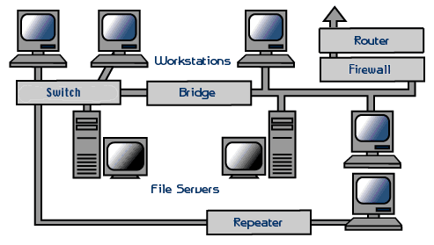

**Exercise 1. Find the English equivalents of the following words and word combinations.**

сетевой адаптер; элемент печатной (схемной) платы; увеличить функциональность системы; обеспечивать аппаратное соединение между компьютером и сетью; использоваться для локальной сети; получить доступ в интернет; маршрутизатор обеспечивает связь между локальной сетью и интернетом; первая линия защиты; защитить компьютер от атак; маршрутизаторы имеют встроенное ПО; маршрутизатор физически соединялся с модемом через сетевой кабель; коммутатор позволяет устройствам общаться внутри сети; обмениваться файлами друг с другом.

**Exercise 2. Answer the questions below.**

1. What is NIC? What does it do?
2. Is NIC only used for wired networks?
3. NIC is the only component needed to interface with other devices, isn’t it?
4. What is a router?
5. What do the routers contain?
6. How do most modern routers connect to the Internet?
7. What is a switch? Is it always an independent hardware device?

**Exercise 3. Learn the vocabulary.**

**Exercise 4. Retell the text.**

**Exercise 5. Complete the text on DSL using the words from the list below:**

1. *ADSL – асимметричная цифровая абонентская линия*
2. *speed - скорость*
3. *broadband internet – широкополосный интернет*
4. *downloading – загрузка, скачивание, выгрузка данных из интернета*
5. *connections – соединения*
6. *uploads – загрузка в удалённый компьютер (по линии связи)*
7. *technology – технология*
8. *unavailable – недоступный*

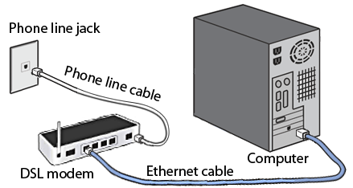

* **Digital Subscriber Line** technology offers high-speed internet service for homes and businesses that competes with cable and other forms of **…** .
* DSL provides high-speed networking over ordinary phone lines using [broadband modem](https://www.lifewire.com/definition-of-broadband-modem-817451) **…** .
* The technology behind DSL means your network and telephone service share the same phone line without disrupting either your voice or network **…** .
* Most [types of DSL service](https://www.lifewire.com/different-types-of-dsl-technology-817522) are asymmetric — also known as [**…**](https://www.lifewire.com/asymmetric-digital-subscriber-line-817526) .
* ADSL offers higher download speeds than upload speeds, a *tradeoff* *(компромисс)* that most providers make to better match up with the needs of typical households who generally do much more **…** .
* Symmetric DSL maintains equal data rates for both downloads and **…** .
* DSL service only works over a limited physical distance and in many areas where the local telephone infrastructure does not support DSL technology it remains **…** .
* DSL does not perform as fast as [*fiber internet*](https://www.lifewire.com/fiber-optic-cable-817874) connections: even some high-speed wireless options can offer competitive **…** .

**Exercise 6. Tell in a few words about DSL technology.**

**Network Hardware (Part 2)**

# The definition and purpose of a network firewall

***Read the vocabulary:***

1. Firewall ['faɪəwɔːl] – межсетевой экран, брандмауэр (аппаратные или программные средства межсетевой защиты)
2. Malicious [mə'lɪʃəs] – злоумышленный, злонамеренный
3. Malware ['mælweə] – вредоносное ПО
4. Vulnerable ['vʌln(ə)rəbl] – уязвимый
5. Configure [kən'fɪgə] – конфигурировать
6. URL [ju͟ː ɑːr e̱l] – *(сокр. от uniform resource locator)* унифицированный указатель информационного ресурса (стандартизованная строка символов, указывающая местонахождение документа в интернете)
7. Proxy (firewall) ['prɔksɪ] - proxy-сервер, брандмауэр; промежуточный сервер
8. Intermediary [ˌɪntə'miːdɪərɪ] – посредник
9. LAN [læn] – (Local Area Network) локальная сеть
10. Stateful inspection firewall ['steɪtful ɪn'spekʃ(ə)n 'faɪəwɔːl]– брандмауэр с анализом состояния сессий
11. UTM [ju͟ː ti: e̱m]- многофункциональные средства обеспечения информационной безопасности

A network firewall protects a computer network from unauthorized access. It might take the form of a [hardware](https://www.lifewire.com/computer-hardware-2625895) device, a software program, or a combination of the two.

Network firewalls guard an internal computer network against [malicious](https://www.lifewire.com/what-is-malware-2625933) access from the outside, such as malware-infested websites or vulnerable open [network ports](https://www.lifewire.com/port-numbers-on-computer-networks-817939). A network firewall also can be configured to limit the access of internal users to outside connections, as in the case of parental controls or workplace locks.

A firewall constantly monitors all incoming and outgoing traffic. A firewall differs from a simple traffic analyzer, though, in that a network administrator can take action to control that traffic.

A firewall might disable particular applications from accessing the network, block [URLs](https://www.lifewire.com/what-is-a-url-2626035) from loading, and prevent traffic through certain network ports. Some firewalls can even be used to block everythingexcept users and actions the administrator specifically allows.

Many home network router products include built-in firewall support. You can install some [software firewall programs](https://www.lifewire.com/free-firewall-programs-4129270) directly onto the [hard drive](https://www.lifewire.com/what-is-a-hard-disk-drive-2618152) of the computer that needs it. Some antivirus programs include built-in firewalls too. As with a network firewall, you can [disable a computer-based firewall](https://www.lifewire.com/how-to-disable-the-windows-firewall-2624505). These types of firewalls, however, protect only the computers that run them. In contrast, network firewalls protect the entire network and generally are installed at the [network gateway](https://www.lifewire.com/definition-of-gateway-817891).

**Types of firewalls include:**

1. **Proxy firewall**: A proxy firewall acts as an intermediary between internal computers and external networks by receiving and selectively blocking data packets at the network boundary. They provide an extra measure of safety by hiding internal [LAN](https://www.lifewire.com/local-area-network-816382) addresses from the outside internet.
2. **Stateful inspection firewall**: This is the kind of firewall that provides end-to-end monitoring of traffic and uses rules that network administrators set to govern access.
3. **Unified threat management (UTM) firewall**: This setup incorporates antivirus and malware detection into a traditional stateful inspection firewall. A UTM firewall is often part of a network management package that might include other functions such as cloud administration.
4. **Next-generation firewall (NGFW):** this type goes beyond traditional approaches with far more sophisticated protection against attack.

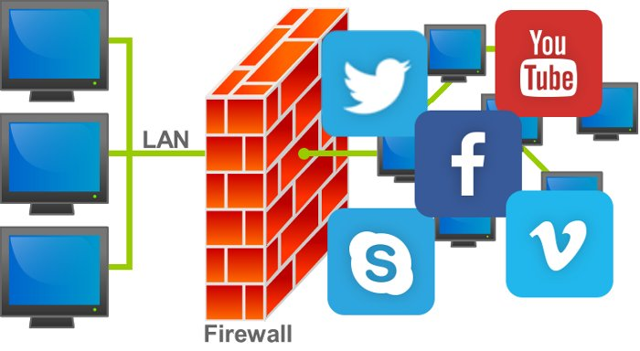

**Exercise 1. Find the English equivalents of the following words and word combinations.**

несанкционированный доступ; защищать от злонамеренного проникновения извне; сайты с вредоносным ПО; открытые сетевые порты; родительский контроль; блокировка рабочих мест; входящий и исходящий трафик; системный администратор может принимать участие в контроле трафика; запретить отдельным приложениям доступ в сеть; блокировать загрузку страниц по ссылкам; антивирусная программа; межсетевой шлюз; выборочно блокирующий данные на границе сети; скрывать адреса внутренней сети; сквозной мониторинг траффика; администрирование облачной среды; брандмауэр нового поколения; за пределами традиционных подходов.

**Exercise 2. Answer the questions.**

1. What is a network firewall?
2. What does a firewall guard a computer network against?
3. A firewall constantly monitors only incoming traffic, doesn’t it?
4. Why does a firewall differ from a simple traffic analyzer?
5. What is a URL?
6. Which home network products may include a built-in firewall?
7. Does a computer-based firewall protect a whole network or just a local PC?
8. What are the main types of firewalls?
9. How does a proxy firewall act?
10. What is a UTM? What does it incorporate?

**Exercise 3. Learn the vocabulary.**

**Exercise 4. Retell the text.**

**Exercise 5. Read and translate the text about Wi-Fi connection. Insert there the necessary words from the list:**

1. *range – зона действия*
2. *login credentials – регистрационные данные*
3. *consoles - приставки*
4. *fidelity – точность*
5. *link – соединиться, связаться*
6. *hardwired – соединённый проводом*
7. *drain – утечка*
8. *hot spots – точки беспроводного доступа*

**Wi-Fi**, which is a trademark of the [*Wi-Fi Alliance*](http://www.wi-fi.org/), is short for wireless ______________. A device with [Wi-Fi](https://www.lifewire.com/what-is-wi-fi-2377430) can wirelessly connect to the internet when it’s in a ______________ of a wireless router that is ______________ to the internet. Wi-Fi-enabled devices can include:

* **Mobile phones
* Personal computers
* Video game ______________
* Home appliances (lightbulbs, stereos systems, TVs)

A Wi-Fi-enabled mobile phone can ______________ to a wireless router at your home, a coffee shop, a business or anywhere with an active wireless router. Wi-Fi connections in airports, hotels, bars, coffee shops and more are traditionally called ______________. Some Wi-Fi hotspots are free and some cost money. To establish a Wi-Fi connection between a mobile phone and a wireless router, it is very likely that ____________________________ (i.e. a password) will be required.

Wi-Fi is a global standard. Any Wi-Fi device will work anywhere in the world.

Wi-Fi requires high power consumption when used with mobile devices. As mobile phones perform more and more tasks by the day, Wi-Fi can be an energy ______________ for such handsets. Wi-Fi networks have a limited range; a typical wireless router can work within a range of 120 feet indoors to 300 feet outdoors.

**Exercise 6. REVISION:**

**Insert the necessary terms** *(network interface card, tool, microchips, DSL, switch, temporarily, router, byte, capabilities, amount, fidelity, firewall, pointer, login credentials, CRT, partition, desktop, malfunction, WAN, layouts)*.

1. A piece of computer hardware (or software) that protects a computer network from unauthorized access is called a network _________________.
2. Microsoft Windows always designates the "C" drive letter to the primary _________________ on the primary hard drive in a computer.
3. The __________________________________ may be required to establish a Wi-Fi connection between a mobile phone and a wireless router.
4. All-in-one units always include the basic functions of Print and Scan, with most also including Copy functionality and a lesser number with [Fax](https://en.wikipedia.org/wiki/Fax) _________________.
5. A computer mouse, sometimes called a _________________, is a hand-operated input device used to manipulate objects on a computer screen.
6. All the data actively used on a computer is _________________ stored in RAM.
7. Just like with a [CPU](https://www.lifewire.com/what-is-a-cpu-2618150) and hard drive, the _________________ of main memory you need for your computer depends entirely on what you use, or plan to use, your computer for.
8. Many different keyboard _________________ are available around the world but most keyboards are of the [QWERTY type](https://www.lifewire.com/definition-of-qwerty-keyboard-578674).
9. The technology behind _________________ means your network and telephone service share the same phone line without disrupting either your voice or network connection.
10. A _________________ is the piece of network [hardware](https://www.lifewire.com/computer-hardware-2625895) that allows communication between a local network and the Internet.
11. A _________________ is a network [hardware](https://www.lifewire.com/computer-hardware-2625895) device that allows communication between devices within a network.
12. _________________ monitors look much like old-fashioned televisions and are very deep in size.
13. An SSD has no moving parts and information fed into it is stored in _________________.
14. All of the computer technology storage units of measurement are based on the _________________, which is the amount of storage required to store a single character of text.
15. One of the most common issues is a [hard drive that's making noise](https://www.lifewire.com/what-to-do-when-your-hard-drive-is-making-noise-2624891), and the best first step in troubleshooting a hard drive _________________ of any kind is to [run a hard drive test](https://www.lifewire.com/how-to-test-hard-drive-for-problems-2626130).
16. [Network adapter hardware](https://www.lifewire.com/introduction-to-computer-network-adapters-817580) in the form of an add-in card that fits in an [expansion slot](https://www.lifewire.com/expansion-slot-2625870) on a computer's [motherboard](https://www.lifewire.com/motherboards-system-boards-and-mainboards-2618154) is called a __________________________________.
17. Wireless _________________ is a full definition for Wi-Fi.
18. Originally, routers were connected physically, via a network cable, to the modem via the “*Internet*” or “_________________” port and then physically, again via a network cable, to the network interface card of any device.
19. The Win-D is one example of using the Windows key to quickly show/hide the _________________.
20. Windows includes a built-in _________________ called “checkdisk” that helps identify and maybe even correct various hard drive errors.

**Unit 10**

**What is Software?**

***Read the vocabulary:***

1. Software engineering ['sɔftweə ˌenʤɪ'nɪərɪŋ] – программотехника
2. Beyond [bɪ'jɔnd] – за пределами
3. Behavior [bɪ'heɪvjə] – поведение; *(тех.)* режим работы
4. Essential [ɪ'sen(t)ʃ(ə)l] – важнейший, основной
5. On top of – вдобавок к чему-либо; поверх чего-либо
6. Supervisory program [ˌs(j)uːpə'vaɪz(ə)rɪ 'prəugræm] – программа контроля
7. Boot loader [buːt 'ləudə] – загрузчик операционной системы
8. Shell [ʃel] – программная оболочка
9. Utility [juː'tɪlətɪ] – служебная программа; утилита
10. Disrupt [dɪs'rʌpt] – нарушать работу
11. Practical joke ['præktɪk(ə)l ʤəuk] – розыгрыш

**Computer software**, or simply **software**, is a collection of [data](https://en.wikipedia.org/wiki/Data_(computing)) or computer instructions that tell the computer how to work. This is in contrast to [physical hardware](https://en.wikipedia.org/wiki/Computer_hardware), from which the system is built and actually performs the work. In [Computer science](https://en.wikipedia.org/wiki/Computer_science) and [Software engineering](https://en.wikipedia.org/wiki/Software_engineering), computer software is all [information](https://en.wikipedia.org/wiki/Information) processed by [computer systems](https://en.wikipedia.org/wiki/Computer_system), [programs](https://en.wikipedia.org/wiki/Computer_program) and [data](https://en.wikipedia.org/wiki/Data). Computer hardware and software require each other and neither can be realistically used on its own. 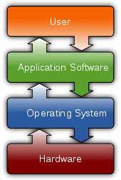

Based on the goal, computer software can be divided into:

* [**Application software**](https://en.wikipedia.org/wiki/Application_software)

which is software that uses the computer system to perform special functions or provide [entertainment functions](https://en.wikipedia.org/wiki/Video_game) beyond the basic operation of the computer itself. There are many different types of application software, because the range of tasks that can be performed with a modern computer is incredibly large.

* [**System software**](https://en.wikipedia.org/wiki/System_software)

which is software for managing [computer hardware](https://en.wikipedia.org/wiki/Computer_hardware) behaviour, as to provide basic functionalities that are required by users, or for other software to run properly. System software, in its turn, includes the following:

* 1. [**Operating systems**](https://en.wikipedia.org/wiki/Operating_system)

which are essential collections of software that manage resources and provides common services for other software that runs "on top" of them. [Supervisory programs](https://en.wikipedia.org/wiki/Supervisory_program), [boot loaders](https://en.wikipedia.org/wiki/Boot_loader), [shells](https://en.wikipedia.org/wiki/Shell_(computing)) and [window systems](https://en.wikipedia.org/wiki/Window_system) are core parts of operating systems. In practice, an operating system comes bundled with additional software (including application software) so that a user can potentially do some work with a computer that only has one operating system.

* 1. [**Device drivers**](https://en.wikipedia.org/wiki/Device_driver)

which operate or control a particular type of device that is attached to a computer. Each device needs at least one corresponding device driver; because a computer typically has at least one input device and at least one output device, a computer typically needs more than one device driver.

* 1. [**Utilities**](https://en.wikipedia.org/wiki/Software_utility)

which are computer [programs](https://en.wikipedia.org/wiki/Programs_and_Features) designed to assist users in the maintenance and care of their computers.

* [**Malicious software**](https://en.wikipedia.org/wiki/Malicious_software) or **malware**

which is software that is developed to harm and disrupt computers. As such, malware is undesirable. Malware is closely associated with computer-related crimes, though some malicious programs may have been designed as [practical jokes](https://en.wikipedia.org/wiki/Practical_joke).

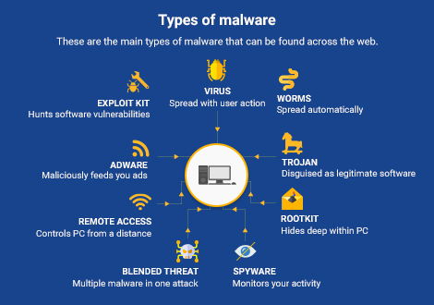

**Exercise 1. Find the English equivalents of the following words and word combinations.**

собрание данных или компьютерных инструкций; фактически выполнять работу; аппаратное и программное обеспечение необходимы друг другу; прикладное ПО; обеспечивать развлекательные функции; невообразимо большой круг задач; системное ПО; обеспечивать базовые возможности, которые требуются пользователям; в свою очередь; управлять ресурсами; системы окон; ключевые элементы; дополнительное ПО; устройству необходим как минимум один соответствующий драйвер; помогать пользователям обслуживать свои компьютеры; вредоносное ПО; причинить вред компьютеру.

**Exercise 2. Answer the questions.**

1. What is “software”? Why is it called like this?
2. What is the definition of software in Computer science and Software engineering?
3. What are three main categories of software, based on the goal?
4. How many types of application software are there?
5. What is system software? Does it include operating systems only?
6. What are the core parts of operating systems?
7. How many drivers does each hardware device need?
8. What is a utility?
9. Why is malware undesirable?
10. What is malware closely associated with? What are the main types of malware?

**Exercise 3. Learn the vocabulary.**

**Exercise 4. Retell the text.**

**Extra reading task: What is software piracy?**

Software piracy refers to the act of stealing software that is legally protected, which means protected under *copyright*. Most software purchased today has a single-use *license*, which means only one user can use the software. Software piracy occurs when that software is copied, modified, or sold to another party.

Pirated software is also referred to as *"bootlegged" software (нелегальное ПО)*.

Although some software piracy is malicious, it can also happen in seemingly innocent circumstances. For example, copying software to share with a friend is considered piracy. Copying software to use on two different computers for personal use is also considered piracy.

### Software Piracy: A Brief History

In 1975, the first personal computer was invented. Unfortunately, software wasn't protected up until 1980, when the *Computer Software Copyright Act* of 1980 came into effect. At this time, however, only those who understood the ins and outs of the computer in its infancy had the ability to pirate.

In late 1989, the United States Patent Office began to issue patents to developers of the software, further protecting their property.

#### Notable Software Piracy Cases of the Past

Over the past decade, there have been notable software piracy cases underlining the importance of keeping an eye on what you're using.

* **A $100 million software piracy ring**: Six men once [plead guilty](https://www.wired.com/2015/12/6-men-admit-to-running-a-giant-100m-software-piracy-ring/) to pirating Adobe and Microsoft programs such as Windows and Photoshop. Each of the men faced up to five years in prison and a quarter of a million dollars in restitution each.
* **Bitmanagement vs the U.S. Navy**: Software company Bitmanagement once [filed a lawsuit](https://www.revulytics.com/blog/biggest-piracy-stories-2016) against the U.S. Navy, stating they copied and installed their virtual reality software on hundreds of thousands of computers.

### How to Tell If Your Software Is Pirated

Even if you don't pirate the software yourself, purchasing software online or receiving software from someone else could be far from the real thing. How can you know if the software you're using is pirated?

* **Price**: If you are purchasing software online, be sure to check the price first. Software that is on major discount should throw up a red flag.
* **Ease of use**: Sure, most software requires a download and activation. However, if the software you choose makes you follow a detailed process to use, it could be pirated.
* **Packaging**: Does the software you're using have the correct packaging? Did it come with manuals and all necessary paperwork? If not, the software has probably been used before.
* **Software updates**: All legitimate software will include the future updates needed for use. Software that doesn't update could be a pirated copy.

### The Consequences of Using Pirated Software

Software piracy is illegal. In fact, it's considered direct copyright infringement. Piracy denies the owners of the copyright compensation for the use of their product. And although this is serious enough, there can be severe consequences for using pirated software on your personal computer.

* **Pirated software may infect your computer**: Some software that seems safe could actually be malicious, infecting your computer with [*malware*](https://www.lifewire.com/what-is-malware-2625933) or *viruses*.
* **It will only update so far**: Pirated software can't be updated and may stop working after a certain amount of use. Software that doesn't update properly can leave you open to even more security issues beyond the virus such as data loss.
* **Piracy results in fines and legal trouble**: Severe cases of software piracy, such as those that occur in businesses, are often subjected to legal trouble in the form of large fines and prison time.

Software piracy should be taken seriously. Before you purchase software or download software to your computer, be sure to check its authenticity to protect yourself from any repercussions.

**Unit 11**

**Operating systems (Part 1)**

***Read the vocabulary:***

1. Host [həust] – выполнять роль ведущего узла; управлять
2. System call ['sɪstəm kɔːl] – системный вызов
3. Application programming interface [ˌæplɪ'keɪʃ(ə)n 'prəugræmɪŋ 'ɪntəfeɪs]– интерфейс прикладного программирования
4. MacOS ['mæk əus] – операционная система Макинтош
5. Linux ['lɪnəks ], ['laɪnəks] – операционная система Линукс
6. Execute ['eksɪkjuːt] – выполнять
7. Scheduling algorithm ['skeʤuːlin 'ælg(ə)rɪð(ə)m]– алгоритм оперативного планирования
8. Rather ['rɑːðə] – *(здесь)* наоборот
9. Network administrator ['netwɜːk əd'mɪnɪstreɪtə] – сетевой администратор
10. Unix [ˈjuːnɪks] – многопользовательская многозадачная операционная система с разделением времени (Юникс)

# An operating system is a software component of a computer system that is responsible for the management of various activities of the computer and the sharing of computer resources. It hosts several applications that run on a computer and handles the operations of computer hardware. Users and application programs access the services offered by the operating systems, by means of system calls and application programming interfaces. Users interact with a [computer operating system](https://techspirited.com/computer-operating-systems) through Command Line Interfaces (CLIs) or Graphical User Interfaces known as GUIs.

Operating systems are found on many devices that contain a computer – from [cellular phones](https://en.wikipedia.org/wiki/Cellular_phone) and [video game consoles](https://en.wikipedia.org/wiki/Video_game_console) to [web servers](https://en.wikipedia.org/wiki/Web_server) and [supercomputers](https://en.wikipedia.org/wiki/Supercomputer).

The dominant [desktop](https://en.wikipedia.org/wiki/Personal_computer) operating system is [**Microsoft Windows**](https://en.wikipedia.org/wiki/Microsoft_Windows) with a market share of more than 80%. [**MacOS**](https://en.wikipedia.org/wiki/MacOS) by [Apple Inc.](https://en.wikipedia.org/wiki/Apple_Inc.) is in the second place nowadays, and the varieties of [**Linux**](https://en.wikipedia.org/wiki/Linux) are collectively in the third place.[Linux distributions](https://en.wikipedia.org/wiki/Linux_distribution) are dominant in the server and supercomputing sectors. Other specialized classes of operating systems, such as embedded and real-time systems, exist for many applications.



1. **Real-time Operating System:** It is a multitasking operating system that aims at executing real-time applications. Real-time operating systems often use specialized scheduling algorithms. The main object of real-time operating systems is their quick and predictable response to events.
2. **Multi-user and Single-user Operating Systems:** Computer operating systems of the first type allow multiple users to access a computer system simultaneously. Single-user operating systems, as opposed to a multi-user operating system, are usable by only one user at a time. Being able to have multiple accounts on a Windows operating system does not make it a multi-user system. Rather, only the network administrator is the real user. But for a **Unix-like** operating system, it is possible for two users to log in at a time and this capability of the OS makes it a multi-user operating system.
3. **Multi-tasking and Single-tasking Operating Systems:** When a single program is allowed to run at a time, the system is grouped under the single-tasking system category, while in case the operating system allows for execution of multiple tasks at a time, it is classified as a multi-tasking operating system.

**Exercise 1. Find the English equivalents of the following words and word combinations.**

ответственный за управление; распределение ресурсов компьютера; получать доступ к сервисам операционной системы; посредством; интерфейс командной строки; графический пользовательский интерфейс; мобильный телефон; интернет-сервер; операционная система настольного ПК; разновидности; преобладающий; выполнение программ в реальном времени; предсказуемый ответ; позволять многочисленным пользователям работать с ОС одновременно; учётные записи; ОС типа Unix; выполнение нескольких задач одновременно.

**Exercise 2. Answer the questions.**

1. What is an operating system?
2. What are the most popular OS for desktops and servers?
3. Do you remember the name of Apple OS?
4. How do users interact with a computer operating system?
5. What devices need operating systems?
6. What do real-time OS often use?
7. What is the difference between single-user and multi-user operating systems?
8. Is a Unix-like operating system a multi-user or single-user one?
9. What are single-tasking and multi-tasking OS?
10. What is GUI?

**Exercise 3. Learn the vocabulary.**

**Exercise 4. Retell the text.**

**Operating systems (Part 2)**

***Read the vocabulary:***

1. Distributed [dɪstrɪ̱bjuːtɪd] - распределённый
2. Give rise [gɪv raɪz] - давать начало
3. Embedded [ɪm'bedɪd] – встроенный, интегрированный
4. PDA [ˌpiːdiː'eɪ] – (от Personal Digital Assistant) персональный цифровой секретарь (тип КПК)
5. Autonomy [ɔː'tɔnəmɪ] – автономность
6. Compact [ˌkəm'pækt] – сжатый, занимающий мало места
7. Multimedia [ˌmʌltɪ'miːdɪə] – мультимедиа
8. Batch [bæʧ] – пакет (данных)
9. Intervention [ˌɪntə'venʃ(ə)n] – вмешательство
10. Prompting ['prɔmptɪŋ] – подсказка; побуждение
11. Hence [hen(t)s] – отсюда; следовательно
12. **Distributed Operating System:** An operating system that manages a group of independent computers and makes them appear to be a single computer is known as a distributed operating system. The development of networked computers that could be linked and made to communicate with each other, gave rise to distributed computing. Distributed computations are carried out on more than one machine. When computers in a group work in cooperation, they make a distributed system.
13. **Embedded System:** The operating systems designed for being used in embedded computer systems are known as embedded operating systems. They are designed to operate on small machines like PDAs with less autonomy. They are able to operate with a limited number of resources. They are very compact and extremely efficient.
14. **Mobile Operating System:** A mobile OS controls a mobile device and its design supports wireless communication and mobile applications. It has built-in support for mobile multimedia formats. Tablet PCs and smartphones run on mobile operating systems.

**Blackberry OS**, Google's **Android** and Apple's **iOS** are some of the most known names of mobile operating systems.

1. 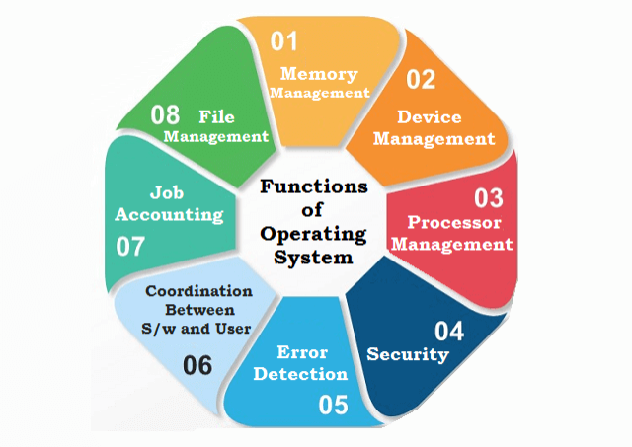**Batch Processing and Interactive Systems:** Batch processing refers to execution of computer programs in 'batches' without manual intervention. In batch processing systems, programs are collected, grouped and processed on a later date. There is no prompting the user for inputs as input data are collected in advance for future processing. Input data are collected and processed in batches, hence the name batch processing. As against this, interactive operating requires user intervention. The process cannot be executed in the user's absence.

**Exercise 1. Find the English equivalents of the following words and word combinations.**

управлять группой независимых компьютеров; рост числа компьютеров, подключённых к сети; общаться друг с другом; распределённая вычислительная обработка данных; работать совместно; разработанный для использования во встроенных компьютерных системах; ограниченное количество ресурсов; поддерживать беспроводную связь; мультимедийные форматы для мобильных устройств; пакетная обработка данных; собирать, группировать и обрабатывать; заранее; в противоположность этому; вмешательство пользователя.

**Exercise 2. Translate into English.**

1. Распределённая операционная система управляет группой независимых компьютеров.
2. Распределённые вычисления всегда выполняются более чем на одном устройстве.
3. Встроенные операционные системы разработаны для небольших устройств с меньшей автономностью, таких как, например, персональный цифровой секретарь и т.п.
4. Современные планшеты и смартфоны работают на собственных мобильных операционных системах.
5. В системах пакетной обработки данных нет необходимости напоминать пользователю о вводе информации, так как все необходимые данные уже были собраны заранее.
6. Интерактивные операционные системы требуют вмешательства пользователя.

**Exercise 3. Learn the vocabulary.**

**Exercise 4. Retell the text.**

**Unit 12**

**Programming and programming languages**

***Read the vocabulary:***

1. Coder ['kəudə] - кодировщик
2. Spectrum ['spektrəm] – диапазон
3. Machine language [mə'ʃiːn 'læŋgwɪʤ]– машинный язык; язык программирования
4. Assembly [ə'semblɪ] – Ассемблер (язык программирования)
5. Java ['ʤɑːvə] – язык программирования Java
6. Abstract [æb'strækt] – абстрагировать; обобщать; уводить
7. Translation [trænz'leɪʃ(ə)n] – преобразование, трансляция с одного языка в другой
8. Generic [ʤɪ'nerɪk] – обобщённый
9. Interpret [ɪn'tɜːprɪt] – выполнять программу в режиме интерпретации
10. Compile [kəm'paɪl] – компилировать программу
11. Syntax error - последовательность символов, нарушающая правила синтаксиса данного языка
12. Debugging [ˌdiː'bʌgɪŋ] – отладка программы

**Programming** is the art and science of translating a set of ideas into a **program** - a list of instructions a computer can follow. The person writing a program is known as a **programmer** (also a **coder** or a **software engineer**).

The exact form the instructions take depend on the **Programming Language** used.

Languages run the spectrum from very low level like *Machine Language* or *Assembly*, to a very high level like *Java*. Lower level languages are more closely tied to the platform they are targeted for, while higher level languages abstract an increasing amount of the platform from the programmer.

In other words, **low level programming languages** represent the instructions in a manner that resembles more closely the way the computer actually works. **High level languages** do resemble more the way the human mind works. Each type is a good fit depending on the particular case. Whenever speed and resource consumption are important, low level languages can provide an advantage since they cause much less "translation" and are less generic, thus causing less load on the computer. High level languages have much more abstraction and thus are better suited for tasks where maintenance and complex design is required.

After a programmer has finished writing the program, it must be executed. Traditionally, some languages (*like Basic*) are interpreted, while others (*like C*) are compiled prior to execution. **Interpreted languages** are executed "on the fly" at run time, while **compiled languages** have a separate compilation step that must be completed prior to running. Compilers are able to make certain optimizations that are unavailable to interpreters.

The program may fail to compile or execute due to syntax errors. These are errors caused by doing something that is unknown or illegal according to the language they have used. These errors have to be corrected before the program will execute.

If the program runs, the programmer must then verify that the program is working as they intended it to. When things don't go as the programmer intended, the error is said to be a bug. To eliminate bugs, the programmer goes through a process called debugging, where he tries to isolate and fix the source of the problem.

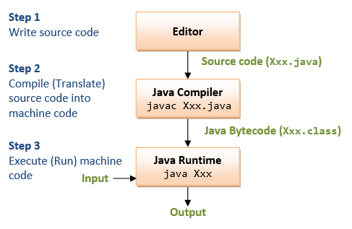

**Exercise 1. Find the English equivalents of the following words and word combinations.**

превращение набора идей в программу; следовать инструкциям; программист; зависеть от; тесно связаны с платформой, на которую они ориентированы; язык программирования низкого уровня; напоминать (иметь сходство); язык программирования высокого уровня; конкретный случай; потребление ресурсов; меньшая загрузка компьютера; поддержка и сложный дизайн; писать программу; некоторые языки интерпретируются, а некоторые – компилируются; на ходу; компилятор; интерпретатор; неизвестный либо не соответствующий правилам; проверить; планировать (подразумевать); такая ошибка называется «баг»; изолировать и отрегулировать источник проблемы.

**Exercise 2. Answer the following questions.**

1. How could you explain what programming is?
2. What are the names of the programming languages you know?
3. What is a low level programming language?
4. What is a high level programming language?
5. What are other names of a programmer?
6. What type of a programming language is more suitable when speed and resource consumption are important?
7. Which language is the best for tasks where maintenance and complex design is required?
8. What is the difference between interpreted and compiled languages?
9. Why may a written program fail to compile or execute?
10. What is debugging?

**Exercise 3. Learn the vocabulary.**

**Exercise 4. Retell the text.**

**REFERENCES:**

1. Вичугов В.Н., Краснова Т.И. Английский язык. Практикум для СПО. – Саратов: Профобразование, 2017. – 115 с.
2. G. Brown, D. Watson. ICT: Information and Communication Technology. – London, 2010. – 299 p.
3. <https://www.lifewire.com/> - англоязычный Интернет-ресурс, посвящённый аппаратному и программному обеспечению современных компьютеров и портативных устройств, а также работе с сетями передачи данных.
4. <https://techspirited.com/> - англоязычный Интернет-ресурс, посвящённый последним разработкам в области аппаратного и программного обеспечения и содержащий информацию по их применению.
5. <https://learnenglish.britishcouncil.org> – англоязычный Интернет-ресурс для изучающих английский язык.