- 基础接口应用
package zjnu.edu.cn;
interface Shape {
double calculateArea();
double calculatePerimeter();

String getName();

default void displayInfo() {
System.out.println("图形名称：" + getName());
System.out.printf("面积：%.2f" , calculateArea());
System.out.printf("周长：%.2f" , calculatePerimeter());

}
}

class Circle implements Shape {
private double radius;

public Circle(double radius){
this.radius = radius;
}
@Override
public double calculateArea() {
return Math.PI * radius * radius;

}

@Override
public double calculatePerimeter(){
return 2 * Math.PI * radius;

}

@Override
public String getName(){
return "圆形" ;

}
}

class Rectangle implements Shape{
private double length;
private double width;
public Rectangle(double length , double width) {
this.length = length;
this.width = width;
}

@Override
public double calculateArea() {
return length * width ;

}

@Override
public double calculatePerimeter() {
return 2 * (length + width) ;
}

@Override
public String getName() {
return "矩形" ;

}
}

class Triangle implements Shape {
private double a , b , c ;
public Triangle(double a , double b,double c) {
if(a+b > c && a + c > b && b + c > a){
this.a = a ;
this.b = b ;
this.c = c ;

}else{
System.out.println("边长无法构成三角形");
this.a = 3 ;
this.b = 4 ;
this.c = 5 ;
}
}
@Override
public double calculateArea(){
double p = (a+b+c) / 2 ;
return Math.sqrt(p*(p-a)*(p-b)*(p-c)) ;

}

@Override
public double calculatePerimeter(){
return a+b+c ;

}

@Override
public String getName(){
return "三角形" ;
}
}

public class Test {
public static void main(String[] args) {
Shape s1 = new Circle(5);
Shape s2 = new Rectangle(4,6);
Shape s3 = new Triangle(3,4,5);

s1.displayInfo();
s2.displayInfo();
s3.displayInfo();
}
}

测试样例和结果：
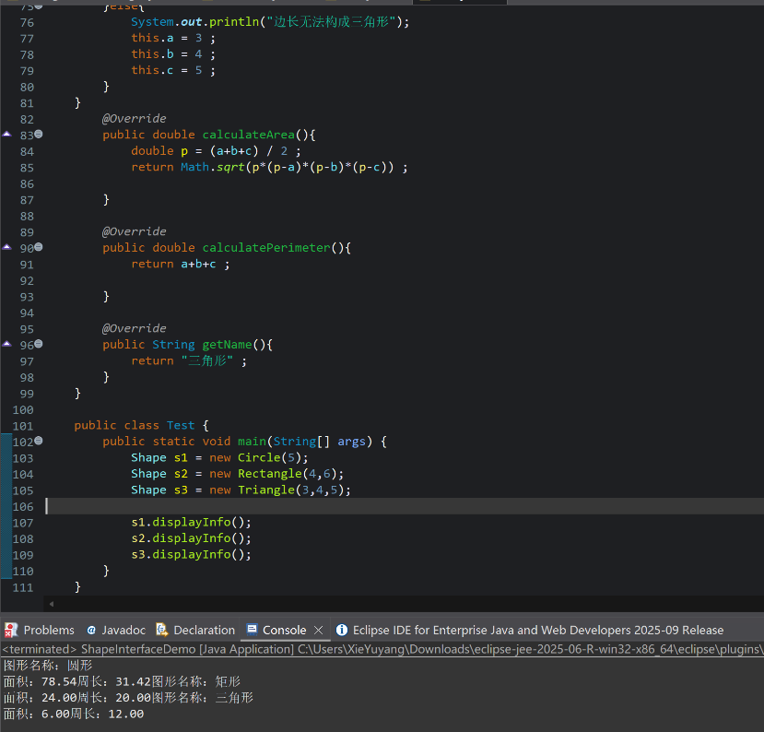

- 图形面积计算系统

package zjnu.edu.cn;
abstract class AbstractShape {
public abstract double calculateArea();
public void displayArea() {
System.out.printf("该图形的面积为: %.2f\n", calculateArea());
}
}
class CircleObj extends AbstractShape {
private double radius;

public CircleObj(double radius) {
this.radius = radius;
}

@Override
public double calculateArea() {
return Math.PI * radius * radius;
}
}
class RectangleObj extends AbstractShape {
private double length;
private double width;

public RectangleObj(double length, double width) {
this.length = length;
this.width = width;
}

@Override
public double calculateArea() {
return length * width;
}
}
class TriangleObj extends AbstractShape {
private double base;
private double height;

public TriangleObj(double base, double height) {
this.base = base;
this.height = height;
}

@Override
public double calculateArea() {
return 0.5 * base * height;
}
}

public class Test {
public static void main(String[] args) {

AbstractShape circle = new CircleObj(10);
AbstractShape rect = new RectangleObj(5, 8);
AbstractShape tri = new TriangleObj(10, 5);

System.out.print("圆形");
circle.displayArea();

System.out.print("矩形");
rect.displayArea();

System.out.print("三角形");
tri.displayArea();
}
}

测试样例和结果：
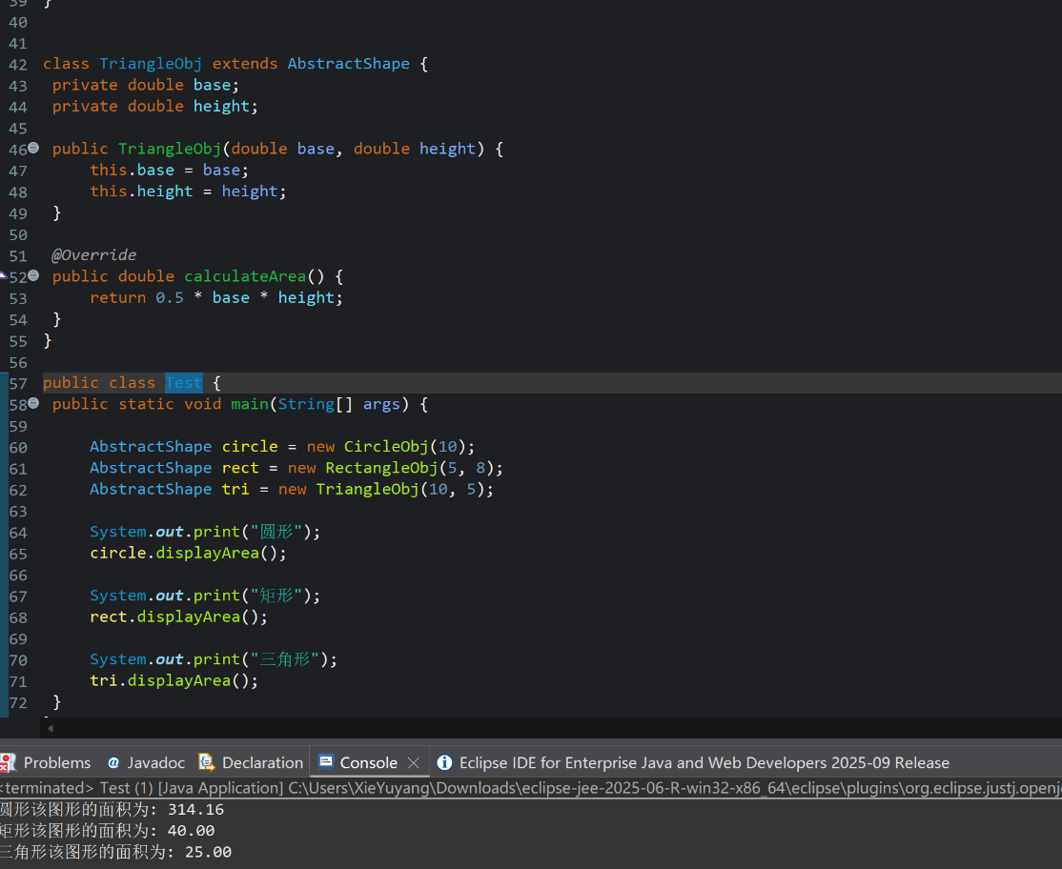

3．支付系统设计
package zjnu.edu.cn;
interface Payment {
boolean pay(double amount);
String getPaymentType();
}

class AlipayPayment implements Payment {
@Override
public boolean pay(double amount) {
System.out.printf("正在调用支付宝API... 支付金额: %.2f 元\n", amount);
return true;
}

@Override
public String getPaymentType() {
return "支付宝";
}
}

class WechatPayment implements Payment {
@Override
public boolean pay(double amount) {
System.out.printf("正在拉起微信支付窗口... 支付金额: %.2f 元\n", amount);
return true;
}

@Override
public String getPaymentType() {
return "微信支付";
}
}

class BankCardPayment implements Payment {
@Override
public boolean pay(double amount) {
System.out.printf("正在连接银行网关... 支付金额: %.2f 元\n", amount);
return true;
}

@Override
public String getPaymentType() {
return "银行卡";
}
}

class PaymentFactory {

public static Payment createPayment(String type) {
if (type == null) {
return null;
}
if (type.equalsIgnoreCase("ALIPAY")) {
return new AlipayPayment();
} else if (type.equalsIgnoreCase("WECHAT")) {
return new WechatPayment();
} else if (type.equalsIgnoreCase("BANK")) {
return new BankCardPayment();
}
return null;
}
}

class OrderProcessor {
public void processOrder(double amount, String paymentType) {
Payment payment = PaymentFactory.createPayment(paymentType);

if (payment != null) {
System.out.println("订单开始处理，选择支付方式: " + payment.getPaymentType());
boolean success = payment.pay(amount);
if (success) {
System.out.println("订单支付成功！");
} else {
System.out.println("订单支付失败。");
}
} else {
System.out.println("不支持的支付方式: " + paymentType);
}
}
}

public class Test {
public static void main(String[] args) {
OrderProcessor orderSystem = new OrderProcessor();

orderSystem.processOrder(199.00, "ALIPAY");
orderSystem.processOrder(58.50, "WECHAT");
orderSystem.processOrder(1000.00, "BANK");
orderSystem.processOrder(20.00, "CASH");
}
}

测试样例和结果：
