- 设计一个动物园动物行为管理系统，不同类型的动物有不同的行为和叫声。
package zjnu.edu.cn;

abstract class Animal {
protected String name ;
protected int age ;

public Animal(String name , int age) {
this.name = name ;
this.age = age ;

}

public abstract void makeSound();
public abstract void performAction();

public void sleep() {
System.out.println(name + "正在睡觉...");
}
}

class Lion extends Animal{
public Lion(String name , int age) {
super(name,age);

}

@Override
public void makeSound() {
System.out.println(name + "Roar!");

}

@Override
public void performAction() {
System.out.println(name + "狮子在表演奔跑");
}
}

class Elephant extends Animal {
public Elephant(String name, int age) {
super(name,age);
}

@Override
public void makeSound() {
System.out.println(name + "Trumpet!");

}

@Override
public void performAction() {
System.out.println(name + "大象在表演用鼻子喷水") ;

}
}

class Monkey extends Animal {
public Monkey(String name , int age ) {
super(name,age);
}

@Override
public void makeSound() {
System.out.println(name + "Chatter!");

}

@Override
public void performAction() {
System.out.println(name + "猴子在表演爬树");
}
}

class Trainer {
public void train(Animal animal) {
System.out.println("训练员开始训练" + animal.name + "...");
animal.makeSound();
animal.performAction();
animal.sleep();

}
}

public class Test {
public static void main(String[] args) {
Trainer trainer = new Trainer();

Animal lion = new Lion("辛巴",5);
Animal elephant = new Elephant("大象",10);
Animal monkey = new Monkey("悟空",3);

trainer.train(lion);
trainer.train(elephant);
trainer.train(monkey);
}
}

样例输出：
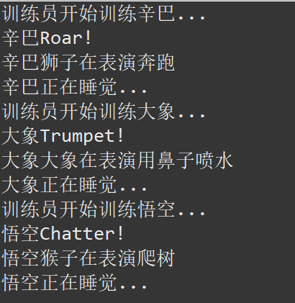

- 设计一个图形计算系统，能够计算不同形状的面积。系统需要支持圆形、矩形和三角形， 并且要方便扩展新的图形类型。

package demo;

abstract class Shape {
public abstract double calculateArea();
public void displayArea() {
System.out.printf("该图形的面积为：%.2f\n", calculateArea());

}
}

class Circle extends Shape {
private double radius ;
public Circle(double radius) {
this.radius = radius ;

}

@Override
public double calculateArea() {
return Math.PI * radius * radius ;

}
}

class Rectangle extends Shape{
private double length ;
private double width ;
public Rectangle(double length , double width) {
this.length = length;
this.width = width ;

}

@Override
public double calculateArea() {
return length *width;

}
}

class Triangle extends Shape {
private double base ;
private double height;

public Triangle(double base , double height) {
this.base = base ;
this.height = height ;

}

@Override
public double calculateArea() {
return 0.5 * base * height ;

}
}

public class Test {
public static void main(String[] args) {
Shape[] shapes = new Shape[3];
shapes[0] = new Circle(5.0);
shapes[1] = new Rectangle(4.0,6.0);
shapes[2] = new Triangle(3.0,8.0);

for(Shape shape : shapes) {

System.out.print("正在计算：" + shape.getClass().getSimpleName() + "->");
shape.displayArea();
}
}
}

样例输出：
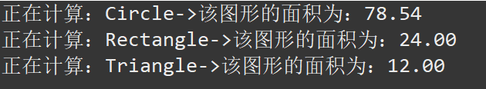

3. 设计一个支持多种支付方式的系统，目前需要支持支付宝、微信支付和银行卡支付。

package zjnu.edu.cn;

interface Payment {
boolean pay(double amount);
String getPaymentType();

}

class AlipayPayment implements Payment {
@Override
public boolean pay(double amount) {
System.out.println("正在调用支付宝接口支付：" + amount +"元");
return true ;

}

@Override
public String getPaymentType() {
return "支付宝";

}

}

class WechatPayment implements Payment {
@Override
public boolean pay(double amount) {
System.out.println("正在调用微信接口支付：" + amount + "元");
return true ;
}

@Override
public String getPaymentType() {
return "微信支付";

}
}

class BankCardPayment implements Payment {
@Override
public boolean pay(double amount) {
System.out.println("正在验证银行卡信息并支付: " + amount + "元");
return true ;
}

@Override
public String getPaymentType() {
return "银行卡支付";
}
}

class PaymentFactory {
public static Payment createPayment(String type) {
if("Alipay".equalsIgnoreCase(type)) {
return new AlipayPayment();
}else if("Wechat".equalsIgnoreCase(type)) {
return new WechatPayment();
}else if("BankCard".equalsIgnoreCase(type)) {
return new BankCardPayment();
}

return null ;
}
}

class OrderProcessor {
public void processOrder(double amount , String paymentType) {
Payment payment = PaymentFactory.createPayment(paymentType);

if(payment != null) {
System.out.println("订单处理中，请选择支付方式：" + payment.getPaymentType());
boolean result = payment.pay(amount);
if(result) {
System.out.println("订单支付成功！");

}else {
System.out.println("订单支付失败。");
}
}else {
System.out.println("不支持此支付方式: " + paymentType);
}
}
}

public class PaymentSystem{
public static void main(String[] args) {
OrderProcessor processor = new OrderProcessor();

processor.processOrder(100.50,"Alipay");
processor.processOrder(50.00,"Wechat");
processor.processOrder(2000.00, "BankCard");
processor.processOrder(10.00, "Cash");
}
}

样例输出：
