接口和多态
一、实验目的
- 理解接口和实现类概念
- 掌握接口的定义和变量声明；
- 掌握实现类的定义及对象创建；
- 掌握接口回调
- 理解多态及其机理
- 理解面向接口的编程
二、实验内容
根据如下UML类图，设计有理数类，该有理数类继承自Number并实现了Comparable接口。
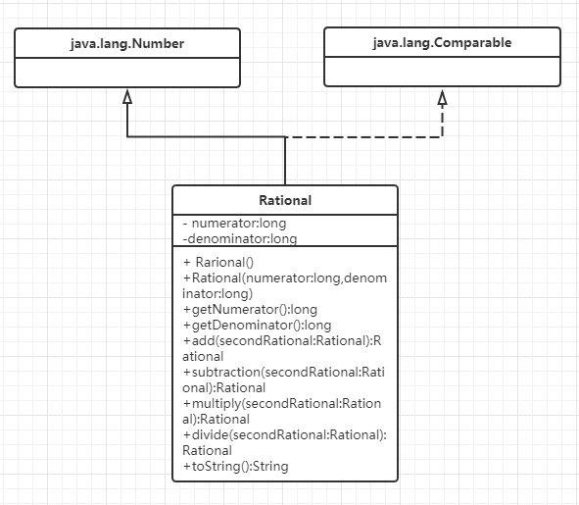
图1. 有理数类图
提示：
请查阅相关材料，学习Number类和Comparable接口

三、实验步骤
1. 学习Number类
2. 学习Comparable接口
3. 设计有理数类
四、实验要求
- 准确描述有理数
- 提供有理数的算术运算（加减乘除）和比较大小运算
- 重载构造方法，以便利地创建有理数对象
- 重写所有继承自Number的方法
- 重写toString()方法
- 重写compareTo()方法
- 提供带提示的输入与输出
- 满足如下输入输出要求
package zjnu.edu.cn;
import java.util.Scanner;

class Rational extends Number implements Comparable<Rational> {
private long numerator; // 分子
private long denominator; // 分母

public Rational() {
this(0, 1);
}

public Rational(long numerator, long denominator) {
long gcd = gcd(Math.abs(numerator), Math.abs(denominator));

if (denominator > 0) {
this.numerator = numerator / gcd;
this.denominator = denominator / gcd;
} else {
this.numerator = -numerator / gcd;
this.denominator = -denominator / gcd;
}
}

//求最大公约数
private long gcd(long n, long d) {
long n1 = Math.abs(n);
long n2 = Math.abs(d);
long remainder = n1 % n2;
while (remainder > 0) {
n1 = n2;
n2 = remainder;
remainder = n1 % n2;
}
return n2;
}

//Getter方法
public long getNumerator() {
return numerator;
}

public long getDenominator() {
return denominator;
}

// 四则运算方法
// 加法
public Rational add(Rational secondRational) {
long n = this.numerator * secondRational.getDenominator() +
this.denominator * secondRational.getNumerator();
long d = this.denominator * secondRational.getDenominator();
return new Rational(n, d);
}

// 减法
public Rational subtraction(Rational secondRational) {
long n = this.numerator * secondRational.getDenominator() -
this.denominator * secondRational.getNumerator();
long d = this.denominator * secondRational.getDenominator();
return new Rational(n, d);
}

// 乘法
public Rational multiply(Rational secondRational) {
long n = this.numerator * secondRational.getNumerator();
long d = this.denominator * secondRational.getDenominator();
return new Rational(n, d);
}

// 除法:
public Rational divide(Rational secondRational) {
long n = this.numerator * secondRational.getDenominator();
long d = this.denominator * secondRational.getNumerator();
return new Rational(n, d);
}

//重写toString()方法
@Override
public String toString() {
if (denominator == 1) {
return numerator + "";
} else if (numerator == 0) {
return "0";
} else {
return numerator + "/" + denominator;
}
}

//重写Comparable接口的方法
@Override
public int compareTo(Rational o) {

Rational diff = this.subtraction(o);
if (diff.getNumerator() > 0) {
return 1;
} else if (diff.getNumerator() < 0) {
return -1;
} else {
return 0;
}
}

//重写Number类的方法
@Override
public int intValue() {
return (int) doubleValue();
}

@Override
public long longValue() {
return (long) doubleValue();
}

@Override
public float floatValue() {
return (float) doubleValue();
}

@Override
public double doubleValue() {
return (double) numerator / denominator;
}
}

public class Test {
public static void main(String[] args) {
Scanner input = new Scanner(System.in);

System.out.println("请输入R1的分子和分母，以及R2的分子和分母:");

long n1 = input.nextLong();
long d1 = input.nextLong();
long n2 = input.nextLong();
long d2 = input.nextLong();

Rational r1 = new Rational(n1, d1);
Rational r2 = new Rational(n2, d2);

System.out.println("R1=" + r1.doubleValue() + " R2=" + r2.doubleValue());

// 输出加法
System.out.println("R1 + R2 = " + r1.add(r2).toString());
// 输出减法
System.out.println("R1 - R2 = " + r1.subtraction(r2).toString());
// 输出乘法
System.out.println("R1 * R2 = " + r1.multiply(r2).toString());
// 输出除法
System.out.println("R1 / R2 = " + r1.divide(r2).toString());

// 输出比较大小
boolean isGreater = r1.compareTo(r2) > 0;
System.out.println("R1>R2 " + isGreater);

input.close();
}
}

Case 1：
Input(r1,r2)
1 2 2 3
Output
R1=0.5 R2=0.6666666666666666
R1 + R2 = 7/6
R1 - R2 = -1/6
R1 * R2 = 1/3
R1 / R2 = 3/4
R1>R2 false

运行结果：
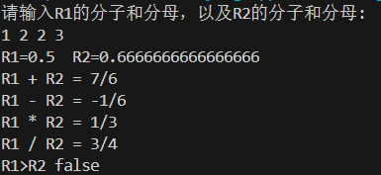
Case 2：
Input(r1,r2)
0 2 2 3
Output
R1=0 R2=0.6666666666666666
R1 + R2 = 2/3
R1 - R2 = -2/3
R1 * R2 = 0
R1 / R2 = 0
R1>R2 false

运行结果：
