1. 基础计数器（理解基本概念与内存分配）

Counter.java:

package zjnu.edu.cn;

class Counter {
protected int instanceCount = 0;
private static int classCount = 0;
public Counter(){
this.instanceCount++;
Counter.classCount++;
}
protected int getInstanceCount(){
return this.instanceCount;
}
protected static int getClassCount(){
return Counter.classCount;
}

}

CounterTest.java:

package zjnu.edu.cn;

public class CounterTest {
public static void main(String[] args) {
Counter c1 = new Counter();
System.out.println("c1的实例计数: " + c1.getInstanceCount());
System.out.println("类计数: " + Counter.getClassCount());
Counter c2 = new Counter();
System.out.println("c2的实例计数: " + c2.getInstanceCount());
System.out.println("类计数: " + Counter.getClassCount());
Counter c3 = new Counter();
System.out.println("c3的实例计数: " + c3.getInstanceCount());
System.out.println("类计数: " + Counter.getClassCount());
}
}

输出结果：
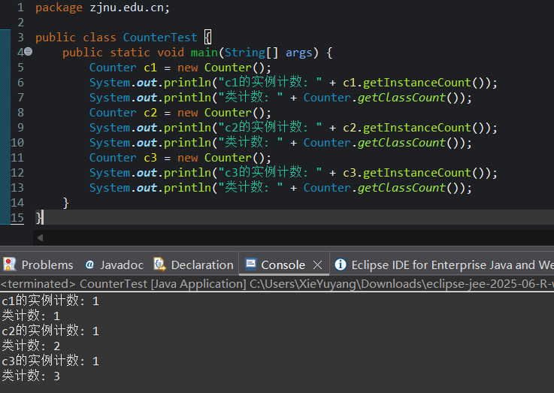

2. 银行账户与利率（理解应用场景与设计）

BankAccount.java:

package zjnu.edu.cn;

public class BankAccount {
private String accountId;
private double balance ;
private static double annualInterestRate ;
protected BankAccount(String accountId , double balance) {
this.accountId = accountId ;
this.balance = balance ;

}
protected BankAccount() {

}

protected String getAccountId() {
return this.accountId;
}
protected double getBalance() {
return this.balance;
}

protected void deposit(double amount) {
if(amount > 0) {
this.balance += amount ;
}
}

protected double calculateMonthlyInterest() {
return this.balance * annualInterestRate / 12 ;

}

protected static void setAnnualInterestRate(double rate) {
BankAccount.annualInterestRate = rate ;

}
}

AccountTest.java :

package zjnu.edu.cn;

public class AccountTest {
public static void main(String[] args) {
BankAccount acc1 = new BankAccount("A1",5000.00);
BankAccount acc2 = new BankAccount("B2",200000.00);

System.out.println("年利率：3%");
BankAccount.setAnnualInterestRate(0.03);

System.out.println("账户 "+acc1.getAccountId()+" 余额："+ acc1.getBalance());
System.out.printf("月利息：%.2f%n", acc1.calculateMonthlyInterest());

System.out.println("账户 "+acc2.getAccountId()+" 余额："+ acc2.getBalance());
System.out.printf("月利息：%.2f%n", acc2.calculateMonthlyInterest());

System.out.println("调整年利率：5%");
BankAccount.setAnnualInterestRate(0.05);

System.out.println("账户 "+acc1.getAccountId()+" 余额："+ acc1.getBalance());
System.out.printf("新的月利息：%.2f%n", acc1.calculateMonthlyInterest());

System.out.println("账户 "+acc2.getAccountId()+" 余额："+ acc2.getBalance());
System.out.printf("新的月利息：%.2f%n", acc2.calculateMonthlyInterest());

}

}
输出结果：
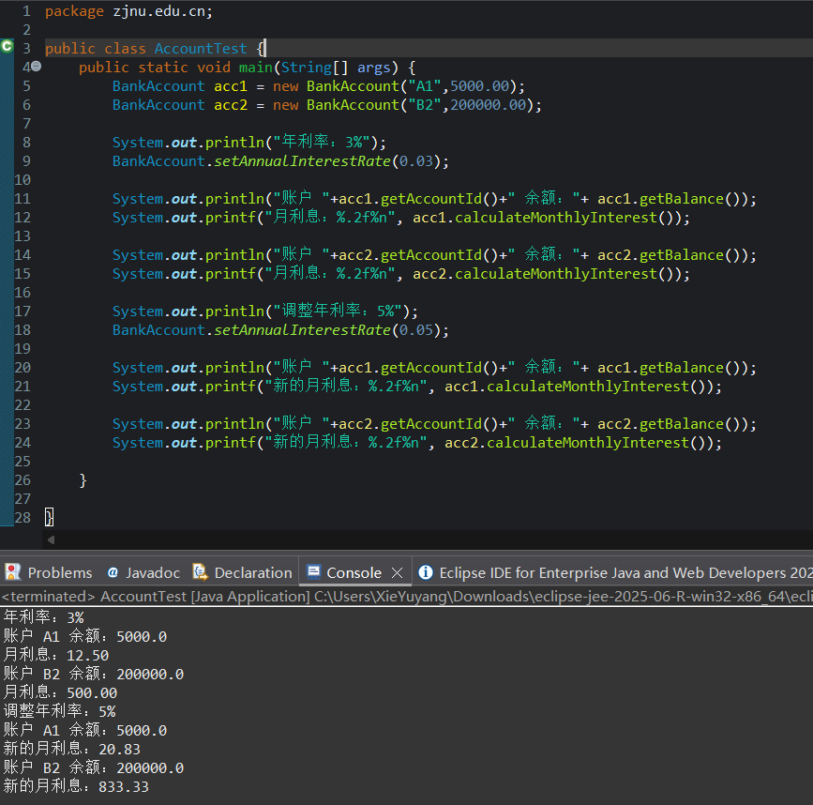

3. 单例模式与工具类（理解高级用法与限制）

ConfigurationManager.java:

package zjnu.edu.cn;
import java.util.HashMap;
import java.util.Map;

public class ConfigurationManager {

private static ConfigurationManager instance;

private Map<String , String> configData;

public static ConfigurationManager getInstance() {
if(instance == null) {
instance = new ConfigurationManager();

}

return instance ;

}

public void setConfig(String key , String value) {
this.configData.put(key,value);

}

public String getConfig(String key) {
return this.configData.get(key);

}

private ConfigurationManager() {
this.configData = new HashMap<>();
System.out.println("ConfigurationManager 实例已被创建");
}

}

MathUtils.java:

package zjnu.edu.cn;

public class MathUtils {

public static int max(int a , int b) {
return (a>b) ? a:b ;
}

public static double circleArea(double radius) {
return Math.PI * radius * radius;

}

private MathUtils() {
throw new UnsupportedOperationException("工具类禁止实例化");

}

}

Test.java:

package zjnu.edu.cn;

public class Tests {
public static void main(String[] args) {
System.out.println("单例模式");

ConfigurationManager mgr1 = ConfigurationManager.getInstance();
ConfigurationManager mgr2 = ConfigurationManager.getInstance();

System.out.println("mgr1 和 mgr2是否为同一对象: " + (mgr1 == mgr2));

mgr1.setConfig("db_host","127.0.0.1");
System.out.println("mgr2读取配置：db_host = " + mgr2.getConfig("db_host"));

System.out.println("工具类");

int maxVal = MathUtils.max(10,20);
double area = MathUtils.circleArea(5.0);
System.out.println("10 和 20 的最大值是：" + maxVal);
System.out.println("半径为 5.0 的圆面积是" + area);
}

}

输出结果：
