Statistics: The Science of Decisions Project Instructions

Background Information

In a Stroop task, participants are presented with a list of words, with each word displayed in a color of ink. The participant’s task is to say out loud the *color of the ink* in which the word is printed. The task has two conditions: a congruent words condition, and an incongruent words condition. In the *congruent words* condition, the words being displayed are color words whose names match the colors in which they are printed: for example RED, BLUE. In the *incongruent words* condition, the words displayed are color words whose names do not match the colors in which they are printed: for example PURPLE, ORANGE. In each case, we measure the time it takes to name the ink colors in equally-sized lists. Each participant will go through and record a time from each condition.

Questions For Investigation

As a general note, be sure to keep a record of any resources that you use or refer to in the creation of your project. You will need to report your sources as part of the project submission.

1. What is our independent variable? What is our dependent variable?

**Independent variable: congruent or incongruent words condition**

**Dependent variable: time it takes to name the ink colors in equally-sized lists**

2. What is an appropriate set of hypotheses for this task? What kind of statistical test do you expect to perform? Justify your choices.

**Null hypothesis: Time it takes to name the ink colors in equally-sized lists would not be different whether they are congruent or not.**

$H_{0}$**: $μ_{d}≤0$**

**Alternative hypothesis: Time it takes to name the ink colors in equally-sized lists would be different whether they are congruent or not.**

$H_{1}$**: $μ_{d}>0$**

**One-tailed t-test to compare the difference in performance: Variance for population is unknown, and assume variance for two data is the same.**

Now it’s your chance to try out the Stroop task for yourself. Go to [this link](https://www.google.com/url?q=https://faculty.washington.edu/chudler/java/ready.html&sa=D&ust=1482129096737000&usg=AFQjCNEqbzh81oO_SN5aHufa8XSBdVkLEA), which has a Java-based applet for performing the Stroop task. Record the times that you received on the task (you do not need to submit your times to the site.) Now, download [this dataset](https://www.google.com/url?q=https://drive.google.com/file/d/0B9Yf01UaIbUgQXpYb2NhZ29yX1U/view?usp%3Dsharing&sa=D&ust=1482129096738000&usg=AFQjCNHnXIosFu_b1za_YaryY0v9DaBdWg) which contains results from a number of participants in the task. Each row of the dataset contains the performance for one participant, with the first number their results on the congruent task and the second number their performance on the incongruent task.

3. Report some descriptive statistics regarding this dataset. Include at least one measure of central tendency and at least one measure of variability.

**- Congruent words**

**Mean: 14.051125**

**Median: 14.3565**

**Standard deviation: 3.55935796**

**Variance: 12.6690291**

**- Incongruent words**

**Mean: 22.01591667**

**Median: 21.0175**

**Standard deviation: 4.79705712**

**Variance: 23.01175704**

4. Provide one or two visualizations that show the distribution of the sample data. Write one or two sentences noting what you observe about the plot or plots.

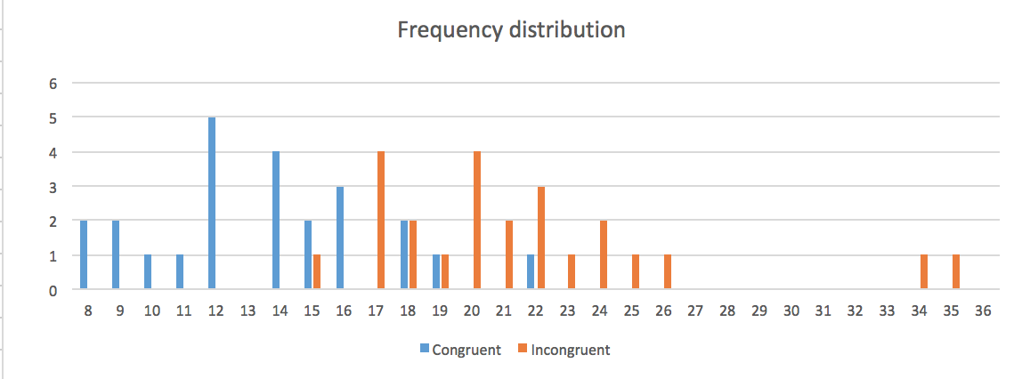

**Mean of congruent words group is obviously smaller. There are some outliers in incongruent words group.**

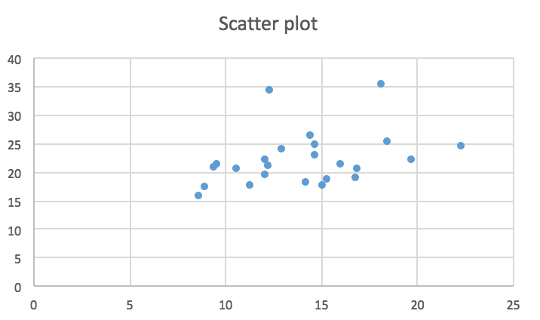

**Two scores have very little correlations.**

5. Now, perform the statistical test and report your results. What is your confidence level and your critical statistic value? Do you reject the null hypothesis or fail to reject it? Come to a conclusion in terms of the experiment task. Did the results match up with your expectations?

**in $α$ = 0.05 significance (confidence level)**

$H_{0}$**: $μ_{d}≤0$**

$H_{1}$**: $μ_{d}>0$**

**n = 24**

$t_{0.05, 23}≈$**1.713872**

**Sample mean: ${\overline{μ}}_{d}$ = 7.96479167**

**Sample standard deviation: $S_{d}$ = 4.86482691**

**Standard error for mean: 0.993028635**

**t = 8.020706944**

**t > $t_{0.05, 23}$**

**C = 1.701923972**

**Rejection region: R = {$μ_{d}>1.701923972\}$**

**=> Reject the null**

**= There is significance between performance for congruent words and incongruent words.**

**I expect this since the difference in average was quite obvious.**

6. Optional: What do you think is responsible for the effects observed? Can you think of an alternative or similar task that would result in a similar effect? Some research about the problem will be helpful for thinking about these two questions!

**I think the concept of ‘cognitive bias’ can be responsible for this result. People automatically think of the name of the color they see, but the word was different so that they hesitate for a short period.**

**We can experiment with this by size or direction of words.**