Explanations for common questions

## Introduction to the model

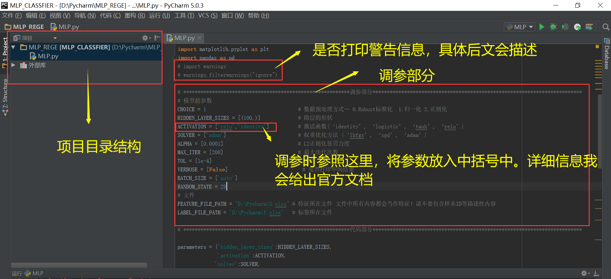e

Refer to this for adjusting parameters,put the parameters in parentheres. See the official documentation in details

Adjusting parameter section

Wheather to print warning message,detail will be dscribed later

Project directory structure

## The role of warning messages

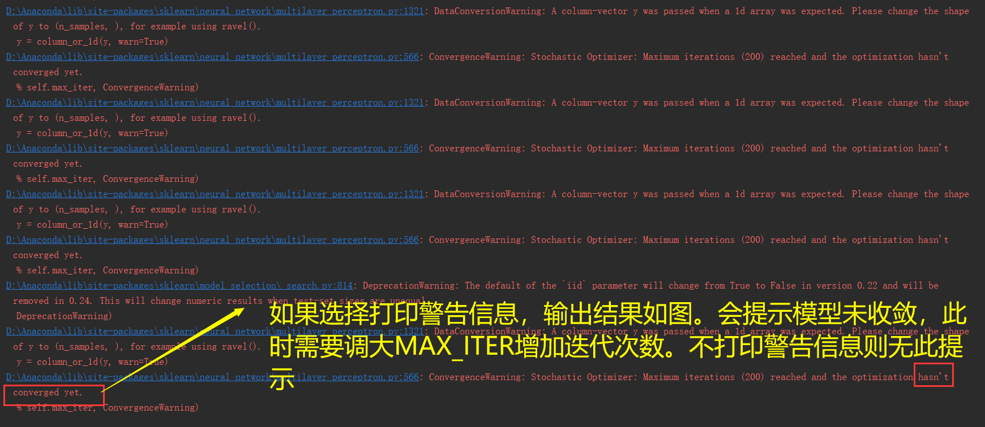

If you choose to print warning message,the output result is shown in the figure.It says the model is not convergent.You need to turn MAX_ITER up and increase the number of iterations.If you do not print a warning message, there will be no prompt

## Display of operation results

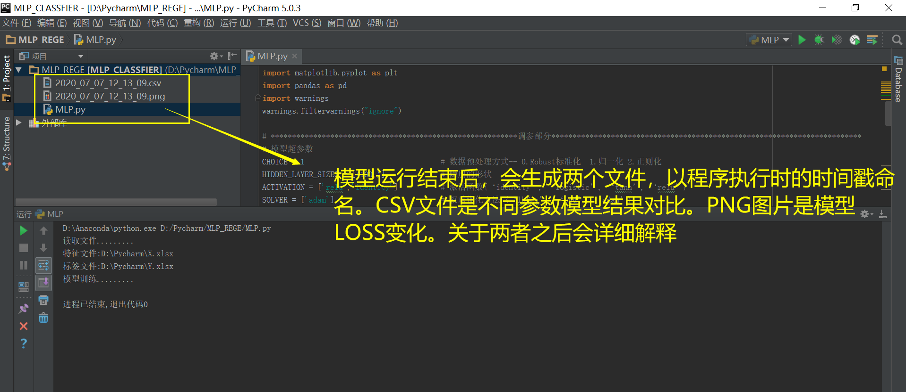

After the model runs,two files named with the timestamp of program execution are gengrated.CSV file is a comparison of the results of different parameter models.PNG images are model loss changes.. The details will be explained later

## Explanation of generated files

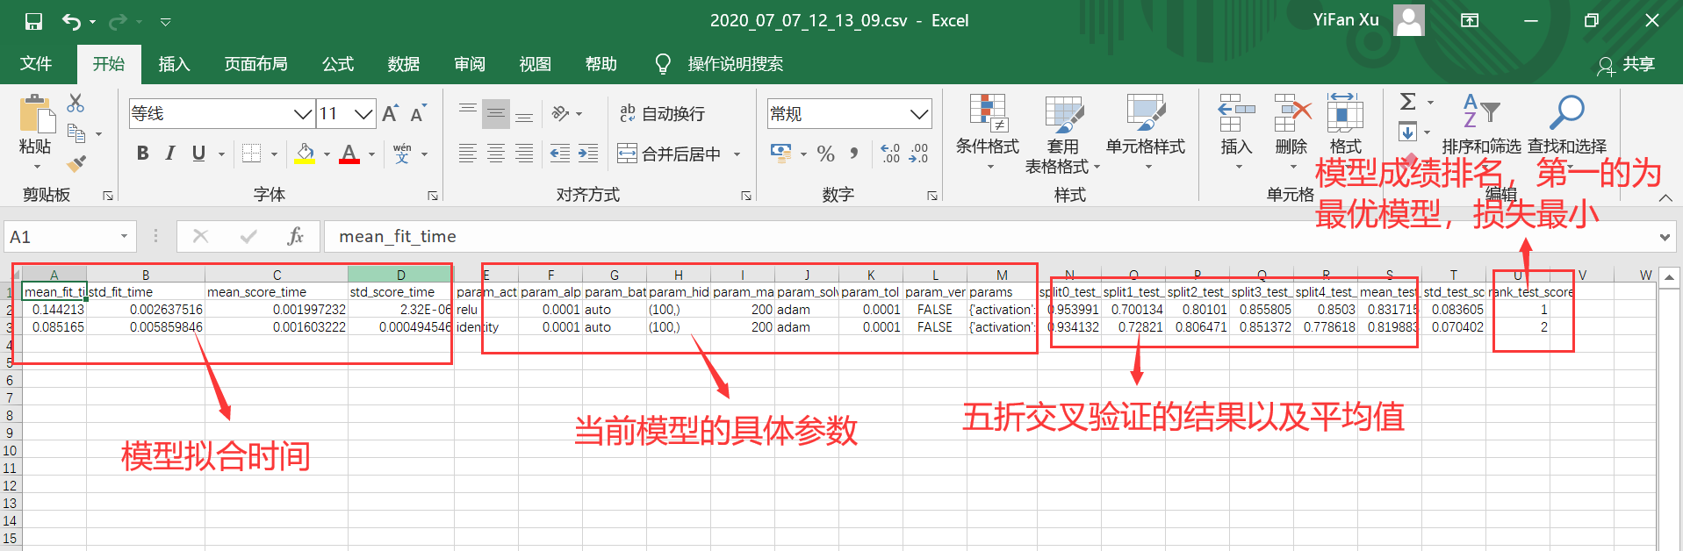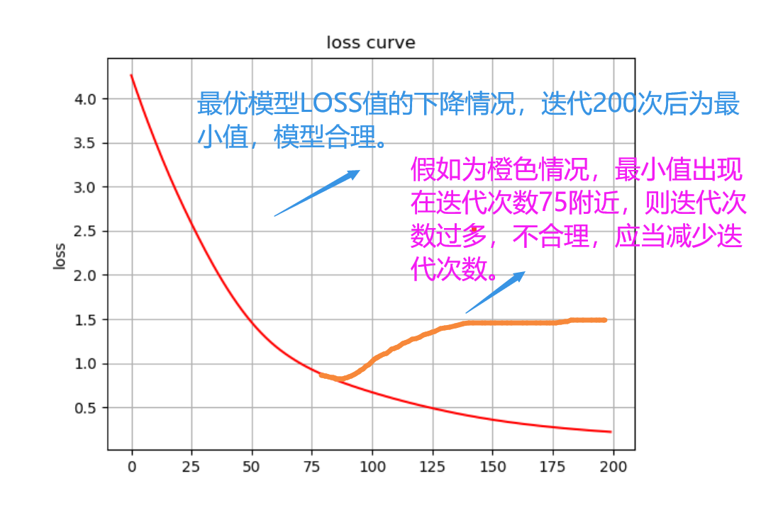

**Model ranking:the first medel is optimal and the loss of the least**

Validation results and averages of Cross-validation

Specific parameters of the current model

Model fitting time

**Decline of the optimal model loss value,the minimum value is obtained after 20 iterations,the model is reasonable**

**If it is orange and the minimum value appears at 75,then the number of iterations is too many and unreasonable,shuold be reduced**