Exercise 1: This experiment illustrates the use of simple k-mean clustering with Weka. The sample data set used for this example is based on the vote.arff data set. This document assumes that appropriate pre-processing has been performed.
I. Using Weka Explore
1. Open weka tool and click Explorer.
2. clickOpen file…in Preprocess tab.- choose vote.arff
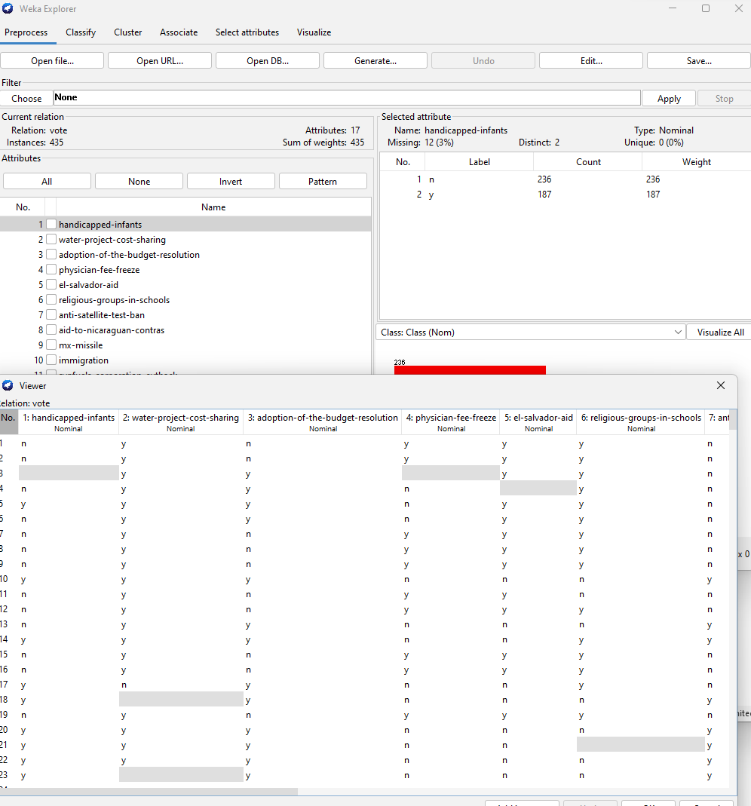
Choose cluster tab – click choose button – choose SimpleKmeans.
Click Start button
OUTPUT:
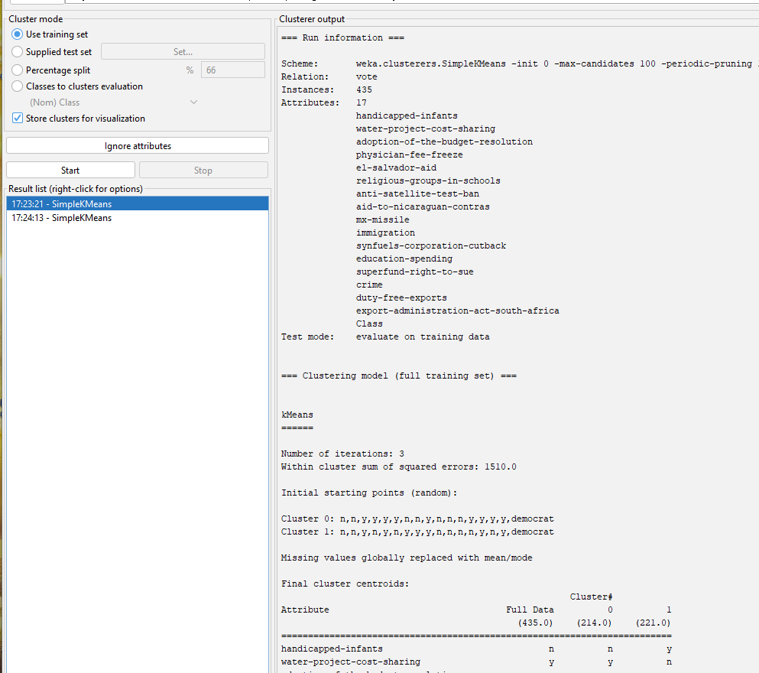
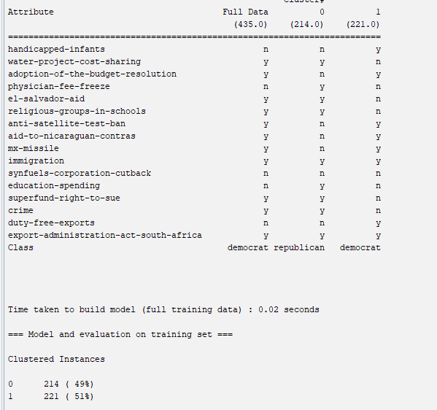
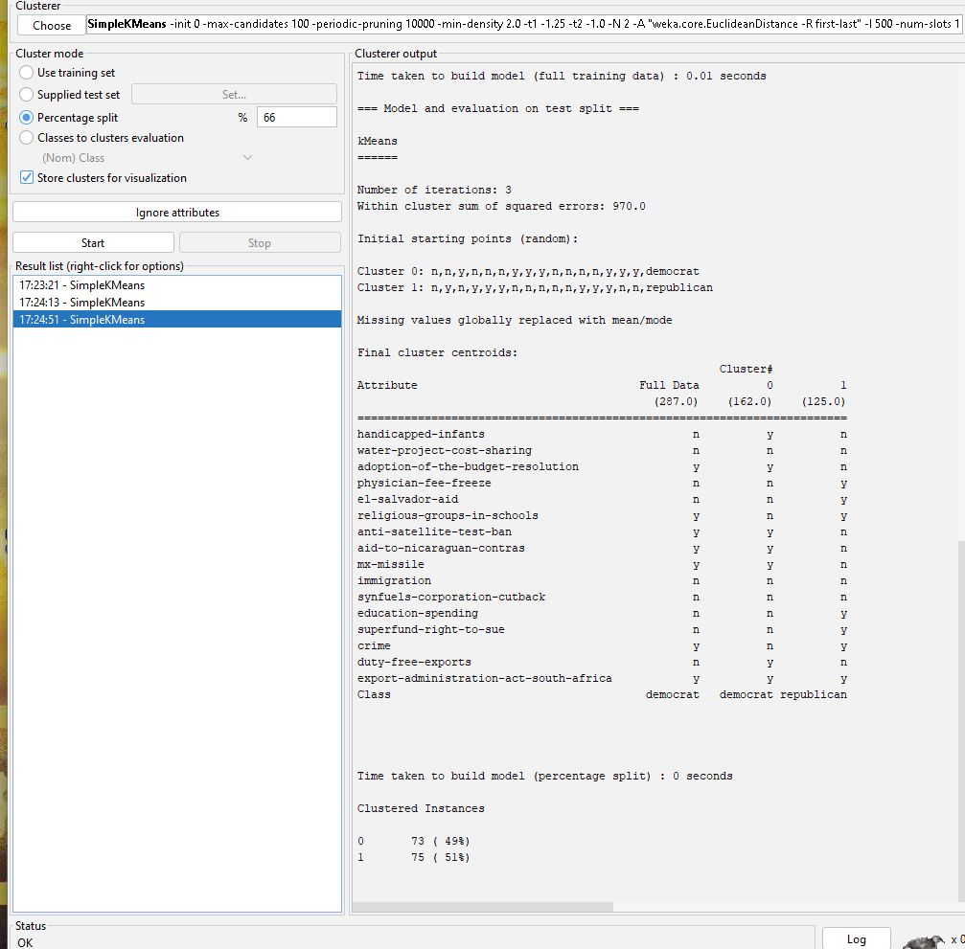
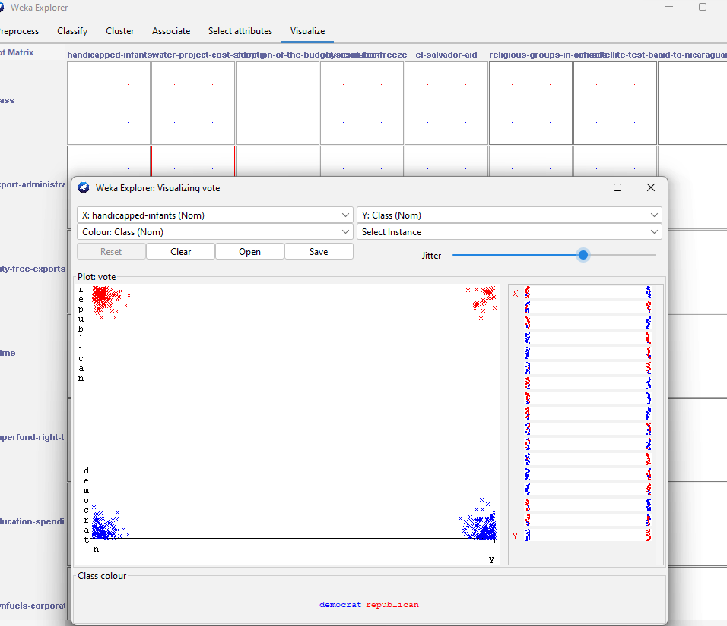
II. Using Weka KnowledgeFlow
- Open weka tool and click KnowledgeFlow.
- Right click the TextViwer choose Show results option.
- OUTPUT:
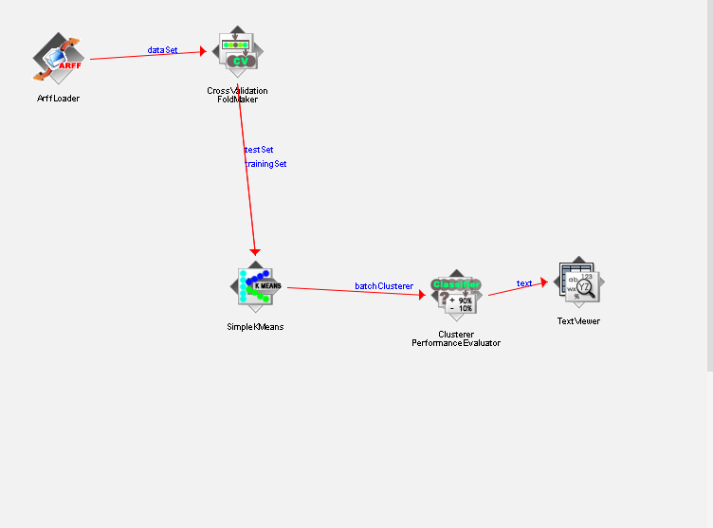
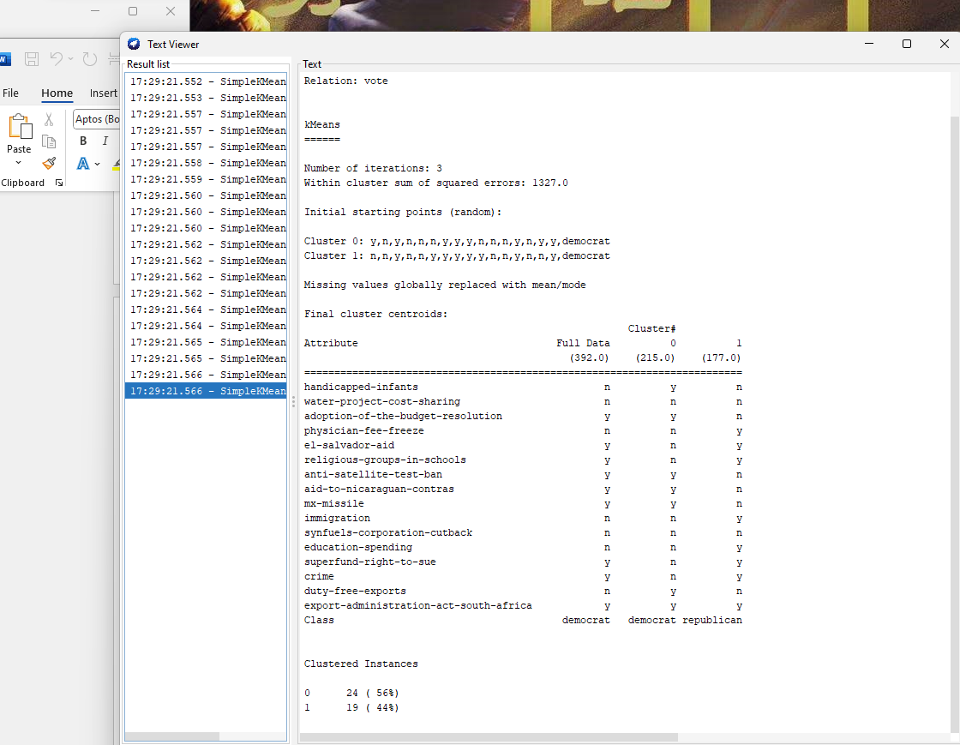
Exercise 2: This experiment illustrates the use of one hierarchical clustering with Weka. The sample data set used for this example is based on the vote.arff data set. This document assumes that appropriate pre-processing has been performed. PROCEDURE: 1.Open the data file in Weka Explorer. It is presumed that the required data fields have been discretized.
2. Clicking on the cluster tab will bring up the interface for cluster algorithm.
3. We will use hierarchical clustering algorithm.
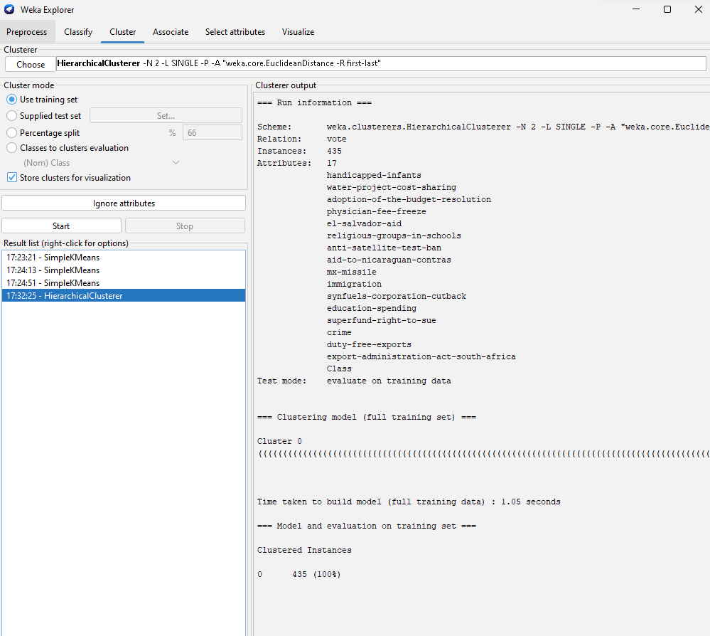
4. Visualization of the graph

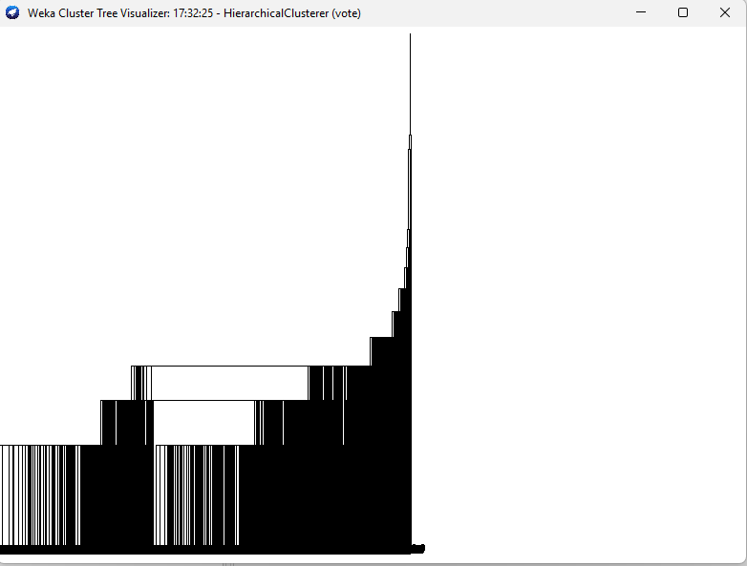
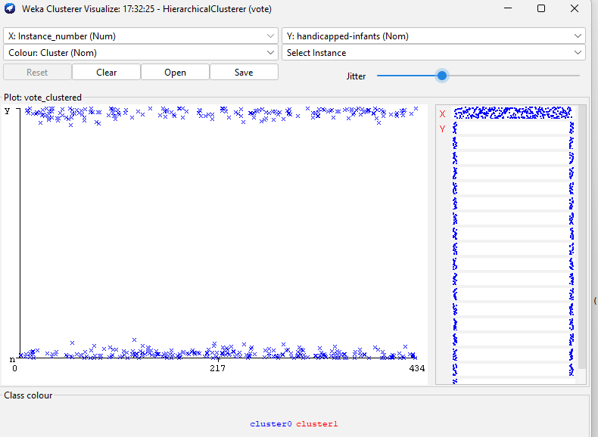Exercise 3: The goal of this data mining study is to find groups of animals in the zoo dataset, and to check whether these groups correspond to the real animal types in the dataset.
- What types of variables are in this dataset?
Nominal;numeric
b. How many rows / cases are there?
101 rows; 18 cases
c. How many animal types are represented in this dataset? List them here.
6 animal types
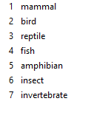
d. After removing the type attribute, go to the Cluster tab. How many clustering algorithms are available in Weka?
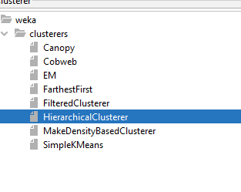
e. List the clustering algorithms seen in class, and map these to the ones provided in Weka.
f. Start using the SimpleKMeans clusterer choosing 7 clusters. Do the clusters learnt and their centroids seem to match the animal types?
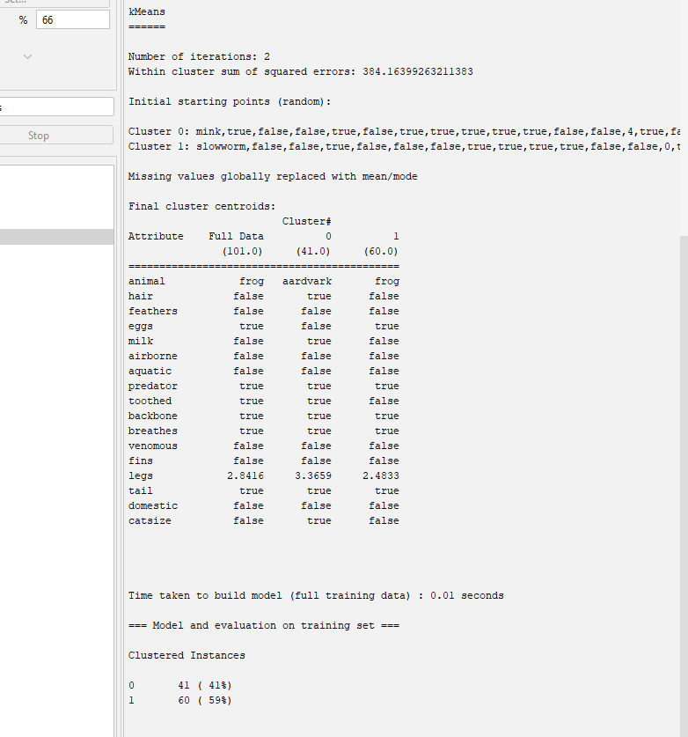
g. Start using the HierarchicalClusterer with Single Link.
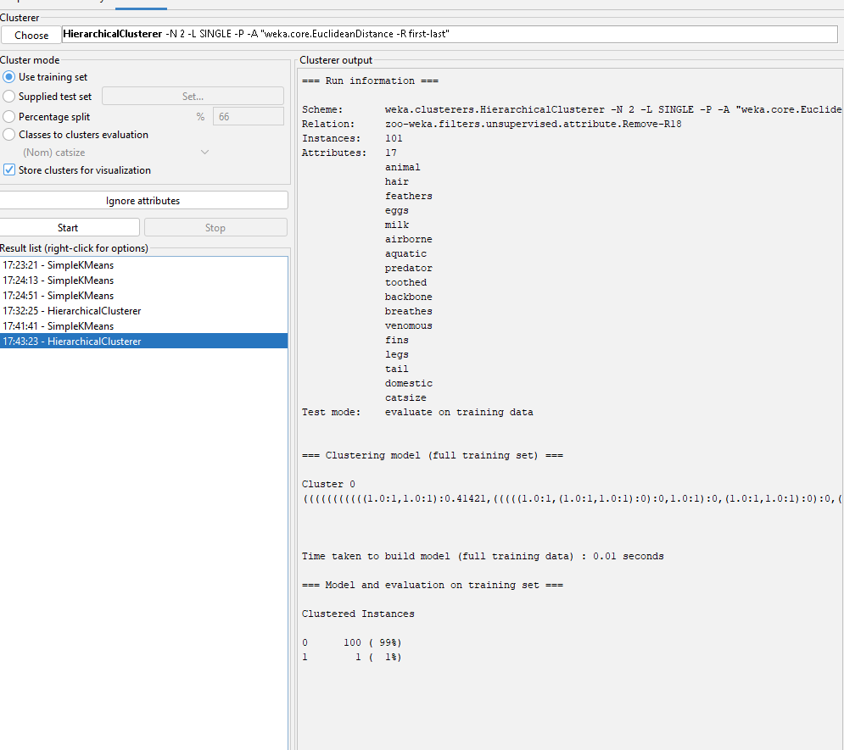
h. Start using the HierarchicalClusterer with Complete Link.
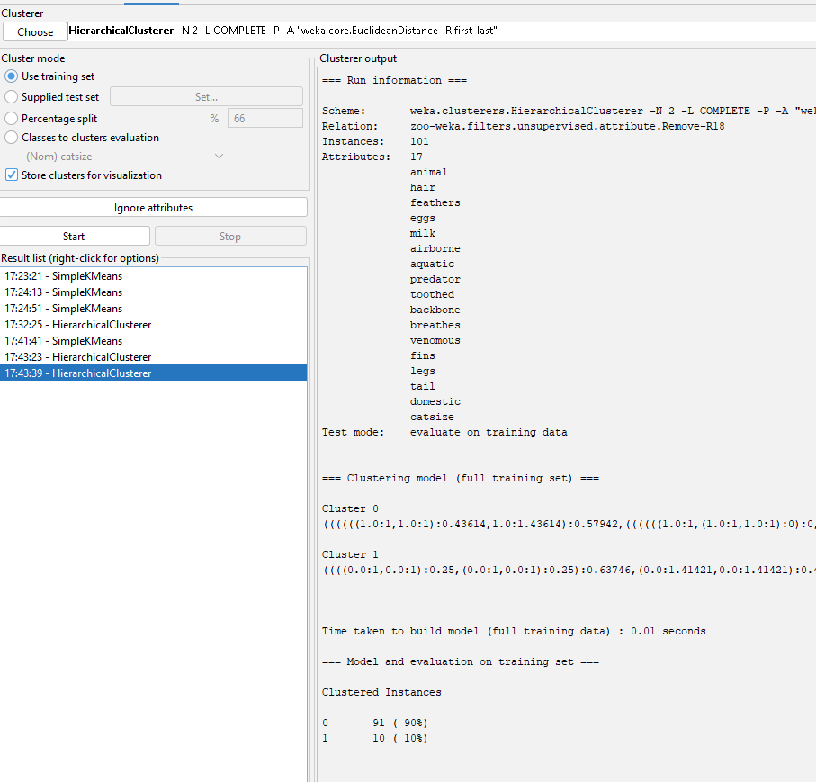
- Start using the HierarchicalClusterer with Average Link.
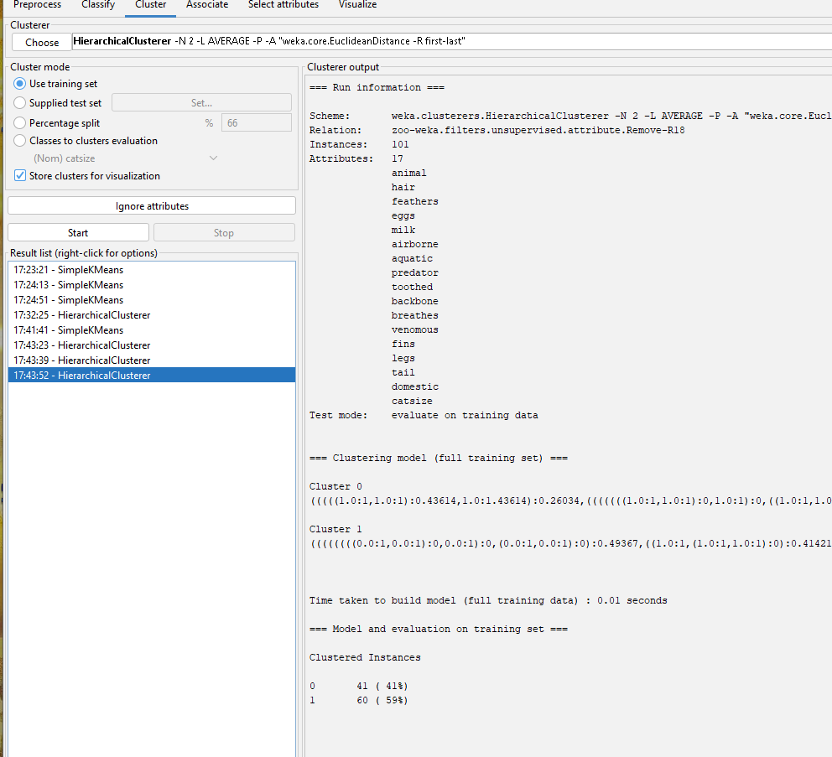
j. Start using the HierarchicalClusterer with Mean Link.
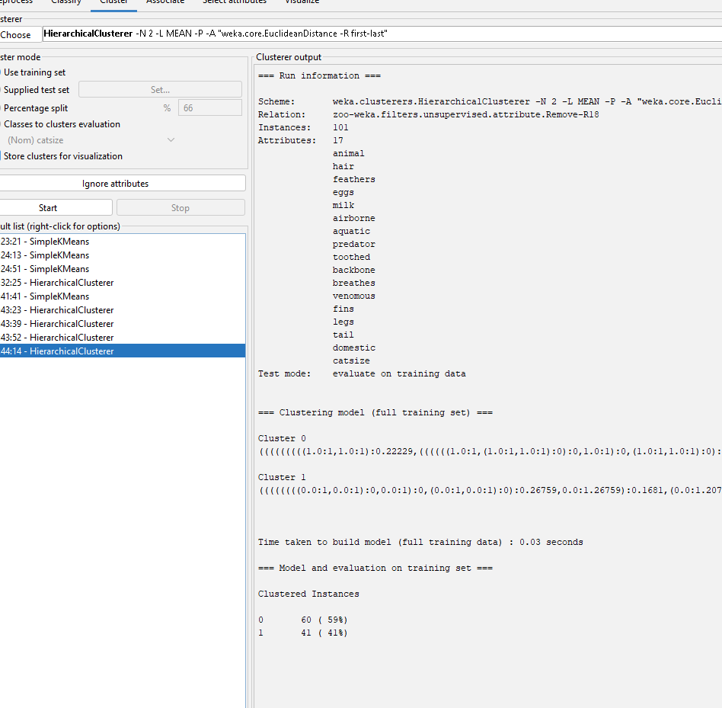
k. Start using the HierarchicalClusterer with Centroid Link
