Exercise 1: Using Weka Explorer to construct decision tree for the weather.nominal.arff with
the J48 algorithm (or the other classification model) and classify it.
1. Launch the Weka tool and activate the Explorer environment.
2. Open the “weather.nominal” dataset
3. Go to the Classify tab. Select the J48 classifier. Choose the “Cross-validation” (10 folds) test mode.
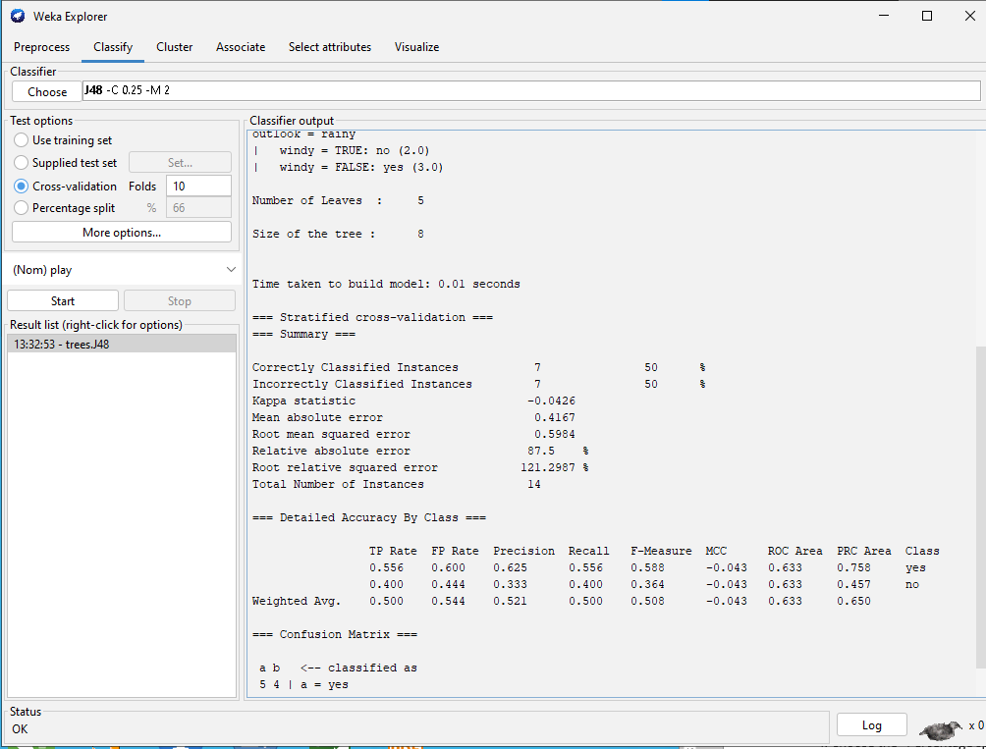
Run the classifier and observe the results shown in the “Classifier output” window.
- How many instances are incorrectly classified?
- What is the MAE (mean absolute error) made by the classifier?
- What can you infer from the information shown in the Confusion Matrix?
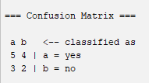
- >Trong trường YES có 5 mẫu phân đúng lớp, 4 mẫu phân lớp sai; Trong trường NO có 3 mẫu phân lớp đúng, 2 mẫu phân lớp sai.

- Visualize the classifier errors. In the plot, how can you differentiate between the correctly and
incorrectly classified instances?
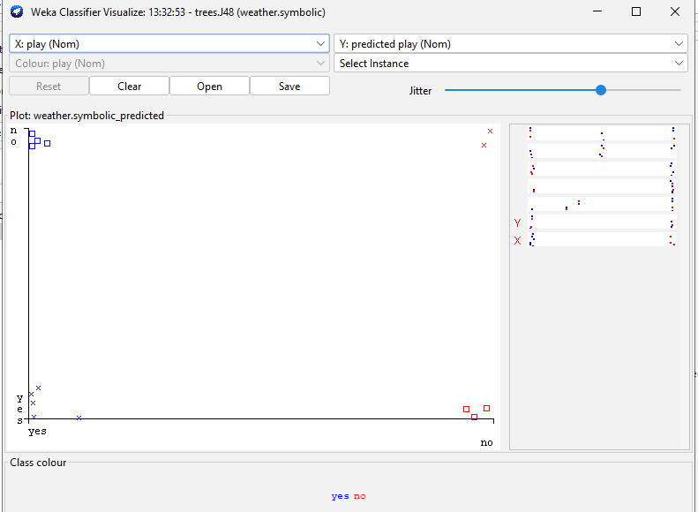
-> Correct plot phía dưới; incorrect plot phía trên
- How can you save the learned classifier to a file?
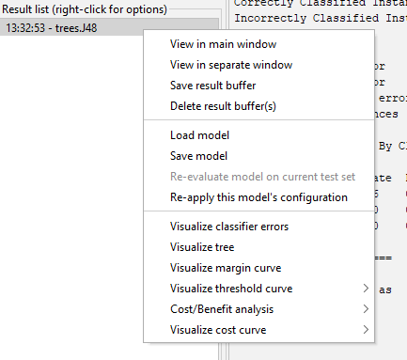
- B1: Click chuột phải vào Result list
- B2: Save model
- B3: nhập địa chỉ save model
- B4: Save
- How can you load a learned classifier from a file?
- B1: Click chuột phải vào Result list
- B2: Load model
- B3: nhập địa chỉ file cần load model
- B4: Open

4. Choose the “Percentage split” (66% for training) test mode. Run the J48 classifier and observe the
results shown in the “Classifier output” window.
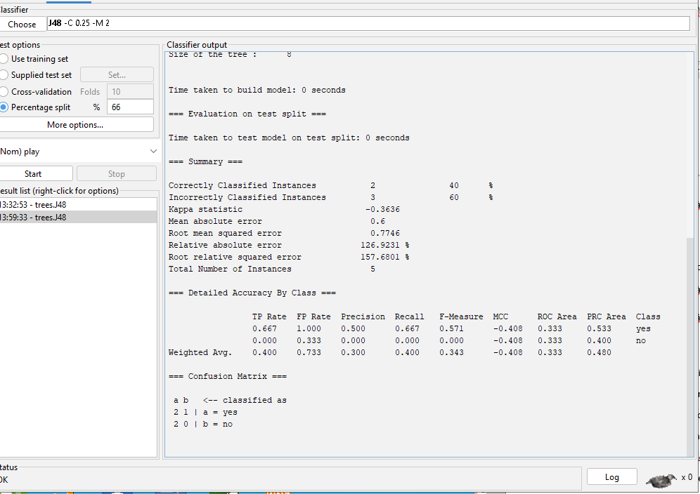
- How many instances are incorrectly classified? Why this number is smaller than that observed in the
previous experiment (i.e., using the cross-validation test mode)?
- What is the MAE made by the classifier?
- Visualize the classifier errors to see the detailed information.
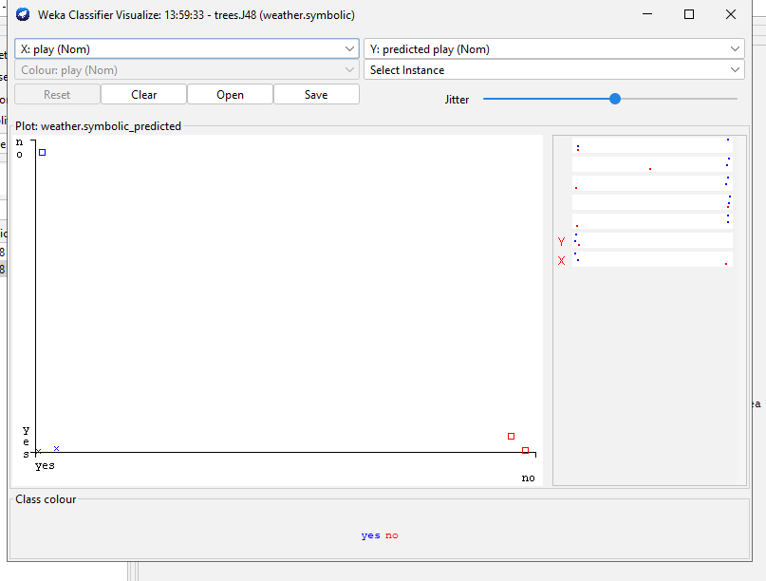
5. Choose the “Use training set” (66% for training) test mode. Run the J48 classifier and observe the
results shown in the “Classifier output” window.
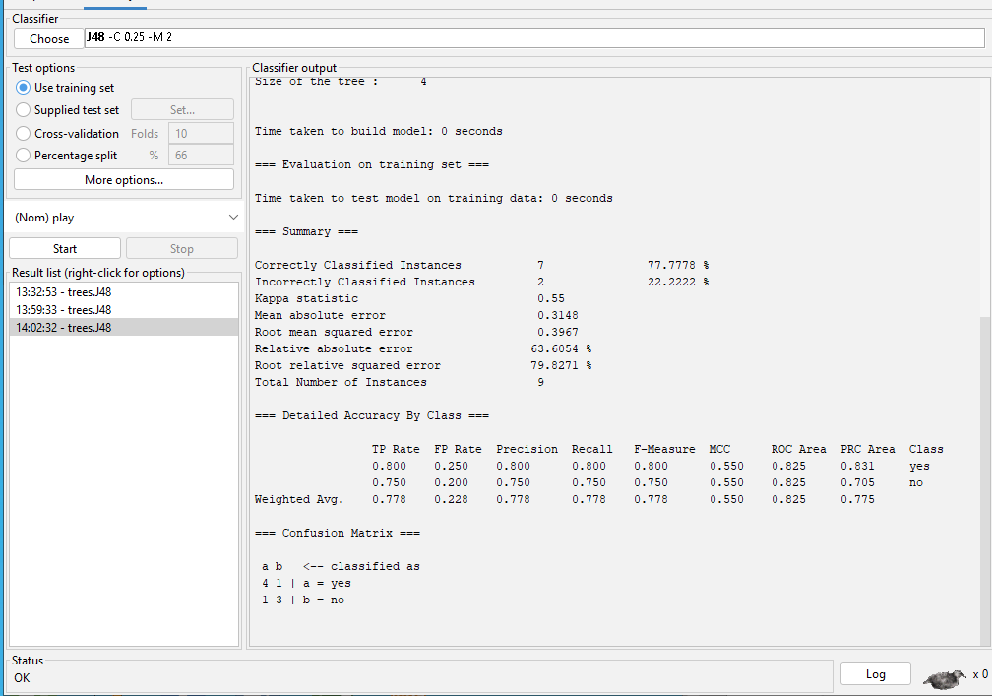
- How many instances are incorrectly classified? Why this number is smaller than that observed in the
previous experiment (i.e., using the cross-validation test mode)?
- What is the MAE made by the classifier?
- Visualize the classifier errors to see the detailed information.
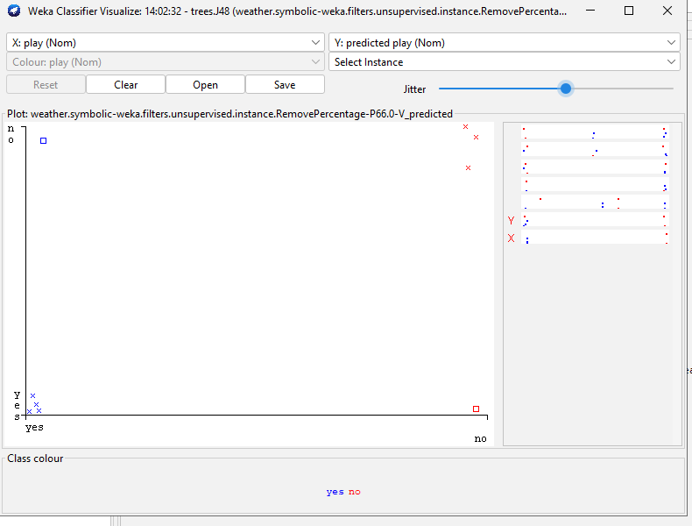
6. Compare test modes provided in the J48 classifiers and fill-in the following table:
Test option | Kappa statistic | Mean absolute error | Root mean squared error | Relative absolute error | Root relative squared error
Use training set | 1 | 0 | 0 | 0% | 0%
Cross validation | -0.0426 | 0.4167 | 0.5984 | 87.5% | 121.2987%
Percenttagesplit | -0.3636 | 0.6 | 0.7746 | 126.9231% | 157.6801%

7. Compare the performance of other classification approaches in this dataset: (Cross validation)
- J48
- OneR
- Naive Bayes
Test option | Kappa statistic | Mean absolute error | Root mean squared error | Relative absolute error | Root relative squared error
OneR | -0.1429 | 0.5714 | 0.7559 | 120 % | 153.2194 %
J48 | -0.0426 | 0.4167 | 0.5984 | 87.5% | 121.2987%
Naive Bayes | -0.0244 | 0.4374 | 0.4916 | 91.8631 % | 99.6492 %

Exercise 2:
Let’s assume that we have collected the following data set of users who decided to buy a computer
and others who decided not. Each user record (i.e., example) is represented by the 5 attributes.
- Age, with the possible values {Young, Medium, Old}.
- Income, with the possible values {Low, Medium, High}.
- Student, with the possible values {Yes, No}.
- Credit_Rating, with the possible values {Fair, Excellent}.
- Buy_Computer – the classification attribute, with the possible values {Yes, No}.
UserID Age Income Student Credit_Rating Buy_Computer
1 Young High No Fair No
2 Young High No Excellent No
3 Medium High No Fair Yes
4 Old Medium No Fair Yes
5 Old Low Yes Fair Yes
6 Old Low Yes Excellent No
7 Medium Low Yes Excellent Yes
8 Young Medium No Fair No
9 Young Low Yes Fair Yes
10 Old Medium Yes Fair Yes
11 Young Medium Yes Excellent Yes
12 Medium Medium No Excellent Yes
13 Medium High Yes Fair Yes
14 Old Medium No Excellent No
15 Medium Medium Yes Fair No
16 Medium Medium Yes Excellent Yes
17 Young Low Yes Excellent Yes
18 Old High No Fair No
19 Old Low No Excellent No
20 Young Medium Yes Excellent Yes
We want to predict, for each of the following users, if s/he will buy a computer or not.
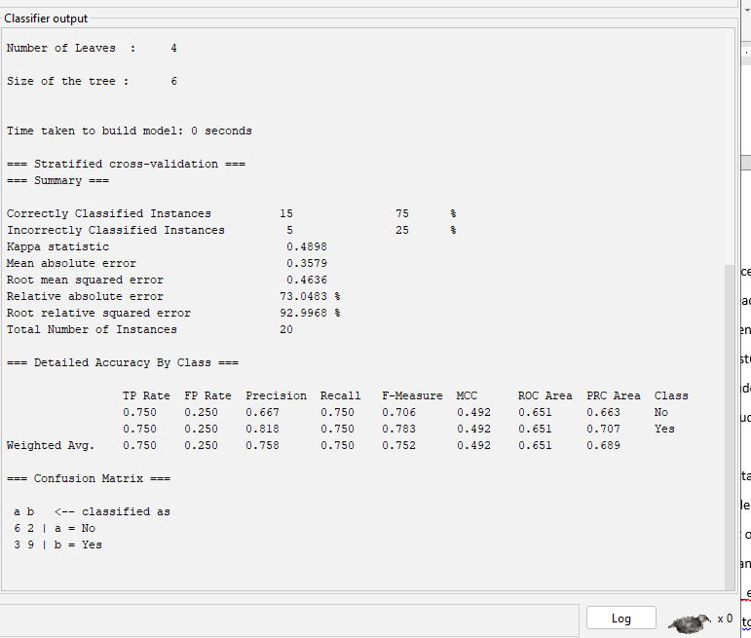
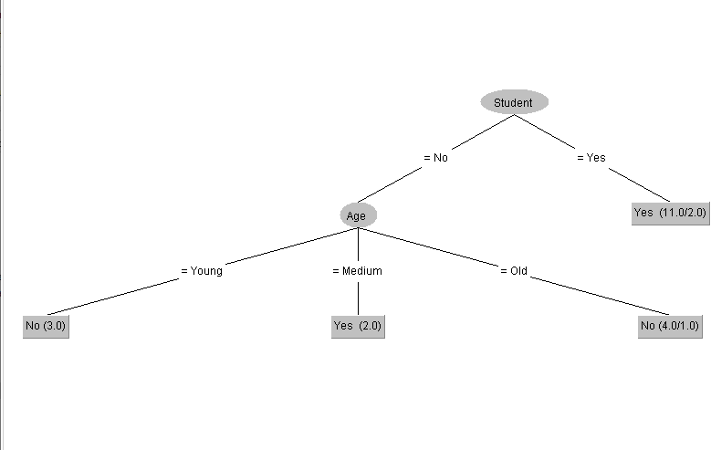- User #21. A young student with medium income and fair credit rating.(Yes)
- User #22. A young non-student with low income and fair credit rating. (No)
- User #23. A medium student with high income and excellent credit rating. (yes)
- User #24. An old non-student with high income and excellent credit rating. (No)
Requirement:
- Create the dataset containing 20 examples (i.e., Users #1-20) into the ARFF format and save it
in the “buy_comp.arff” file.
- For each user in the set of Users #21-24, set the values of the Buy_Computer attribute by the
predictions computed manually. Create the data of these four users into the ARFF format, and
save it in the “buy_comp_extra.arff” file.
- Use the Weka Explorer tool Open the “buy_comp” dataset (i.e., saved in the “buy_comp.arff”
file).
- Go to the “Classify” tab. Select the J48 classifier (or the other classification model). Choose
“Percentage split” (66% for training) test mode. Run the classifier and observe the results shown
in the “Classifier output” window.
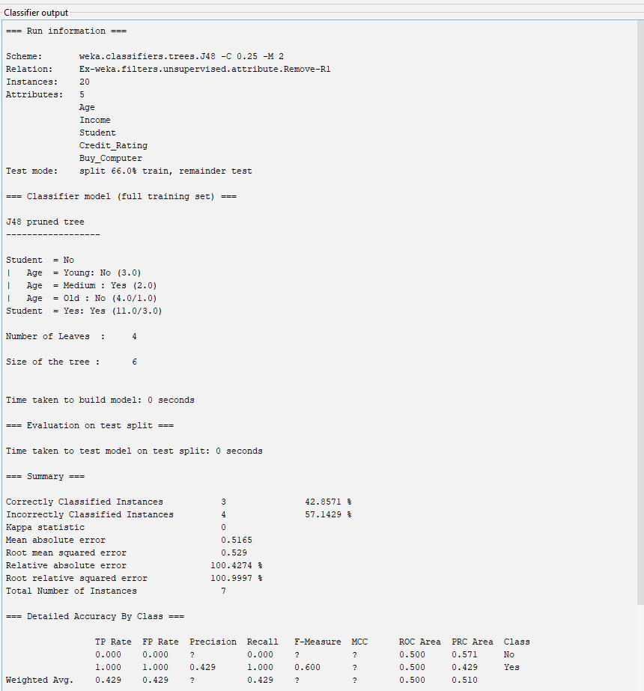
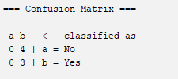
- How many instances used for the training? How many for the test?
13 Instances for training; 7 Instances for test
- Does the test set currently used include the four instances of Users #21-24?
No
- How many instances are incorrectly classified?
- What is the MAE (mean absolute error) made by the learned DT?
- What can you infer from the information shown in the Confusion Matrix?
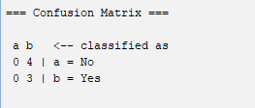
Thuộc tính No có 4 mẫu sai; Thuộc tính Yes có 3 mẫu đúng).
- Visualize the errors made by the learned DT. In the plot, how can you differentiate between the
correctly and incorrectly classified instances? In the plot, how can you see the detailed
information of an incorrectly classified instance?
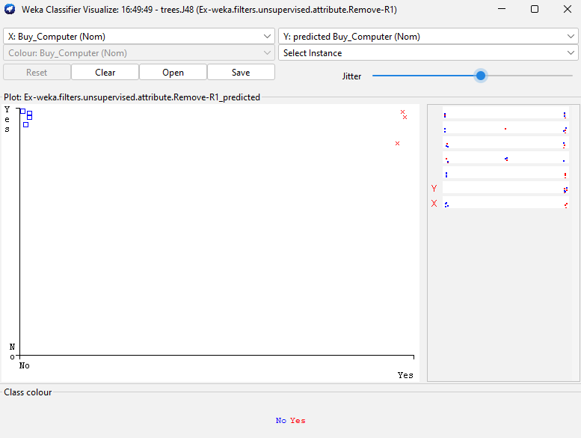
-> Correct plot phía bên phải; incorrect plot phía trái

- How can you save the learned DT to a file?
- How can you visualize the structure of the learned DT?
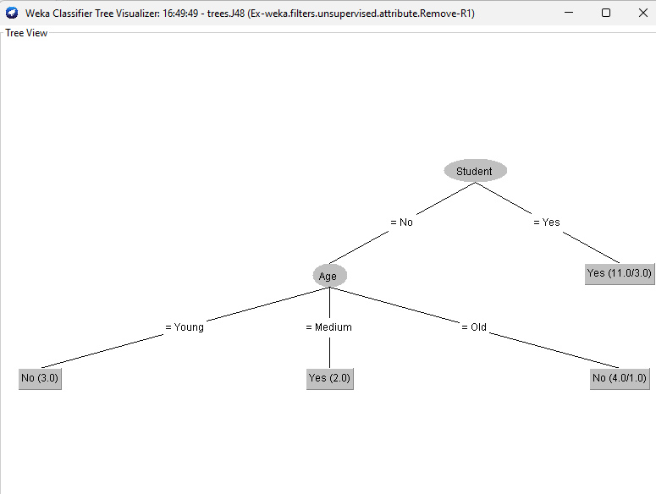s
- In the “Test options” panel select the “Supplied test set” option. Activate the nearby “Set...”
button and locate the “buy_comp_extra.arff” file. Run the classifier and observe the results
shown in the “Classifier output” window.
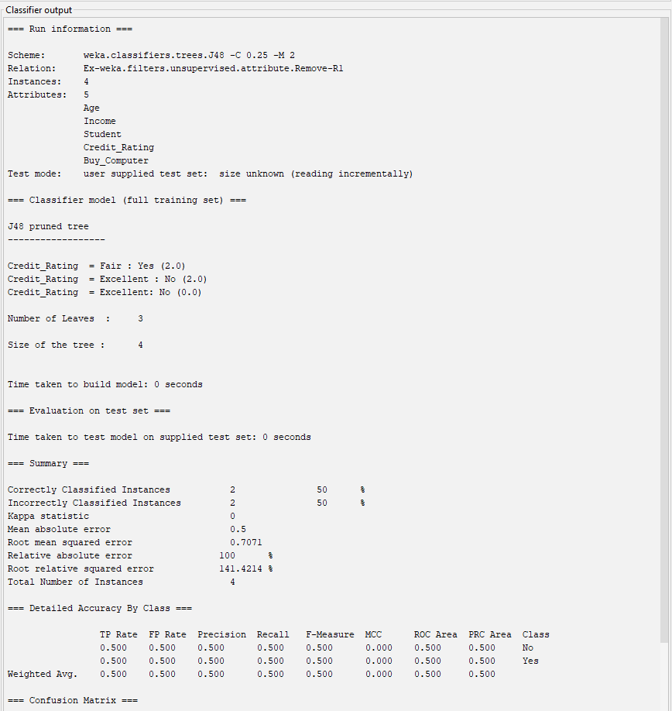
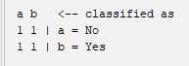
- How many instances used for the training? How many for the test?
20 training ; 4 test
- Does the test set currently used include the four examples (i.e., Users #21-24)?
yes
- In the “Classifier output” window, where you can find the information that says for which of the
four users (i.e., Users #21-24) the learned DT predicts correctly and for which others it predicts
incorrectly?
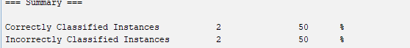
- What is the MAE (mean absolute error) made by the learned DT?
Exercise 3: Using Weka Knowledge Flow to construct a decision tree for the
weather.nominal.arff with the J-48 algorithm (or the other classification model) for the
above exercises
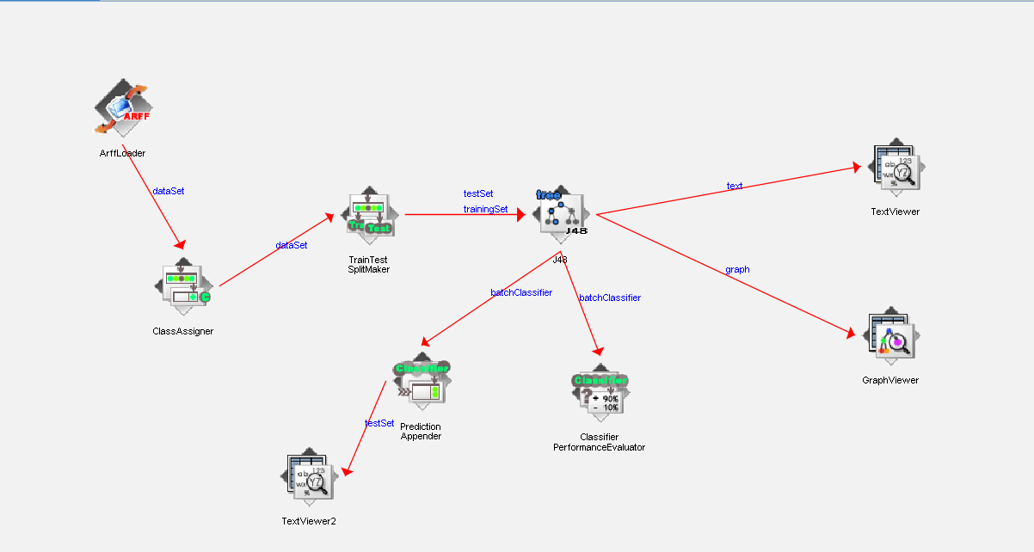
Exercise 4: Using Java programming language to construct a decision tree with the J-48
algorithm (or the other classification model) for the above exercises

