**一、程序改错题**

（1）~Symphony();

（2）char *author;

（3）Symphony::Symphony(char *str1, char *str2,int count):movement(count)

**二、程序完形题**

（1）Entry(Entry* n, int d) : next(n), data(d) { }

（2）top = top->next;

（3）top = new Entry(top, data);

（4）int result = top->data;

**三、程序补全题**

int *_elem = new int[++this->count];

for (int i = 0; i < pos; i++)

_elem[i] = elem[i];

_elem[pos] = data;

for (int i = pos; i < this->count; i++)

_elem[i+1] = elem[i];

for (int i = 0; i < this->count; i++)

elem[i] = _elem[i];

**四、程序设计题**

（1）

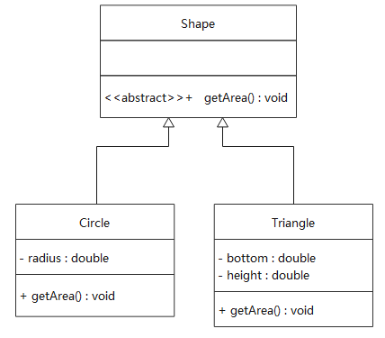

（2）

#include <iostream>

using namespace std;

class Shape {

public:

virtual double getArea() = 0;

};

class Circle : public Shape {

private:

double radius;

public:

Circle(double r) {

radius = r;

}

double getArea() {

return 3.14 * radius * radius;

}

};

class Triangle : public Shape {

private:

double bottom, height;

public:

Triangle(double b, double h) {

bottom = b;

height = h;

}

double getArea() {

return bottom * height * 0.5;

}

};

int main() {

Circle c1(10);

cout << c1.getArea() << endl;

Triangle tr1(3, 4);

cout << tr1.getArea() << endl;

return 0;

}