**一、程序改错题**

（1）void Clock::print() const

（2）set(++total_sec);

（3）return *this;

**二、程序完形题**

（1）return sqrt((x-p.x)*(x-p.x)+(y-p.y)*(y-p.y));

（2）if (num_of_side<MAX_SIDES) {

vertex[num_of_side]=p;

num_of_side++;

}

（3）for(int i=num_of_side-1;i>=pos;i--)

vertex[i+1]=vertex[i];

（4）for(int i=0; i<num_of_side-1; i++)

cir+=vertex[i].distanceTo(vertex[i+1]);

**三、程序补全题**

if (isEmpty()) {

os << endl;

return;

}

Node *temp = head;

while (temp != NULL) {

os << temp->data << " ";

temp = temp->next;

}

os << endl;

**四、程序设计题**

答：

（1）

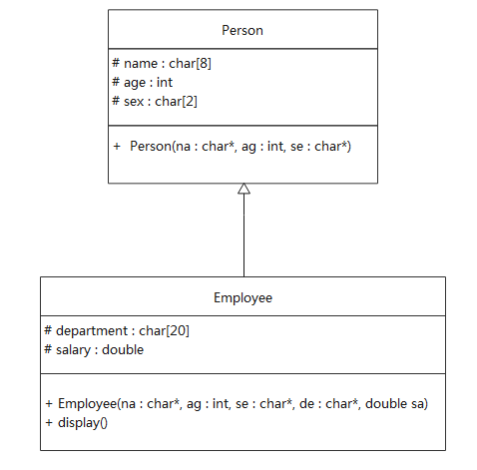

（2）

#include <iostream>

#include <cstring>

using namespace std;

class Person {

protected:

char name[8];

int age;

char sex[5];

public:

Person(const char* na = "", int ag = 0, const char* se = "") {

strcpy(name, na);

age = ag;

strcpy(sex, se);

}

};

class Employee : public Person {

private:

char department[20];

double salary;

public:

Employee(const char* na = "", int ag = 0, const char* se = "", const char* de = "", double sa = 0) : Person(na, ag, se) {

strcpy(department, de);

salary = sa;

}

void display() {

cout << name << " " << age << " " << sex << " " << department << " " << salary << endl;

}

};

int main() {

Employee e1("Bill", 22, "man", "Computer", 4567.89);

e1.display();

return 0;