Sudoku

**[Year]**

[Type the author name]

[Type the company name]

[Pick the date]

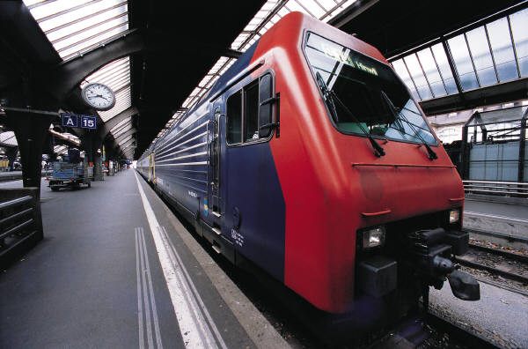

Problem statement:-

To create a Sudoku game using C++.

Feasibility:-

The project is feasible.

Requirements:-

A computer which possesses C++ with working <graphic.h>.

Analysis:-

