3 P2-YOLOv8 and Exploratory Degradation-Conditioned Localization Learning
This chapter presents the proposed P2-YOLOv8 detector and the exploratory degradation-conditioned localization learning (DCLI) extension. The chapter deliberately separates the architectural contribution from the exploratory training mechanism. P2-YOLOv8, hereafter denoted PLAIN_P2 when no auxiliary mechanism is enabled, is the stable inference model. It adds a high-resolution P2 prediction level to the standard feature pyramid while retaining the anchor-free YOLOv8 detection formulation. DCLI is evaluated as a training-time extension that estimates sampling- and visibility-related factors and uses them to condition the localization objective. In the frozen implementation described below, DCLI does not alter the feature-fusion path at inference time. This separation is important because a mechanism-level change in gradients is not, by itself, evidence of an improvement in terminal detection accuracy.

3.1 Overall Architecture
Roadside vulnerable road users, particularly pedestrians and cyclists at long range, often occupy only a small number of pixels. Successive downsampling improves semantic abstraction but also removes boundary and texture evidence that is disproportionately important for these objects. P2-YOLOv8 addresses this resolution bottleneck by extending the conventional P3–P5 prediction pyramid with a stride-4 P2 level. The resulting detector contains three functional stages: a YOLOv8m backbone for hierarchical feature extraction, a bidirectional P2 neck for top-down and bottom-up feature aggregation, and a shared anchor-free detection head applied to P2, P3, P4, and P5.
Let X denote an input image and let B2, B3, B4, and B5 be backbone features at strides 4, 8, 16, and 32, respectively. The neck transforms these backbone tensors into the four prediction features P2–P5. The detection head D then produces class scores and discrete bounding-box distributions at all four levels:
Ŷ = D(P₂, P₃, P₄, P₅), stride(Pₗ) ∈ {4, 8, 16, 32}. (3-1)
All prediction levels use the same detection formulation; the P2 level changes the spatial sampling density rather than introducing a separate task or class-specific head. At an input size of 640 × 640, the four feature maps contain 34,000 spatial prediction locations in total, of which 25,600 belong to P2. The additional high-resolution locations increase the opportunity to assign and localize small objects, while the lower-resolution levels preserve the larger receptive fields required for medium and large instances.
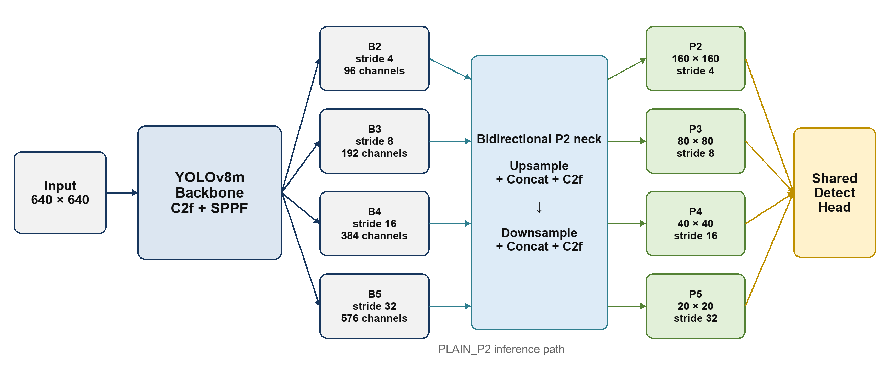
Figure 3-1. Overall architecture of P2-YOLOv8. The stable inference path contains a YOLOv8m backbone, a bidirectional P2 neck, and four prediction levels.
Table 3-1. Frozen four-level prediction pyramid used by P2-YOLOv8.
Level | Source layer | Stride | Feature size at 640 | Channels | Primary role
P2 | 18 | 4 | 160 × 160 | 96 | Fine spatial detail and small-object localization
P3 | 21 | 8 | 80 × 80 | 192 | Small-to-medium objects
P4 | 24 | 16 | 40 × 40 | 384 | Medium objects and semantic context
P5 | 27 | 32 | 20 × 20 | 576 | Large objects and broad contextual support

For PLAIN_P2, training follows the standard YOLOv8 detection objective. Denoting classification, complete-IoU localization, and distribution focal losses by Lcls, LCIoU, and LDFL, respectively, the baseline objective is
Ldet = λcls Lcls + λbox LCIoU + λdfl LDFL. (3-2)
The class and DFL branches are not redefined by the P2 extension. Consequently, comparisons between PLAIN_P2 and the DCLI extension can bind both methods to the same backbone, neck topology, prediction head, assignment rule, and evaluation protocol. Only the registered training mechanism is changed.
Method boundary. P2-YOLOv8 is the primary architectural method. DCLI is an exploratory extension of the training objective; it is not presented as an inference-time feature-routing module in the frozen comparison.

3.2 High-Resolution P2 Detection Branch
The backbone is expanded to the YOLOv8m channel configuration. Its stride-4, stride-8, stride-16, and stride-32 outputs contain 96, 192, 384, and 576 channels. Starting from the SPPF-enhanced B5 feature, the top-down path repeatedly upsamples the deeper tensor, concatenates it with the corresponding lateral backbone feature, and refines the result using C2f blocks. This process first constructs intermediate stride-16 and stride-8 features and then reaches the stride-4 P2 feature:
T₄ = C2f([Up(B₅), B₄]), T₃ = C2f([Up(T₄), B₃]), (3-3)
P₂ = C2f([Up(T₃), B₂]). (3-4)
A bottom-up aggregation path then returns information from the fine P2 grid to the coarser levels. Each step applies a stride-2 convolution, concatenates the downsampled feature with its top-down counterpart, and uses another C2f block to form the final prediction tensors:
P₃ = C2f([Down(P₂), T₃]), P₄ = C2f([Down(P₃), T₄]), (3-5)
P₅ = C2f([Down(P₄), B₅]). (3-6)
This bidirectional construction serves two complementary purposes. The top-down route transfers high-level semantic context into the shallow stride-4 representation, while the bottom-up route returns localization-rich details to the coarser prediction levels. Concatenation is used instead of elementwise addition so that the two branches remain explicitly represented before C2f refinement. The final Detect module consumes layers 18, 21, 24, and 27 in this order, which fixes the feature-to-stride correspondence used by both the detection loss and DCLI factor alignment.
The stride-4 branch is particularly relevant to small-object geometry. If an object has image-space width w and height h, its approximate support on a feature level with stride s is w/s by h/s. Reducing s from 8 to 4 doubles each spatial dimension and increases the number of cells covering the object by approximately a factor of four. This does not guarantee a higher average precision: P2 also increases high-resolution background responses and may create more ambiguous candidates. The architectural hypothesis is therefore limited and testable: preserving a denser grid should reduce the information bottleneck for small vulnerable road users, while final utility must be established through the fixed evaluation protocol described in later chapters.
The model is initialized through a semantic-prefix transfer from the corresponding YOLOv8m weights. Parameters whose layer identity and tensor shape match the common prefix are loaded, whereas tensors belonging to the newly introduced P2 route and the four-scale head are initialized by the project model definition. This prevents an incompatible three-scale head from being treated as a valid four-scale initialization and preserves a reproducible distinction between transferred and newly learned parameters.

3.3 Degradation Factors and Localization-Uncertainty Construction
The exploratory DCLI extension is motivated by the observation that localization ambiguity can arise from different sources. A small or repeatedly resampled object may lack stable edge evidence even when it remains visible, whereas an occluded or truncated object may retain adequate sampling but lose part of its spatial support. Treating these cases as one undifferentiated difficulty score makes it impossible to test whether the model has learned a meaningful degradation mechanism. DCLI therefore represents degradation with two bounded factors: a sampling factor fs and a visibility factor fv, both in [0, 1]. Larger values indicate greater degradation under the corresponding operational definition.
At each registered fusion node, the two incoming feature tensors are projected to 32 channels and concatenated. A shared estimator applies a depthwise 3 × 3 convolution, GroupNorm, SiLU, a 1 × 1 projection, GroupNorm, and SiLU. A final 1 × 1 factor head with a sigmoid activation produces the two-channel factor map
f(x, y) = [fₛ(x, y), fᵥ(x, y)] = sigmoid(gθ(F₁, F₂)). (3-7)
Factor semantics are supervised with reproducible object-centred interventions. A sampling intervention applies a sub-pixel phase shift, area downsampling, and linear restoration within the selected region. A visibility intervention mixes the region with a smooth low-frequency local-colour occluder. Identity, sampling, and visibility cases are sampled with frozen probabilities 0.2, 0.4, and 0.4, and non-identity strength is drawn from [0.1, 0.8]. If b ∈ [0, 1] is a valid natural factor and a ∈ [0, 1] is the intervention strength for the same factor, the combined target is
t = 1 − (1 − b)(1 − a). (3-8)
The target map is supported only on the transformed region and is accompanied by a validity-weight map. Weighted Smooth-L1 supervision is computed after area-resizing the targets to each registered scale. Invalid factor channels contribute zero weight rather than being silently assigned a zero target. This distinction prevents unavailable metadata from being interpreted as evidence of no degradation.
The predicted factor fields are aligned with the flattened anchor-free prediction order. For the final pyramid this order is P2, P3, P4, and P5, matching the spatial flattening used by the detection head. DCLI supplements these learned factors with the uncertainty already present in distributional box regression. Let za,q,k be the logit of bin k for anchor location a and box side q ∈ {l, t, r, b}, with K = reg_max. The normalized mean DFL entropy is
Hₐ = −[1/(4 log K)] Σq Σk pₐ,q,k log pₐ,q,k, pₐ,q,: = softmax(zₐ,q,:). (3-9)
Because H is normalized by log K, it lies in [0, 1] and is comparable to the two factor channels. The frozen configuration uses equal non-negative weights, giving the auditable localization-uncertainty score
uₐ = (wₛ fₛ,ₐ + wᵥ fᵥ,ₐ + wH Hₐ)/(wₛ + wᵥ + wH) = (fₛ,ₐ + fᵥ,ₐ + Hₐ)/3. (3-10)
This score is a training construct, not a calibrated probability that a detection is wrong. It combines interpretable degradation channels with distributional ambiguity so that the subsequent localization transformation can be inspected and ablated. The factor weights and entropy weight remain explicit configuration fields rather than hidden constants.
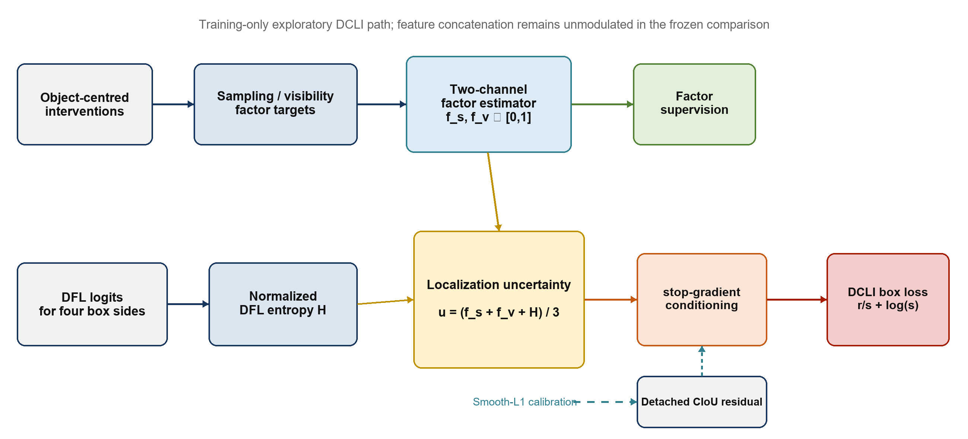
Figure 3-2. Training-only DCLI computation. Learned factors and normalized DFL entropy form a bounded uncertainty score; stop-gradient conditioning prevents a shortcut through the box loss, while separate supervision and calibration train the estimator.

3.4 DCLI Uncertainty-Aware Localization Loss and Training Schedule
For a positive location a, let ra = 1 − CIoU(ba, b*a) denote the localization residual between the predicted box ba and its assigned target b*a. CIoU geometry is computed in at least FP32 to avoid numerical overflow at the dense P2 level. DCLI defines an epoch-dependent scale
sₐ(e) = 1 + β ρ(e) stopgrad(uₐ), β = 0.5, (3-11)
where ρ(e) is the training schedule. The stop-gradient operator is essential: without it, the factor estimator could reduce the localization objective by manipulating u rather than by learning degradation semantics. The conditioned residual follows a heteroscedastic form
ℓDCLI,a = rₐ/sₐ + log sₐ. (3-12)
The first term reduces the contribution of highly uncertain residuals, while the logarithmic term penalizes unnecessarily large uncertainty. Therefore, DCLI is not equivalent to multiplying CIoU loss by an arbitrary small-object weight. Positive locations retain the same task-aligned assignment and target-score weighting as the baseline. The conditioned CIoU component is normalized by the same target-score sum used by YOLOv8, and the DFL term is left unchanged.
A separate calibration term discourages the uncertainty score from drifting away from observed localization difficulty. The target is the detached residual clipped to [0, 1], and the frozen calibration gain is γ = 0.1:
Lcal = γ ρ(e) · [Σa wa SmoothL1(uₐ, stopgrad(clip(rₐ, 0, 1)))] / Σa wa. (3-13)
Let Lfac denote the weighted multiscale factor-supervision loss and η = 0.2 its gain. The exploratory training objective can be summarized as
L = λcls Lcls + λbox(LDCLI + Lcal) + λdfl LDFL + η ρ(e)Lfac. (3-14)
The schedule is defined from the absolute zero-based epoch index e so that resumed runs preserve the same method state. With Ef = 5 frozen epochs and Er = 10 ramp epochs,
ρ(e) = 0, e < Ef; ρ(e) = min[1, (e − Ef + 1)/Er], e ≥ Ef. (3-15)
Thus the DCLI and factor-supervision coefficients are zero during the first five epochs, increase from 0.1 to 1.0 over the next ten epochs, and remain at 1.0 thereafter. The independently sampled input interventions remain enabled by the data pipeline; the schedule controls the DCLI and factor-loss paths rather than rewriting the dataset policy. This distinction is recorded because changing the interventions together with the loss schedule would confound input robustness with localization conditioning.
Table 3-2. Registered component boundary for the exploratory DCLI comparison.
Component | Frozen setting | Role in the described comparison
P2 four-scale detector | Enabled | Stable inference architecture and shared baseline
Factor estimator | 32 channels; two outputs | Predicts sampling and visibility factors
DCLI conditioning | Enabled; β = 0.5 | Conditions the CIoU residual during training
Uncertainty calibration | γ = 0.1 | Matches uncertainty to detached CIoU residuals
Factor supervision | η = 0.2 | Maintains the intended factor semantics
Feature-fusion gate | Disabled | Reliability factors do not modulate feature concatenation
Semantic protection | Disabled | No auxiliary protected semantic adapter
Counterfactual consistency | Disabled; gain = 0 | Excluded from the frozen DCLI comparison
Schedule | 5 frozen + 10 ramp epochs | Activates DCLI and factor supervision reproducibly

Although the reliability module can compute branch weights, the frozen experiment sets fusion_gate = false. Its fusion schedule is consequently fixed at zero, the effective gate strength is zero, and each fusion node returns the ordinary channel-wise concatenation used by PLAIN_P2. The learned factors affect training only through factor supervision, uncertainty calibration, and the DCLI localization transformation. Likewise, semantic protection and counterfactual consistency are disabled, and the counterfactual gain is zero. These settings prevent the comparison from unintentionally combining multiple mechanisms.
The implementation exposes separate diagnostic terms for baseline localization, DCLI conditioning, calibration, and factor supervision. Their gradients can be inspected at the final P2–P5 factor nodes, but they only verify that the intended pathway is active and numerically stable. They do not replace endpoint AP, class-wise performance, scale- and distance-specific analysis, or multi-seed evidence. Subsequent chapters therefore evaluate PLAIN_P2 and DCLI under the same frozen protocol and report negative as well as positive results.

