Modelling a Fixed Qinding Cipu Witness: Candidate Uncertainty and Analytical Exemplarity in a Ten-Label Song Ci Pilot
Lin Zhanyi
Hong Kong Metropolitan University
lzzzy20041125@outlook.com

Research version: August 20, 2026
Correspondence concerning this paper should be addressed to Lin Zhanyi, Hong Kong Metropolitan University. This dated research version was generated from a frozen evidence package.

Abstract
This article asks what becomes visible when a later prosodic compilation is treated as a historical model, not Song-native law. We audit a fixed digital witness of the Siku Qinding Cipu across ten stored tune labels. From 21,053 corpus records, rules exclude 4,570 low-frequency-label and 372 lost-tune-name records, leaving 16,111 records under 99 exact labels; the frozen purposive technical pilot spanning nine source volumes retains 5,574. Codification features, textual-realization residuals, and character-use representation are constructed separately. After adjustment for tune-level mean log text length, none of the 18 aggregate associations passes the frozen joint gate. Separately, none of the eight primary record-level estimands receives Holm support. The asymmetric wrong-reference construction also yields a tone association; without a direct coefficient-difference test, true-tune specificity remains unestablished. Tied-candidate sensitivity is concentrated: Huanxisha contributes 72.2% of the pooled reversible-pair numerator for tone and 91.3% for rhyme. Tone is classified as sensitive under all four tested policies, whereas rhyme is indeterminate under three and is classified as sensitive only after exact-label anonymous exclusion; its four lower endpoints remain near the conventional .05 audit threshold, so this is threshold fragility rather than a demonstrated substantive policy effect. The frozen selector returns three bounded records: candidate-sensitive Zhang Xiaoxiang/Huanxisha, metadata-boundary Anonymous/Xijiangyue, and stable Mao Pang/Shuidiaogetou. We contribute a five-step audit of a later witness as a computational model, choices that shape analytical visibility, and the return from bounded cases to textual inquiry. The study recovers neither a Song-native rule nor intention, corruption, semantic difference, creativity, or literary value.
Keywords: Song Ci, retrospective codification, candidate-pattern uncertainty, corpus boundaries, analytical exemplarity, computational poetics

Modelling a Fixed Qinding Cipu Witness: Candidate Uncertainty and Analytical Exemplarity in a Ten-Label Song Ci Pilot
Introduction
Named tune labels organize the transmission and study of Song Ci, but the particular prescriptions operationalized in this study come from a later historical construction. A fixed tune-book page can provide a reproducible reference for character span, segmentation, tones, and rhyme without becoming a transparent record of every Song-period compositional decision. The question is therefore which apparent regularities remain under the specific modelling and corpus decisions tested here, and how those decisions change the records returned for interpretation.
The paper turns analytical exemplarity into a five-link procedure rather than a label applied after seeing attractive texts: identify the historical source, declare its computational operationalization, freeze the metric and ranking rule, return cases deterministically, and restrict interpretation to what those steps can support. A returned record is exemplary only of a declared model-data relation. It is not thereby typical, representative, important, aesthetically exemplary, or historically exceptional. Model failure and localized sensitivity are therefore useful to literary inquiry because they make the route by which a text entered the audit set inspectable, without claiming to explain authorial intention or meaning.
The operational source is a fixed Chinese Wikisource digital witness of the Siku Qinding Cipu (Qinding Cipu, 1715). Nine pinned page revisions cover the ten exact stored tune labels in the pilot. Fixing that witness makes the computation auditable; it does not turn a Qing retrospective compilation into a transparent Song-native rule. Candidate-pattern uncertainty here concerns structurally tied patterns within those pinned pages. It is not edition uncertainty, cross-codification variance, textual-critical adjudication, or a claim that stored labels have already been philologically harmonized.
Research Questions
(1) What support remains for the apparent associations between codification/textual-realization features and the character-use representation after tune-level length adjustment, and do the record-level and adverse-reference analyses support a portable, tune-specific interpretation?
(2) How unevenly is tied-candidate sensitivity distributed across the ten stored tune labels, and how fragile are its policy-level classifications to modern corpus and author-label boundaries?
(3) Which deterministically returned records are candidate-sensitive, metadata-boundary-sensitive, or stable, and what source-bounded literary questions can each case legitimately support?
Historical and Methodological Context
Later tune manuals are projects of comparison, correction, and norm-making rather than transparent Song-native truth. Lee (2019), Jiang (2020), and Hagiwara (2017) motivate treating a later reference page as a reproducible operational source while keeping its historical and prescriptive status explicit.
Digitized Chinese poetic corpora preserve editorial, attribution, and record/work boundaries that cannot be silently resolved by a model. Liu et al. (2018), Liu (2017), and Song (2026) therefore motivate retaining stored records, labels, and author strings as the units actually observed.
Operationalization and tool criticism require a reversible path from concepts to measures and back to interpretation. Pichler and Reiter (2022), Drucker (2011), Herrmann et al. (2023), and Dobson (2021) motivate the explicit estimands, audit gates, and bounded return to records used here. These literatures motivate the components but do not themselves test whether intra-source candidate choice and corpus policies alter Song-ci audit ordering and case return.
Method
Operational Measures and Estimands
The 18 aggregate tests comprise ten codification predictor–E outcome pairs and eight textual-realization predictor–E outcome pairs. E is a character 1–2-gram TF–IDF/SVD representation following the latent semantic analysis formulation (Deerwester et al., 1990), summarized either as within-tune author-centroid dispersion or as a scalar same-tune leave-one-out cosine distance. These are character-use measures, not measures of semantics, style, creativity, or value.
For candidate uncertainty, structurally tied candidates share the frozen segment and character-span score. Tone and rhyme residuals and their coverage are propagated jointly. A record is in common support only when every tied candidate has a finite residual and coverage greater than zero.
For each metric and tune, every distinct common-support record pair is examined. P_flip is the proportion whose strict relative residual ordering can reverse between the lower and upper tied-candidate values. The reported 95% percentile interval comes from author-string-block bootstrap resampling; the use of author-string blocks is consistent with the multilevel block-preserving principle discussed by Winkler et al. (2015), whose method is permutation-based rather than this bootstrap procedure. Record pairs are not treated as independent observations.
Audit cases are fixed low/high sets containing the ceiling of 10% of n_common records within each tune and metric. Baseline sets are compared with lexicographic-first and lexicographic-last candidate rules by Jaccard overlap, with the record identifier (frozen field: poem_id) as the deterministic tie break.
For each of the eight record-level estimands, predictor and outcome values are average-ranked within each stored tune label; the resulting rank vectors are then standardized over all retained records. Beta is estimated in a linear model with standardized log1p record length and tune fixed effects. Uncertainty uses author-string-clustered sandwich 95% confidence intervals and 9,999 author-block sign flips with seed 20260804; raw permutation p values are Holm-adjusted across the eight-effect family, and the adjusted values are denoted q. Here, wrong-reference denotes the adverse-control category, whereas true-tune and wrong-tune denote the two frozen, non-symmetric outcome constructions. The true-tune construction uses a same-tune leave-one-record centroid; the deterministic wrong-tune construction excludes the target author's records. This is an adverse negative-control design (Lipsitch et al., 2010), not a paired test of coefficient equality. No direct beta_wrong minus beta_true contrast was estimated.
Units, Boundaries, and the Fixed Reference
The frozen ingestion source is the Chinese-Poetry dataset (Chinese-Poetry, n.d.). The frozen ingestion contains 21,053 records: 21,050 primary and 3 supplemental. Excluding 4,570 low-frequency labels and 372 lost-tune-name records leaves 16,111 analytical records under 99 exact stored labels. These are counts of records and labels, not independent works or historically normalized tune forms. The formal pilot retains 5,574 records under ten stored tune labels after a pre-existing leakage rule excluded one corpus record that exactly matched a reference exemplar. It is a frozen purposive technical pilot spanning nine source volumes; the package does not document a probability-sampling or population-representativeness rule. Author strings form blocking labels; they are not entity resolution and do not establish historical persons. The formal analysis uses nine pinned Chinese Wikisource page revisions from the Siku Qinding Cipu for the ten tested labels. The page identities and oldid URLs are recorded in the fixed-witness provenance table and tables/tune_source_provenance.csv. The study does not estimate cross-edition or cross-codification uncertainty. Follow-up audits fixed their inputs and rules before output inspection.
A: Tune-Level Length Adjustment
Analysis A re-estimates the 18 frozen tune-level effects after adding tune-wise mean log1p text length as a covariate. The unit remains one stored tune label, so n = 10 is an aggregate denominator and not a record-level or corpus-wide sample. Each effect uses 99,999 Freedman–Lane residual permutations, 5,000 requested tune-resample bootstrap draws, and seed 20260810. The frozen joint gate passes only when the within-family Holm q < .05, the bootstrap 95% percentile interval excludes zero, and leave-one-tune-out sign consistency = 1. The procedures follow Freedman and Lane (1983), Holm (1979), and the Monte Carlo p-value convention of Phipson and Smyth (2010). The result is 0/18 passing effects; therefore none of the 18 associations is treated as length-robust evidence.
B: Candidate Patterns Within One Fixed Source Page
B resamples the 685 exact stored author-string blocks over the same 5,574 retained records and evaluates baseline, lexicographic-first, lexicographic-last, and metric-specific lower/upper tied-candidate scenarios. Tone has 5,574 common-support records and 1,628,472 comparable within-tune record pairs; rhyme has 5,534 applicable records, 5,521 common-support records, and 1,596,557 comparable pairs. A sensitive call requires all 2,000 requested repetitions to be valid, a pooled P_flip interval wholly above .05, and at least one changed deterministic case set; a stable call requires the interval wholly below .05 and minimum Jaccard at least .90; otherwise the result is indeterminate. The thresholds are audit conventions, not natural constants.
C: Three Modern Corpus/Author Policies
C reuses the B estimand under three isolated policies: remove the eight pilot text-metadata-conflict records; remove the 311 exact-label anonymous-author records; or retain all records while assigning anonymous records to record-specific singleton blocks. The baseline uses 5,574 records and 685 stored author-string blocks; text-metadata-conflict exclusion uses 5,566 records/684 blocks; exact-label anonymous exclusion uses 5,263/684; and anonymous-singleton blocking uses 5,574/995. All four policies use the same 2,000-repetition gate with a separately frozen input and configuration. Early exploratory results motivated A/B/C; the whole study was not externally preregistered. Each follow-up audit froze its inputs, estimand, decision rules, and code identity before its own formal output was inspected. The policies are modern record and author-label decisions, not historical author categories.
Frozen Case Return and Record-Level Caveats
The case selector was frozen before case IDs and text were read. It returns one candidate-sensitive tone case, one anonymous metadata-boundary rhyme case, and one cross-rule/cross-policy stable comparator; collisions are retained and no famous or aesthetically attractive text can replace a selected record. The Zhang Xiaoxiang and Mao Pang stored texts were subsequently checked against public witnesses, while the anonymous record was deliberately kept as metadata-boundary evidence only. Source-bounded case inspection may describe witnessed wording, segmentation, repeated characters, parallelism, metric values, and model membership; it may not infer intention, corruption, deliberate breaking, semantic distance, creativity, or literary value.
Results
Verified Descriptive and Inferential Displays
The tables and figures are generated directly from the frozen CSV and JSON artifacts. Their captions state the relevant denominator, estimand, uncertainty procedure, correction family, and interpretive boundary.
Table 1
Corpus and Formal-Pilot Record Flow
Stage | Count | Sample unit | Rule | Boundary recorded in the frozen source artifact
Ingested records | 21,053 | corpus row | raw_rows | eligible_analysis == True; 99 labels; minimum 30 records per tune
Excluded: label below minimum | 4,570 | corpus row | tune_below_minimum | eligible_analysis == True; 99 labels; minimum 30 records per tune
Excluded: lost tune name | 372 | corpus row | lost_tune_name | eligible_analysis == True; 99 labels; minimum 30 records per tune
Continuity layer retained | 16,111 | corpus row | eligible_analysis_true | eligible_analysis == True; 99 labels; minimum 30 records per tune
Pilot-eligible pool | 16,111 | pilot poem record | eligible_analysis_true | dim128 frozen representation evidence
Pilot aligned | 5,575 | pilot poem record | representation_aligned | dim128 frozen representation evidence
Excluded: exact exemplar leakage | 1 | pilot poem record | exact_exemplar_excluded | dim128 frozen representation evidence
Formal pilot retained | 5,574 | pilot poem record | retained_after_exemplar_exclusion | dim128 frozen representation evidence
The arithmetic is 21,053 ingested records - 4,570 records below the continuity threshold - 372 lost-tune-name records = 16,111 records under 99 exact stored labels. The formal pilot then aligns 5,575 records and excludes that one exact exemplar match, leaving 5,574. Counts are records and labels, not independent works or philologically merged tunes. The final column reports the downstream boundary encoded in each frozen source artifact; it does not assert that every stage row is eligible.
Figure 1
Corpus Selection and Formal-Pilot Flow
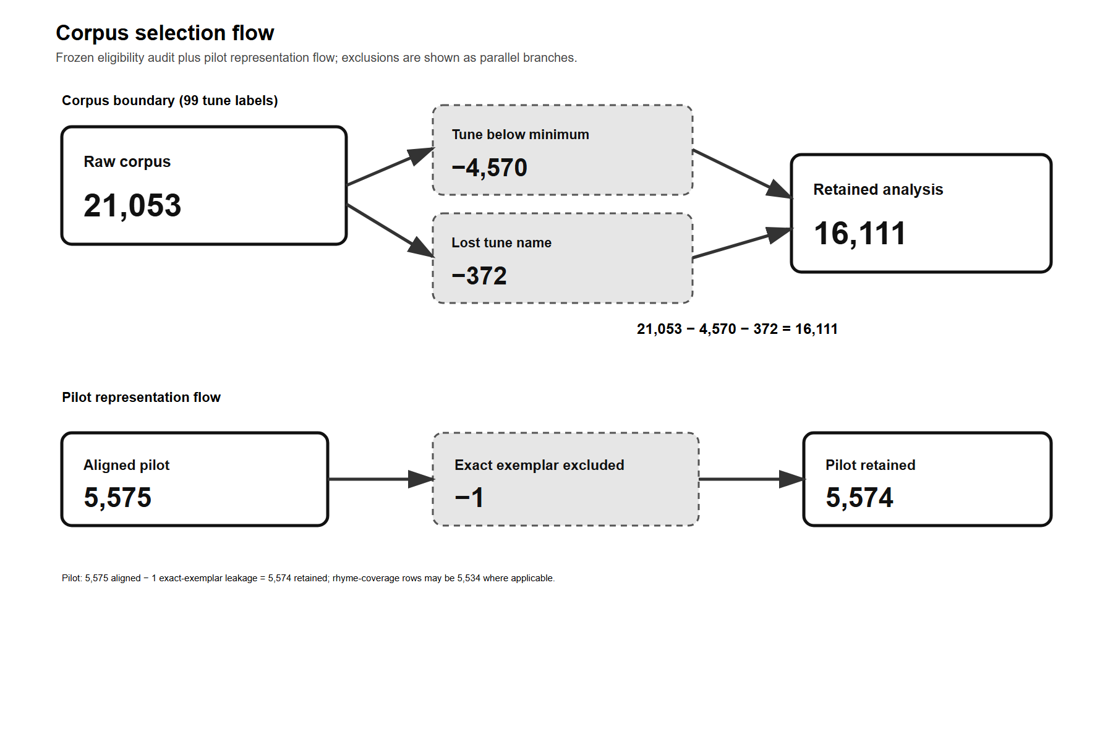
Note. Generated from tables/corpus_flow.csv. Boxes labelled “Excluded” mark exclusions rather than successive retained samples. The rhyme estimands have 5,534 applicable records because coverage is metric-specific.
Table 1 and Figure 1 make two boundaries explicit. The 99-label continuity layer is a descriptive record-accounting layer, whereas the formal follow-up estimands use ten stored labels and 5,574 retained records. Neither number is an independent-work count, and the minimum-frequency rule is an analytical continuity rule rather than a philological judgment about tune identity.
Table 2
Fixed Qinding Cipu Digital Witness and Ten-Label Pilot
Stored-label display | Pinned page / revision | Records / author strings | Candidate patterns | Tone applicable / common | Rhyme applicable / common
Huanxisha | vol. 04; rev. 776662 | 776 / 170 | 5 | 776 / 776 | 772 / 761
Pusaman | vol. 05; rev. 681952 | 598 / 171 | 2 | 598 / 598 | 598 / 598
Jianzi Mulan Hua | vol. 05; rev. 681952 | 425 / 115 | 1 | 425 / 425 | 425 / 425
Xijiangyue | vol. 08; rev. 776671 | 490 / 163 | 2 | 490 / 490 | 490 / 490
Linjiangxian | vol. 10; rev. 776677 | 481 / 154 | 11 | 481 / 481 | 469 / 469
Zhegutian | vol. 11; rev. 776680 | 657 / 167 | 1 | 657 / 657 | 649 / 649
Manjianghong | vol. 22; rev. 776710 | 549 / 183 | 14 | 549 / 549 | 547 / 547
Shuidiaogetou | vol. 23; rev. 776713 | 743 / 212 | 6 | 743 / 743 | 738 / 738
Niannujiao | vol. 28; rev. 776728 | 432 / 173 | 11 | 432 / 432 | 425 / 423
Qinyuanchun | vol. 36; rev. 776749 | 423 / 140 | 7 | 423 / 423 | 421 / 421
Note. Unit = exact stored tune label. The fixed witness is the Chinese Wikisource transcription of the Siku Qinding Cipu, pinned to nine page revisions for ten labels. Candidate counts and applicability are frozen audit inputs. Source-only tone coverage is unavailable in the frozen historical-source input; the reported tone applicability counts therefore use the frozen candidate-applicability inputs. Exact Chinese keys and oldid URLs, together with the local historical_sources.yaml configuration hash, frozen tune-frame and candidate-input hashes, and full denominators, remain in tables/tune_source_provenance.csv. These fields document source-entry and frozen-input provenance; they are not a hash-verified local snapshot of external Wikisource page bytes and do not constitute an edition or cross-codification comparison.
Table 3
Tune-Level Estimates Before and After Length Adjustment
Effect | Before rho (Holm q) | After partial rho (Holm q) | Adjusted 95% bootstrap CI | Gate
C: declared character span -> author dispersion | −.130 (q = 1.000) | .099 (q = 1.000) | [−.828, .848] | not supported
C: declared character span -> same-tune LOO distance | −.223 (q = 1.000) | .029 (q = 1.000) | [−.645, .658] | not supported
C: declared segment span -> author dispersion | −.510 (q = .669) | −.493 (q = 1.000) | [−.952, .783] | not supported
C: declared segment span -> same-tune LOO distance | −.434 (q = .669) | −.485 (q = 1.000) | [−.911, −.065] | not supported
C: line length signature entropy -> author dispersion | −.491 (q = .669) | .029 (q = 1.000) | [−.976, .800] | not supported
C: line length signature entropy -> same-tune LOO distance | −.553 (q = .620) | .185 (q = 1.000) | [−.808, .858] | not supported
C: rhyme position density -> author dispersion | .900 (q = .010) | .827 (q = .073) | [.281, .981] | attenuated
C: rhyme position density -> same-tune LOO distance | .948 (q = .001) | .694 (q = .268) | [.308, 1.000] | attenuated
C: variant count -> author dispersion | −.587 (q = .556) | −.234 (q = 1.000) | [−.859, .737] | not supported
C: variant count -> same-tune LOO distance | −.710 (q = .213) | −.435 (q = 1.000) | [−.875, −.092] | not supported
R: length residual mean -> author dispersion | −.479 (q = .662) | −.026 (q = 1.000) | [−.684, .692] | not supported
R: length residual mean -> same-tune LOO distance | −.479 (q = .662) | .253 (q = 1.000) | [.044, .648] | not supported
R: rhyme high residual mean -> author dispersion | .236 (q = 1.000) | .416 (q = 1.000) | [−.118, .782] | not supported
R: rhyme high residual mean -> same-tune LOO distance | .115 (q = 1.000) | .383 (q = 1.000) | [−.133, .939] | not supported
R: segment residual mean -> author dispersion | −.758 (q = .095) | −.335 (q = 1.000) | [−.897, .108] | not supported
R: segment residual mean -> same-tune LOO distance | −.915 (q = .004) | −.618 (q = .621) | [−1.000, .037] | attenuated
R: tone high residual mean -> author dispersion | −.745 (q = .095) | −.152 (q = 1.000) | [−.976, .766] | not supported
R: tone high residual mean -> same-tune LOO distance | −.842 (q = .026) | .242 (q = 1.000) | [.011, .642] | attenuated
Note. Unit = stored tune label (n = 10). The adjusted estimand is partial Spearman rho after the frozen tune-wise mean log1p-length covariate. The frozen length-adjustment output reports 5,000 requested bootstrap replicates per effect; 3,337–4,954 valid bootstrap replicates were observed across the 18 effects. File paths, effect identifiers, full precision, and hashes are recorded in the release manifest and claim-evidence matrix. The frozen machine label 'attenuated' is a gate-status label and can include a sign reversal; it does not assert monotone shrinkage in absolute magnitude. These counts are frozen outputs and are not recomputed here.
Figure 2
The Same 18 Effects Before and After Length Adjustment
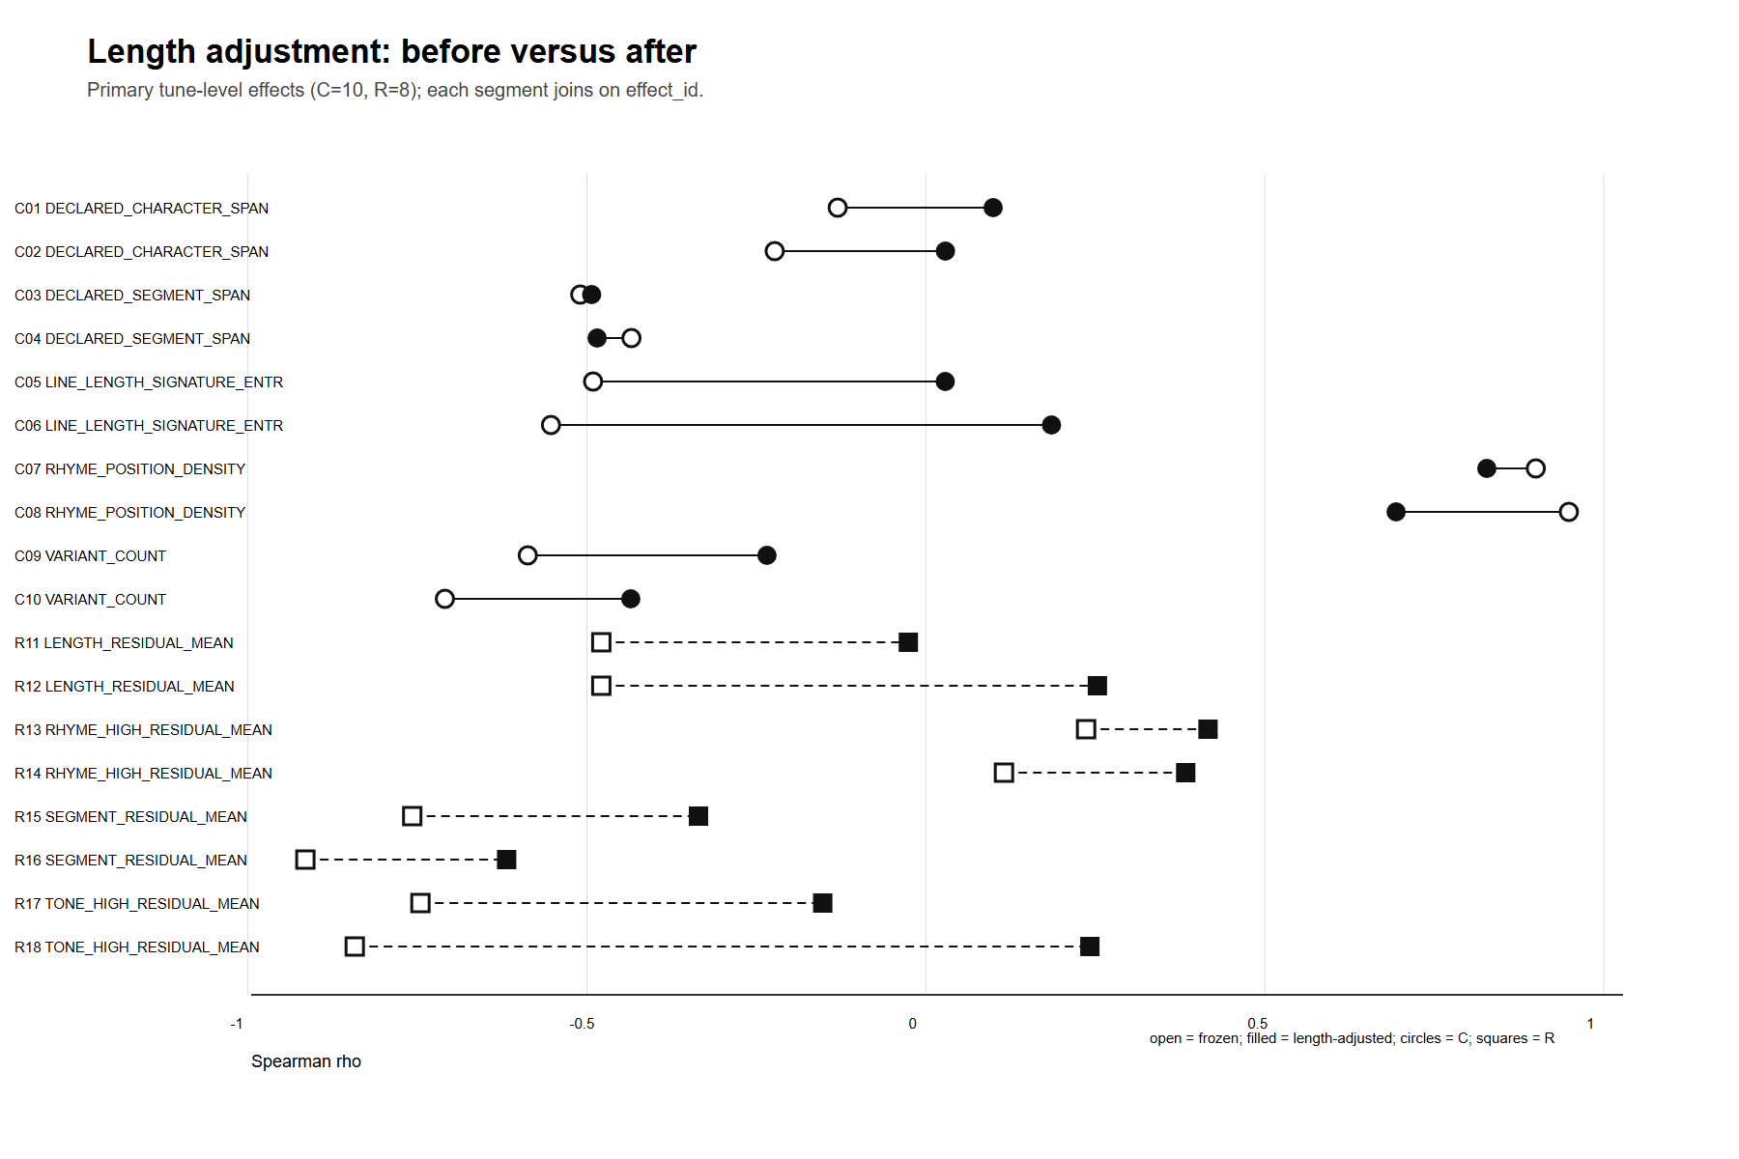
Note. Each horizontal segment joins the same effect_id. Open points are the frozen unadjusted rho estimates; filled points are the length-adjusted partial rho estimates. The plot is descriptive of sensitivity, not evidence that length alone caused the observed estimate changes.
Table 2 records the fixed-witness and pilot inputs. Table 3 and Figure 2 show that four aggregate rows crossed their within-family Holm thresholds before length adjustment, whereas none of the 18 rows passed the frozen joint gate after adjustment. Because the denominator is only ten stored tune labels, this result withdraws the earlier claim that the aggregate associations were demonstrably length-independent; it does not identify length as a unique historical mechanism.
Table 4
Record-Level, Adverse-Control, and Robustness Decisions
Evidence block | Unit / denominator | Estimand | Estimate or decision | Interval / correction | Source and scope
Eight record-level estimands | record; n = 5,574 or 5,534 | beta conditional on length and tune; author-clustered uncertainty | 0/8 Holm-supported; every 95% CI crosses zero | cluster-robust 95% CI; Holm | tables/poem_effects.csv; records are not independent works
True-tune tone | record; n = 5,574 | d_tone_high -> same-tune LOO distance | β = −0.026; [−0.061, 0.009]; q = 1.0000 | cluster-robust 95% CI; Holm | tables/wrong_tune_control.csv; prespecified true reference
Wrong-tune tone control | record; n = 5,574 | d_tone_high -> deterministic wrong-tune distance | β = −0.067; [−0.102, −0.032]; q = .0016 | cluster-robust 95% CI; Holm | tables/wrong_tune_control.csv; adverse specificity control
Baseline configuration | record; n = 5,534–5,574 | four frozen record-level effects; excluded=0 | 0 of 4 Holm-supported | cluster-robust 95% CI; within-policy Holm | tables/robustness_summary.csv; analytical configuration
Author-LOO outcome configuration | record; n = 5,534–5,574 | four frozen record-level effects; excluded=0 | 0 of 4 Holm-supported | cluster-robust 95% CI; within-policy Holm | tables/robustness_summary.csv; analytical configuration
Text-metadata-conflict exclusion | record; n = 5,526–5,566 | four frozen record-level effects; excluded=8 | 0 of 4 Holm-supported | cluster-robust 95% CI; within-policy Holm | tables/robustness_summary.csv; analytical configuration
Nonmissing-author-string eligibility diagnostic | record; n = 5,534–5,574 | four frozen record-level effects; excluded=0 | 0 of 4 Holm-supported | cluster-robust 95% CI; within-policy Holm | tables/robustness_summary.csv; zero-impact eligibility diagnostic
Near-exemplar eligibility diagnostic | record; n = 5,534–5,574 | four frozen record-level effects; excluded=0 | 0 of 4 Holm-supported | cluster-robust 95% CI; within-policy Holm | tables/robustness_summary.csv; zero-impact eligibility diagnostic
Note. Full rows remain in tables/poem_effects.csv, tables/wrong_tune_control.csv, and tables/robustness_summary.csv. The wrong-tune comparison is an adverse specificity control; it is not an alternative historical mechanism.
Figure 3
Eight Prespecified Record-Level Effects
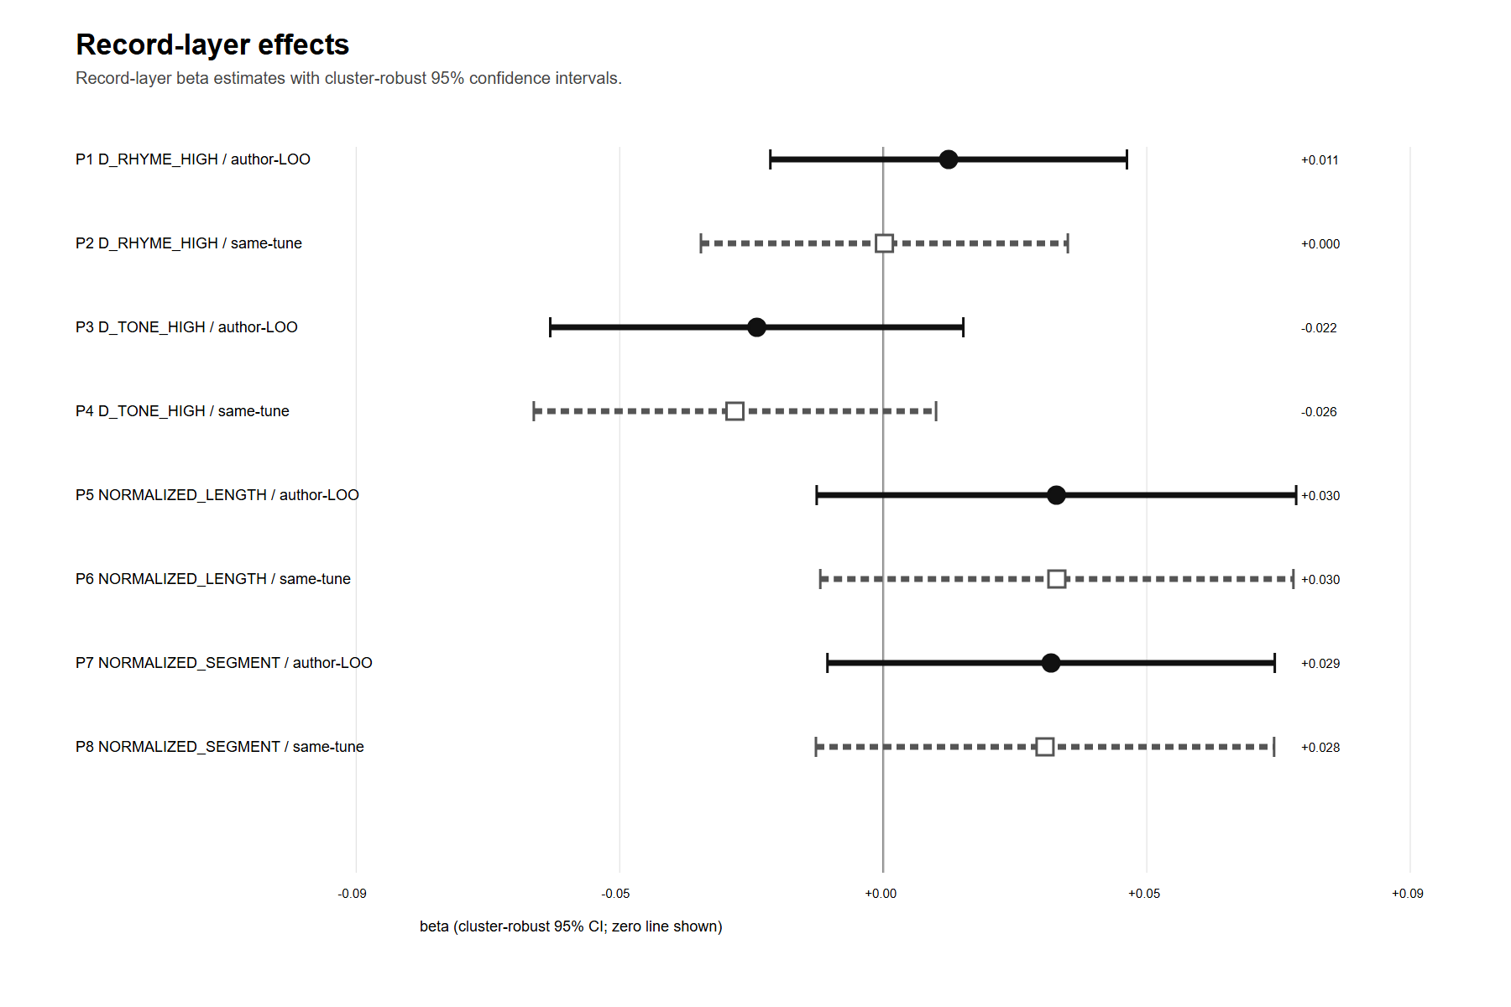
Note. Points are conditional beta estimates; whiskers are author-clustered 95% confidence intervals. All intervals cross zero, and each of the eight Holm-adjusted values is q = 1.000. Units are retained records, not independent works.
The record-level rows in Table 4 and Figure 3 supply the level check that the aggregate analysis cannot provide. The decision is 0/8 after family correction, and every author-clustered interval crosses zero. Accordingly, these estimands provide no basis for extending the aggregate pattern to individual records.
Figure 4
True-Tune and Wrong-Tune Outcomes Under Non-Symmetric Frozen Constructions
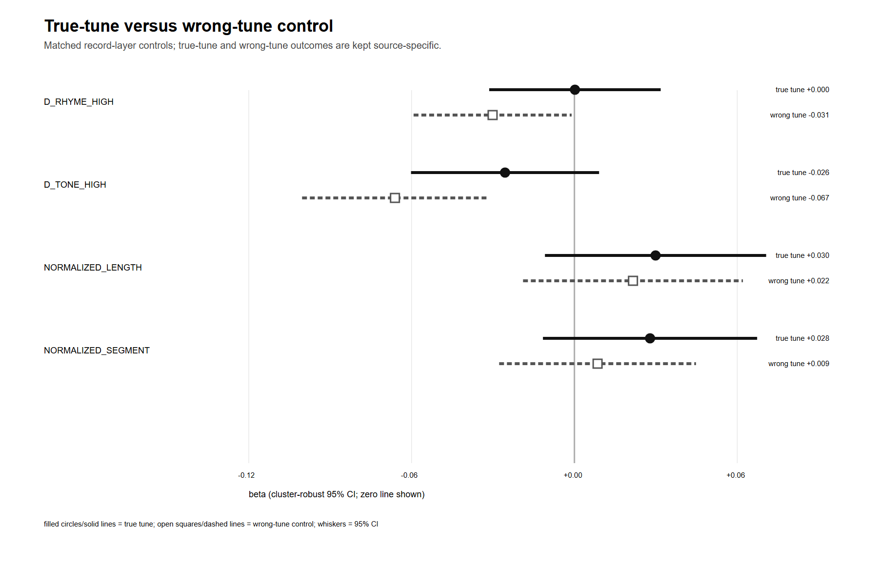
Note. The same four predictors are reported for a same-tune leave-one-record outcome and an author-excluded deterministic wrong-tune outcome. For d_tone_high, the true-tune estimate is β = −0.026, 95% CI [−0.061, 0.009], Holm q = 1.000; the wrong-tune estimate is β = −0.067, 95% CI [−0.102, −0.032], Holm q = .0016. The q values belong to their frozen four-predictor families.
Figure 4 shows an association under the wrong-reference construction, so record-level true-tune specificity is not established under these frozen analyses. No direct paired coefficient-difference test was performed, and the two outcome constructions are not symmetric: the true-tune construction leaves out one record, whereas the wrong-tune construction excludes the target author's records. The result is therefore an adverse specificity warning, not evidence that the wrong-tune association is statistically stronger or historically operative.
Figure 5
Three Analytical Configurations and Two Zero-Impact Eligibility Diagnostics
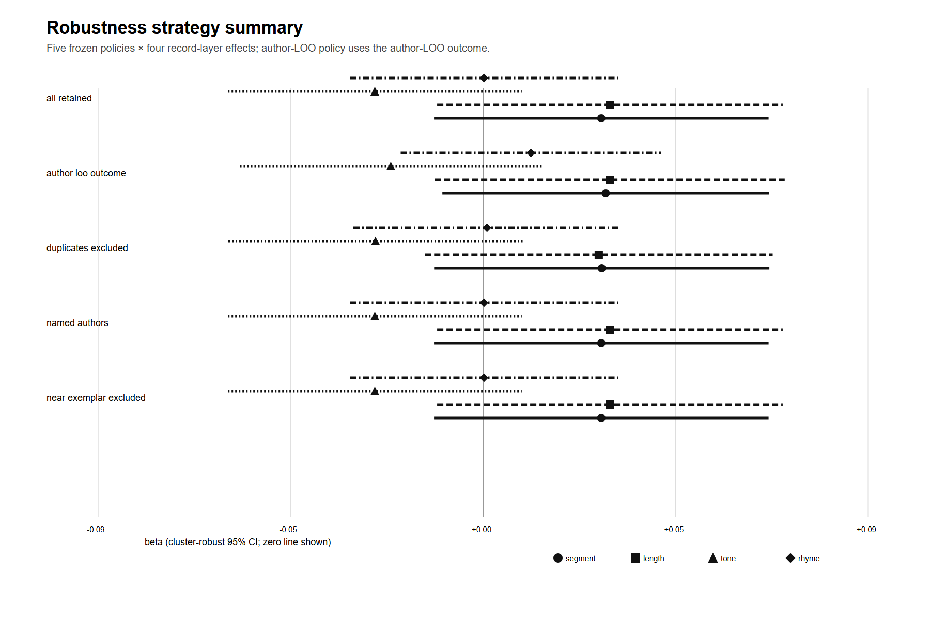
Note. The baseline, author-LOO outcome, and eight-record text-metadata-conflict exclusion are analytical configurations. The nonmissing-author-string and near-exemplar checks remove zero records and are reported as zero-impact eligibility diagnostics rather than independent sensitivity analyses. None of the 20 displayed rows is Holm-supported.
Figure 5 displays three analytical configurations and two zero-impact eligibility diagnostics. Across the analytical configurations, no tested record-level association receives Holm support. The two eligibility diagnostics reproduce the baseline because each excludes zero records; they add pipeline information, not independent robustness evidence. The result is no Holm-supported association under the tested models, not proof of a zero effect or invariance to every corpus construction.
Table 5
Same-Sample Representation-Dimension Sensitivity
SVD dimension | Qualitatively stable / 35 | Inference-sensitive | Record-level Holm-supported / 8 | Flagged effect rho (q) | Bootstrap interval
32 | 35/35 | 0 | 0/8 | ρ = −.794; q = .0523 | [−1.000, −.373]
64 | 34/35 | 1 | 0/8 | ρ = −.806; q = .0442 | [−1.000, −.392]
128 | 35/35 | 0 | 0/8 | ρ = −.758; q = .0952 | [−.962, −.284]
Note. All rows use the same sample. The 128-dimensional row is the reference; the 32- and 64-dimensional rows are refits compared with that reference.
Table 5 classifies all 35 effects as qualitatively stable at 32 dimensions relative to the 128-dimensional reference and 34/35 at 64 dimensions, with one inference-sensitive tune-level effect. The 128-dimensional row is the reference rather than an additional stability test. No record-level effect is Holm-supported at any dimension (0/8 in each refit), and no coefficient changes sign. The single flagged effect has q = .0523 at 32 dimensions, q = .0442 at 64, and q = .0952 at 128. This boundary sensitivity does not override the separate 0/18 length-adjusted gate.
Unresolved Cross-Codification Alignment
Although Cilu and Qinding Cipu are authenticated as distinct retrospective sources, the page-level crosswalk between their physical and digital structures has not been verified. We therefore report no cross-source tone, rhyme, ranking, bootstrap, or case comparison. This material remains a documented source-reconciliation method and a future validation requirement, not an empirical result in this article.
A/B/C Evidence Chain
Table 6
Frozen Evidence Chain
Stage | Estimand / decision rule | Machine judgment | Allowed scope
A length adjustment | 18 tune-level effects; frozen joint gate | All 18 formal effects were completed; 0/18 passed the frozen joint gate. None of the four rows that crossed its within-family Holm threshold before adjustment did so afterward. Among those four rows, one estimate reversed sign. | Length-composition sensitivity; no universal effect claim
B candidate patterns | P_flip interval + case-set Jaccard gate | Tone: sensitive (2,000/2,000; interval [0.185797, 0.308446]; min Jaccard 0.209302; changed sets 12); Rhyme: indeterminate (2,000/2,000; interval [0.049921, 0.091889]; min Jaccard 0.175573; changed sets 6) | Intra-source candidate choice on one fixed later page
C boundaries | Same B gate under three policies | Tone sensitive under all policies; rhyme changes under anonymous exclusion | Modern record/author-label boundary dependence
Note. The 0.05 threshold is a frozen audit convention rather than a natural constant. A/B/C results are descriptive and policy-bounded.
Four Policies by Two Metrics
Table 7
Tone and Rhyme Decisions Across B and C Policies
Policy / denominator (records / blocks) | d_tone_high | d_rhyme_high
B baseline (5,574 / 685) | sensitive (2,000/2,000; interval [0.185797, 0.308446]; min Jaccard 0.209302; changed sets 12) | indeterminate (2,000/2,000; interval [0.049921, 0.091889]; min Jaccard 0.175573; changed sets 6)
C conflict exclusion (5,566 / 684) | sensitive (2,000/2,000; interval [0.183183, 0.305796]; min Jaccard 0.209302; changed sets 12) | indeterminate (2,000/2,000; interval [0.048794, 0.092067]; min Jaccard 0.175573; changed sets 6)
C anonymous exclusion (5,263 / 684) | sensitive (2,000/2,000; interval [0.202258, 0.318894]; min Jaccard 0.183099; changed sets 12) | sensitive (2,000/2,000; interval [0.051695, 0.095241]; min Jaccard 0.171875; changed sets 6)
C anonymous singleton blocks (5,574 / 995) | sensitive (2,000/2,000; interval [0.189876, 0.300052]; min Jaccard 0.209302; changed sets 12) | indeterminate (2,000/2,000; interval [0.049213, 0.091834]; min Jaccard 0.175573; changed sets 6)
Note. Every row has 2,000/2,000 valid repetitions. Under the frozen gate, tone is classified as sensitive in all four rows; rhyme is classified as indeterminate except under exact-label anonymous exclusion, where the decision is sensitive.
Figure 6
Candidate-Boundary Sensitivity Across Frozen Policies
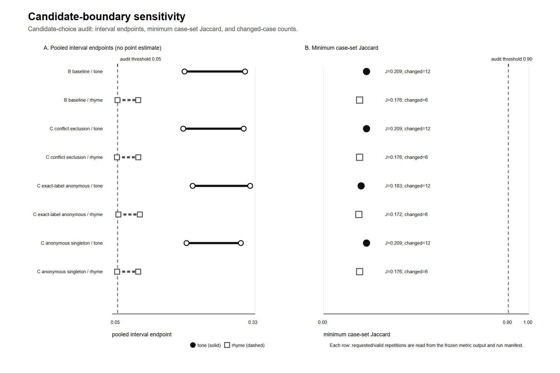
Note. Generated from tables/candidate_boundary_sensitivity.csv. Each metric reports 2,000 requested and 2,000 valid repetitions; policy-specific denominators are B baseline: 5,574 records/685 author blocks; C metadata-conflict exclusion: 5,566/684; C exact-label anonymous exclusion: 5,263/684; C anonymous singleton blocks: 5,574/995. The 0.05 interval and 0.90 Jaccard cutoffs are audit rules; panel A shows endpoints only and panel B shows minimum Jaccard with changed case-set counts.
Table 6 summarizes the A/B/C evidence chain; Table 7 and Figure 6 show that, under the frozen gate, tone is classified as sensitive across all four tested policies; rhyme changes machine classification only under exact-label anonymous exclusion. The four rhyme lower endpoints lie near the frozen .05 audit threshold (.049–.052), so the change is evidence of threshold fragility rather than a demonstrated substantive policy effect. In the baseline audit, rhyme has 5,534 applicable records, 5,521 common-support records, and 1,596,557 comparable record pairs. Across the 40 frozen tune–tail–comparison-rule rows for each metric, deterministic case sets changed in 12/40 tone comparisons and 6/40 rhyme comparisons; the reported minimum Jaccard is an extreme comparison, not a typical overlap.
Figure 7
Tune-Label Concentration of Candidate-Choice Sensitivity
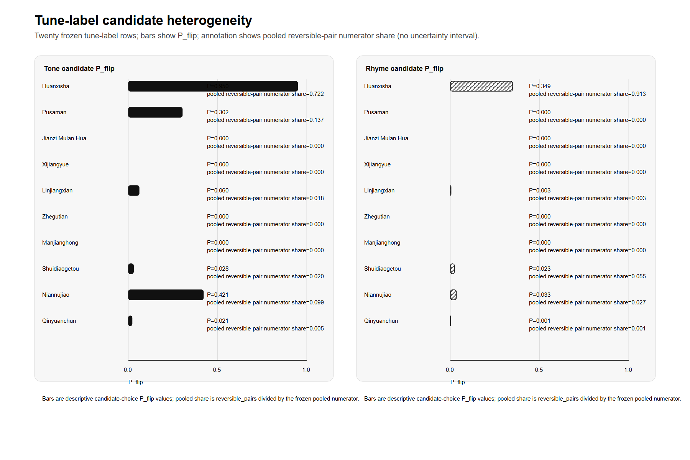
Note. Generated from tables/tune_candidate_heterogeneity.csv. Each panel reports the frozen tune-label P_flip point estimate and the label's share of the pooled reversible-pair numerator. These are descriptive pair-weighted quantities, not confidence intervals or an equal-weighted average over tune labels.
Figure 7 shows that candidate sensitivity is concentrated rather than evenly distributed within this ten-label pilot. Huanxisha has P_flip = .950 for tone and .349 for rhyme and contributes 72.2% of the pooled reversible-pair numerator for tone and 91.3% for rhyme. The pooled audit therefore cannot be interpreted as the sensitivity of a typical tune label or as a corpus-wide Song-ci regularity. The historical task is therefore to investigate how tied patterns in this fixed witness relate to the records that dominate the audit, rather than to treat the pooled result as typical of all tune labels.
Wrong-Reference Adverse Control
The adverse control places an interpretive limit on the record-level specificity claim: because the asymmetric wrong-tune construction also yields an association, the record-level analyses do not establish true-tune specificity. This control is neither a direct paired coefficient-difference test nor a test of the aggregate length-adjustment or B/C candidate-boundary estimands; it therefore does not by itself adjudicate those analyses.
The joint result is metric-specific. Under the frozen gate, tone-residual extremeness is classified as sensitive under every tested policy. Rhyme-residual inference is boundary-dependent: the decision changes only when records carrying the exact stored anonymous-author label are removed. This is a statement about the modern stored-author boundary and the frozen estimand, not about a distinct historical anonymous mechanism.
Three Frozen Cases
Table 8
Records Returned by the Frozen Selector
Selection | Original record locator | Stored author / tune label | Mechanical observation
candidate sensitive tone | songci/ci.song.6000.json#288 | Zhang Xiaoxiang / Huanxisha | Baseline tone residual 20; tied-candidate range 17–21; coverage .595238 under baseline/lexicographic_first versus .547619 under lexicographic_last/upper; selected from the B high-tail stratum with Jaccard .209302.
boundary sensitive rhyme | songci/ci.song.20000.json#361 | Anonymous / Xijiangyue | Rhyme residual and coverage remain .5 under all five candidate scenarios; the record is present in B but absent by definition under exact-label anonymous exclusion; cross-policy high-tail Jaccard .773585.
stable comparator | songci/ci.song.4000.json#702 | Mao Pang / Shuidiaogetou | Tone residual 2 and coverage .694737 under baseline, lexicographic_first, lexicographic_last, lower, and upper; low-tail membership persists across B and all three C policies; global intersection size 65.
Note. Stored author strings and tune labels are reproduced mechanically. A returned record is an audit prompt, not a representative work or a ranking of literary value.
Table 8 first identifies the candidate-sensitive tone case, Zhang Xiaoxiang / Huanxisha. A public text witness (Z1) corroborates the frozen character sequence and stored author string. A university-library indexed excerpt (Z2) provides attribution context, but its underlying PDF was not retrieved and is therefore not treated as a critical-edition check. The witnessed text comprises six seven-character lines. The fourth and fifth witnessed lines form an overt parallel around place names and the terminal moon/wind pair. In the frozen alignment, tied candidates v1, v2, and v5 each have zero segment and length discrepancy, yet their tone residuals are 20, 17, and 21, with coverage from .548 to .595. The selected high-tail comparison has Jaccard .209 with 102 changed membership IDs. The aggregate candidate trace is verified, but no position-level mismatch vector is present in the frozen outputs; the tonal span therefore cannot be assigned to that visible parallel or to any other line.
Model interpretation: the same publicly witnessed stored text can move into or out of a computational audit tail solely because a structurally tied pattern is selected. The record's status as a high-residual example is relational: it belongs to the stored text and the selected retrospective pattern together. This supports a source-and-model question about analytical visibility. It does not locate the responsible syllables, establish a tonal reading, or support intention, innovation, corruption, or literary value.
Counterevidence or boundary check: the publicly witnessed comparator stored with author string Mao Pang retains tone residual 2, coverage .695, and membership in the 65-record all-root intersection across the tested candidates and corpus policies. This tested comparator retains the same tone residual and low-tail membership under the listed candidate scenarios and corpus policies; it does not establish behavior beyond this record.
Metadata-boundary rhyme case: Anonymous / Xijiangyue. The exact-label anonymous record has rhyme residual .5 and coverage .5 under all five candidate scenarios. It is retained under the baseline, metadata-conflict, and anonymous-singleton policies but is absent by definition after exact-label anonymous exclusion; the cross-policy high-tail Jaccard is .774 with 12 changed membership IDs. Its public text identity and authorship were not externally checked. The analysis therefore stops at the metadata boundary rather than converting an unverified record into close-reading evidence.
Corpus interpretation: this is an estimand change created by a modern stored author-label policy, not evidence for anonymous rhyme poetics or a historical author category.
Counterevidence or boundary check: Rhyme remains indeterminate in B, metadata-conflict exclusion, and anonymous-singleton blocks; it becomes sensitive only under anonymous exclusion.
Stable comparator: Mao Pang / Shuidiaogetou. A public text page and two attribution/tune-context witnesses (source IDs M1, M2, and M3) corroborate the same 95-character stored sequence and attribution at the stated witness level. The public punctuation groups one triad of short clauses and a later triad of longer clauses. None of the witnesses is treated as a critical-edition authority. The M3 witness contains interleaved score notation and character/segmentation variants; it corroborates tune and attribution at the stated witness level, not a clean normalized transcription. The stored record has tone residual 2 and coverage .695 under baseline, lexicographic-first, lexicographic-last, lower, and upper scenarios and remains in the 65-record intersection across all four policy roots. Its aggregate stability does not adjudicate among the witnessed segmentation choices.
Counterevidence: this tested stability is a counterexample within the returned cases, not a basis for generalizing to Mao Pang's corpus. It does not make the tune pattern historically certain or make the text aesthetically exemplary.
Counterevidence or boundary check: This contrasts with the returned Zhang Xiaoxiang case. It is one within-selector counterexample and does not establish a corpus-wide frequency or universal record-level pattern.
Discussion
What the Model Makes Visible
What survives is a methodological finding about this audit construction: within the fixed witness, the tied-candidate rule and stored-author policy condition which records become available for inspection. Candidate choice changes the Zhang record's tone residual and tail membership, anonymous-label exclusion removes the Xijiangyue record from the rhyme comparison, and the Mao Pang comparator retains its position. The literary question therefore shifts from which poems break a rule to under which retrospective and editorial construction a record becomes visible as an apparent exception. These cases make analytical visibility inspectable without making any record typical or aesthetically privileged.
Analytical Exemplarity Is Not Literary Exemplarity
The three returned records play different evidential roles. The Zhang case exposes candidate-dependent membership, the anonymous Xijiangyue case exposes a metadata-boundary change, and the Mao Pang comparator provides counterevidence against extending localized sensitivity into a universal narrative. Their value lies in making the conditions of selection available for inspection before stronger close-reading claims are made.
Historical and Corpus Qualifications
The tested candidate variation remains inside one fixed later source page per tune. No edition, version, or cross-codification variance is estimated. The corpus contains records, exact stored tune labels, and stored author strings; these categories are not works, witnesses, or authenticated historical persons. The anonymous policy is therefore a modern attribution-boundary sensitivity, and the 21,053 ingestion count is not an independent-work census.
Limitations
The formal pilot contains ten stored tune labels and one fixed later source page per label. It is a frozen purposive technical pilot spanning nine source volumes, not a probability sample of the 99-label continuity layer; the package documents no population-sampling rule. Huanxisha dominates the pooled reversible-pair numerator, so the localized sensitivity cannot be generalized to a typical tune label. Author strings are stored labels without entity resolution, and the unit is a record rather than a work. No work-level deduplication was performed, so repeated records can contribute more than once to pair-weighted summaries. No manual critical-edition or prosodic adjudication was performed. The character-use representation is not semantic, and the 0.05 decision threshold is frozen but conventional rather than a natural constant.
Finally, the return-to-text stage contains three audit cases selected by the frozen rules. They are deliberately bounded and are not representative of the corpus. The results therefore support model and corpus qualification, not generalization from the cases or a Song-native literary law.
Counterevidence and Limits
Together, these boundaries define the contribution more narrowly: the three case returns diagnose model- and corpus-dependent visibility, while the baseline rhyme decision remains indeterminate and only exact-label anonymous exclusion changes the policy classification.
Alternative Explanations for the Observed Pattern
The displays constrain the interpretation but do not identify a single explanation. The changes in tune-level correlations after adjustment are compatible with length composition, the small ten-label denominator, unequal author and record composition, the retrospective reference's applicability, and the character-use representation. The record-level results do not support a simple portable account under these estimands, and the adverse control does not establish record-level true-tune specificity; neither analysis distinguishes among the remaining historical and corpus explanations.
The B/C finding addresses a different question: tied candidates and modern author-label policies can alter which records enter an audit tail even when no general formal law is supported. The tune-label decomposition localizes most reversible pairs in Huanxisha, so this policy-bounded result concerns model-dependent visibility in specific source-and-corpus configurations rather than a universal property of tune patterns. It is not evidence that the selected records are aesthetically representative, that a poet intended to break a rule, or that a later tune book reconstructs a unique Song-period norm.
Figure 6 shows policy-level audit decisions and their threshold fragility; Figure 7 shows that pooled candidate-choice sensitivity is concentrated in a small subset of tune labels rather than evenly distributed across the pilot.
Limits of the Unified Evidence Displays
The seven visualizations reuse frozen analyses; they are not independent replications. The 21,053 and 16,111 denominators count editorial records, the 99 values are exact stored labels without philological alias harmonization, author strings are not resolved historical persons, and the ten-label formal pilot is small. Confidence intervals and Holm adjustment address the declared uncertainty families but do not resolve unmeasured historical or editorial variation. The 32- and 64-dimensional fits are same-sample comparisons against the 128-dimensional reference. Cross-codification claims remain outside the results until a page-level provenance crosswalk is verified.
Conclusion
The strongest conclusion of this ten-label pilot is methodological: none of the 18 aggregate associations passes the length-adjusted joint gate, and none of the eight primary record-level estimands receives Holm support. Even so, the choice among tied patterns and the treatment of stored author labels still shape which records enter the audit set under this construction. Because most of the pooled reversible-pair numerator is concentrated in Huanxisha and the rhyme decision changes at a conventional threshold under one policy, these results belong to this fixed witness and corpus construction. Analytical exemplarity thus offers a disciplined return from historical source, through computational modelling, to textual questions whose conditions of visibility remain explicit.
Data and Reproducibility Statement
All quantitative results reported in this revision derive from frozen length-adjustment, tied-candidate, corpus-boundary, adverse-control, and case-selector artifacts. The release manifest records source paths, hashes, row counts, and effect identifiers. The 102-row crosswalk links each indexed claim to its data source, statistic, display, and manuscript text. The case dossier records the public-witness URLs and case-specific limitations for Z1, Z2, and M1–M3, including that the Zhang position-level trace is unavailable. No new inferential model, resampling run, significance search, server run, or cross-edition comparison was performed. Local hashes establish internal traceability only; no public archival release or independent clean-room reproduction is claimed.
Unified Table and Figure Provenance
The seven figures and nine tables are deterministic transformations of frozen outputs. The release manifest records source and output hashes, row counts, and dimensions. The 102-row crosswalk is the current complete claim index.
AI-Assisted Research Disclosure
OpenAI Codex was used for code drafting and testing assistance, evidence-ledger maintenance, document formatting, and English-language editing. The author determined and reviewed the research questions, estimands, evidence-selection decisions, and literary interpretations. AI output was not treated as data, a citation, or evidence; the author is responsible for the final code, sources, analyses, claims, and interpretations.

References
Chinese-Poetry. (n.d.). chinese-poetry: The most comprehensive database of Chinese poetry [Data set]. GitHub. Commit b8594f81a89752241442f2ce267d6f66f96704ee. Retrieved August 7, 2026, from https://github.com/chinese-poetry/chinese-poetry/commit/b8594f81a89752241442f2ce267d6f66f96704ee
Deerwester, S., Dumais, S. T., Furnas, G. W., Landauer, T. K., & Harshman, R. (1990). Indexing by latent semantic analysis. Journal of the American Society for Information Science, 41(6), 391–407. https://doi.org/10.1002/(SICI)1097-4571(199009)41:6<391::AID-ASI1>3.0.CO;2-9
Dobson, J. (2021). Interpretable outputs: Criteria for machine learning in the humanities. Digital Humanities Quarterly, 15(2). https://doi.org/10.63744/gqdn7tfwn6r8
Drucker, J. (2011). Humanities approaches to graphical display. Digital Humanities Quarterly, 5(1). https://digitalhumanities.org/dhq/vol/5/1/000091/000091.html
Freedman, D., & Lane, D. (1983). A nonstochastic interpretation of reported significance levels. Journal of Business & Economic Statistics, 1(4), 292–298. https://doi.org/10.1080/07350015.1983.10509354
Hagiwara, M. (2017). The study of Cipu (anthology of ci-poem tunes) and Chikukei Morikawa [Doctoral dissertation, Ritsumeikan University]. Ritsumeikan Research Repository. https://doi.org/10.34382/00010479
Herrmann, J. B., Bories, A.-S., Frontini, F., Jacquot, C., Pielström, S., Rebora, S., Rockwell, G., & Sinclair, S. (2023). Tool criticism in practice. On methods, tools and aims of computational literary studies. Digital Humanities Quarterly, 17(2). https://doi.org/10.63744/apvw2r52eet3
Holm, S. (1979). A simple sequentially rejective multiple test procedure. Scandinavian Journal of Statistics, 6(2), 65–70. https://www.jstor.org/stable/4615733
Jiang, H. (Ed.). (2020). Qing dai ci pu cong kan [Collection of Qing-dynasty ci prosody manuals] (30 vols.). National Library Press.
Lee, Y. H. (2019). From examination of music to canonization of ci: A research on Wanshu's Cilu [Doctoral dissertation, Hong Kong Baptist University]. HKBU Institutional Repository. https://scholars.hkbu.edu.hk/ws/portalfiles/portal/55017675/OA-0714.pdf
Lipsitch, M., Tchetgen Tchetgen, E., & Cohen, T. (2010). Negative controls: A tool for detecting confounding and bias in observational studies. Epidemiology, 21(3), 383–388. https://doi.org/10.1097/EDE.0b013e3181d61eeb
Liu, C.-L., Mazanec, T. J., & Tharsen, J. R. (2018). Exploring Chinese poetry with digital assistance: Examples from linguistic, literary, and historical viewpoints. Journal of Chinese Literature and Culture, 5(2), 276–321. https://doi.org/10.1215/23290048-7257002
Liu, Z.-M. (2017). Amount and achievement of cidiao in anonymous ci in Song Dynasty. Journal of Shenzhen University (Humanities & Social Sciences), 34(3), 149–154. https://xb.szu.edu.cn/article/2017/1000-260X-34-3-149.html
Phipson, B., & Smyth, G. K. (2010). Permutation p-values should never be zero: Calculating exact p-values when permutations are randomly drawn. Statistical Applications in Genetics and Molecular Biology, 9(1), Article 39. https://doi.org/10.2202/1544-6115.1585
Pichler, A., & Reiter, N. (2022). From concepts to texts and back: Operationalization as a core activity of digital humanities. Journal of Cultural Analytics, 7(4). https://doi.org/10.22148/001c.57195
Qinding cipu (Siku quanshu ed.) [Imperially commissioned ci pattern compendium]. (1715). Chinese Wikisource. https://zh.wikisource.org/wiki/%E5%BE%A1%E5%AE%9A%E8%A9%9E%E8%AD%9C_(%E5%9B%9B%E5%BA%AB%E5%85%A8%E6%9B%B8%E6%9C%AC)
Song, Y. (2026). A comprehensive digital corpus of Song Ci poetry for computational analysis. Journal of Open Humanities Data, 12, Article 7. https://doi.org/10.5334/johd.405
Winkler, A. M., Webster, M. A., Vidaurre, D., Nichols, T. E., & Smith, S. M. (2015). Multi-level block permutation. NeuroImage, 123, 253–268. https://doi.org/10.1016/j.neuroimage.2015.05.092

Appendix
Machine-Readable Claim Ledger Index
As a provenance index, Table 9 preserves the prior 15-row ledger subset; the current unified crosswalk is listed separately in Data and Reproducibility.
Table 9
Frozen Evidence Claim Index
Claim ID | Hierarchy | Status
E01 | corpus | PASS
E02 | pilot | PASS
E03 | length_A | PASS_NEGATIVE
E04 | candidate_B_tone | PASS_SENSITIVE
E05 | candidate_B_rhyme | PASS_INDETERMINATE
E06 | boundary_C_tone | PASS_BOUNDARY_INVARIANT
E07 | boundary_C_rhyme | PASS_BOUNDARY_DEPENDENT
E08 | case_tone | PASS_BOUNDED_CASE
E09 | case_rhyme | PASS_BOUNDARY_CASE
E10 | case_stable | PASS_BOUNDED_STABILITY
E11 | legacy | RETIRED_FALSE
E12 | adverse_control | PASS_ADVERSE_CONTROL
CASE_candidate_sensitive_tone | case | PASS_BOUNDED
CASE_boundary_sensitive_rhyme | case | PASS_BOUNDARY_DEPENDENT
CASE_stable_comparator | case | PASS_BOUNDED_STABILITY
Note. Table 9 is a provenance subset, not the current complete crosswalk. Full effect/record IDs, source paths, hashes, allowed and forbidden wording, and counterevidence are recorded in the 102-row crosswalk and release manifest.

