Retrospective Prosodic Codification and Analytical Visibility in Song Ci: A Leakage- and Uncertainty-Audited Computational-Linguistic Study
Lin Zhanyi
Hong Kong Metropolitan University, lzzzy20041125@outlook.com
How should a later prosodic manual enter computational analysis without being promoted to a law of the Song period? We treat one frozen digital witness of the Qing Qinding Cipu as a retrospective knowledge model and keep three analytical objects apart: the later codification, textual realization in a modern corpus, and a character-use expression space. Source-derived predictors are fixed before corpus outcomes are examined; the one corpus record identical to a source exemplar is removed; and tone and rhyme diagnostics remain properties of the later witness and the frozen mapping, not reconstructions of Song pronunciation. The corpus contains 21,053 records. A continuity layer retains 16,111 records under 99 exact stored tune labels; a purposive ten-label pilot aligns 5,575 records and retains 5,574 after leakage exclusion. None of 18 tune-level associations passes the frozen joint gate after adjustment for mean log length, and none of eight primary record-level estimands is Holm-supported. A non-symmetric wrong-tune control also yields a tone association, leaving true-tune specificity unestablished. Even so, tied source candidates and modern author-label policies alter which records enter extreme audit sets, with sensitivity concentrated in Huanxisha. The result is an interpretable, non-circular audit and text-return procedure for computational linguistics and text mining, not an algorithmic performance gain or a general law of Song Ci.
CCS CONCEPTS • Computing methodologies → Natural language processing; Information systems → Text mining; Applied computing → Arts and humanities.
Additional Keywords and Phrases: Song Ci, computational linguistics, text mining, interpretable language intelligence, Qinding Cipu, historical phonology, leakage audit
- Introduction
Named tune labels organize the transmission of Song Ci, yet the rule systems easiest to compute often come from later compilations. Work on digital Chinese poetry has shown both the value of machine-readable corpora and the editorial decisions and inherited uncertainty they contain [1,2]. Prosody sharpens this temporal problem. A Qing manual can be pinned, parsed, and compared with poem records, but computational convenience does not turn it into a direct transcript of Song-period pronunciation, performance, or authorial choice.
Two questions set the limits of the study. First, under one fixed witness of the Qinding Cipu, which relationships among later codification, recorded textual realization, and character-use distance survive prespecified audits? Second, when a pinned page offers structurally tied candidate patterns, or when modern author labels are handled under another frozen policy, which records enter or leave the extreme audit sets? The second question concerns analytical visibility, not historical influence.
Our design draws on operationalization as a reversible route from concepts to textual indicators and back [3], and on tool criticism as an inquiry into how corpora and software condition knowledge claims [4,5]. For humanities computing, an appealing score is not enough: readers must be able to inspect the features, transformations, uncertainties, and textual objects behind it [6,7]. The paper therefore moves from the problem and a non-circular definition to method, frozen protocol, evidence, failure boundaries, and a deliberately limited contribution.
The contribution has three parts. First, retrospective codification, stored textual realization, and expression space remain separate rather than being folded into a synthetic 'constraint' score. Second, one traceable protocol brings together exact-exemplar leakage, tied-candidate uncertainty, modern metadata policies, multiplicity, length sensitivity, and an adverse control. Third, analytical exemplarity is defined as a deterministic path back from an aggregate result to bounded text records, including negative and stable cases. These are evidential contributions to computational linguistics, text mining, and interpretable language intelligence. They do not demonstrate better prediction or a universal formal law.
- Definition and Non-Circularity
  - Three non-equivalent layers
Figure 1 keeps the objects of inference apart. The codification layer uses a fixed Wikisource witness of the Siku Qinding Cipu (1715) [8], pinned to nine page revisions for ten exact stored tune labels. It provides declared character and segment spans, rhyme positions, candidate counts, and candidate-specific tone and rhyme patterns. The textual-realization layer contains modern digital poem records together with declared residuals from the selected pattern. The expression-space layer represents character 1-2-gram use through TF-IDF and truncated SVD, then summarizes distance within each tune label. The arrows mark analytical mappings; they are not causal paths through historical time.
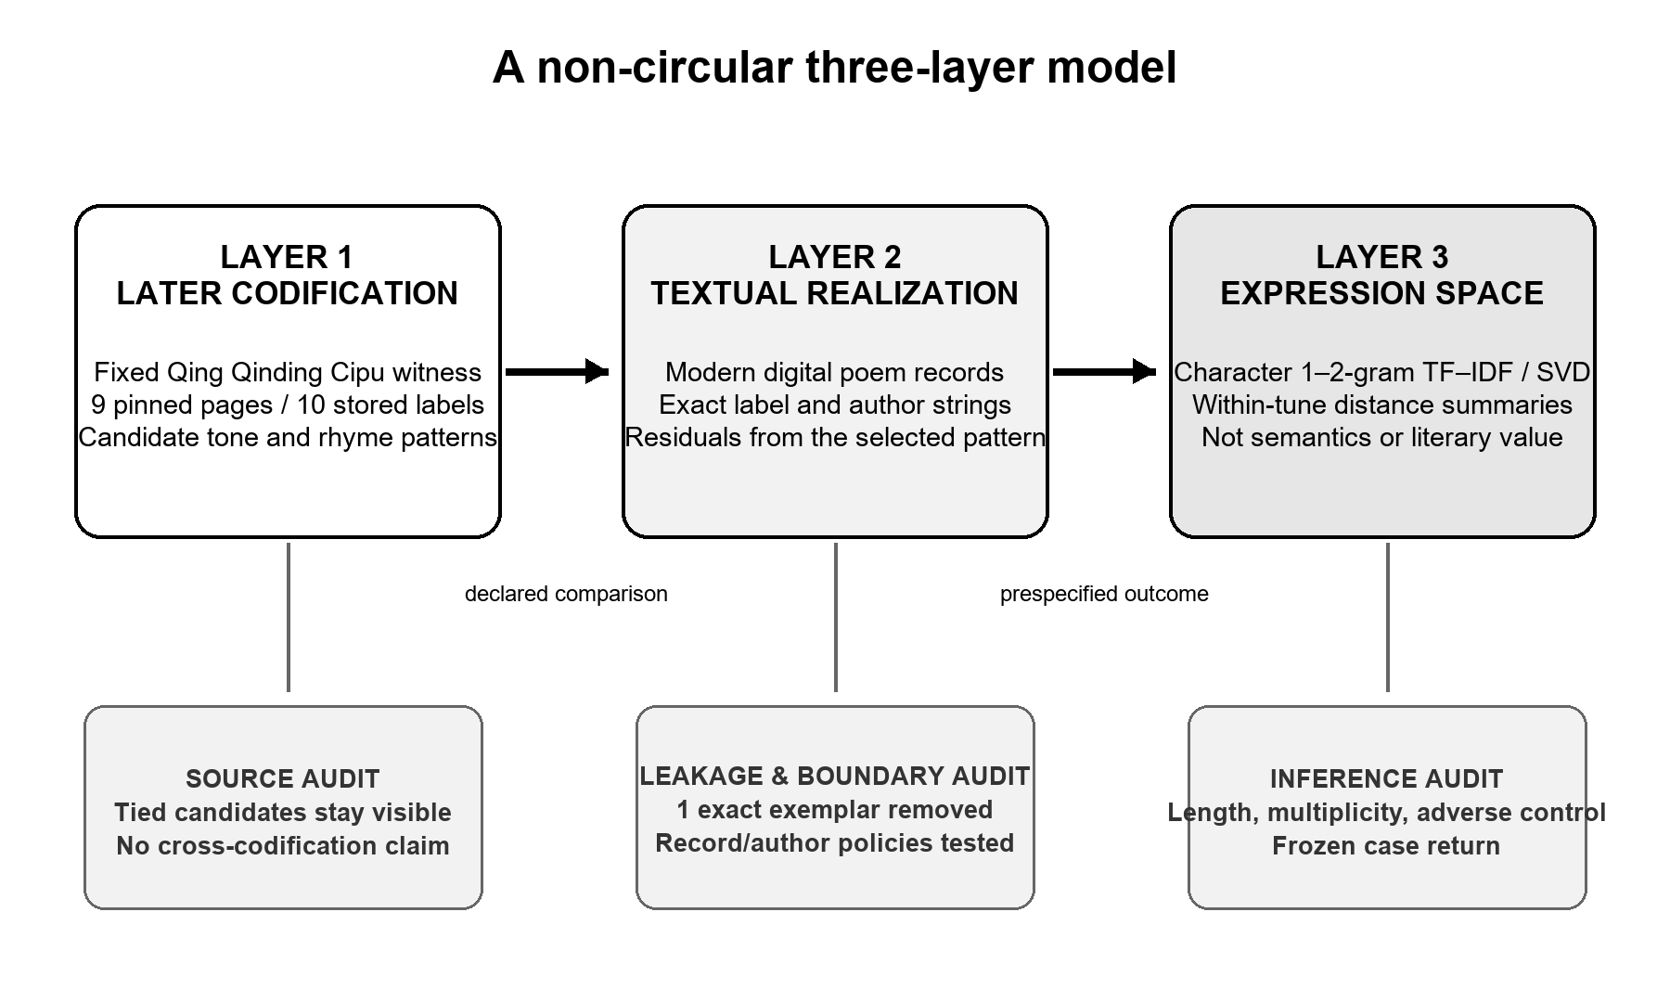
Figure 1: Three non-equivalent layers and their audit interfaces. Predictors are fixed before expression-space outcomes; no arrow asserts that a Qing witness caused Song textual practice or reconstructs Song pronunciation.
  - Non-circular definition and leakage rule
Each layer is defined from its own source. A codification feature comes only from the pinned source page; a realization residual is the declared comparison between that page and a stored record; and an expression-space outcome comes only from character use in the corpus. The same distance ranking is never used both to learn 'constraint' and to prove it. Candidate patterns are not selected for stronger associations, and cases are not chosen after their poems are read. Before the pilot begins, the one record that exactly reproduces a source exemplar is excluded, preventing a trivial fit caused by placing a normative example on both sides.
Later ci manuals matter as historical practices of comparison and norm-making [9,10,11], but this pilot does not estimate variation across editions or codification systems. Modern ci-generation research shows that fixed patterns can serve engineering tasks [12,13]; it does not show how Song writers related to a Qing witness. Here, tone and rhyme are computable encodings in a declared later source and frozen character-mapping pipeline, not acoustic observations or a reconstruction of local Song pronunciation.
- Data, Measures, and Frozen Protocol
  - Corpus flow and pilot boundary
The frozen input is the Chinese-Poetry Song Ci repository at commit b8594f81a89752241442f2ce267d6f66f96704ee [14]. Table 1 separates the broad 99-label continuity layer from the ten-label formal pilot. Labels below the analysis minimum and records whose tune name is lost remain in the ledger but do not enter the corresponding analytical layer. Exact stored labels are not silently converted into philologically normalized tune identities.
Table 1: Corpus and formal-pilot flow.
Stage | Records | Unit and boundary
Ingested | 21,053 | Corpus rows; 21,050 primary + 3 supplemental
Low-frequency label excluded | 4,570 | Continuity rule, not tune-identity adjudication
Lost tune name excluded | 372 | Exact stored-label boundary
Continuity layer retained | 16,111 | Records under 99 exact stored labels
Ten-label pilot aligned | 5,575 | Purposive pilot across nine source volumes
Exact source-exemplar match excluded | 1 | Pre-existing leakage rule
Formal pilot retained | 5,574 | Records; not deduplicated independent works
The ten-label pilot is purposive, spans nine source volumes, and is not a probability sample of the 99 labels. Huanxisha alone contributes 776 records. Author strings serve as dependency blocks because they are the only repeated-record grouping available; no entity-resolution procedure establishes that spelling variants name one person or that a shared string always names the same person. No work-level deduplication was performed. Rhyme is applicable to 5,534 records, of which 5,521 lie in common support for the baseline candidate audit.
  - Representation and estimands
Eighteen relationships are prespecified at tune level. Ten pair source-side properties - declared span, segmentation, line-length-signature entropy, rhyme-position density, and candidate count - with two expression-space summaries; the remaining eight pair tune-level realization summaries with those outcomes. Expression space is built from character 1-2-gram TF-IDF and a frozen 128-dimensional SVD representation in the latent-semantic family [15]. The outcomes are within-tune author-centroid dispersion and same-tune leave-one-record cosine distance. They describe the geometry of character use, not semantics, creativity, style, or literary value.
At record level, residual predictors and distance outcomes are average-ranked within each exact label and standardized across the retained records. The linear models include standardized log1p record length and tune fixed effects. Uncertainty is reported through author-string-clustered 95% confidence intervals and 9,999 author-block sign flips with seed 20260804; raw values are Holm-adjusted across eight effects [16]. Blocking addresses a stated dependency problem, but it does not authenticate historical persons.
  - Three audits and an adverse control
Audit A adds tune-wise mean log text length to every one of the 18 aggregate relationships. It uses 99,999 Freedman-Lane residual permutations and 5,000 requested tune-resample bootstrap draws [17,18]. An effect passes only when its within-family Holm-adjusted value is below .05, its percentile interval excludes zero, and every leave-one-tune-out estimate has the same sign. The denominator for these aggregate tests is ten stored labels.
Audit B keeps visible every candidate tied on the frozen segment and character-span score. For each residual metric, all distinct record pairs in common support are checked for a strict reversal of order between candidate-specific lower and upper values. The pooled reversible-pair proportion, P_flip, receives an author-string-block bootstrap interval from 2,000 requested repetitions. Independently frozen 10% high and low sets are compared under baseline, lexicographic-first, and lexicographic-last rules using Jaccard overlap. 'Sensitive' requires all repetitions to be valid, an interval wholly above .05, and at least one changed case set. 'Stable' requires an interval wholly below .05 and minimum Jaccard at least .90; every other outcome is indeterminate. The dependency-preserving idea is related to multilevel block permutation [19], although the estimator used here is a bootstrap.
Audit C reruns B under three isolated modern policies: removing eight text-metadata conflicts; removing 311 records with the exact anonymous-author label; or retaining all records while giving anonymous records record-specific singleton blocks. The four configurations contain 5,574/685, 5,566/684, 5,263/684, and 5,574/995 records/author-string blocks, respectively. A separate adverse control compares the prespecified true-tune outcome with a deterministic wrong-tune outcome. The true centroid leaves out one record, whereas the wrong reference excludes the target author's records. The control can therefore warn against specificity, but it cannot test equality of the coefficients. Its role follows negative-control logic [20].
- Evidence
  - Primary claims fail their gates
Before length adjustment, four of the 18 tune-level rows crossed their within-family Holm thresholds. After the adjustment, none satisfies the complete joint gate; several estimates move substantially, and one of the previously threshold-crossing estimates reverses sign. With only ten aggregate units, the evidence supports withdrawing a length-independent aggregate claim. It does not identify length as a unique historical cause, nor does it prove that every underlying relationship is zero.
At record level, none of the eight primary estimands is Holm-supported. Every author-clustered interval crosses zero, and all eight adjusted values are q = 1.000. Refitting the same sample at 32 and 64 SVD dimensions again produces 0/8 supported record-level effects. One tune-level row crosses the conventional threshold at 64 dimensions, which points to representation dependence rather than stable evidence.
The adverse control narrows the interpretation further. For tone residual, the true-tune estimate is β = −0.026, 95% CI [−0.061, 0.009], q = 1.0000; the deterministic wrong-tune estimate is β = −0.067, 95% CI [−0.102, −0.032], q = .0016. No direct β_wrong − β_true contrast was estimated, and the two constructions use different exclusions. The permissible conclusion is therefore that true-tune specificity has not been established - not that the wrong-tune relationship is statistically stronger or historically meaningful. Table 2 keeps the complete frozen policy results visible rather than replacing exact values with a grayscale summary.
Table 2: Policy-complete candidate-choice audit. J denotes minimum Jaccard overlap; S, sensitive; I, indeterminate.
Policy | Tone interval | Tone J | Rhyme interval | Rhyme J | Class T/R
Baseline | [0.185797,  0.308446] | 0.209302 | [0.049921,  0.091889] | 0.175573 | S / I
Conflict  exclusion | [0.183183,  0.305796] | 0.209302 | [0.048794,  0.092067] | 0.175573 | S / I
Anonymous  exclusion | [0.202258,  0.318894] | 0.183099 | [0.051695,  0.095241] | 0.171875 | S / S
Anonymous  singleton | [0.189876,  0.300052] | 0.209302 | [0.049213,  0.091834] | 0.175573 | S / I
  - Source candidates and metadata change visibility
Under Audit B, tone has 2,000/2,000 valid repetitions, interval [0.185797, 0.308446], minimum Jaccard 0.209302, and 12 changed deterministic comparisons. It is sensitive under the frozen rule. Rhyme also has 2,000/2,000 valid repetitions, but its interval is [0.049921, 0.091889], minimum Jaccard is 0.175573, and six comparisons change. It remains indeterminate. These labels describe an audit convention, not a historical category.
Figure 2 shows how candidate-choice sensitivity changes across the four frozen corpus and author policies. Solid circles and dashed squares keep the two series legible in grayscale.
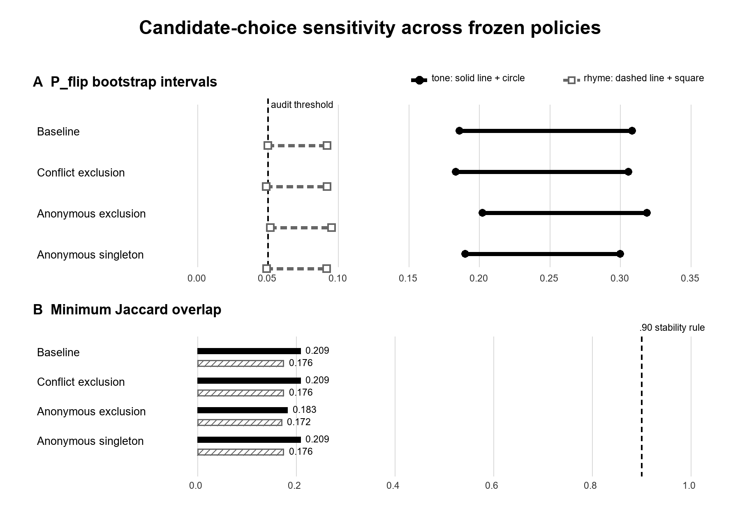
Figure 2: Candidate-choice sensitivity under four frozen corpus policies. Solid-circle and dashed-square series remain distinguishable in grayscale. The .05 and .90 lines are prespecified audit rules, not historical thresholds.
Tone is sensitive under all four policies. Rhyme is indeterminate at baseline, after conflict exclusion, and under the anonymous-singleton policy, but it becomes sensitive when the exact anonymous label is excluded. Because the four lower interval endpoints cluster around .049-.052, the category change reveals threshold fragility at a modern label boundary rather than an effect of 'anonymous poetics.' The pooled sensitivity is also concentrated. Huanxisha contributes 72.2% of the reversible-pair numerator for tone and 91.3% for rhyme, while its label-level P_flip values are .950 and .349. The pooled estimate should not be read as a typical-tune result.
  - Frozen cases return analysis to texts
The selector was frozen before identities and poem texts were inspected. Table 3 returns three records with different evidential roles; none is a validation set, a representative sample, or a ranking of literary quality.
Table 3: Three bounded audit cases.
Role | Stored record | Mechanical evidence | Interpretive use
Candidate-sensitive | Zhang Xiaoxiang / Huanxisha  ci.song.6000.json#288 | Tone residual 20; tied range 17–21; coverage .595238 vs .547619; high-tail Jaccard .209302 | Inspect how a witnessed text changes status under tied later patterns
Metadata-boundary | Anonymous / Xijiangyue  ci.song.20000.json#361 | Rhyme residual/coverage .5 in all candidate scenarios; removed by anonymous exclusion | Expose a stored-author boundary; no anonymous-poetics claim
Stable comparator | Mao Pang / Shuidiaogetou  ci.song.4000.json#702 | Tone residual 2; coverage .694737; low-tail across tested policies | Counter localized sensitivity with within-selector stability
The Zhang Xiaoxiang record changes audit status even though its stored text and tied-candidate span score remain fixed: its tone residual ranges from 17 to 21. Without a position-level mismatch vector, that numerical shift cannot be assigned to a particular character, audible performance, or authorial intention. The anonymous Xijiangyue record keeps rhyme residual and coverage at .5 across candidate scenarios and disappears only when one policy removes its stored author label. The Mao Pang comparator stays in the low tail, with tone residual 2 and coverage .694737, under every tested candidate and corpus policy. Taken together, the cases show candidate dependence, metadata dependence, and localized stability without turning any of them into literary proof.
- Failure Boundaries and Interpretation
'Expression space' denotes a declared geometry of character use; it does not exhaust meaning, emotion, voice, or aesthetic possibility. The negative primary results rule out the stronger claim that codified formal complexity systematically narrows or enlarges literary expression. A smaller conditional result remains: later-source candidates and corpus rules can alter rankings and case return even when portable associations fail.
The pilot bounds every contribution. Ten exact stored labels were chosen for technical coverage rather than probability sampling, and one label dominates the sensitivity numerator. One later digital witness is used for each label, without manual critical-edition or cross-codification adjudication. Historical tone and rhyme remain unresolved. Records are not proven independent works, author strings are not resolved identities, and the expression model measures character-use proximity. The .05 and .90 rules are audit conventions. The adverse control is non-symmetric, and the three returned cases belong to the same analysis rather than an independent replication.
Those limits make failed claims informative. The later codification is evidence of later norm-making and provides a reproducible source-side model, but it is not a historically sovereign score of Song practice. A record becomes analytically exemplary only when its source, operationalization, ranking rule, uncertainty policy, and deterministic return path are visible. It does not thereby become typical, canonical, innovative, or aesthetically superior.
- Limited Contribution and Conclusion
The tested associations do not survive their strongest checks: 0/18 tune-level effects passes the length-adjusted joint gate, 0/8 record-level estimands is Holm-supported, and the wrong-reference diagnostic blocks a claim of true-tune specificity. The source model is nevertheless not inert. Tied candidates and modern author-label policies change which texts become salient, but that sensitivity is concentrated rather than general.
The limited contribution is an auditable computational-linguistic procedure that relates later codification, modern text records, and expression-space representations without collapsing them into one score. It keeps leakage and uncertainty about historical phonology in view, treats negative and stable cases as evidence, and returns computation to inspectable texts. Future work should preregister manual source and prosody adjudication, verify alignments across codification pages, resolve record/work and author identities where possible, and test richer representations without treating them as proxies for literary value.
- Use of AI Tools
OpenAI Codex assisted with evidence-ledger review, source verification, document integration, layout, and English editing. It was not used as data, as an annotator, or as an author. The human author remains responsible for the research questions, evidence, code, citations, claims, and interpretation. No GPTZero-style score is presented as a valid measure of authorship or an 'AI percentage.'
REFERENCES
- Chao-Lin Liu, Thomas J. Mazanec, and Jeffrey R. Tharsen. 2018. Exploring Chinese Poetry with Digital Assistance: Examples from Linguistic, Literary, and Historical Viewpoints. Journal of Chinese Literature and Culture 5, 2, 276–321. https://doi.org/10.1215/23290048-7257002.
- Yao Song. 2026. A Comprehensive Digital Corpus of Song Ci Poetry for Computational Analysis. Journal of Open Humanities Data 12, Article 7. https://doi.org/10.5334/johd.405.
- Axel Pichler and Nils Reiter. 2022. From Concepts to Texts and Back: Operationalization as a Core Activity of Digital Humanities. Journal of Cultural Analytics 7, 4, Article 1295. https://doi.org/10.22148/001c.57195.
- J. Berenike Herrmann, Anne-Sophie Bories, Francesca Frontini, Clémence Jacquot, Steffen Pielström, Simone Rebora, Geoffrey Rockwell, and Stéfan Sinclair. 2023. Tool Criticism in Practice: On Methods, Tools and Aims of Computational Literary Studies. Digital Humanities Quarterly 17, 2. https://doi.org/10.63744/apvw2r52eet3.
- Karin van Es. 2023. Unpacking Tool Criticism as Practice, in Practice. Digital Humanities Quarterly 17, 2. https://www.digitalhumanities.org/dhq/vol/17/2/000692/000692.html.
- James Dobson. 2021. Interpretable Outputs: Criteria for Machine Learning in the Humanities. Digital Humanities Quarterly 15, 2. https://doi.org/10.63744/gqdn7tfwn6r8.
- Johanna Drucker. 2011. Humanities Approaches to Graphical Display. Digital Humanities Quarterly 5, 1. https://digitalhumanities.org/dhq/vol/5/1/000091/000091.html.
- Qinding Cipu [Imperially Commissioned Ci Pattern Compendium]. 1715. Siku quanshu edition. Chinese Wikisource. https://zh.wikisource.org/wiki/御定詞譜_(四庫全書本).
- Masaki Hagiwara. 2017. The Study of Cipu (Anthology of Ci-Poem Tunes) and Chikukei Morikawa. Ph.D. dissertation, Ritsumeikan University. https://doi.org/10.34382/00010479.
- Yat Hin Lee. 2019. From Examination of Music to Canonization of Ci: A Research on Wanshu’s Cilu. Ph.D. dissertation, Hong Kong Baptist University. https://scholars.hkbu.edu.hk/en/studentTheses/考律以求雅-萬樹詞律研究/.
- Heyou Jiang, ed. 2020. Qingdai Cipu Ciyun Congkan [Collection of Qing-Dynasty Ci Prosody and Rhyme Manuals]. 30 vols. Beijing: National Library Press.
- Yan Song. 2022. Composing Ci with Reinforced Non-autoregressive Text Generation. In Proceedings of the 2022 Conference on Empirical Methods in Natural Language Processing, 7219–7229. Association for Computational Linguistics. https://doi.org/10.18653/v1/2022.emnlp-main.486.
- Zhan Qu, Shuzhou Yuan, and Michael Färber. 2026. PoeTone: A Framework for Constrained Generation of Structured Chinese Songci with LLMs. Proceedings of the AAAI Conference on Artificial Intelligence 40, 39, 32764–32772. https://doi.org/10.1609/aaai.v40i39.40555.
- Chinese-Poetry. n.d. chinese-poetry: The Most Comprehensive Database of Chinese Poetry. GitHub dataset, commit b8594f81a89752241442f2ce267d6f66f96704ee. Accessed August 7, 2026. https://github.com/chinese-poetry/chinese-poetry/commit/b8594f81a89752241442f2ce267d6f66f96704ee.
- Scott Deerwester, Susan T. Dumais, George W. Furnas, Thomas K. Landauer, and Richard Harshman. 1990. Indexing by Latent Semantic Analysis. Journal of the American Society for Information Science 41, 6, 391–407. https://doi.org/10.1002/(SICI)1097-4571(199009)41:6%3C391::AID-ASI1%3E3.0.CO;2-9.
- Sture Holm. 1979. A Simple Sequentially Rejective Multiple Test Procedure. Scandinavian Journal of Statistics 6, 2, 65–70. https://www.jstor.org/stable/4615733.
- David Freedman and David Lane. 1983. A Nonstochastic Interpretation of Reported Significance Levels. Journal of Business & Economic Statistics 1, 4, 292–298. https://doi.org/10.1080/07350015.1983.10509354.
- Belinda Phipson and Gordon K. Smyth. 2010. Permutation P-values Should Never Be Zero: Calculating Exact P-values When Permutations Are Randomly Drawn. Statistical Applications in Genetics and Molecular Biology 9, 1, Article 39. https://doi.org/10.2202/1544-6115.1585.
- Anderson M. Winkler, Matthew A. Webster, Diego Vidaurre, Thomas E. Nichols, and Stephen M. Smith. 2015. Multi-Level Block Permutation. NeuroImage 123, 253–268. https://doi.org/10.1016/j.neuroimage.2015.05.092.
- Marc Lipsitch, Eric Tchetgen Tchetgen, and Ted Cohen. 2010. Negative Controls: A Tool for Detecting Confounding and Bias in Observational Studies. Epidemiology 21, 3, 383–388. https://doi.org/10.1097/EDE.0b013e3181d61eeb.

* Place the footnote text for the author (if applicable) here.

