**Indian Institute of Information Technology Vadodara**

**CS202: Systems Software**

**Assignment 1**

**Roll No. 201951105 Name: Nishant Andoriya**

Explore your current machine (Desktop/Laptop/Mobile) you are using, collect the details of the following. 1. Name and Model of device, 2. Take a device picture, 3. CPU, 4. Register Size, 5. RAM, 6. Cache, 7. Motherboard, 8. Word size, 9. list of Ports, 10. Other details

Name :- Lenovo ideapad S540

Model:- LNVNB161216

CPU:- Intel Core i5 8265U CPU @ 1.60GHZ

Register Size :- 64 bits

RAM:- 8.00 GB (7.85 Used)

Cache:

* L1D-Cache 32KBytes (x4)
* L1 I -Cache 32KBytes (x4)
* L2-Cache 256KBytes (x4)
* L3-Cache 6MBytes

Motherboard:-

Model :- LNVNB161216 SDK0Q55722 WIN

Chip-Set:- Intel Coffee Lake

Word Size:- 64 bits

Ports:-

* USB 3.0 slots (x2)
* SD Card Reader
* Headphone Jack
* Microphone Jack

Other Deailts:-

OS name:- Miscrosoft Windows 10 Home single Language

GPU:- Intel®UHD Graphic 620

Graphic Interface:- PCI-Express 3.0

OS Path Value:- window_NT

Device Photograph

Front:-

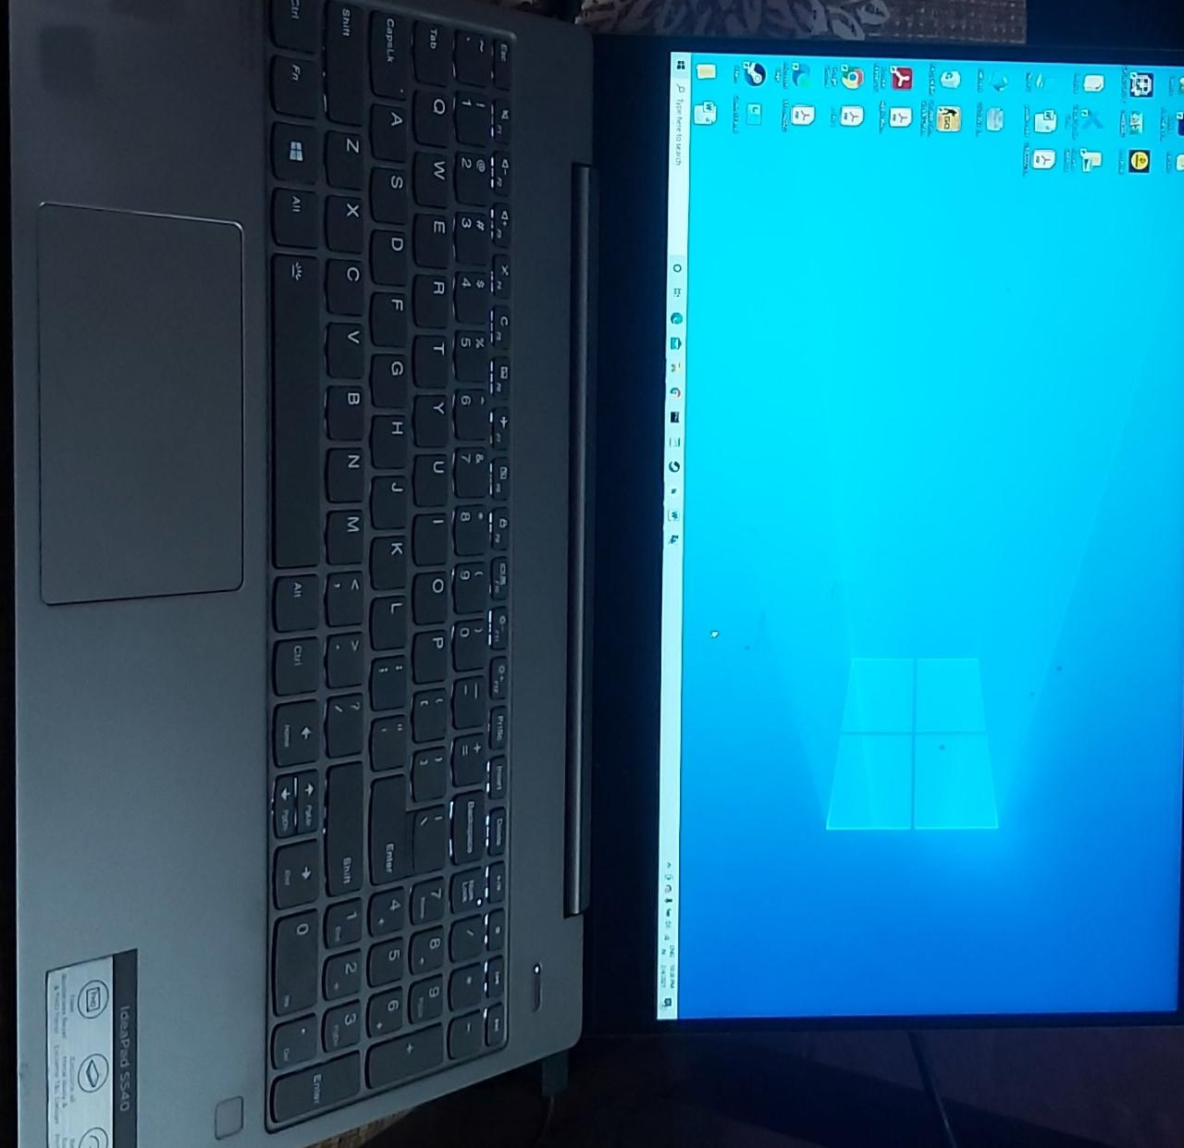

Back:-

