**Indian Institute of Information Technology Vadodara**

**CS262: Operating Systems Lab**

**Lab**

**Roll No. 201951105 Name: Nishant Andoriya**

1.) IIIT council is organising an inter IIIT cricket tournament. You are maintaining the

database of IIIT League (all the teams of different IIIT). The IIIT League has many teams.Each team has a name, a captain, a location, a trainer and a set of players. Each player belongs to one team. Player has name, a role (such as Batsman or Bowler or

WicketKeeper or Allrounder etc.), a skill level, and a history of his previous injury records. A team captain is also a player. A game is organized by any of the IIIT. A game is played between two teams (referred to as host_team and guest_team) at a particular date with some score ( such as team1 230/5, team2 150/4). Construct a ER diagram for the IIIT league database.

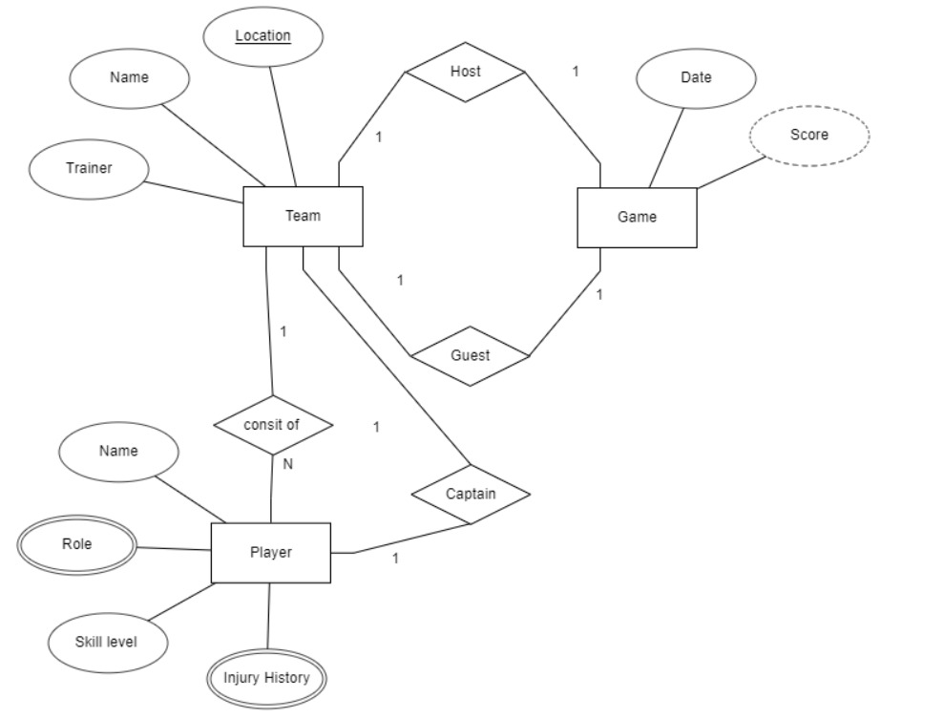

In the **Game** entity we have two attributes , Date and Scorecard. A **Team** entity has two one-to-one relation with game naming host and guest. Each Team has name ,trainer and location attribute as well as has relation with **Player** entity. Team consists of Players i.e, it is a one to many relation and Team has a Captain of Player entity i.e, it has one to one relation . Each **Player** has name, skill level,injury history and role attribute. Role and injury history are multivalued attributes.Player and Captain  are weak entities since a Captain will not stand without the team and players too. There will be no players without team, or any game.

2.) Draw an detailed E-R diagram for maintaining the academic data of IIIT Vadodara. It

may include students, courses, instructors, results. Further, the enrollment of students in

courses and grades awarded to students in each course they are enrolled for must be

appropriately modeled. Document all assumptions that you make about the mapping

constraints.

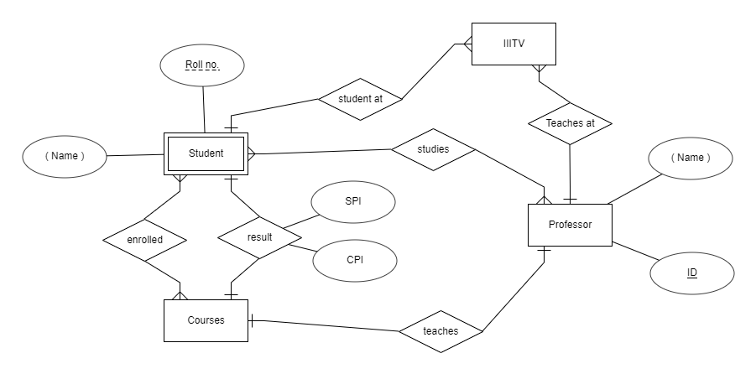

**IIITV** entity has one-to-many relation with **Student** and **Professor** entity.

**Student** has a unique Roll no. and a composite name attribute.

**Professor** has a composite name and a unique ID attribute.

**Student** has many-to-many relationship with courses which is enrollment, and a one-to-one relationship with courses which is result, i.e, A student can be enrolled in many courses or many students can be enrolled in a course and a single student can have only one result of a single course. Also a result consists of SPI and CPI attributes.

**Student** studies under a professor so here we have another relation of many-to-many, since many students can study under single professor and a student can study into many professors.Student is a weak entity as it will not strong alone without a course or a professor.

**Professor** has a one-to-one relationship with courses assuming a single course is taught by a single professor.