**Indian Institute of Information Technology Vadodara**

**CS262: Database Management System**

**Lab 3**

**Roll No. 201951105 Name: Nishant Andoriya**

1. Construct an E-R diagram for a hospital with a set of patients and a set of medical doctors.  Associate with each patient a log of the various tests and examinations conducted. Clearly mention  the participation and cardinality constraints. Submit an ER diagram along with the documentation, which describes entity, relationship, attributes and constraints.

Ans:-

**ERD Diagram:**

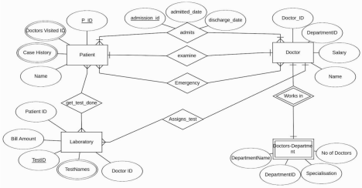**Explanation:**

The above ERD diagram is about a Hospital database.

1. The above ER Diagram consist of following entities Patient, Doctor, Laboratory, Doctors-Department (weak entity) .  2. Patient entity comprise of P_ID, Name, Case History, Doctor Visited ID as its entities.

3. Doctor entity consist of Doctor ID, Department ID, Salary and Name as its entities.

4. Laboratory comprise of Patient ID, Test ID, Doctor ID,Test Names,Bill Amount as its entities.

5. Doctor_Department is a weak entity which has DepartmentID, DepartmentName, Specialisation ans no of doctors as  its attributes.

**Relationships:**

1. Patient and Doctors are related by following relationships

a. Admits: many to many relationship with attributes as admission id, admitted date and discharge date.  b. Examines: one to one relationship

c. Emergency: many to many relationship

2. Laboratory and Patient are related by a many to many relationship named get_test_done.

3. Doctor and laboratory are connected by a one to many relationship named Assigns_test.

4. Doctor and doctors depart ment are related by an identifying one to one relationship named Works in.

**2.)** Based on the below given information, create the ER Diagram. Clearly mention the participation and cardinality constraints. Submit an ER diagram along with the documentation, which describes  entity, relationship, attributes and constraints.

a.) Company Database

**Employee** :- ssn, ename, bdate, dno_of_employee, employee_gender, ssn_of_supervsior, **Department** :- dno, dname, ssn_of_department_manager, manager_start_date (current manager  joining date), department_locations (a department has multiple locations)

**Project** :- proj_no, proj_name, proj_location, dno_that_controls_project, HOURS an employee  works on a project; an employee can work on multiple project, and a project can have multiple  employees working on it.

**Dependent details of each employee**: dep_name, gender, bdate of dependent, relationship with  employee, ssn_of_employee_of_dependent

Ans:-

**ERD Diagram:**

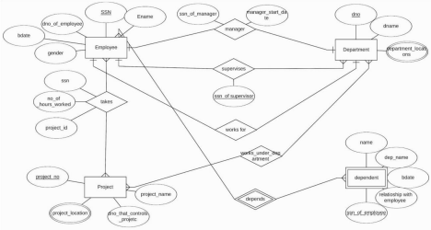**Explanation:**

The above ERD diagram is about a Company database.

1. Company Database contains Employee,Department,Project and dependent as entities and dependent as weak  entity.

2. Employee has SSN as primary key, Ename , dno_of_employee, bdate, gender as its attributes.

3. Department has the following attributes dno, dname,department_loctaion as multi valued attribute as location acn  contain various values.

4. Project comprise of project no as primary key, project name, dno that controls the project and project location as  multivalued attribute.

5. Dependent is a weak entity with following attributes ssn_of employee as primary key,name,dep_name, bdate,  relationship with employee

**Relationships defined:**

1. Employee and department has three relations they are:

a. Manager is a one to one relationship between the two with attributes ssn_of manger and

manager_start_date.

b. Spervises as a one to many relationship as a supervisor can supervise more than one department but one  department has only one supervisor with an attribute ssn_of_supervisor..

c. Employee and department has a one to one relationship named works for as a employee has a particular  assigned department for which he works for.

2. Employee and Project has a relationship between them named takes i.e. an employee takes a project. It is a many to  many relationship as an employee can take more than one project and visa-versa.

3. Project and department are also related with a many to many relationship named works_under department.

4. Employee and dependent are related by a many to many relationship as an employee can have many dependent and  a dependent can have many employee with whom he is related to . Eg Two brothers working in a same company have  same dependent i.e. there parents.

b.) MyFacebook

**User**: User_ID (unique for each user), User_Name, User_Email, User_Join_date, User_City_Name, User_City_Country,

**Friend** Friend_ID (a user may have zero or more friends), Friend_Since,

Friend_Message_IN_Count, Friend_Message_Out_count,

**Post** Post_ID, Post_TimeStamp, Post_Text, Post_Attachemnt_ID (can be multiple),  Post_Attachemnt_Text, Post_Attachemnt_Type (JPEG, MP3, MP4),

Post_Attachemnt_Data, Post_User_ID (a user can have multiple), Post_Like_User_ID (can be  multiple user liking a post), Post_Comment_ID (can be multiple comments for a post),  Post_Comment_User_ID (can be multiple users commenting on a post), Post_Comment_Text,  Post_Comment_TimeStamp (can be multiple users commenting on), Post_Comment_Like_UserID  (can be multiple users commenting on), Post_Comment_Reply_ID (can be multiple replies to a  comment),

Post_Comment_Reply_UserID, Post_Comment_Reply_Addressed_to_UserID, Post_Comment_Reply_Text, Post_Comment_Reply_Time,

Post_Comment_Reply_Like_UserID (can be multiple users commenting on)

Ans:-

**ERD Diagram:**

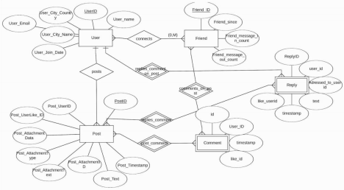**Explanation:**

The above ERD diagram is about a My Facebook database.

1. The My Facebook database consist of following entities User,Friend,Post,Comment(Weak Entity) and Reply(Weak  Entity).

2. User comprise of following attributes UserID (primary key), User_Name,User_city_Country, User_Email,  User_City_Name, User_Join Date.

3. Friend consist of FriendID, Friend_since, Friend_message_in_count and Friend_message_out_count as attributes.

4. Post comprise of Post_ID, Post_UserID. Post_UserLike_ID, Post_AttachmentData,

Post_AttachmentType, Post_AttachmentText, Post_AttachmentID, Post_Text, Post_Timestamp as attributes.

5. Comment is a weak entity set with attributes CommentID, User_id, timestamp, like_id.

6. Reply is another weak entity set with attributes as ReplyID, User_ID, Addressed_to_user_id, text, timestamp,  like_user_id.

**Relationships defined:**

1. User and Friend are related with a many to many relationship named connects.

2. User and Post are related by a one to many relationship named posts.

3. Post and replies are related by an identifying many to many relationship named replies_comment made on post.  4. Post and comment are related by an identifying many to many relationship named comment_post.  5. Friend and comment are related by an identifying many to many relationship named comment_on_posts.  6. User and Reply are related by an identifying one to many relationship named replies_on_comment.