**Indian Institute of Information Technology Vadodara**

**CS262: Database Management System**

**Lab 4**

**Roll No. 201951105 Name: Nishant Andoriya**

In this lab we have to use the online tool

( <https://dbisuibk.github.io/relax/landing>**)**

**Using (UIBK – R, S, T) database**

Q.1) Find all the tuples in the R with value of attribute ‘a’ greater than 4.

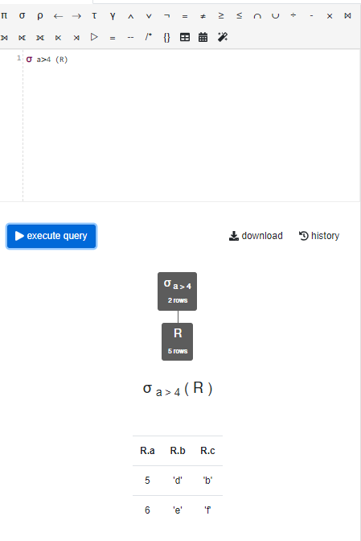

Q.2) Find all the tuples of R that are having the same value in attribute ‘b’ of S.

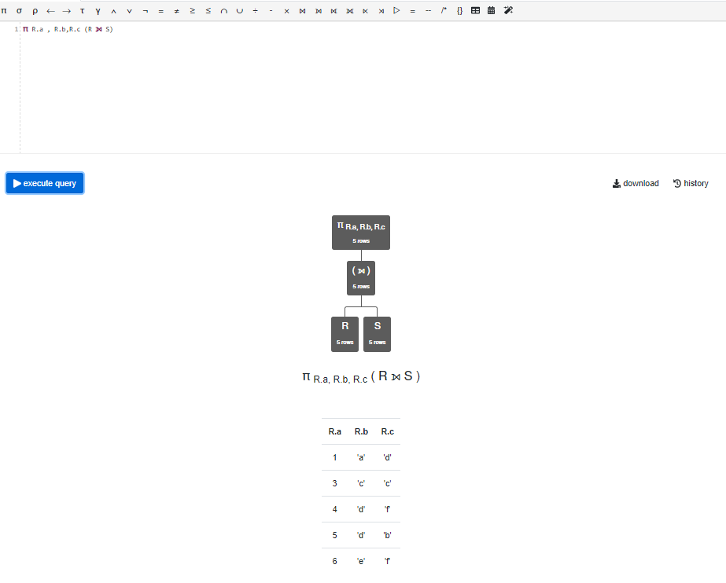

Q.3) Find all the values of ‘d’ from S that is having the matching value in attribute ‘b’ of S with the  attribute ‘b’ of R

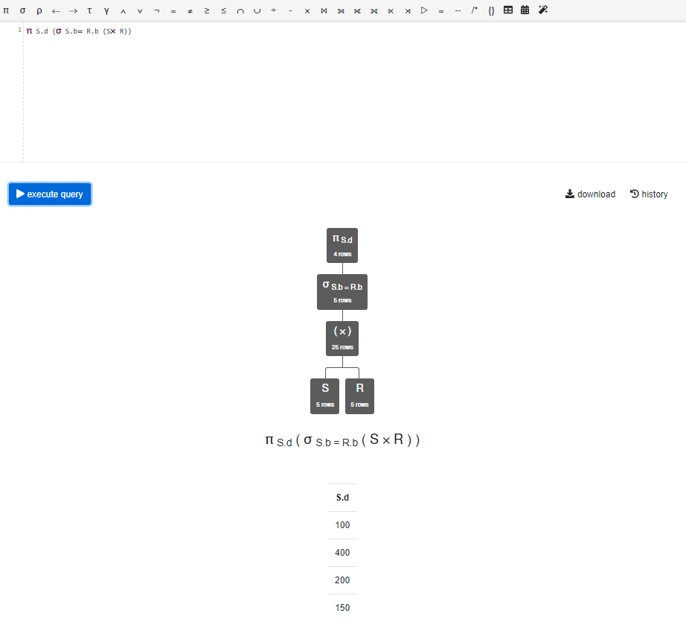

Q.4) Find the minimum value of attribute ‘a’ in R.

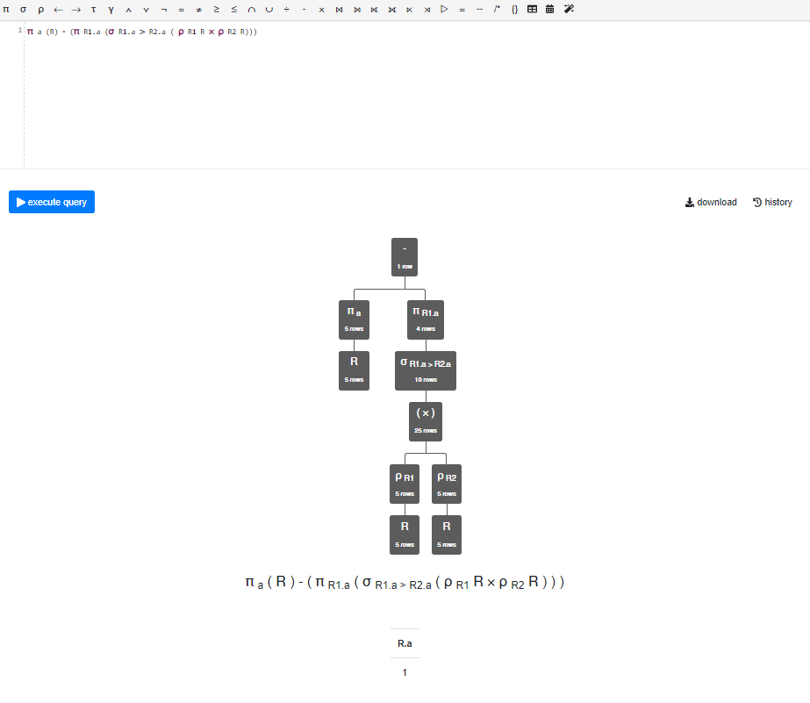

**Using Silberschatz-University database**

Q.1) Find the building name with the maximum room capacity.

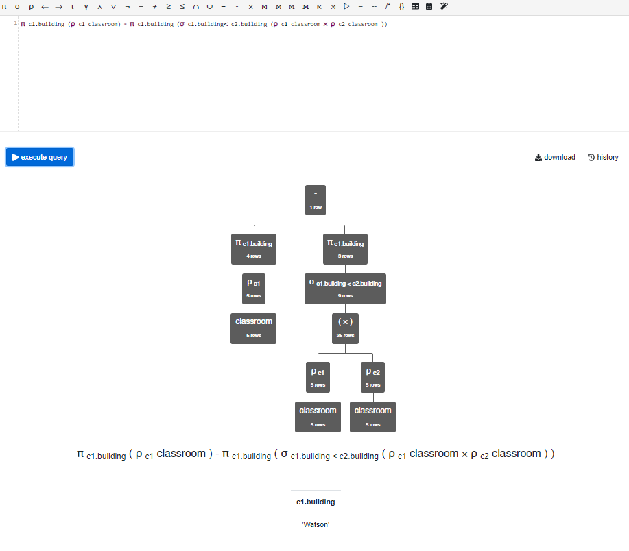

Q.2) Find the room capacity of ‘Biology’ department.

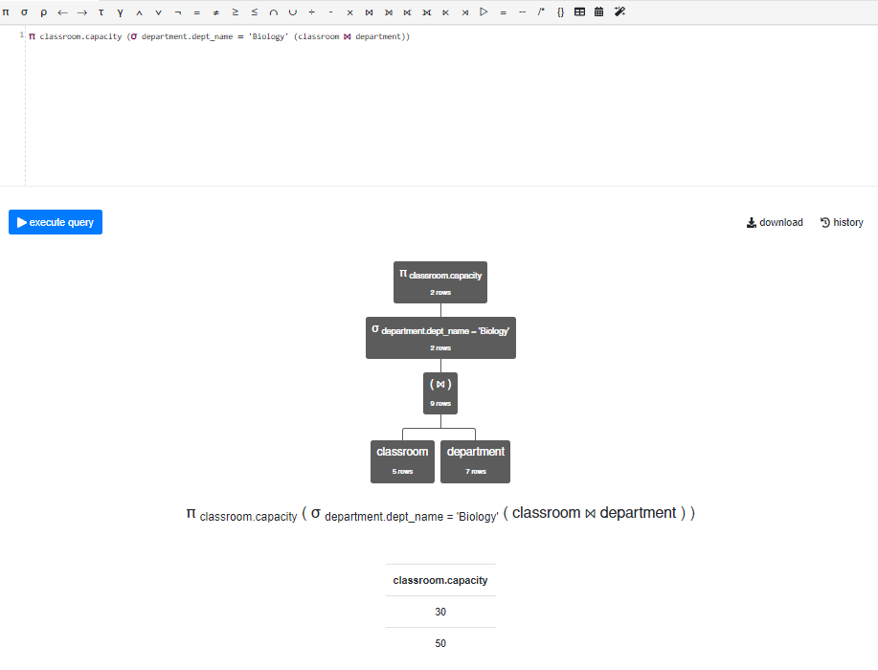

Q.3) Find the department with maximum budget.

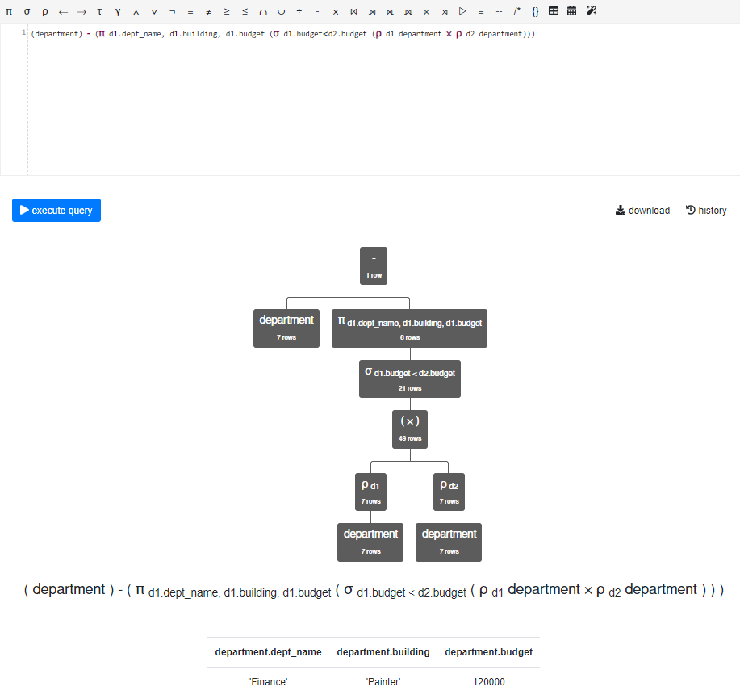

Q.4) Find the department with minimum budget.

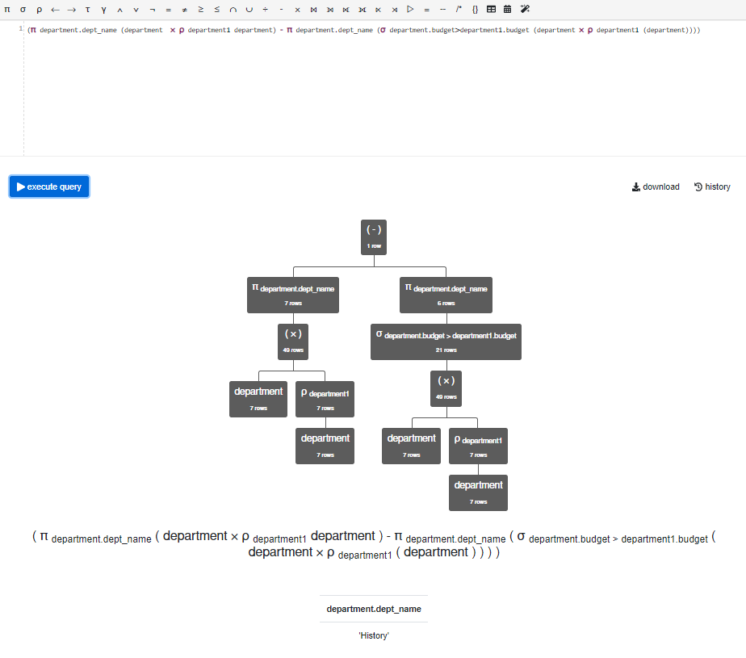

Q.5) Find all the courses related with the ‘Biology’ department.

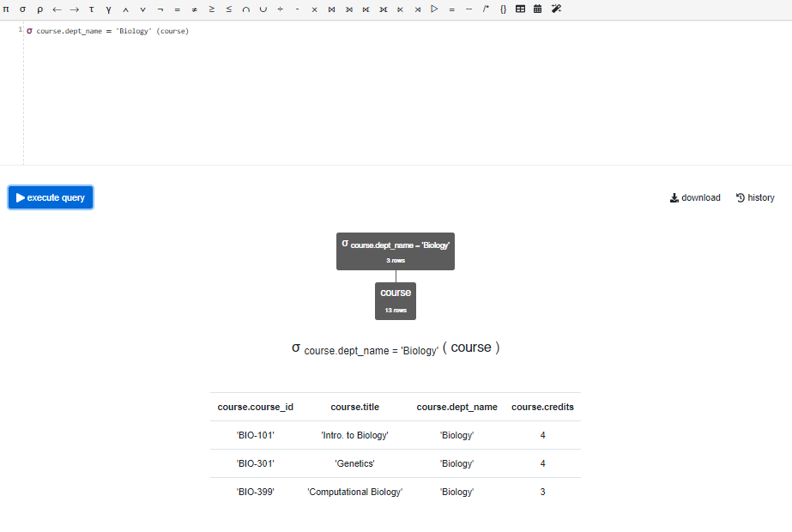

Q.6) Find all the courses in the ‘Biology’ department with minimum credits. ( For example minimum  credit asociated with any course in the biology department is 2 then the answer should include all the  courses having credit value equal to 2)

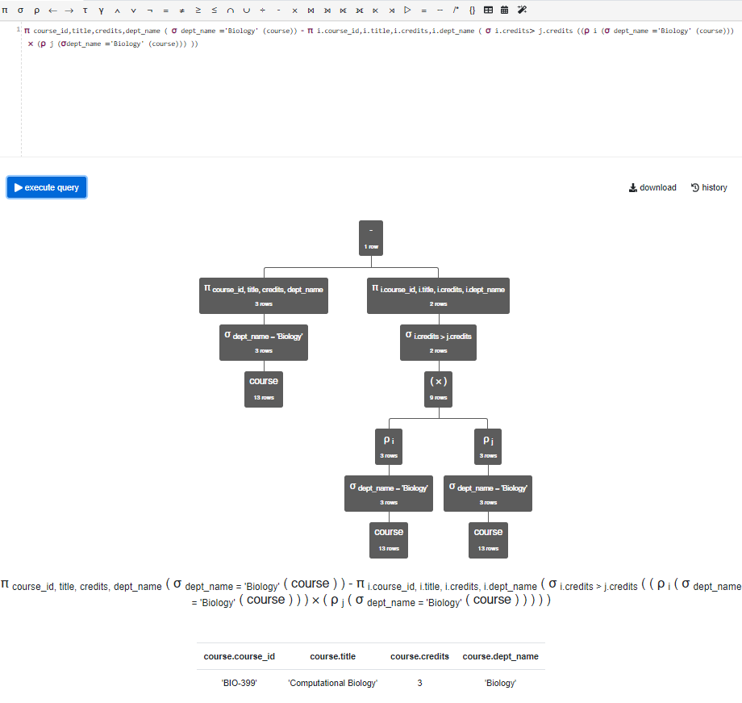

Q.7) Find all the prerequisit courses for the course with ID CS-190 and CS-347.

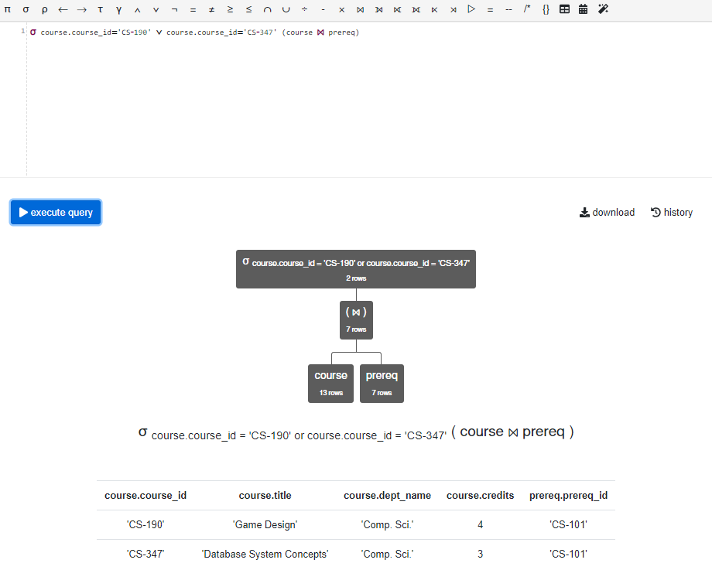

Q.8) Find the mapping of courses taken and the student name.

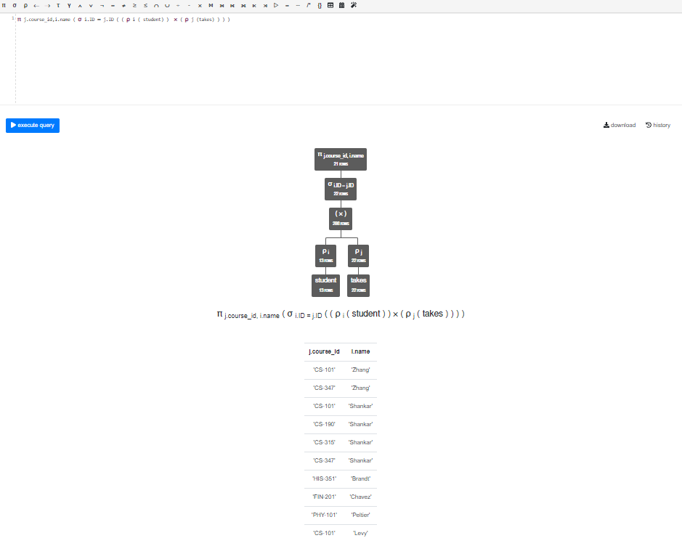

Q.9) Find the grade of ‘Zhang’ in the course with course ID CS-101.

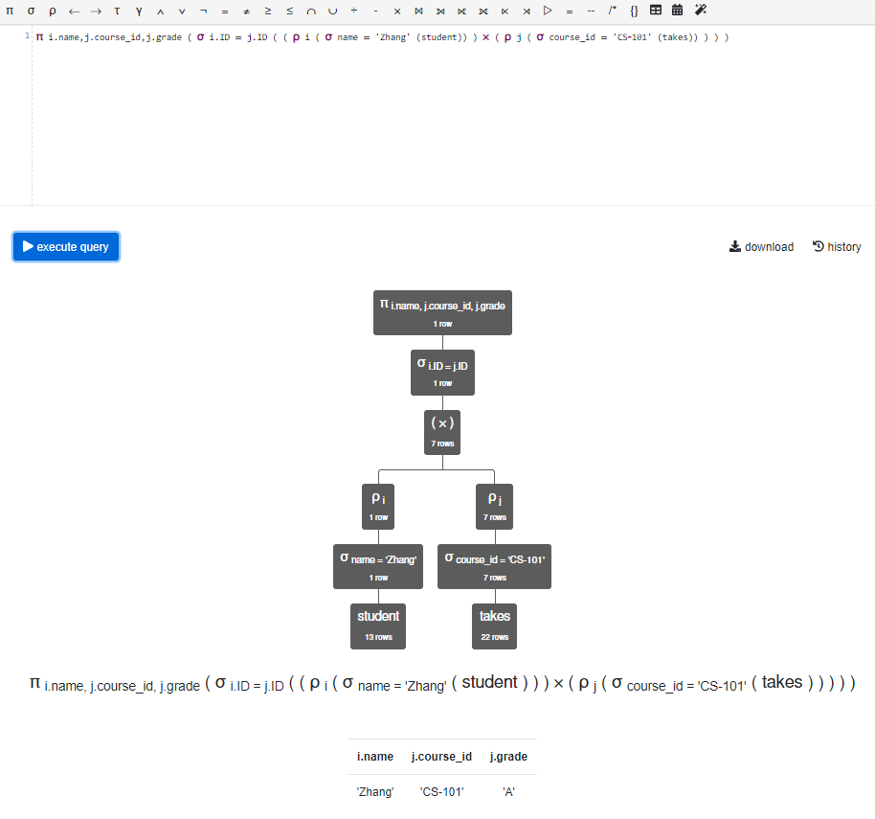

Q.10) Find the room capacity of the course with ID CS-101 running in the spring semester.

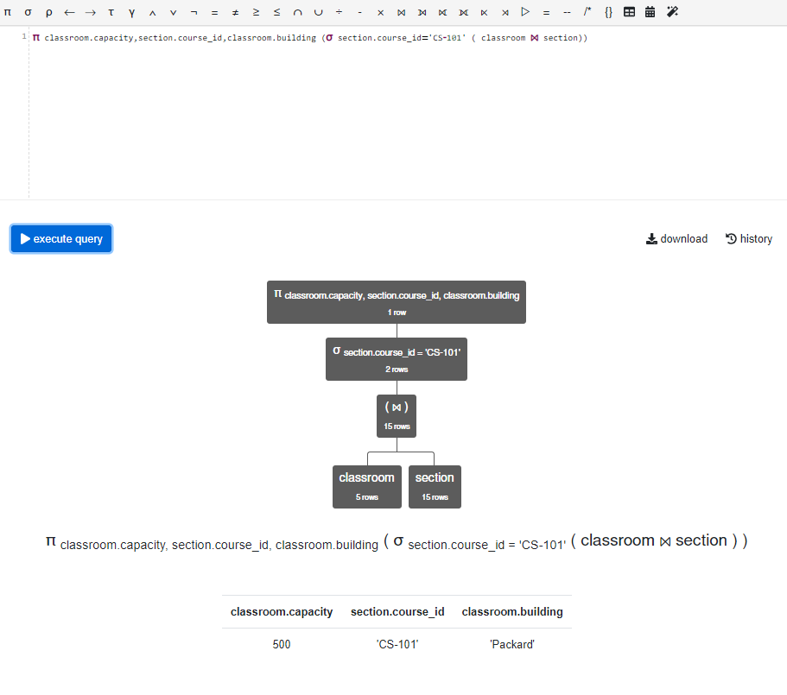

Q.11) Find all the time slots (day, start hour, start min) of the couse with course ID CS-101.

