**Indian Institute of Information Technology Vadodara**

**CS262: Database Management System**

**Lab 5**

**Roll No. 201951105 Name: Nishant Andoriya**

1.) You have already created the E-R diagram of the following database,

MyFacebook

**User**: User_ID (unique for each user), User_Name, User_Email, User_Join_date, User_City_Name, User_City_Country,

**Friend** Friend_ID (a user may have zero or more friends), Friend_Since,

Friend_Message_IN_Count, Friend_Message_Out_count,

**Post** Post_ID, Post_TimeStamp, Post_Text, Post_Attachemnt_ID (can be multiple), Post_Attachemnt_Text, Post_Attachemnt_Type (JPEG, MP3, MP4),

Post_Attachemnt_Data, Post_User_ID (a user can have multiple), Post_Like_User_ID (can be multiple user liking a post), Post_Comment_ID (can be multiple comments for a post), Post_Comment_User_ID (can be multiple users commenting on a post), Post_Comment_Text, Post_Comment_TimeStamp (can be multiple users commenting on), Post_Comment_Like_UserID (can be multiple users commenting on), Post_Comment_Reply_ID (can be multiple replies to a comment),

Post_Comment_Reply_UserID, Post_Comment_Reply_Addressed_to_UserID,

Post_Comment_Reply_Text, Post_Comment_Reply_Time,

Post_Comment_Reply_Like_UserID (can be multiple users commenting on)

In this lab create the database for this E-R diagram in the MySQL (take care of any integrity constraint). After creating the database insert some entries in the database. Then write the sql queries for the following listings,

* List the user having an email id.

* List all the users from a given city

* Find total number of users joined on a given date.

* List all the friends of a given user

* List total number of friends of a given user

* Find the total number of message in of a given user

* Find the total number of message out of a given user

* List all the post done by a given user’s friend

* List all the post where a given user commented

* List all the post where a given user commented but his given friend not commented

* Find total number of likes in a given post

* Find the post with maximum likes

1. List the user having an email id:-

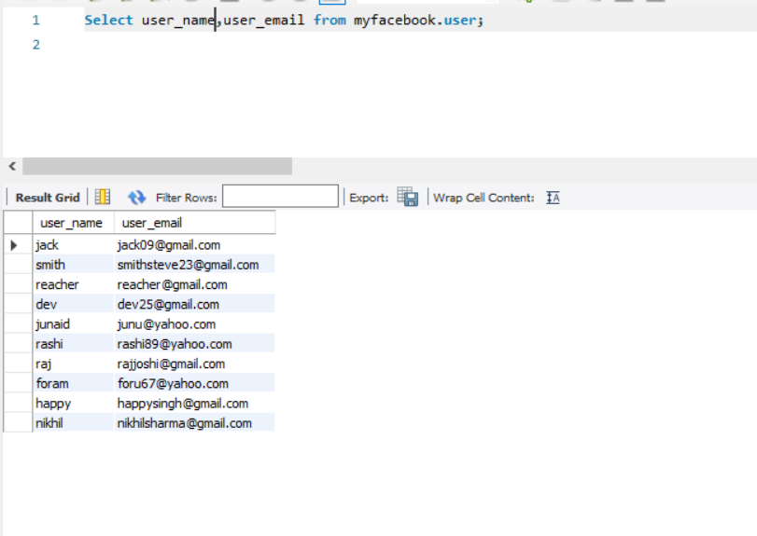

1. List all the users from a given city:-

* City name is chicago:

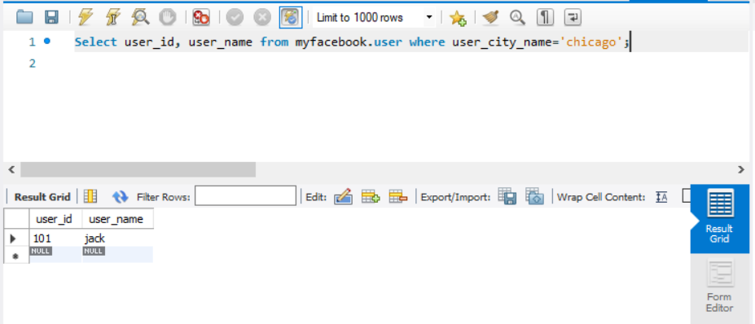

1. Find total number of users joined on a given date:-

Date: 2020-01-25

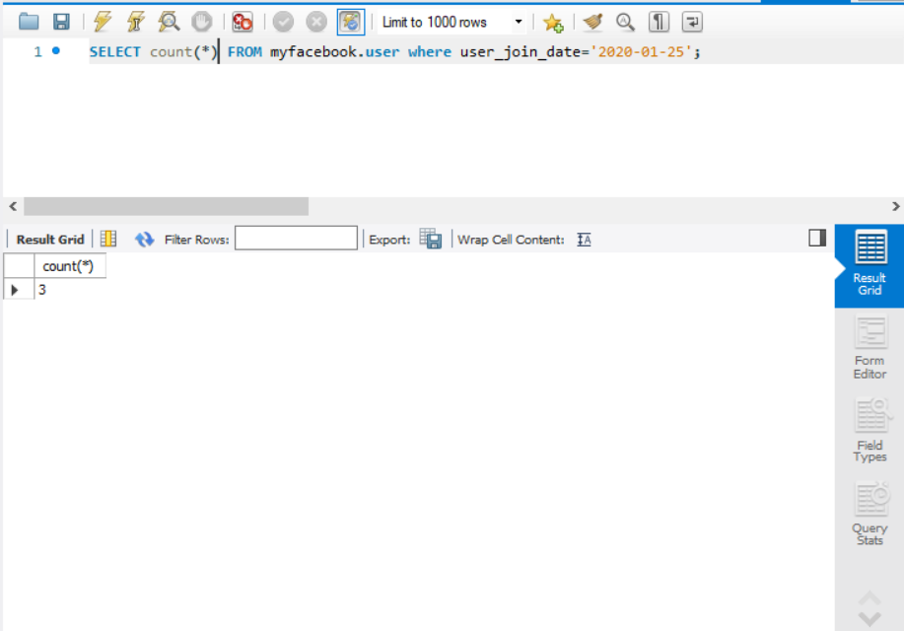

1. List all the friends of a given user:

Given user_id is ‘104’

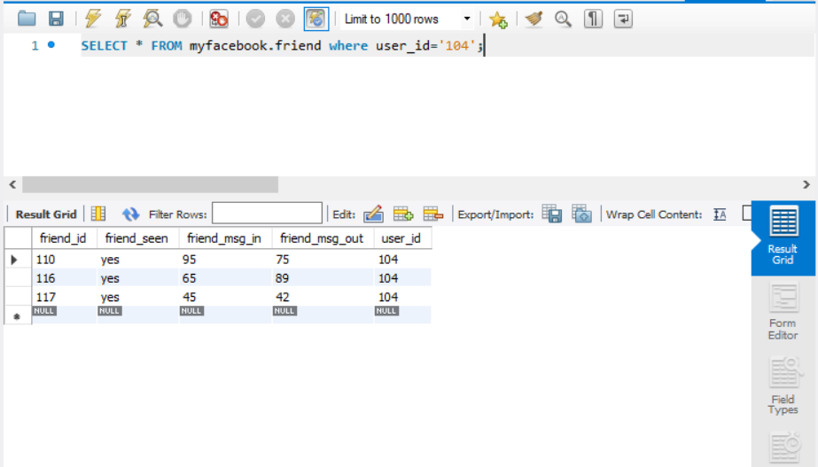

1. List total number of friends of a given user:

Given user id is ‘104’

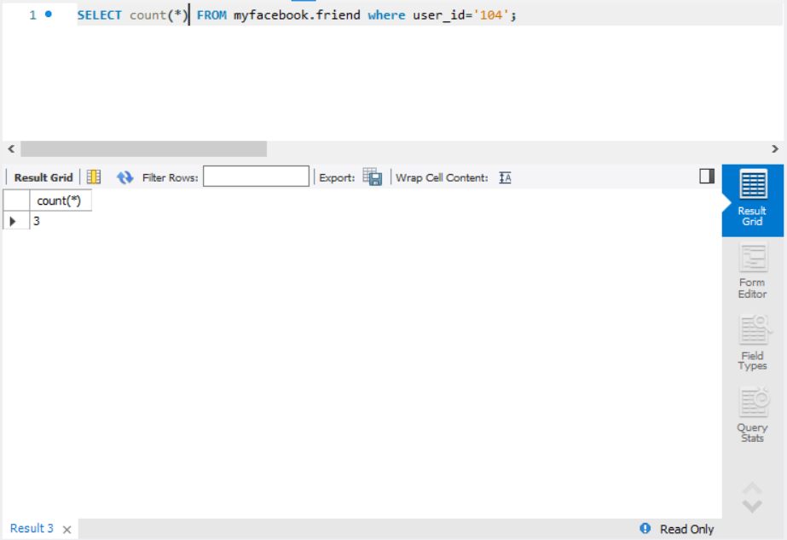

1. Find total number of message in of a given user:

User_id= 108

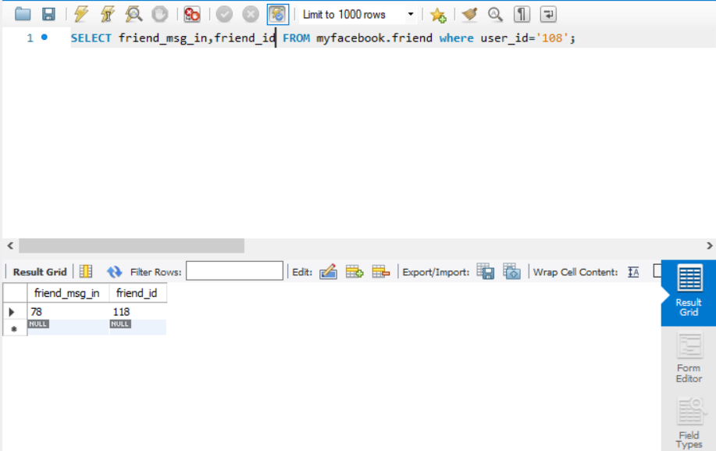

1. Find total number of message out of a given user:

User_id= 108

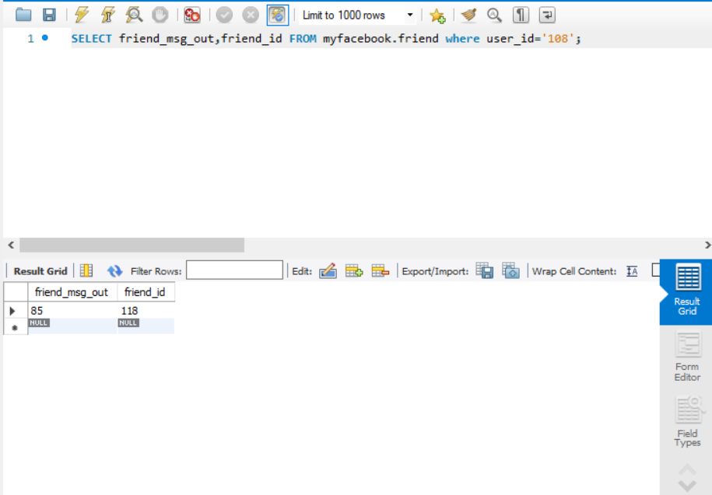

1. List all the post done by a given user’s friend:-

User id is 108:

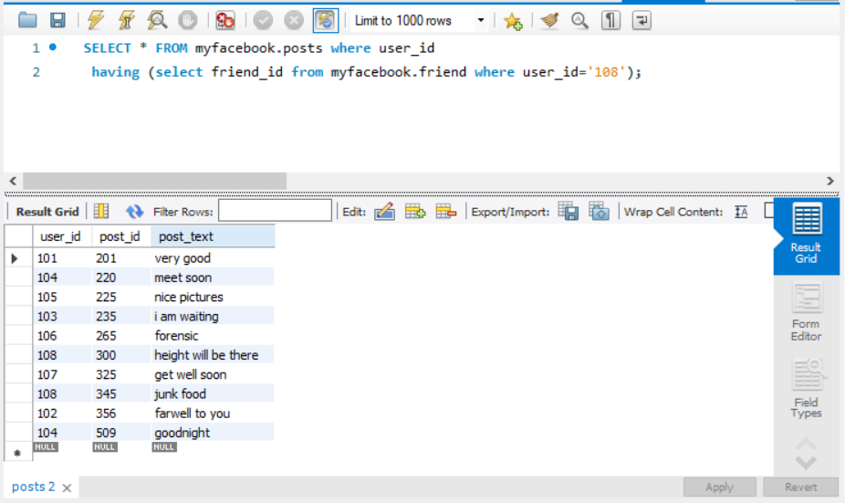

1. List all the post where a given user commented:

Given user id= 108

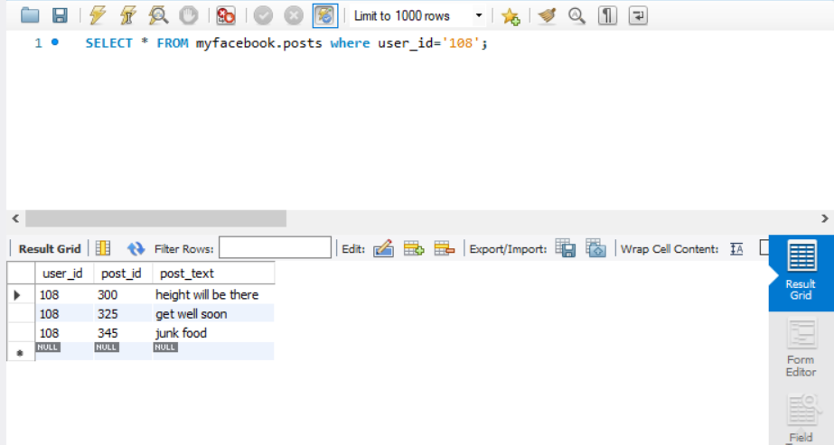

1. List all the post where a given user commented but his given friend not commented:

User id is 108:

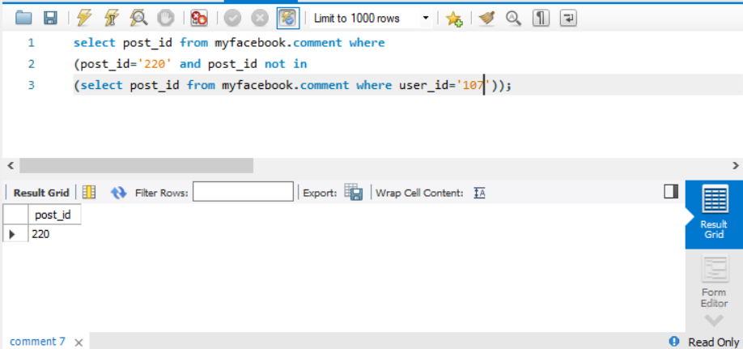

1. Find total number of likes in a given post:

Post id = 101

