**Indian Institute of Information Technology Vadodara**

**CS266 Operating System Lab**

**Lab Assignment 2**

**Roll No. 201951105 Name: Nishant Andoriya**

**File handling**

1. Write a file handling program to read .c file (C program file) and remove vowels from the  source and copy the remaining content to another file.

Ans:-

**Code:**

#include<iostream>

#include <fstream>

#include <vector>

using namespace std;

int main(){

auto clear = [&](string &s)-> void {

string res= "" ;

for ( auto &i: s){

if (i== 'a' ||i== 'A' ) continue ;

else if (i== 'e' ||i== 'E' ) continue ;

else if (i== 'i' ||i== 'I' ) continue ;

else if (i== 'o' ||i== 'O' ) continue ;

else if (i== 'u' ||i== 'U' ) continue ;

else res+=i;

}

s=res;

};fstream source;

cout << "Enter name of source file with extension: " ;

string name;

cin >> name;

source.open(name,ios:: in );

if (!source) {

}

cout << "No such file" ;

else {

vector<string> v;

string s;

while ( 1 ) {

getline(source,s);

if (source.eof())

break ;

v.push_back(s);

}

source.close();

name = name.substr( 0 ,name.size()- 2 ) + "New.c" ;

source.open(name,ios::out|ios::trunc);

for ( auto &i: v){

clear(i);

if (i.size()) source<<i<< "\n" ;

}

cout << "Work done, successfully!" ;

}

source.close();

return 0 ;

}

**Shell Scripting**

2. Write a shell script to display arguments to script. Enter any three input arguments to script  and display.

e.g. < scriptname > arg1 arg2 arg3

o/p: argument1 is arg1. argument2 is arg2. argument3 is arg3

Ans:-

**Code:-**

echo "Enter argument 1"

read arg1

echo "Enter argument 2"

read arg2

echo "Enter argument 3"

read arg3

echo "Argument 1 is $arg1 "

echo "Argument 2 is $arg2 "

echo "Argument 3 is $arg3 "

**Output:-**

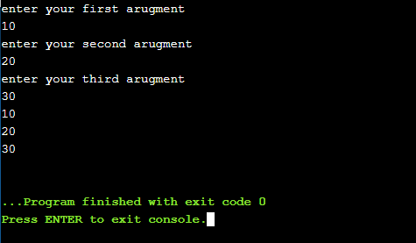

3. Enter 5 integer numbers as arguments to shell script and obtain the highest, the lowest and the  average number.

e.g. i/p: < scriptname > 11 22 33 44 55 !

o/p: Highest: 55, Lowest:11, Average:33

Ans:-

**Code:-**

read integers[0]

read integers[1]

read integers[2]

read integers[3]

read integers[4]

biggest=${integers[0]}

smallest=${integers[0]}

sum=0

for i in ${integers[@]}

do

    sum=$((sum+$i))

     if [[ $i -gt $biggest ]]

     then

        biggest="$i"

     fi

     if [[ $i -lt $smallest ]]

     then

        smallest="$i"

     fi

done

echo "Highest: $biggest, Lowest: $smallest, Average:$(($sum/5)) "

**Output:-**

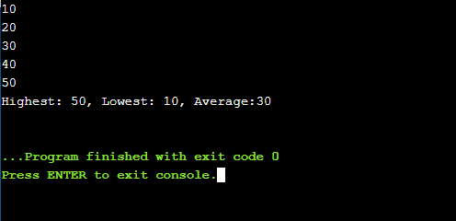

4. Perform basic operations such as addition, subtraction, multiplication and division onto two  input integers. Use three arguments (value1, operator, value2) for shell script. e.g. i/p: < scriptname > 4 + 3 ! o/p:7, i/p: < scriptname > 4 - 3 ! o/p:1 , <scriptname > 13 * 3 !  o/p:39, i/p: < scriptname > 13 / 4 ! o/p: 3

Ans:-

**Code:-**

a=16

b=35

val=`expr $a + $b`

echo "a + b : $val"

val=`expr $a - $b`

echo "a - b : $val"

val=`expr $a \* $b`

echo "a * b : $val"

**Output**:-

